**PATIENT MONITOR**

**PM PRO-1**

**MANUAL BOOK**





**About this Manual**

**Statement**

This manual will help you understand the operation and maintenance of the product better. It is reminded that the product shall be used strictly complying with this manual. User’s operation failing to comply with this manual may result in malfunction or accident for which PT. SINKO PRIMA ALLOY (hereinafter called SINKO) cannot be held liable.

SINKO owns the copyrights of this manual. Without prior written consent of SINKO, any materials contained in this manual shall not be photocopied, reproduced or translated into other languages.

Materials protected by the copyright law, including but not limited to confidential information such as technical information and patent information are contained in this manual, the user shall not disclose such information to any irrelevant third party.

The user shall understand that nothing in this manual grants him, expressly or implicitly, any right or license to use any of the intellectual properties of SINKO.

SINKO holds the rights to modify, update, and ultimately explain this manual.

**Responsibility of the Manufacturer**

SINKO only considers itself responsible for any effect on safety, reliability and performance of the equipment if:

Assembly operations, extensions, re-adjustments, modifications or repairs are carried out by persons authorized by SINKO, and

The electrical installation of the relevant room complies with national standards, and The instrument is used in accordance with the instructions for use.

Upon request, SINKO may provide, with compensation, necessary circuit diagrams, and other information to help qualified technician to maintain and repair some parts, which SINKO may define as ‘user serviceable’.

**Terms Used in this Manual**

This guide is designed to give key concepts on safety precautions.

WARNING

A **WARNING** label advises against certain actions or situations that could result in personal injury or death.

CAUTION

A **CAUTION** label advises against actions or situations that could damage equipment, produce inaccurate data, or invalidate a procedure.

NOTE

A **NOTE** provides useful information regarding a function or a procedure.

**Table of Contents**

Chapter 1 Intended Use and Safety Guidance 1

* 1. Intended Use/Indications for Use 1
  2. Safety Guidance 1
  3. Explanation of Symbols on the Monitor 6

Chapter 2 Installation 9

* 1. Initial Inspection 9
  2. Mounting the Monitor 9
  3. Connecting the Power Cable 9
  4. Checking the Monitor 10
  5. Checking the Recorder 10
  6. Setting Date and Time 10
  7. Handing Over the Monitor 10
  8. FCC Statement 11
  9. FCC RF Radiation Exposure Statement 11

Chapter 3 Basic Operation 12

* 1. Overview 12
     1. Main Unit 12
     2. Parameter Amplifier Mainframe 22
     3. Measurement Modules 23
     4. XM Module 25

3.1.5 PM Pro-2 27

* 1. Operating and Navigating 27
     1. Using Keys 29
  2. Setting Parameters 30
     1. Accessing the Parameter Menu 30
     2. Activating / Deactivating a Parameter Measurement 32
     3. Resolving Module Conflicts 32
     4. Resolving IBP Label Conflicts 33
  3. Operating Mode 33
     1. Demo Mode 33
     2. Standby Mode 34
     3. Night Mode 34
  4. Changing Monitor Settings 34
     1. Adjusting Screen Brightness 34
     2. Changing Date and Time 34
  5. Adjusting Volume 35
     1. Adjusting Key Volume 35
     2. Adjusting Alarm Volume 35
     3. Adjusting Beat Volume 35
  6. Checking Your Monitor Version 35
  7. Networked Monitoring 35
  8. Setting Languages 36
  9. Calibrating Screens 36
  10. Disabling the Touch Screen 36
  11. Using the Bar Code Scanner 36

Chapter 4 Alarms 37

* 1. Alarm Category 37
     1. Physiological alarms 37
     2. Technical Alarms 37
     3. Prompts 37
  2. Alarm Levels 37
  3. Controlling Alarm 38
     1. Setting Parameter Alarm 38
     2. Audio Alarm Paused 39
     3. Audio Alarm off 40
     4. Alarm Reset 40
  4. Latching Alarms 40
  5. Disabling Sensor off Alarms 41
  6. Network Disconnected Alarms 41
  7. Testing Alarms 41

Chapter 5 Alarm Information 42

* 1. Physiological Alarm Information 42
  2. Technical Alarm Information 48
  3. Prompts 67
  4. Adjustable Range of Alarm Limits 70

Chapter 6 Managing Patients 76

* 1. Admitting a Patient 76
     1. Patient Category and Paced Status 77
  2. Quick Admit 77
  3. Editing Patient Information 77
  4. Updating a Patient 77
  5. Central Monitoring System 78

Chapter 7 User Interface 79

* 1. Setting Interface Style 79
  2. Selecting Display Parameters 79
  3. Changing Waveform Position 79
  4. Changing Interface Layout 79
  5. Viewing Trend Screen 80
  6. Viewing Oxygen Screen 80
  7. Viewing Large Font Screen 80
  8. Viewing the Vital Screen 81
  9. Viewing the Bed View Window 81
     1. Opening the Bed View Window 81
     2. Settings of the Bed View Window 81
  10. Changing Parameter and Waveform Colors 82
  11. User Configuration 82
  12. Default Configuration 82

Chapter 8 Monitoring ECG 83

* 1. Overview 83
  2. ECG Safety Information 83
  3. ECG Display 85
     1. Changing the Size of the ECG Wave 85
     2. Changing the ECG Filter Settings 86
  4. Selecting Calculation Lead 86
  5. Monitoring Procedure 86
     1. Preparation 86
     2. Connecting ECG Cables 87
     3. Selecting Lead Type 87
     4. Installing Electrodes 87
  6. ECG Menu Setup 92
     1. Setting Alarm Source 92
     2. Setting Beat Source 92
     3. Smart Lead Off 93
     4. ECG Display 93
     5. Setting Pace Status 93
     6. ECG Calibration 94
     7. ECG Waveform Settings 94
  7. 12-Lead ECG Monitoring 94
     1. Activating 12-Lead ECG Monitoring 94
     2. Diagnosis Function 94
     3. Waveform Durations and Isoelectric Segments 95
  8. ST Segment Monitoring 95
     1. Setting ST Analysis 96
     2. ST Display 96
     3. About ST Measurement Points 96
     4. Adjusting ST and ISO Measurement Points 96
  9. Arr. Monitoring 97
     1. Arrhythmia Analysis 97
     2. ARR Analysis Menu 98

Chapter 9 Monitoring RESP 99

* 1. Overview 99
  2. RESP Safety Information 99
  3. Electrode Placement for Monitoring RESP 99
  4. Cardiac Overlay 100
  5. Chest Expansion 100
  6. Abdominal Breathing 100
  7. Selecting RESP Lead 100
  8. Changing Hold Type 101
  9. Changing the Size and Speed of the Respiration Wave 101
  10. Changing the Apnea Time 101

Chapter 10 Monitoring SpO2 102

* 1. Overview 102
  2. SpO2 Safety Information 102
  3. Measuring SpO2 103
  4. Assessing the Validity of a SpO2 Reading 104
  5. SpO2 Alarm Delay 105
  6. Perfusion Index (PI)* 105
  7. Setting Pitch Tone 106
  8. Setting Sensitivity 106
  9. SatSeconds Alarm Management* 106
     1. Describing SatSeconds 106
     2. SatSeconds “Safety Net” 107
     3. Setting SatSeconds Duration 107

Chapter 11 Monitoring PR 108

* 1. Overview 108
  2. Setting PR Source 108
  3. Setting PR Volume 108
  4. Selecting the Active Alarm Source 108

Chapter 12 Monitoring NIBP 110

* 1. Overview 110
  2. NIBP Safety Information 110
  3. Measurement Limitations 111
  4. Measurement Methods 112
  5. Measurement Procedures 112
     1. Operation Prompts 113
     2. Correcting the Measurement if Limb is not at Heart Level 114
  6. NIBP Multi-Review Window 114
  7. Resetting NIBP 114
  8. Calibrating NIBP 115
  9. Leakage Test 115
  10. Setting Inflation Mode 116

Chapter 13 Monitoring TEMP 117

* 1. Overview 117
  2. TEMP Safety Information 117
  3. TEMP Monitoring Setup 118
  4. Calculating Temp Difference 118

Chapter 14 Monitoring IBP 119

* 1. Overview 119
  2. IBP Safety Information 119
  3. Monitoring Procedures 120
     1. Selecting a Pressure for Monitoring 120
     2. Zeroing the Pressure Transducer 121
     3. Zeroing a Pressure Measurement 121
     4. Troubleshooting the Pressure Zeroing (Taking Art for Example) 121
     5. IBP Pressure Calibration 121
  4. Changing the IBP Waveform Ruler 122
  5. Measuring PAWP 122
     1. Measurement Procedures 122

Chapter 15 Monitoring CO2 124

* 1. Overview 124
  2. CO2 Safety Information 125
  3. Monitoring Procedures 125
     1. Zeroing the sensor 125
     2. Sidestream CO2 Module 126
     3. Mainstream CO2 Module 128
  4. Setting CO2 Corrections 130
  5. Changing Apnea Alarm 130
  6. Setting CO2 Waveform 130

Chapter 16 Monitoring C.O. 131

* 1. Overview 131
  2. C.O. Safety Information 131
  3. C.O. Monitoring Procedures 131
  4. C.O. Measurement Window 133
  5. Measurement Process 134
  6. Editing C.O. 135
  7. Blood Temperature Monitoring 135
  8. Setting the Computation Constant 136
  9. Recording C.O. Measurements 136
  10. Setting INJ. TEMP Source 136
  11. Setting the Interval 136

Chapter 17 Monitoring AG 137

* 1. Overview 137
  2. Safety Information 138
     1. Safety Information for ISA Analyzer 138
     2. Safety Information for Dräger Minimodule 140
     3. Safety Information for IRMA Module 141
  3. Monitoring Steps 143
     1. Monitoring Steps for ISA Analyzer 143
     2. Monitoring Steps for Dräger Minimodule 145
     3. Monitoring Steps for IRMA Module 146
  4. Setting Apnea Alarm Time 150
  5. Working Status of ISA analyzer 150
  6. Working Status of IRMA Module 150
  7. O2 Compensations 151
  8. Effects of Humidity 151

Chapter 18 Monitoring BIS 152

* 1. Overview 152
  2. Safety Information 155
  3. BIS Monitoring Setup 157
  4. BIS Continuous Impedance Check 158
  5. BIS Sensor Check 158
     1. Starting a Sensor Check 158
     2. Stopping a Sensor Check 158
  6. BIS Sensor Window 159
  7. Changing the BIS Smoothing Rate 160
  8. Switching Secondary Parameters On and Off 160
  9. Changing the Scale of the EEG Wave 160
  10. Setting the Trend Length 160
  11. Switching BIS Filters On or Off 160

Chapter 19 Monitoring RM 161

* 1. Overview 161
  2. Safety Information 162
  3. Sensor Setup 165
  4. Zero Calibration 166
  5. Purging 166
     1. Automatic Purging 166
     2. Manual Purging 166
  6. Gas Compensation 167
     1. Changing the Concentration of Inspired O2 and Inspired Agents 167
     2. Changing the Type of Balance Gas 167
     3. Changing the Temperature of the Inspired and Expired Gas 168
     4. Changing the Humidity of the Inspired and Expired Gas 168
  7. RM Configuration 168
     1. Changing the Apnea Alarm Delay 168
     2. Selecting Measured Airway Volume Components 168
     3. Changing the Respiration Mode 168
     4. Selecting Waveform 168
  8. Respiratory Loops 168
     1. Viewing Loops 169
     2. Storing and Reviewing Loops 169
     3. Changing Loop Type 169
     4. Showing/Hiding the Reference Loop 169
     5. Resizing the Loops 169

Chapter 20 Monitoring ICG 170

* 1. Overview 170
  2. Safety Information 171
  3. ICG Patient Cable 171
  4. Precautions and Limitations 172
  5. Starting a Measurement 173
     1. Measurement Procedure 173
     2. ICG Sensor Application 173
     3. Setting Patient Data 174
  6. Selecting Secondary Parameters 174

Chapter 21 Freeze 175

* 1. Entering/Exiting Freeze Status 175
     1. Entering Freeze Status 175
     2. Exiting Freeze Status 175
  2. Reviewing Frozen Waveform 176

Chapter 22 Review 177

* 1. Trend Graph Review 177
     1. Selecting Trend Graph of Specific Parameter 177
     2. Adjusting Trend Scale 177
     3. Setting Resolution 178
     4. Scrolling Left and Right the Screen 178
     5. Switching to the Trend Table 178
     6. Record 178
  2. Trend Table Review 178
     1. Setting Resolution 178
     2. Scrolling the Screen 178
     3. Switching to Trend Graph 178
     4. Recording 179
  3. NIBP Review 179
     1. Scrolling the Screen 179
     2. Recording 179
  4. Alarm Review 179
     1. Scrolling the Screen 179
     2. Selecting Alarm Event of Specific Parameter 179
     3. Setting Time Index 180
  5. Arr Review 180
     1. Scrolling the Screen 180
     2. Arrhythmia Alarm Review 180
  6. 12-lead Diagnosis Review 181
     1. Scrolling the Screen 181
     2. Deleting Diagnosis Results 181
     3. Switching Between Waveforms and Results 181
     4. Recording 181

Chapter 23 Calculation and Titration Table 182

* 1. Drug Calculation 182
     1. Calculation Procedures 182
     2. Calculation Unit 183
     3. Titration Table 183
  2. Hemodynamic Calculation 184
     1. Calculation Procedure 184
     2. Input Parameters 184
     3. Output Parameters 184
  3. Oxygenation Calculation 185
     1. Calculation Procedure 185
     2. Input Parameters 185
     3. Output Parameters 186
  4. Ventilation Calculation 187
     1. Calculation Procedure 187
     2. Input Parameters 187
     3. Output Parameters 187
  5. Renal Function Calculation 188
     1. Calculation Procedure 188
     2. Input Parameters 188
     3. Output Parameters 188

Chapter 24 Recording 189

* 1. Performance of the Recorder 189
  2. Starting and Stopping Recording 190
  3. Recorder Operations and Status Messages 191
     1. Record Paper Requirement 191
     2. Proper Operation 191
     3. Paper Out 191
     4. Replacing Paper 191
     5. Removing Paper Jam 192

Chapter 25 Printing Patient Reports 194

* 1. Printer Settings 194
  2. Starting and Stopping Report Printing 194

Chapter 26 Other Functions 196

* 1. Nurse Call 196
  2. Wireless Network 196
  3. Storing Data in the Storage Device 197
     1. Data Stored in the Storage Device 197
     2. Activating/ Deactivating Data Storing 197
     3. Selecting a Storage Device 197
     4. Reviewing Data Stored in the Storage Device 198
     5. Deleting Data Stored in the Storage Device 198
     6. Exporting Data Stored in the Internal Storage Device 198
     7. Formatting the Internal Storage Device 199
     8. Ejecting a Removable Device 199

Chapter 27 Using Battery 200

* 1. Battery Safety Information 200
  2. Battery Power Indicator 201
  3. Battery Status on the Main Screen 201
  4. Checking Battery Performance 201
  5. Replacing the Battery 202
  6. Recycling the Battery 202
  7. Maintaining the Battery 202

Chapter 28 Care and Cleaning 204

* 1. General Points 204
  2. Cleaning 204
     1. Cleaning the Monitor 205
     2. Cleaning the Reusable Accessories 205
  3. Disinfection 206
     1. Disinfecting the Monitor 207
     2. Disinfecting the Reusable Accessories 207
  4. Cleaning and Disinfecting Other Accessories 208

Chapter 29 Maintenance 209

* 1. Inspecting 209
  2. Maintenance Task and Test Schedule 209

Chapter 30 Warranty and Service 211

* 1. Warranty 211
  2. Contact information 211

Chapter 31 Accessories 212

* 1. ECG Accessories 212
  2. SpO2 Accessories 214
  3. NIBP Accessories 215
  4. TEMP Accessories 216
  5. IBP Accessories 216
  6. CO2 Accessories 217
  7. C.O. Accessories 218
  8. AG Accessories 218
  9. BIS Accessories 219
  10. RM Accessories 219
  11. ICG Accessories 219
  12. Other Accessories 219

A Product Specifications 221

* 1. Classification 221
  2. Physical Specifications 221
  3. Environmental Specifications 223
  4. Power Supply 226
  5. Battery 226
  6. Display 227
  7. Indicators 228
  8. Recorder 228
  9. Data Storage 228
  10. Wi-Fi 229
  11. ECG 229
  12. RESP 234
  13. NIBP 234
  14. SpO2 238
  15. TEMP 240
  16. IBP 240

A.17 CO2 241

A.18 C.O. 246

* 1. AG 246
     1. Sidestream 246
     2. Mainstream 252
  2. BIS 255
  3. RM 255
  4. ICG 259
  5. Interfaces 259
     1. Analog Output 259
     2. Defibrillator Synchronization 260
     3. Nurse Call 261
     4. USB Interfaces 261
     5. VGA Interface 261
     6. DVI Interface* 261
     7. RS232 Interface 262
     8. PAM Interface* 262
     9. Network Interface 262

B EMC Information 263

* 1. Electromagnetic Emissions 263
  2. Electromagnetic Immunity 263
  3. Electromagnetic Immunity 265
  4. Recommended Separation Distances 266

C Default Settings 267

* 1. Patient Information Default Settings 267
  2. Alarm Default Settings 267
  3. ECG Default Settings 267
  4. RESP Default Settings 269
  5. SpO2 Default Settings 269
  6. PR Default Settings 269
  7. NIBP Default Settings 270
  8. TEMP Default Settings 270
  9. IBP Default Settings 271
  10. CO2 Default Settings 271
  11. C.O. Default Settings 272
  12. AG Default Settings 272
  13. BIS Default Settings 273
  14. RM Default Settings 273
  15. ICG Default Settings 274

D Abbreviation 276

# Chapter 1 Intended Use and Safety Guidance

## Intended Use/Indications for Use

The monitors are intended to be used for monitoring, storing, and reviewing of, and to generate alarms for, multiple physiological parameters of adults, pediatrics and neonates. The monitors are intended for use by trained healthcare professionals in hospital environments.

The monitored physiological parameters include: ECG, respiration (RESP), temperature (TEMP), oxygen saturation of arterial blood (SpO2), pulse rate (PR), non-invasive blood pressure (NIBP), invasive blood pressure (IBP), carbon dioxide (CO2), cardiac output (C.O.), anesthetic gas (AG), bispectral index (BIS), respiration mechanics (RM) and impedance cardiography (ICG).

BIS is intended for use on adult and pediatric patients. ICG monitoring is intended for use on adults only.

The arrhythmia detection and ST Segment analysis are intended for adult patients.

The monitors are additionally intended for use during patient transport inside hospitals. The monitors are not intended for MRI environments.

## Safety Guidance

Federal (U.S.) law restricts this device to sale by or on the order of a physician.

**WARNING**

1. Before using the device, the equipment, patient cable and electrodes etc. should be checked. Replacement shall be taken if there is any evident defect or signs of aging which may impair the safety or performance.
2. Medical technical equipment such as this monitor/monitoring system must only be used by persons who have received adequate training in the use of such equipment and who are capable of applying it properly.
3. SHOCK HAZARD-To avoid the RISK of electric shock, this equipment must only be connected to a SUPPLY MAINS with protective earth.
4. EXPLOSION HAZARD-Do not use the device in a flammable atmosphere where concentrations of flammable anesthetics or other materials may occur.
5. The equipment can provide protective means to prevent the patient from being burned when used with HF SURGICAL EQUIPMENT. The equipment can protect against the effects of the discharge of a defibrillator. Use only SINKO-approved accessories.

**WARNING**

1. Do not come into contact with the patient, table, or the monitor during defibrillation.
2. The simultaneous use of cardiac pacemaker and other patient-connected equipment may cause safety hazard.
3. Extreme care must be exercised when applying medical electrical equipment. Many parts of the human/machine circuit are conductive, such as the patient, connectors, electrodes, transducers. It is very important that these conductive parts do not come into contact with other grounded, conductive parts when connected to the isolated patient input of the device. Such contact would bridge the patient's isolation and cancel the protection provided by the isolated input. In particular, there must be no contact of the neutral electrode and ground.
4. Magnetic and electrical fields are capable of interfering with the proper performance of the device. For this reason make sure that all external devices operated in the vicinity of the monitor comply with the relevant EMC requirements. X-ray equipment or MRI devices are a possible source of interference as they may emit higher levels of electromagnetic radiation.
5. Route all cables away from patient’s throat to avoid possible strangulation.
6. Devices connecting with monitor should be equipotential.
7. If the earth protection system is not stable, use the batteries for power supply.
8. Two batteries must be used when the monitor uses internal power supply.
9. Accessory equipment connected to the analog and digital interfaces must be certified according to the respective IEC/EN standards. Furthermore all configurations shall comply with the valid version of the standard IEC/EN 60601-1. Therefore anybody, who connects additional equipment to the signal input or output connector to configure a medical system, must make sure that it complies with the requirements of the valid version of the system standard IEC/EN60601-1. If in doubt, consult our technical service department or your local distributor.
10. The monitor is equipped with Wi-Fi to receive RF electromagnetic energy. Therefore, any other equipment complying with CISPR radiation requirements may also interfere with the wireless communication and make it interrupted.
11. Only use patient cable and other accessories supplied by SINKO. Or else, the performance and electric shock protection cannot be guaranteed, and the patient may be injured. Prior to use, check if the casing of a disposable or sterilized accessory is intact. Do not use it if its casing is damaged.
12. Do not rely exclusively on the audible alarm system for patient monitoring. Adjustment of alarm volume to a low level or off during patient monitoring may result in a hazard to the patient. Remember that the most reliable method of patient monitoring combines close personal surveillance with correct operation of monitoring equipment.

**WARNING**

1. Wireless LAN equipment contains an intentional RF radiator that has the potential of interfering with other medical equipment, including patient implanted devices. Be sure to perform the electromagnetic compatibility test, as described in the Wireless LAN System Installation, before installation and any time new medical equipment is added to the Wireless LAN coverage area.
2. When interfacing with other equipment, a test for leakage current must be performed by qualified biomedical engineering personnel before using with patients.
3. If multiple instruments are connected to a patient, the sum of the leakage currents must not exceed the limits or it may result in shock hazard.
4. During monitoring, if the power supply is off and there is no battery for standby, the monitor will be off. All last settings used will be recovered when the power is restored.
5. Keep away from fire immediately when leakage or foul odor is detected.
6. The device and accessories are to be disposed of according to local regulations after their useful lives. Alternatively, they can be returned to the dealer or the manufacturer for recycling or proper disposal. Batteries are hazardous waste. Do NOT dispose them together with house-hold garbage. At the end of their life hand the batteries over to the applicable collection points for the recycling of waste batteries. Inappropriate disposals of waste may contaminate the environment. For more detailed information about recycling of this product or battery, please contact your local Civic Office, or the shop where you purchased the product.
7. The packaging is to be disposed of according to local or hospital’s regulations; otherwise, it may cause environmental contamination. Place the packaging at the place which is inaccessible to children.
8. After defibrillation, the ECG display recovers within 10 seconds if the correct electrodes are used and applied based on the manufacturers’ instructions.
9. Clinical decision making based on the output of the device is left to the discretion of the provider.
10. This equipment is not intended for home usage.
11. Do not service or maintain the monitor or any accessory which is in use with the patient.
12. Without use of data store function, all data measured (including trend data, review data, alarm events and so on) are cleared either when the monitor is turned off or when the monitor is powered down in the process of monitoring.
13. The appliance coupler or mains plug is used as isolation means from supply mains. Position the monitor in a location where the operator can easily access the disconnection device.

**WARNING**

1. Assembly of the monitor and modifications during actual service life shall be evaluated based on the requirements of IEC60601-1.
2. Additional multiple socket-outlets or extension cords can’t be connected to the system.
3. Only items that have been specified as part of the system or specified as being compatible with the system can be connected to the system.
4. Connecting any accessory (such as external printer) or other device (such as the computer) to this monitor makes a medical system. In that case, additional safety measures should be taken during installation of the system, and the system shall provide:
   1. Within the patient environment, a level of safety comparable to that provided by medical electrical equipment complying with IEC/EN 60601-1, and
   2. Outside the patient environment, the level of safety appropriate for non-medical electrical equipment complying with other IEC or ISO safety standards.
5. All the accessories connected to system must be installed outside the patient vicinity, if they do not meet the requirement of IEC/EN 60601-1.
6. The medical electrical equipment needs to be installed and put into service according to the EMC Information provided in this user manual.
7. Portable and mobile RF communications equipment can affect medical electrical equipment, refer to the recommended separation distances provided in this user manual.
8. Using accessories other than those specified may result in increased electromagnetic emission or decreased electromagnetic immunity of the monitoring equipment.
9. The monitor should not be used adjacent to or stacked with other equipment. If adjacent or stacked use is necessary, you must check that normal operation is possible in the necessary configuration before you start monitoring patients.
10. Do not touch accessible parts of electrical equipment in the patient environment and the patient simultaneously.
11. SHOCK HAZARD - Don't connect electrical equipment, which has not been supplied as a part of the system, to the multiple portable socket-outlet supplying the system.
12. SHOCK HAZARD - Don't connect electrical equipment, which has been supplied as a part of the system, directly to the wall outlet when the non-medical equipment is intended to be supplied by a multiple portable socket-outlet with an isolation transformer.

**CAUTION**

1. Electromagnetic Interference - Ensure that the environment in which the patient monitor is installed is not subject to any sources of strong electromagnetic interference, such as radio transmitters, mobile telephones, etc.
2. Keep the environment clean. Avoid vibration. Keep it far away from corrosive medicine, dust area, high temperature and humid environment.
3. Do not immerse transducers in liquid. When using solutions, use sterile wipes to avoid pouring fluids directly on the transducer.
4. The device and reusable accessories could be sent back to the manufacturer for recycling or proper disposal after their useful lives.
5. Disposable devices are intended for single use only. They should not be reused as performance could degrade or contamination could occur.
6. Remove a battery whose life cycle has expired from the monitor immediately.
7. Avoid liquid splash on the device.
8. To ensure patient safety, use only parts and accessories manufactured or recommended by SINKO.
9. Before connecting the monitor to the AC power, make sure the voltage and the power frequency are consistent with the requirements indicated on the device label or in this user manual.
10. Protect the device against mechanical damage resulting from gravitation, collision, powerful vibration and so on.
11. Do not touch the touch screen with a sharp object.
12. A drafty environment for monitor installation is required, and do not block up the ventilation grille at the back of the device.
13. The monitors are not intended for use in an MRI environment.

NOTE：

1. Position the device in a location where the operator can easily see the screen and access the operating controls.
2. The monitor can only be used on one patient at a time.
3. If the monitor gets damp or liquid pours on the monitor, immediately turn off and dry up the monitor and please contact the service personnel of SINKO.
4. This monitor is not a device for treatment purposes.
5. The pictures and interfaces in this manual are for reference only.
6. Regular preventive maintenance should be carried out every two years. You are responsible for any requirements specific to your country.
7. Operation of the equipment exceeding the measurement range may cause inaccurate results.

## Explanation of Symbols on the Monitor

|  |  |  |
| --- | --- | --- |
| 1 |  | DEFIBRILLATION-PROOF TYPE CF APPLIED PART |
| 2 |  | DEFIBRILLATION-PROOF TYPE BF APPLIED PART |
| 3 |  | Caution |
| 4 |  | MR Unsafe |
| 5 |  | Equipotential grounding |
| 6 |  | Operating instructions |
| 7 |  | Refer to User Manual  (Background: Blue; Symbol: White) |
| 8 |  | Warning  (Background: Yellow; Symbol & outline: black) |
| 9 |  | Non-ionizing electromagnetic radiation |
| 10 |  | Alternating Current |
| 11 |  | Battery check |
| 12 |  | Chargeable battery |
| 13 |  | Power Supply switch |
| 14 |  | SERIAL NUMBER |

|  |  |  |
| --- | --- | --- |
| 15 |  | Network port |
| 16 |  | USB (Universal Serial Bus) Connection |
| 17 |  | Bell cancel – AUDIO OFF |
| 18 |  | NIBP measurement |
| 19 |  | Trend |
| 20 |  | Picture freeze |
| 21 |  | Graphical recorder |
| 22 |  | Menu |
| 23 |  | Video output |
| 24 |  | RS-232 port |
| 25 |  | Nurse call port |
| 26 |  | Write data into store |
| 27 |  | Defibrillator synchronization/Signal output port |
| 28 |  | Output |
| 29 |  | PAM connector |
| 30 |  | CE marking |

|  |  |  |
| --- | --- | --- |
| 31 |  | AUTHORISED REPRESENTATIVE IN THE EUROPEAN COMMUNITY |
| 32 |  | Date of manufacture |
| 33 |  | MANUFACTURER |
| 34 |  | Part Number |
| 35 |  | General symbol for recovery/recyclable |
| 36 |  | Disposal method |
| 37 |  | Anti-theft lock |
| 38 |  | Gas inlet |
| 39 |  | Gas outlet (evac) |
| 40 |  | ISA equipped to measure CO2 only. |
| 41 |  | ISA equipped to measure multiple gases. |
| 42 |  | DO NOT REUSE |
| 43 |  | Ingress Protection IPX1 (Protected against vertically falling water drops) |
| 44 |  | Caution: Federal (U.S.) Law restricts this device to sale by or on the order of a physician. |

NOTE:

The user manual may be printed in black and white.

# Chapter 2 Installation

NOTE:

1. The monitor settings must be specified by the authorized hospital personnel.
2. To ensure that the monitor works properly, please read the user manual and follow the steps before using the monitor.

## Initial Inspection

Before unpacking, check the packaging and ensure that there are no signs of mishandling or damage. If the shipping cartons are damaged, contact the carrier for compensation and package them again.

Open the package carefully and remove the monitor and accessories. Check that the contents are complete and that the correct options and accessories have been delivered.

If you have any question, please contact your local supplier.

## Mounting the Monitor

Place the monitor on a flat, level surface, hang it on the bed rail, or mount it on a wall. For detailed information about how to install the wall mount for the monitor, please refer to the *Wall Mounting Bracket Assembly Instruction*.

**WARNING**

1. The wall mounting bracket can be fixed only on a concrete wall.
2. The safe load of the top splint is 20kg. Overweight may cause the device to rupture and even fall over.

## Connecting the Power Cable

Before connecting the power cable, check if the fuse is well installed inside the connector. (Refer to the illustration *Rear View* in the section *3.1.1* and locate “AC power input”.) The specification of the fuse is T3.15AH250VP.

Connection procedure of the AC power line is listed below:

1. Make sure the AC power supply complies with the following specifications: 100V-240V~, 50Hz/60Hz, 1.8A to 0.75A.
2. Apply the power cable provided with the monitor. Plug the power cavble to inlet interface of the monitor. Connect the other end of the power line to a grounded power output.

NOTE:

1. Connect the power cable to the socket specialized for hospital use.
2. Only use the power cable supplied by SINKO.

## Checking the Monitor

Make sure there is no damage on the measurement accessories and cables. Then turn on the monitor, check whether the monitor can start normally. Make sure all alarm lamps light up and the alarm sound is heard when turning on the monitor.

**WARNING**

If any sign of damage is detected, or the monitor displays some error messages, do not use it on any patient. Contact Customer Service Center immediately.

NOTE:

1. Check all the functions of the monitor and make sure that the monitor is in good status.
2. If rechargeable batteries are provided, charge them after using the device every time, to ensure the electric power is enough.
3. The interval between double pressing of POWER switch should be longer than 1 minute.

## Checking the Recorder

If your monitor is equipped with a recorder, open the recorder’s door to check if paper is properly installed in the slot. If no paper exists, refer to *Chapter 24 Recording* for details.

## Setting Date and Time

To set the date and time:

1. Select **Menu** > **Maintenance** > **User Maintain** > **Date/Time Setup**.
2. Adjust the date display format based on the user’s habit.
3. Set the correct time of year, month, day, hour, min and sec.

## Handing Over the Monitor

If you are handing over the monitor to the end-users directly after configuration, make sure that it is in the monitoring mode.

The users must be adequately trained to use the monitor before monitoring a patient. To achieve this, they should have access to, and read, the following documentation delivered with the monitor:

* User Manual (this book) - for full operating instructions.
* Quick Reference Card - for quick reminders during use.

## FCC Statement

This equipment has been tested and found to comply with the limits for a Class B digital device, pursuant to part 15 of FCC Rules. These limits are designed to provide reasonable protection against harmful interference in a residential installation. This equipment generates and can radiate radio frequency energy and, if not installed and used in accordance with the instructions, may cause harmful interference to radio communications. However, there is no guarantee that interference will not occur in a particular installation. If this equipment does cause harmful interference to radio or television reception, which can be determined by turning the equipment off and on, the user is encouraged to try to correct the interference by one or more of the following measures:

1. Reorient or relocate the receiving antenna.
2. Increase the separation between the equipment and receiver.
3. Connect the equipment into an outlet on a circuit different from that to which the receiver is connected.
4. Consult the dealer or an experienced radio/TV technician for help.

This device complies with Part 15 of FCC Rules. Operation is subject to the following two conditions:

1. This device may not cause harmful interference, and
2. This device must accept any interference received, including interference that may cause undesired operation.

NOTE:

The manufacturer is not responsible for any radio or TV interference caused by unauthorized modifications to this equipment. Such modifications could void the user’s authority to operate this equipment.

## FCC RF Radiation Exposure Statement

This equipment complies with FCC RF radiation exposure limits set forth for an uncontrolled environment. This equipment should be installed and operated with a minimum distance of 20 centimeters between the radiator and your body.

# Chapter 3 Basic Operation

This user manual is based on the maximum configuration and therefore your monitor may not have all of the functions and options described in the manual. Also, illustrations in this manual serve as examples only and do not necessarily reflect the setup on your monitor. The content displayed on your monitor depends on the way it has been tailored for your hospital.

You may frequently use the follow functions:

* ECG monitoring (Refer to *Chapter 8 Monitoring ECG* for more information.)
* SpO2 monitoring (Refer to *Chapter 10 Monitoring SpO2* for more information.)
* PR monitoring (Refer to *Chapter 11 Monitoring PR* for more information.)
* NIBP monitoring (Refer to *Chapter 12 Monitoring NIBP* for more information.)
* Alarm (Refer to *Chapter 4 Alarms* for more information.)

## Overview

### **Main Unit**

##### Front View

###### PM Pro-1

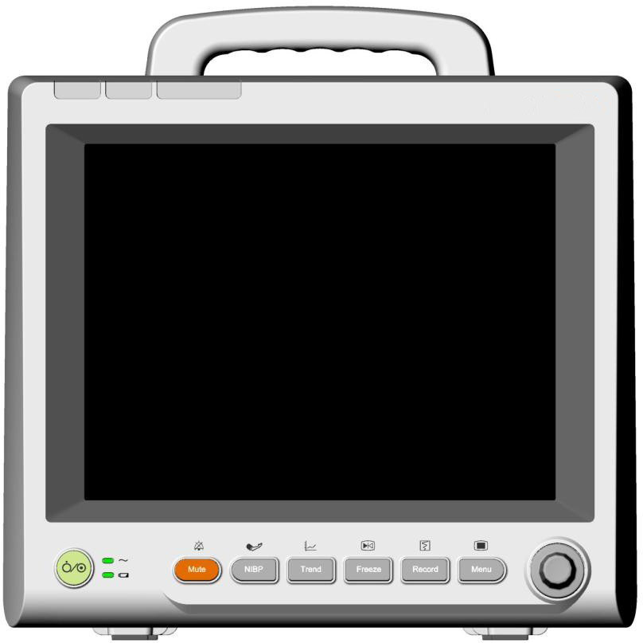

4

3

2

1

14

13

12

11

10

9

8

7

6

5

* + - 1. Alarm mute indicator When the audible alarm is mute, the indicator is in red.
      2. Physiological alarm indicator

When a physiological alarm occurs, the indicator lights on or flashes with different frequencies and colors reflecting the alarm level.

* + - 1. Technical alarm indicator

When a technical alarm occurs, the indicator lights on or flashes with different frequencies and colors reflecting the alarm level.

* + - 1. Display
      2. Power supply switch Press it to turn the monitor on when the monitor

is connected to the AC power supply, or press the key to turn the monitor off when the monitor is on.

* + - 1. Battery indicator Refer to the section *Battery Indicator* for details.
      2. AC power indicator When the monitor is connected to AC power, the

indicator is in green.

* + - 1. Mute Press it to suspend the output of all audible alarm signals. Upon the configuration, pressing this button to pause or turn off the audio alarm. Further information can be found in the section *Audio Alarm Paused* and section *Audio Alarm Off*.
      2. Start/stop NIBP measurement

Press it to start or stop blood pressure measurement.

* + - 1. Trend Press it to review the trend table.
      2. Freeze/unfreeze Press it to freeze or unfreeze waveforms.
      3. Start/stop recording Press it to start or stop recording.
      4. Menu If no menu is displayed on the screen, pressing it will enter the main menu. If there is a menu displayed on the screen, pressing it will close that menu.
      5. Trim Knob Users can rotate the trim knob clockwise or counter-clockwise to highlight the desired item, and press it to select the item.

##### Side View

###### PM Pro-1

1

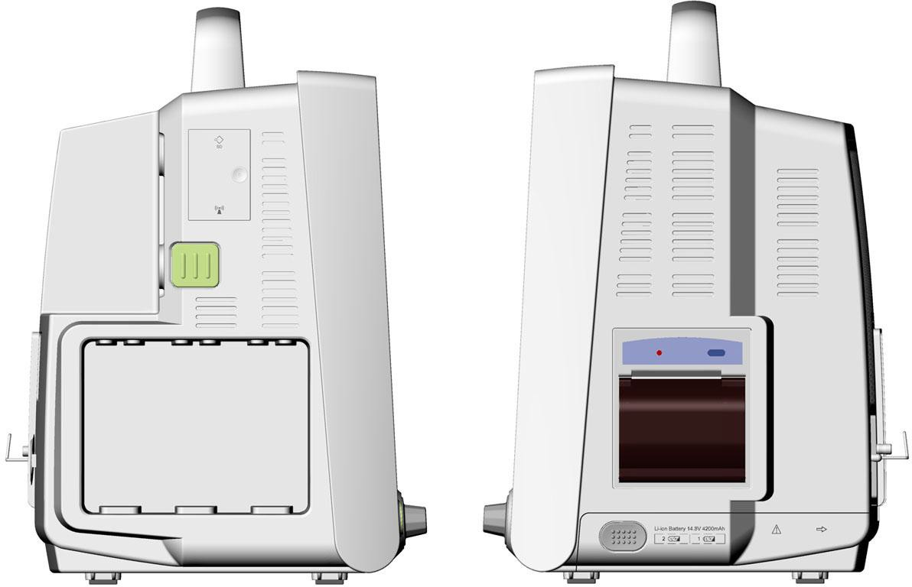

4

2

3 5

6

* + - * 1. Compartment for SD card and Wi-Fi module (Wi-Fi module is optional)
        2. XM module snap-fix
        3. Plug-in module slots
        4. Speaker
        5. Recorder
        6. Battery compartment latch

NOTE:

To avoid bad contact caused by dust accumulation, clean the contacts regularly by wiping them with a cotton swab moistened with alcohol.

##### Rear View

###### PM Pro-1

1

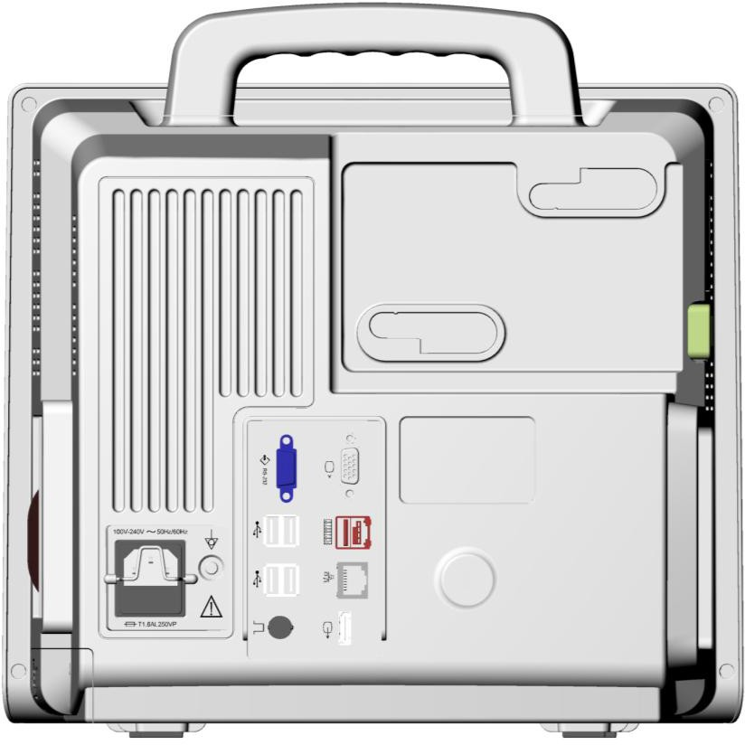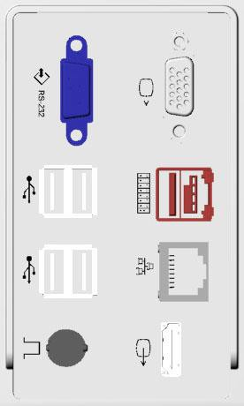

2 11

3

4 7

8

5

9

6 10

1. Power cable safety latch

Used to prevent the power cable from detaching.

1. AC power input
2. Equipotential grounding terminal

If the monitor is used together with other devices, connect this terminal to eliminate potential ground differences between devices.

1. RS232 interface Connect it to communicate with other devices.
2. USB interfaces They support USB1.0/2.0 output.
3. Nurse call port/ analog output/ defibrillator synchronization

Nurse call port: it connects the monitor to the hospital’s nurse call system. Alarms indications are alerted through the nurse call system if configured to do so.

Analog output: the monitor outputs the waveform through the port.

Defibrillator synchronization: the monitor outputs the defibrillator synchronization signal through the port.

1. VGA output It enables the VGA video output.
2. PAM connector It connects the Parameter Amplifier Mainframe to the monitor.
3. Network interface It connects the monitor to the central

monitoring system via standard network cable.

1. Extended video interface

It connects a secondary display, which extends the display capability of your monitor.

1. Anti-thief lock

**CAUTION**

Connect only the SINKO Parameter Amplifier Mainframe to the PAM connector. Do not connect any other device to this connector.

NOTE:

1. If incomplete display occurs on the screen of an external display connecting to the monitor via the VGA output, adjust it with the button for automatic screen adapting of the external display, or refer to its user manual.
2. The functions of nurse call, analog output and defibrillator synchronization are only available when the XM module is inserted in the monitor.
   * 1. **Parameter Amplifier Mainframe**

Users can connect one Parameter Amplifier Mainframe (PAM) to the monitor via a particular link cable. The PAM provides 8 slots for mounting measurement modules. The number of modules mounted in the PAM varies with the number of slots needed by different modules.

1

##### Front View

2

Rear View

3

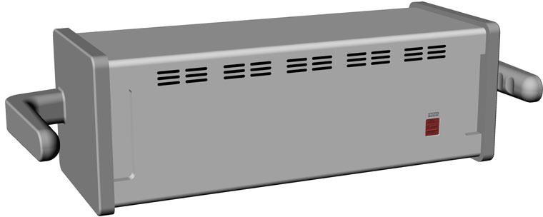

4

1. Indicator
   * On: when the PAM works normally;
   * Off: when the PAM is disconnected from the monitor, power supply malfunction occurs or the monitor is powered off.
2. Contact
3. Handle
4. PAM connector

NOTE:

To avoid bad contact caused by dust accumulation, clean the contacts regularly by wiping them with a cotton swab moistened with alcohol.

* + 1. **Measurement Modules**

Users can use a maximum of 8 measurement modules with the PAM and additional 3 modules in the integrated module slots in the monitor. The number of modules mounted in the monitor varies with the number of slots needed by different modules.

The connector socket on the front of each module is of the same color as the corresponding connector plug on the transducer or patient cable.

Modules supported by this monitor are:

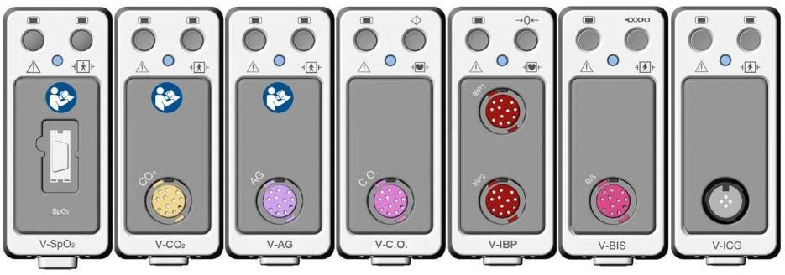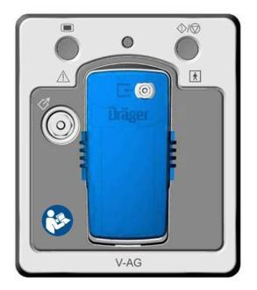

**1 2 3 4 5 6 7 8**

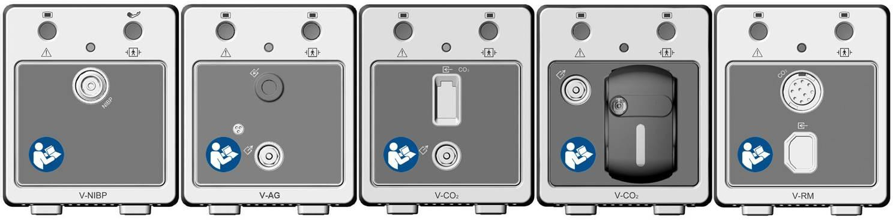

**9 10 11 12 13**

1. V-SpO2 module: Functional arterial oxygen saturation module
2. V-CO2 module (mainstream): Respironics carbon dioxide module for mainstream
3. V-AG module (mainstream): Anesthetic gas module for mainstream
4. V-C.O. module: Cardiac output module
5. V-IBP module: Invasive blood pressure module
6. V-BIS module: Bispectral index module
7. V-ICG module: Impedance cardiography module
8. V-AG module (Sidestream): Dräger Minimodule for sidestream
9. V-NIBP module: Omron non-invasive blood pressure module
10. V-AG module (sidestream): Anesthetic gas module for sidestream
11. V-CO2 module (sidestream): Respironics carbon dioxide module for sidestream
12. V-CO2 module (sidestream): SINKO carbon dioxide module for sidestream
13. V-RM module: Respiration mechanics module

##### **Example Module**

The structure of each plug-in module is similar: the module name is located at the bottom part; hard keys are in the upper part; measurement connectors are in the lower part. Take the V-IBP module for example:

1 4

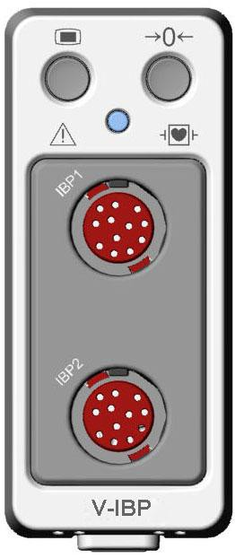

2

3

5

1. Setup key: press to enter setup menu of the measurement module.
2. Indicator
   * On: when the module works normally.
   * Flash: when the module is being initialized or malfunctioning.
   * Off: when the module is unconnected.
3. Connectors for transducer/sensor
4. Second module-specific key, such as the zero key for IBP.
5. Module name.

##### **Plugging/ Unplugging Modules**

Users can plug and unplug modules during monitoring.

* To plug a module, insert the module until the lever on the module clicks into place.
* To unplug a module, press the lever upwards and pull the module out.

NOTE:

Make sure the indicator on the module is on after the module is plugged in the monitor. Otherwise, re-plug the module until the indicator is on.

* + 1. **XM Module**

The XM module is integrated with functions of multiple measurement modules of ECG, RESP, SpO2, TEMP, IBP and NIBP. Plug the XM module in the XM module slot on the left side of the monitor, and it is connected with the monitor as shown below:

XM module mounted on the left of the monitor

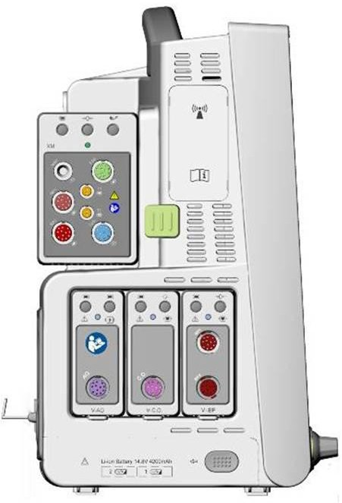

##### Overview of XM Module

1 2 3

4

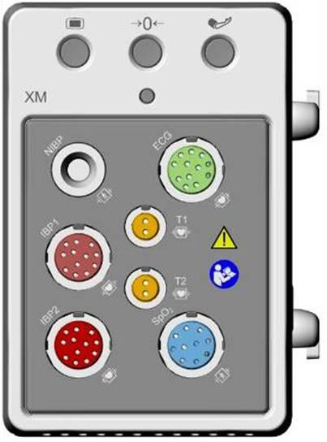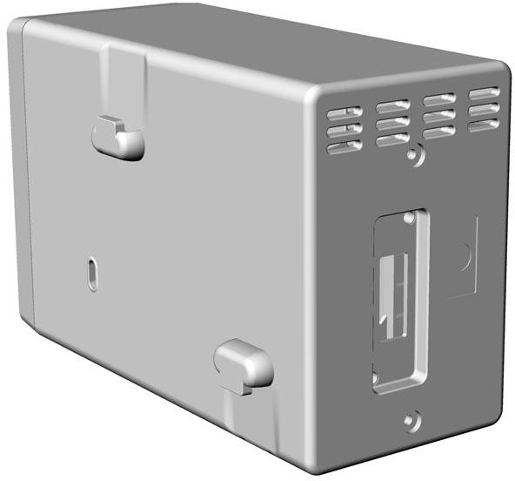

5

7

6

8

1. Setup key: press to enter the XM module setup menu.
2. Zero key: press to enter the zero IBP menu.
3. NIBP start/ stop key: press to start or stop NIBP measurement.
4. Indicator
   * On: when the module works normally.
   * Flash: when the module is being initialized or malfunctioning.
   * Off: when the module is unconnected.
5. Module name
6. Connectors for transducer/sensor
7. Snap-fix
8. Connector to the monitor

##### Installing the XM Module

Mate the snap-fixes on the right side of the module with the slots on the rear of the monitor, and push the module forwards until the lever clicks in place, then fasten the module with the snap-fix on the left side of the monitor.

* + 1. **PM Pro-2**

The monitor can be coupled with PM Pro-2 patient monitor, where PM Pro-2 acts as a multi-measurement module, providing the measurements, trends, and patient information for the monitor. PM Pro-2 is integrated with functions of multiple measurement modules of ECG, RESP, SpO2, TEMP, IBP and NIBP. Plug PM Pro-2 in the module slot on the left side of the monitor, and it is connected with the monitor as shown below:

PM Pro-2

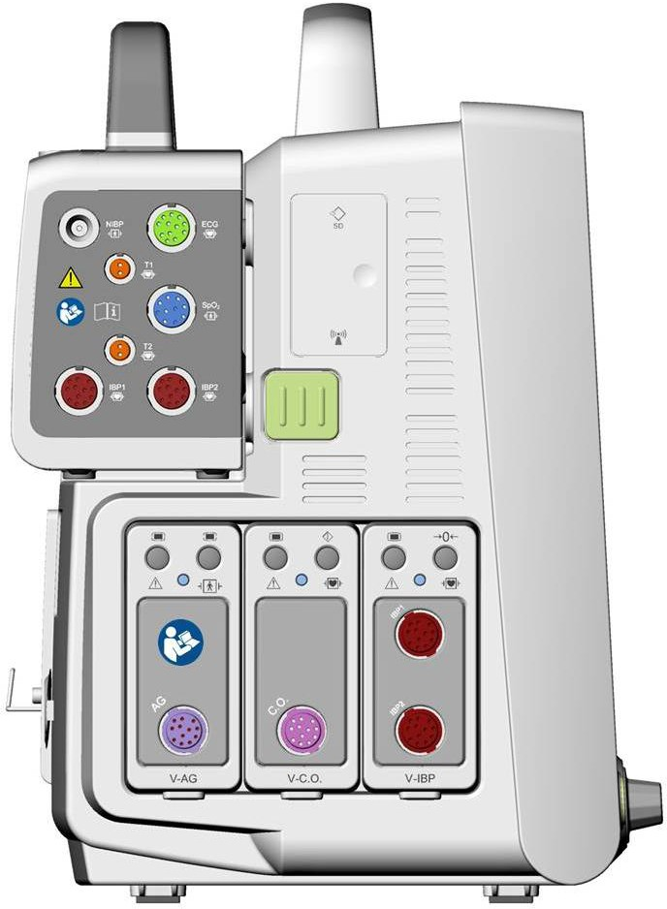

mounted on the left of the monitor

For detailed information about how to use the monitor with PM Pro-2, please refer to the *PM Pro-2 Patient Monitor User Manual*.

* 1. **Operating and Navigating**

Everything you need to operate the monitor is contained on its screen. Almost every element on the screen is interactive. Screen elements include measurement numerics, waveforms, screen keys, information fields, alarms fields and menus. The configurability of the monitor means that often you can access the same element in different ways. For example, you might be able to access an item through its on-screen setup menu, via a hard key, or via a shortcut key. The User Manual always describes how to access items via an on-screen menu. You may use whichever way you find most convenient.

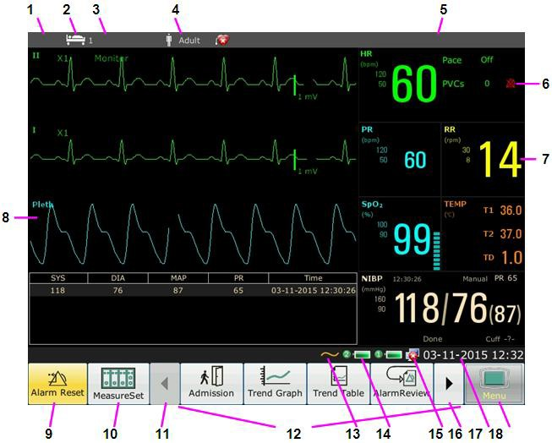

|  |  |  |
| --- | --- | --- |
| 1 Department | 10 | Measurement setup key |
| 2 Bed number | 11 | Scroll left to display more shortcut keys |
| 3 Patient name | 12 | Shortcut key area |
| 4 Patient type | 13 | Symbol for AC power supply |
| 5 Alarm status area | 14 | Symbol for battery status |
| 6 Symbol for alarm off | 15 | Symbol for networking |
| 7 Measurement value | 16 | Scroll right to display more shortcut keys |
| 8 Parameter waveform | 17 | Date and time |
| 9 Alarm reset key | 18 | Menu key |

* + 1. **Using Keys**

##### **Permanent Keys**

A permanent key is a graphical key that remains on the screen all the time to give you fast access to functions, such as:

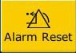 To reset the alarm.

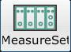 To display the measuring setup interface. 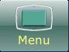 To display the main setup menu.

##### **Shortcut Keys**

A shortcut key is a configurable graphical key, located at the bottom of the main screen. It gives you fast access to functions. The selection of shortcut keys available on your monitor depends on your monitor configuration and on the options purchased.

 Perform a 12-lead analysis  Switch to the standard screen

 Exit from 12-lead analysis  Switch to the OxyCRG screen

 Access the 12-lead review  Switch to the large font screen

 Perform 12-lead record  Set the module switch

 Admit a patient Change the key volume

 Review the trend graph  Adjust the screen brightness

Review the trend table Zero the IBP sensor

Review the alarm event Alarm setup

 Access the NIBP review  Change the beat volume

 Access the ARR review  Enter standby mode

 Switch to the trend screen  Printer Setup

 Switch to the vital screen  Enter night mode

Select this item by the trim knob to enable the touch screen operation

##### **Hardkeys**

A hardkey is a physical key on a monitoring device, such as the recording key on the front panel. Refer to the illustration in *3.1.1 Main Unit* for more information.

##### **Pop-up keys**

Pop-up keys are task-related graphical keys that appear automatically on the screen when required. For example, the confirmation pop-up key appears only when you need to confirm a change.

* 1. **Setting Parameters**
     1. **Accessing the Parameter Menu**

Select  on the bottom of the screen to enter the **MeasureSet** menu as shown below. The display on your monitor may be configured to look slightly different depending on the modules mounted.

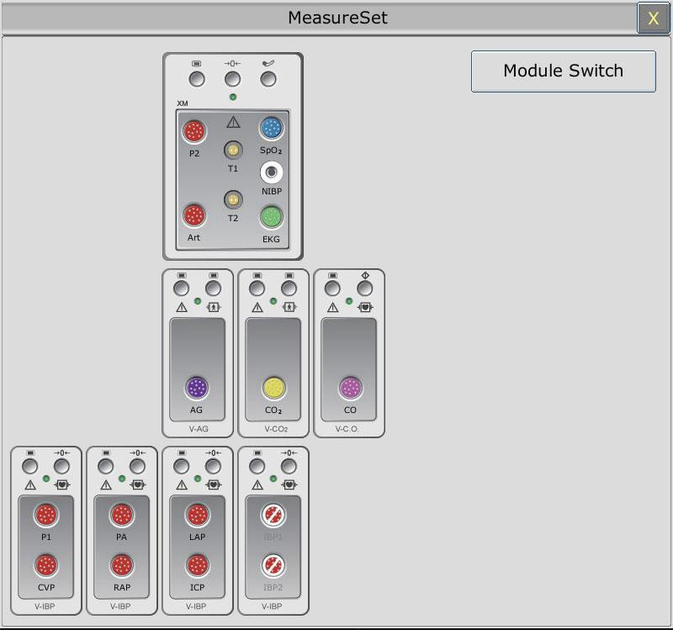

This menu displays the measurement modules which have been mounted in the XM module slot, three-slot module rack and PAM from top to bottom. Beside each measurement connector is the measurement label. The color in which a measurement connector appears matches the status of the measurement parameter.

Colored: indicates the module is activated.

Grey: indicates the module is deactivated.

Colored with a “!” appearing: indicates a module conflict.

For IBP connectors, with a circle-slash symbol appearing: indicates an IBP module conflict.

For IBP connectors in the XM module: indicates this XM module is not configured with an IBP module.

* + 1. **Activating / Deactivating a Parameter Measurement**

For different measurement parameters, approaches to parameter activation / deactivation may vary a little. Take the parameters ECG and NIBP in XM module for example:

* To activate / deactivate the ECG measurement, select the ECG connector in the XM module on the **MeasureSet** menu, and set the ECG measurement to on or off on the pop-up submenu.
* To activate / deactivated the NIBP measurement, select the NIBP connector in the XM module on the **MeasureSet** menu, and the NIBP measurement will directly be activated / deactivated.
  + 1. **Resolving Module Conflicts**

This monitor supports a maximum of eight channels of IBP measurement. Both the XM module and each V-IBP module provide two channels of IBP measurement. A maximum of four V-IBP modules can be used simultaneously if the XM module is not used, while three if the XM module is used. If eight channels of IBP measurement are loaded, another IBP module’s plugging in will

trigger an IBP module conflict; the corresponding IBP connector will be changed into on the **MeasureSet** menu as an indication. To remove the IBP conflict, unplug the conflicting module and re-plug it while less than eight channels of IBP are loaded.

For other modules, only one of the same type is available at a time; another one inserted will be in the conflicting status. For example, if a CO2 module (module A) is loaded then another CO2 module (module B) is inserted, a symbol “!” in red will appear on the corresponding connector on the **MeasureSet** menu to indicate a module conflict. To use module B, directly select the connector of module B on the **MeasureSet** menu, and module A is consequently switched to be in conflicting status. Especially, for resolving a BIS module conflict, you also need to disconnect connection between the V-BIS module and the BISx device and reconnect the BISx device to the V-BIS module which you need to use.

* + 1. **Resolving IBP Label Conflicts**

Each label must be unique and can only be assigned once. The measurement labels are stored in the measurement modules. If you try to use two measurement modules that have identical labels, this causes a label conflict in the monitor.

For example, an IBP module (module A) has already been loaded and the label Art is used for module A. Then another IBP module (module B) is inserted and the label Art is also used for module B. In this case, a label conflict will be triggered. A prompt indicating IBP label conflict will appear on the left of the screen. Additionally, at the corresponding measurements area, two labels flicker to indicate a label conflict. The label inside the brackets is the conflicting one while the label outside the brackets is the default one assigned by the system. Via comparing the labels displayed on the **MeasureSet** menu with the label outside the brackets, you may identify the model with a label conflict and accordingly decide on the module to work.

The IBP module with a label conflict will not provide any measurement data; besides, the functions of setup, zeroing and calibrating are unavailable. To resolve the label conflict, you have to change the conflicting label into a non-conflicting one. Three resolutions are available:

Resolution 1:

1. Select the IBP channel with a label conflict on the screen and open the **Options** menu.
2. Choose another label among the options from the **Alias** pull-down list to resolve the label conflict.

Resolution 2:

1. Deactivate the parameter with label A which works properly or unplug the corresponding module.
2. The conflicting label A will consequently turn to be available. Resolution 3:
3. Choose another label for label A which works properly.
4. The conflicting label A will consequently turn to be available.
   1. **Operating Mode**
      1. **Demo Mode**

To change the operating mode into the demo mode, please refer to the following procedure:

Select **Menu** > **Common Function**, then choose **Demo Mode** from the popup interface and input password **3045**.

To exit **Demo Mode**, select **Menu** > **Common Function** > **Demo Mode**.

**WARNING**

Demo Mode is for demonstration purposes only. You must not change into Demo Mode during monitoring. In Demo Mode, all stored trend information is deleted from the monitor’s memory.

* + 1. **Standby Mode**

Standby mode can be used when you want to temporarily interrupt monitoring. To enter standby mode, please press the shortcut key  on the screen directly. To resume monitoring, select anything on the screen or press any key.

* + 1. **Night Mode**

To switch to night mode, you may:

* Select the shortcut key  on the main screen, or
* Select **Menu**> **Common Function**> **Night Mode**.

NOTE:

In night mode, the sound of key, heart beat and pulse is muted; the alarm volume and screen brightness are down to their minimum; the settings including key volume, beat volume, PR volume, alarm volume and screen brightness are unavailable.

* 1. **Changing Monitor Settings**
     1. **Adjusting Screen Brightness**

To change the screen brightness:

1. Select the shortcut key on the screen directly, or
2. Select **Menu > Common Function > Brightness**, and select the appropriate setting for the screen brightness**. 10** is the brightest, **1** is the least bright.
   * 1. **Changing Date and Time**

To change the date and time, please refer to Section *Setting Date and Time*.

**WARNING**

A change in date and time will influence the storage of trend data.

* 1. **Adjusting Volume**
     1. **Adjusting Key Volume**

The key volume is the volume you hear when you select any field on the monitor screen or when you turn the knob. To adjust the key volume:

1. Select the shortcut key on the screen directly, or
2. Select **Menu** > **System Setup** > **Key Volume**, then select the appropriate setting for the key volume: five bars represent the maximum volume and one bar represents the minimum volume. If none of bars are selected, the key volume will be off.
   * 1. **Adjusting Alarm Volume**

To change the alarm volume, please

1. Select the shortcut key on the screen directly, or
2. Select **Menu** > **Alarm Setup** and select the desired setting for the **Alarm Volume** item: five bars represent the maximum volume and one bar represents the minimum volume.
   * 1. **Adjusting Beat Volume**

Beat volume is from HR or PR, depending on your setting of the alarm source. To change the beat volume:

1. Select the shortcut key on the screen directly, or
2. Select **ECG Setup** > **Beat Volume**, then select the appropriate setting for the beat volume: five bars represent the maximum volume and one bar represents the minimum volume. If none of bars are selected, the beat volume will be off.
   1. **Checking Your Monitor Version**

To check the monitor version, please select **Menu** > **Common Function** > **About** to check the monitor software revision.

* 1. **Networked Monitoring**

Your monitor can be connected to the wired network and the wireless network. If the monitor is networked, a network symbol is displayed on the screen.

NOTE:

Be aware that some network-based functions may be limited for monitors on wireless networks in comparison to those on wired networks.

* 1. **Setting Languages**

To change the language, please:

1. Select **Menu** > **Maintenance** > **User Maintain**, then type the correct password **ABC** into the displayed interface.
2. Select the **Language** option on the popup interface to open the language list.
3. Select the desired language from the list. To make the change valid, please restart the monitor.
   1. **Calibrating Screens**

To calibrate the screen, please refer to the following steps:

1. Select **Menu** > **Maintenance** > **User Maintain**, input the user password **ABC**, and select

**TouchScr Calibration** on the **User Maintain** menu.

1. The symbol  appears on the screen.
2. Click on the central point of the symbol  .
3. After the screen calibration is finished, it will return to the **User Maintain** menu.
   1. **Disabling the Touch Screen**

The user can disable touch screen operation by selecting and holding the permanent key  for three seconds. A message of **Screen Locked** and the symbol  will be displayed at the bottom of screen. To enable the touch screen operation, select the symbol  by using the knob**.**

* 1. **Using the Bar Code Scanner**

To enter the barcode setup menu, select **Menu > Maintenance > User Maintain**, after entering the required password **ABC**, select **Other Setup > BarCode Setup**. You can configure the settings such as MRN, Last Name, First Name and so on.

# Chapter 4 Alarms

**WARNING**

A potential hazard can exist if different alarm presets are used for the same or similar equipment in any single area, e.g. an intensive care unit or cardiac operating room.

## Alarm Category

The monitor provides two types of alarm: physiological alarms and technical alarms. Also, the monitor provides prompts.

### **Physiological alarms**

If one or several physiological parameters of the currently monitored patient exceed the predefined alarm limit, the monitor will give an alarm, and this type of alarm is called physiological alarms. About the detailed alarm information, please refer to the Section *physiological alarm information*.

### **Technical Alarms**

If one or several technical status of the device is in abnormal status, the monitor will give an alarm. And this type of alarm is called technical alarms. Technical alarms can’t be disabled. About the detailed alarm information, please refer to Section *technical alarm information*.

### **Prompts**

The monitor can give the character indication of monitoring process or other functions. And this character is called prompts. About the detailed alarm information, please refer to Section *Prompts*.

## Alarm Levels

In terms of severity, the device’s alarm levels can be classified into three categories: high level alarms, medium level alarms and low level alarms.

1. High level alarms

A high level alarm intensively warns the operator of a high priority alarm condition which requires immediate operator response. Failure to respond to the cause of the alarm condition is likely to result in death or irreversible injury of the patient.

1. Medium level alarms

A medium level alarm warns the operator of a medium priority alarm condition which requires prompt operator response. Failure to respond to the cause of the alarm condition is likely to result in reversible injury of the patient.

1. Low level alarms

A low level alarm reminds the operator of a low priority alarm condition which requires response. And the response time for a low priority alarm condition can be greater than that for a medium priority alarm condition. Failure to respond to the cause of the alarm condition is likely to result in discomfort or reversible minor injury of the patient.

Alarm Sound

The high/medium/low-level alarms are indicated by the system in following different audio ways:

|  |  |
| --- | --- |
| Alarm level | Prompt |
| High | Mode is “DO-DO-DO------DO-DO, DO-DO-DO------DO-DO”, which  is triggered once every 10 seconds. The alarm indicator flashes in red,  with frequency of 1.4Hz～2.8Hz. |
| Medium | Mode is “DO-DO-DO”, which is triggered once every 25 seconds. The alarm indicator flashes in yellow, with frequency of 0.4Hz～0.8Hz. |
| Low | Mode is “DO-”, which is triggered once every 30 seconds. |

The sound pressure range for audible alarm signals is from 45 dB to 85 dB.

**WARNING**

1. Do not rely exclusively on the audible alarm system for patient monitoring. Adjustment of alarm volume to a low level or off during patient monitoring may result in patient danger. Remember that the most reliable method of patient monitoring combines close personal surveillance with correct operation of monitoring equipment.
2. Ensure the volume is properly set up. When the sound pressure of audible alarm is below or equivalent to the ambient noise, it may be difficult for the operator to distinguish the audio alarm.

## Controlling Alarm

### **Setting Parameter Alarm**

Parameter alarm settings including alarm switch, alarm record, alarm level and alarm limit are available on the respective alarm setup menu for each parameter. To access the menu for parameter alarm settings, use the shortcut key  or select **Menu**> **Alarm Setup**, and then click **Alarm Options** to open the menu shown below for alarm settings of each parameter. Also, you can access this menu via the respective parameter setup menu.

Upper arrow or lower arrow to increase or

decrease the alarm limit

High

Alarm Limit

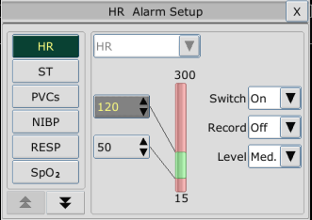

Setting value of high alarm limit

Setting value of low alarm limit

Low

Alarm Limit

**WARNING**

1. When the alarm is set to OFF, the monitor won’t give an alarm prompt even if an alarm occurs. In order to avoid endangering the patient’s life, the user should use this function cautiously.
2. Prior to monitoring, make sure that the alarm limit settings are appropriate for your patient.
3. Setting alarm limits to extreme values may cause the alarm system to become ineffective. It is recommended to use the default settings.

### **Audio Alarm Paused**

You can temporarily prevent alarms from sounding by pressing the hard key on the front panel.

You can set the alarm pause time as desired. The default alarm pause time is 120s.

1. Select **Menu** > **Maintenance > User Maintain**, and enter the required password **ABC**.
2. Select **Alarm Setup**, and set **Pause Time** to **60s**, **120s**, or **180s**.

When alarms are paused,

* The audio alarm is turned off and no alarms are sounding.
* The visual alarm indications are still displayed.
* The monitor displays the audio alarm paused icon .
* The monitor displays the remaining pause time in seconds with red background.
* The hardkey on the front panel flashes in yellow.

When the alarm pause time expires, the audio alarm paused status is automatically terminated and

alarm is sounding. You can also terminate the alarm paused status by pressing the hard key

NOTE:

If a new alarm occurs during the audio alarm paused period, the new alarm will not be sounding.

### **Audio Alarm off**

Set **Pause Time** to **Permanent**, and the monitor will enter into audio alarm off status after the hardkey is pressed. During the audio alarm off status,

* The audio alarm is turned off and no alarms are sounding.
* The visual alarm indications are still displayed.
* The hardkey on the front panel flashes in yellow.

**Remind signal**: Audio alarm off symbol  and **Audio Alarm off** on a red colored background are displayed with an interval of 2s during the audio alarm off status. If module loading or data transferring is in progress at the meantime, the remind signal for audio alarm off will disappear till the module loading or data transferring is finished.

Pressing the hardkey again can resume the audio alarm.

NOTE:

If a new alarm occurs during the audio alarm off period, the new alarm will not be sounding.

### **Alarm Reset**

Select the shortcut key **Alarm Reset ** on the screen directly. When the alarm is reset,

* No alarms are sounding until a new alarm occurs.
* As for the active alarms, the visual alarm indications are still displayed.
* All latching alarms are cleared. If the alarm condition is no longer present, all alarm indications stop and the alarm is reset.
* It will not influence the configuration of physiological alarm off, audio paused, and audio off status.

NOTE:

If a new alarm occurs after the alarm is reset, the new alarm will be sounding.

## Latching Alarms

To configure the alarm latching setting, select **Menu** > **Maintenance** > **User Maintain** > **Alarm Setup** and choose **Alarm Latch** which can be set to **On** or **Off**. When it is set to **Off**, alarm

indications end when the alarm condition ends. When it is set to **On**, the visual alarm indication is still displayed after the alarm condition ends; meanwhile, the alarm time is also displayed for the latched alarm for your reference. The indication lasts until you acknowledge the alarm.

You can use the permanent key  on the screen to acknowledge the latched alarm.

## Disabling Sensor off Alarms

To set sensor off alarm, please select **Menu** > **Maintenance** > **User Maintain** and enter the required password **ABC**. Then select **Alarm Setup** and set **Sensor Off Alm** from the pull-down

list. If it is set to **On**, and a sensor off alarm occurs, the user can press the hardkey on the front panel or the permanent key **Alarm Reset ** to disable the audio alarm signal. However, the visual alarm indications are still displayed. If it is set to **Off**, and a sensor off alarm occurs, sensor-off status will be announced with a prompt message after pressing the hardkey

on the front panel or the permanent key **Alarm Reset **.

## Network Disconnected Alarms

To configure the network disconnected alarms, select **Menu** > **Maintenance** > **User Maintain** > **Alarm Setup** and choose **Disconnect Alarm** which can be set to **On** or **Off**. The alarm is off by default.

NOTE:

When the monitor is connected with the central monitoring system, you must set

Disconnect Alarm to On.

## Testing Alarms

When you switch the monitor on, a self test is started. You must check that the alarm indicator lights and that you hear a single tone. This indicates that the visible and audible alarm indicators are functioning correctly. For further testing of individual measurement alarms, perform the measurement on yourself or use a simulator. Adjust alarm limits and check that appropriate alarm behavior is observed.

# Chapter 5 Alarm Information

## Physiological Alarm Information

**WARNING**

During monitoring, the physiological alarms including ASYSTOLE, RESP APNEA, SpO2 No Pulse, CO2 APNEA, AG FiO2 Low, AG APNEA and RM Apnea are preset to be on and cannot be turned off.

|  |  |  |  |  |  |  |
| --- | --- | --- | --- | --- | --- | --- |
| **Message** | **Cause** | | | | | **Alarm level** |
| HR High | HR measuring value is above the upper alarm limit. | | | | | User-selectable |
| HR Low | HR measuring value is below the lower alarm limit. | | | | | User-selectable |
| ST-X High | ST measuring value is above the upper alarm limit. (X stands for I, II, III, aVR, aVL, aVF, V, V1, V2, V3, V4, V5 or V6) | | | | | User-selectable |
| ST-X Low | ST measuring value is below the lower alarm limit.(X stands for I, II, III, aVR, aVL, aVF, V, V1, V2, V3, V4, V5 or V6) | | | | | User-selectable |
| PVCs High | PVCs measuring value is above the upper alarm limit. | | | | | User-selectable |
| ASYSTOLE | No QRS is detected for 4 consecutive seconds | | | | | High |
| VFIB/VTAC | 4 consecutive seconds' fibrillation wave occurs, or each RR interval for 5 consecutive ventricular beats is less than 600 ms. | | | | | High |
| VT>2 | 3< the number of consecutive PVCs < 5 | | | | | User-selectable |
| COUPLET | 2 consecutive PVCs | | | | | User-selectable |
| BIGEMINY | A dominant rhythm supraventricular beat, detected. | of V | = | N, V, N,  ventricular | V (N =  beat) was | User-selectable |
| TRIGEMINY | A dominant rhythm of N, N, V, N, N,V | | | | | User-selectable |
| R ON T | A type of single PVC under the condition that HR<100，R-R interval is less than 1/3 the average interval, followed by a compensating pause of 1.25X the average R-R interval (the next R wave advances onto the previous T wave). | | | | | User-selectable |
| PVC | Single PVC detected in normal heartbeats. | | | | | User-selectable |

|  |  |  |
| --- | --- | --- |
| **Message** | **Cause** | **Alarm level** |
| TACHY | Adult: RR interval for 5 consecutive QRS complex < 0.5s.  Pediatric/neonatal: RR interval for 5 consecutive QRS complex < 0.375s. | User-selectable |
| BRADY | Adult: RR interval for 5 consecutive QRS complex ≥ 1.5s.  Pediatric/neonatal: RR interval for 5 consecutive QRS complex ≥ 1s. | User-selectable |
| MISSED BEATS | If HR < 120 bpm, no beats are detected for 1.75 times average RR interval; or if HR ≥ 120 bpm, no beats are detected for one second. | User-selectable |
| IRR | Consistently irregular heart rhythm | User-selectable |
| PNC | PACER NOT CAPTURE: no QRS complex detected in 300ms after a pace pulse. | User-selectable |
| PNP | PACER NOT PACED: no pace pulse detected in 1.75 times RR interval after a QRS complex. | User-selectable |
| VBRADY | VENTRICULAR BRADYCARDIA: Each RR  interval for 5 consecutive ventricular beats > 1000 ms. | User-selectable |
| VENT | VENTRICULAR RHYTHM: Each RR interval for 5 consecutive ventricular beats ranges from 600 ms to 1000 ms. | User-selectable |
| RESP APNEA | RESP cannot be measured within the set apnea alarm delay time. | High |
| RR High | RR measuring value is above upper alarm limit. | User-selectable |
| RR Low | RR measuring value is below lower alarm limit. | User-selectable |
| SpO2 High | SpO2 measuring value is above upper alarm limit. | User-selectable |
| SpO2 Low | SpO2 measuring value is below lower alarm limit. | User-selectable |
| SpO2 No Pulse | The signal of the measurement site is too weak, so the monitor can’t detect the pulse signal. | High |
| PR High | PR measuring value is above upper alarm limit. | User-selectable |
| PR Low | PR measuring value is below lower alarm limit. | User-selectable |
| T1 High | Measuring value of T1 channel is above upper alarm limit. | User-selectable |
| T1 Low | Measuring value of T1 channel is below lower alarm limit. | User-selectable |
| T2 High | Measuring value of T2 channel is above upper alarm limit. | User-selectable |

|  |  |  |
| --- | --- | --- |
| **Message** | **Cause** | **Alarm level** |
| T2 Low | Measuring value of T2 channel is below lower alarm limit. | User-selectable |
| TD High | Measuring value of TD channel is above upper alarm limit. | User-selectable |
| SYS High | SYS measuring value is above upper alarm limit. | User-selectable |
| SYS Low | SYS measuring value is below lower alarm limit. | User-selectable |
| DIA High | DIA measuring value is above upper alarm limit. | User-selectable |
| DIA Low | DIA measuring value is below lower alarm limit. | User-selectable |
| MAP High | MAP measuring value is above upper alarm limit. | User-selectable |
| MAP Low | MAP measuring value is below lower alarm limit. | User-selectable |
| PR (NIBP) High | PR measuring value from the NIBP module is above upper alarm limit. | User-selectable |
| PR (NIBP) Low | PR measuring value from the NIBP module is below lower alarm limit. | User-selectable |
| Art SYS High | Art SYS measuring value is above upper alarm limit. | User-selectable |
| Art SYS Low | Art SYS measuring value is below lower alarm limit. | User-selectable |
| Art DIA High | Art DIA measuring value is above upper alarm limit. | User-selectable |
| Art DIA Low | Art DIA measuring value is below lower alarm limit. | User-selectable |
| Art MAP High | Art MAP measuring value is above upper alarm limit. | User-selectable |
| Art MAP Low | Art MAP measuring value is below lower alarm limit. | User-selectable |
| PA SYS High | PA SYS measuring value is above upper alarm limit. | User-selectable |
| PA SYS Low | PA SYS measuring value is below lower alarm limit. | User-selectable |
| PA DIA High | PA DIA measuring value is above upper alarm limit. | User-selectable |
| PA DIA Low | PA DIA measuring value is below lower alarm limit. | User-selectable |
| PA MAP High | PA MAP measuring value is above upper alarm limit. | User-selectable |
| PA MAP Low | PA MAP measuring value is below lower alarm limit. | User-selectable |
| CVP MAP High | CVP MAP measuring value is above upper alarm limit. | User-selectable |
| CVP MAP Low | CVP MAP measuring value is below lower alarm limit. | User-selectable |
| ICP MAP High | ICP MAP measuring value is above upper alarm limit. | User-selectable |
| ICP MAP Low | ICP MAP measuring value is below lower alarm limit. | User-selectable |
| LAP MAP High | LAP MAP measuring value is above upper alarm limit. | User-selectable |
| LAP MAP Low | LAP MAP measuring value is below lower alarm limit. | User-selectable |
| RAP MAP High | RAP MAP measuring value is above upper alarm limit. | User-selectable |

|  |  |  |
| --- | --- | --- |
| **Message** | **Cause** | **Alarm level** |
| RAP MAP Low | RAP MAP measuring value is below lower alarm limit. | User-selectable |
| P1 SYS High | P1 SYS measuring value is above upper alarm limit. | User-selectable |
| P1 SYS Low | P1 SYS measuring value is below lower alarm limit. | User-selectable |
| P1 DIA High | P1 DIA measuring value is above upper alarm limit. | User-selectable |
| P1 DIA Low | P1 DIA measuring value is below lower alarm limit. | User-selectable |
| P1 MAP High | P1 MAP measuring value is above upper alarm limit. | User-selectable |
| P1 MAP Low | P1 MAP measuring value is below lower alarm limit. | User-selectable |
| P2 SYS High | P2 SYS measuring value is above upper alarm limit. | User-selectable |
| P2 SYS Low | P2 SYS measuring value is below lower alarm limit. | User-selectable |
| P2 DIA High | P2 DIA measuring value is above upper alarm limit. | User-selectable |
| P2 DIA Low | P2 DIA measuring value is below lower alarm limit. | User-selectable |
| P2 MAP High | P2 MAP measuring value is above upper alarm limit. | User-selectable |
| P2 MAP Low | P2 MAP measuring value is below lower alarm limit. | User-selectable |
| EtCO2 High | EtCO2 measuring value is above upper alarm limit. | User-selectable |
| EtCO2 Low | EtCO2 measuring value is below lower alarm limit. | User-selectable |
| FiCO2 High | FiCO2 measuring value is above alarm limits. | User-selectable |
| CO2 APNEA | In the set apnea alarm delay time interval, no RESP can be detected using CO2 module. | High |
| AwRR High | AwRR measuring value is above upper alarm limit. | User-selectable |
| AwRR Low | AwRR measuring value is below lower alarm limit. | User-selectable |
| EtCO2 (AG) High | EtCO2 (AG) measuring value is above upper alarm limit. | User-selectable |
| EtCO2 (AG) Low | EtCO2 (AG) measuring value is below lower alarm limit. | User-selectable |
| FiCO2 (AG) High | FiCO2 (AG) measuring value is above alarm limits. | User-selectable |
| AwRR (AG) High | AwRR (AG) measuring value is above upper alarm limit. | User-selectable |
| AwRR (AG) Low | AwRR (AG) measuring value is below lower alarm limit. | User-selectable |
| EtO2 High | EtO2 measuring value is above upper alarm limit. | User-selectable |
| EtO2 Low | EtO2 measuring value is below lower alarm limit. | User-selectable |
| FiO2 High | FiO2 measuring value is above upper alarm limit. | User-selectable |
| FiO2 Low | FiO2 measuring value is below lower alarm limit. | User-selectable |
| EtN2O High | EtN2O measuring value is above upper alarm limit. | User-selectable |

|  |  |  |
| --- | --- | --- |
| **Message** | **Cause** | **Alarm level** |
| EtN2O Low | EtN2O measuring value is below lower alarm limit. | User-selectable |
| FiN2O High | FiN2O measuring value is above upper alarm limit. | User-selectable |
| FiN2O Low | FiN2O measuring value is below lower alarm limit. | User-selectable |
| EtHAL High | EtHAL measuring value is above upper alarm limit. | User-selectable |
| EtHAL Low | EtHAL measuring value is below lower alarm limit. | User-selectable |
| FiHAL High | FiHAL measuring value is above upper alarm limit. | User-selectable |
| FiHAL Low | FiHAL measuring value is below lower alarm limit. | User-selectable |
| EtENF High | EtENF measuring value is above upper alarm limit. | User-selectable |
| EtENF Low | EtENF measuring value is below lower alarm limit. | User-selectable |
| FiENF High | FiENF measuring value is above upper alarm limit. | User-selectable |
| FiENF Low | FiENF measuring value is below lower alarm limit. | User-selectable |
| EtISO High | EtISO measuring value is above upper alarm limit. | User-selectable |
| EtISO Low | EtISO measuring value is below lower alarm limit. | User-selectable |
| FiISO High | FiISO measuring value is above upper alarm limit. | User-selectable |
| FiISO Low | FiISO measuring value is below lower alarm limit. | User-selectable |
| EtSEV High | EtSEV measuring value is above upper alarm limit. | User-selectable |
| EtSEV Low | EtSEV measuring value is below lower alarm limit. | User-selectable |
| FiSEV High | FiSEV measuring value is above upper alarm limit. | User-selectable |
| FiSEV Low | FiSEV measuring value is below lower alarm limit. | User-selectable |
| EtDES High | EtDES measuring value is above upper alarm limit. | User-selectable |
| EtDES Low | EtDES measuring value is below lower alarm limit. | User-selectable |
| FiDES High | FiDES measuring value is above upper alarm limit. | User-selectable |
| FiDES Low | FiDES measuring value is below lower alarm limit. | User-selectable |
| AG FiO2 Low | FiO2 measure value is below 18%. | High |
| AG APNEA | In the set apnea alarm delay time interval, no RESP can be detected using AG module. | High |
| TB High | TB measuring value is above upper alarm. | User-selectable |
| TB Low | TB measuring value is below lower alarm. | User-selectable |
| BIS High | BIS measuring value is above upper alarm. | User-selectable |
| BIS Low | BIS measuring value is below lower alarm. | User-selectable |
| RM Apnea | In a specific time interval, no respiration can be detected by RM module. | High |

|  |  |  |
| --- | --- | --- |
| **Message** | **Cause** | **Alarm level** |
| AwRR (RM)  High | AwRR (RM) measuring value is above upper alarm limit. | User-selectable |
| AwRR (RM) Low | AwRR (RM) measuring value is below lower alarm limit. | User-selectable |
| PEEP High | PEEP measuring value is above upper alarm limit. | User-selectable |
| PEEP Low | PEEP measuring value is below lower alarm limit. | User-selectable |
| PIP High | PIP measuring value is above upper alarm limit. | User-selectable |
| PIP Low | PIP measuring value is below lower alarm limit. | User-selectable |
| MVe High | MVe measuring value is above upper alarm limit. | User-selectable |
| MVe Low | MVe measuring value is below lower alarm limit. | User-selectable |
| CI High | CI measuring value is above upper alarm limit. | User-selectable |
| CI Low | CI measuring value is below lower alarm limit. | User-selectable |

## Technical Alarm Information

NOTE:

The ECG alarm information listed in the below table describes the lead names in America. For the corresponding lead names in Europe, please refer to the section *Installing Electrodes*.

|  |  |  |  |
| --- | --- | --- | --- |
| **Message** | **Cause** | **Alarm Level** | **Action Taken** |
| **ECG** | | | |
| ECG Lead Off | 1. The drive electrode or more than one ECG limb electrode falls off the skin; 2. ECG cables fall off the monitor. | Low | Make sure that all electrodes, leads and patient cables are properly connected. |
| ECG LL Lead Off | ECG electrode LL falls off the skin or the ECG cable LL falls off the monitor. | Low | Make sure that all electrodes, leads and patient cables are properly connected. |
| ECG LA Lead Off | ECG electrode LA falls off the skin or the ECG cable LA falls off the monitor. | Low | Make sure that all electrodes, leads and patient cables are properly connected. |
| ECG RA Lead Off | ECG electrode RA falls off the skin or the ECG cable RA falls off the monitor. | Low | Make sure that all electrodes, leads and patient cables are properly connected. |
| ECG V Lead Off | ECG electrode V falls off the skin or the ECG cable V falls off the monitor. | Low | Make sure that all electrodes, leads and patient cables are properly connected. |
| ECG V1 Lead Off | ECG electrode V1 falls off the skin or the ECG cable V1 falls off. | Low | Make sure that all electrodes, leads and patient cables are properly connected. |
| ECG V2 Lead Off | ECG electrode V2 falls off the skin or the ECG cable V2 falls off. | Low | Make sure that all electrodes, leads and patient cables are properly connected. |
| ECG V3 Lead Off | ECG electrode V3 falls off the skin or the ECG cable V3 falls off. | Low | Make sure that all electrodes, leads and patient cables are properly connected. |

|  |  |  |  |
| --- | --- | --- | --- |
| **Message** | **Cause** | **Alarm Level** | **Action Taken** |
| ECG V4 Lead Off | ECG electrode V4 falls off the skin or the ECG cable V4 falls off. | Low | Make sure that all electrodes, leads and patient cables are properly connected. |
| ECG V5 Lead Off | ECG electrode V5 falls off the skin or the ECG cable V5 falls off. | Low | Make sure that all electrodes, leads and patient cables are properly connected. |
| ECG V6 Lead Off | ECG electrode V6 falls off the skin or the ECG cable V6 falls off. | Low | Make sure that all electrodes, leads and patient cables are properly connected. |
| ECG Signal Exceeded | ECG measuring signal is beyond measuring range. | Low | Check lead  connection and patient condition |
| ECG Comm Fail | ECG module failure or communication failure | High | Stop measuring function of ECG module, and notify biomedical engineer or manufacturer’s service staff. |
| ECG Noise | ECG measuring signal is greatly interrupted. | Low | Check lead  connection and patient condition |
| **RESP** | | | |
| RESP Comm Fail | RESP module failure or communication failure | High | Stop measuring function of RESP module, and notify biomedical engineer or the manufacturer’s service staff. |

|  |  |  |  |
| --- | --- | --- | --- |
| **Message** | **Cause** | **Alarm Level** | **Action Taken** |
| RESP Cardiac Artifact | No RESP waveform can be detected due to apnea or shallow breathing of the patient. | High | Check whether the patient is breathing normally. Take measures to help the patient breathe normally when necessary. If the patient is breathing normally, try to adjust the electrode position on the patient in order to reduce the interference of cardiogenic artifact. |
| RESP Noise | RR cannot be measured due to patient movement. | Low | Check whether the RESP leads are well connected. Keep the patient calm for better monitoring. |
| RR Exceed | RR measuring value is out of the measure range. | Medium | Check whether interference to the respiratory signal exists. And check whether the patient is breathing normally; breathing too rapidly or too slowly may endanger patient’s life. |
| **SpO2** | | | |
| SpO2 Sensor Off | SpO2 sensor may be disconnected from the patient or the monitor. | Low | Make sure the sensor is well connected to the patient’s finger or other parts. Make sure the monitor and cables are well connected. |

|  |  |  |  |
| --- | --- | --- | --- |
| **Message** | **Cause** | **Alarm Level** | **Action Taken** |
| SpO2 Comm Fail | SpO2 module failure or communication failure | High | Stop using measuring function of SpO2 module, and notify biomedical engineer or  Manufacturer’s service staff. |
| SpO2 Sensor Err | Malfunction in the SpO2 sensor or in the extension cable. | Low | Replace the SpO2 sensor or the extension cable. |
| SpO2 Low Perfusion | The pulse signal is too weak or the perfusion of the measurement site is too low. The SpO2 value and PR value might be inaccurate then. | Low | Reconnect the SpO2 sensor and change the measurement site. If problem exists, please notify biomedical engineer or manufacturer’s service staff. |
| SpO2 Noisy Signal | There is interference with SpO2 measurement signals and the waveform is abnormal. The SpO2 value and PR value might be inaccurate then. | Low | Check the condition of patient and avoid patient movement; make sure the cable is well connected. |
| SpO2 Light  Interference | Ambient light around the sensor is too strong. | Low | Reduce interference of the ambient light and avoid sensor’s exposure to strong light. |
| **NIBP** | | | |
| NIBP Comm Fail | NIBP module failure or communication failure | High | Stop using measuring function of NIBP module, and notify biomedical engineer or  manufacturer’s service staff. |

|  |  |  |  |
| --- | --- | --- | --- |
| **Message** | **Cause** | **Alarm Level** | **Action Taken** |
| NIBP Leak | NIBP pump, valve, cuff or tube has a leakage. | Low | Check the connections and the wrapped cuff to see whether they are all prepared well. |
| NIBP Pressure Excessive | Pressure has exceeded the specified upper safety limit. | Low | Measure again, if failure persists, stop measuring function of NIBP module and notify biomedical engineer or manufacturer’s service staff. |
| NIBP High Init Pressure | The initial pressure is too high during measuring | Low | Measure again, if failure persists, stop measuring function of NIBP module and notify biomedical engineer or manufacturer’s service staff. |
| NIBP Aux Excessive Pressure | Pressure has exceeded the second safety limit as specified. | High | Notify biomedical engineer or manufacturer’s service staff. |
| NIBP Time Out | Measuring time has exceeded the specified time. | Low | Measure again or use other measuring method. |

|  |  |  |  |
| --- | --- | --- | --- |
| **Message** | **Cause** | **Alarm Level** | **Action Taken** |
| NIBP Self Test Error | Sensor or other hardware errors. | Low | If failure persists, stop using measuring function of NIBP module and notify biomedical engineer or manufacturer’s service staff. |
| NIBP Cuff Type Error | The cuff type used isn’t consistent with the patient type. | Low | Confirm the patient type and change the cuff. |
| NIBP System Pressure Abnormality | Atmospheric pressure or system pressure is abnormal. The valve is occluded so that deflation is failed. | Low | Check whether the airway is occluded or pressure sensor works properly. If the problem still exists, contact your service personnel. |
| NIBP System Failure | NIBP is not calibrated. | High | Contact your service personnel. |
| NIBP Weak Signal | Cuff is too loose or patient pulse is too weak. | Low | Use other methods to measure blood pressure. |

|  |  |  |  |
| --- | --- | --- | --- |
| **Message** | **Cause** | **Alarm Level** | **Action Taken** |
| NIBP Range Exceeded | Maybe the patient blood pressure value is beyond the measurement range. | High | Use other methods to measure blood pressure. |
| NIBP Loose Cuff | Cuff is not properly wrapped or no cuff is connected. | Low | Properly wrap the cuff. |
| NIBP Interference | Signal noise is too large or pulse rate is not regular due to the patient movement. | Low | Make sure that the patient under monitoring is motionless. |
| NIBP Leak Test Error | Fail to deflate normally during the leak test, so NIBP leak test cannot be finished. | Low | Test again. If the problem still exists, contact your service personnel. |
| **TEMP** | | | |
| TEMP T1 Sensor Off | Temperature cable of TEMP channel 1 may be disconnected from the monitor. | Low | Make sure that the cable is properly connected |
| TEMP T2 Sensor Off | Temperature cable of TEMP channel 2 may be disconnected from the monitor. | Low | Make sure that the cable is properly connected. |
| Excessive T1 | TEMP1 measuring value is beyond measuring range. | High | Check sensor connection and patient condition |
| Excessive T2 | TEMP2 measuring value is beyond measuring range. | High | Check sensor connection and patient condition |

|  |  |  |  |
| --- | --- | --- | --- |
| **Message** | **Cause** | **Alarm Level** | **Action Taken** |
| TEMP Comm Fail | TEMP module failure or communication failure. | High | Stop measuring function of TEMP module, and notify biomedical engineer or Manufacturer’s service staff. |
| T1 Calibration Failed | T1 calibration failed. | High | Please check whether the module works properly. |
| T2 Calibration Failed | T2 calibration failed | High | Please check whether the module works properly. |
| **IBP** | | | |
| YY Sensor Off (YY stands for the IBP label name: Art, PA, CVP, RAP, LAP, ICP, P1  and P2) | IBP sensor falls off. | Medium | Check the sensor connection and reconnect the sensor. |
| IBP Catheter Off | IBP catheter falls off due to patient movement. | High | Check the catheter connection and reconnect it. |
| IBP Sensor Err | Malfunction in the IBP sensor or in the extension cable. | Medium | Replace the IBP sensor or the extension cable. |
| YY Comm Fail (YY stands for the IBP label name: Art, PA, CVP, RAP, LAP, ICP,  P1 and P2) | IBP module failure or communication failure | High | Stop measuring function of IBP module, and notify biomedical engineer or Manufacturer’s service staff. |
| **C.O.** | | | |
| C.O. Comm Fail | C.O. module failure or communication failure | High | Stop measuring of  C.O. module, or notify biomedical engineer or  Manufacturer’s service staff. |

|  |  |  |  |
| --- | --- | --- | --- |
| **Message** | **Cause** | **Alarm Level** | **Action Taken** |
| C.O. TI Sensor Off | C.O. TI sensor not connected | Low | Insert injective temperature sensor. |
| C.O. TB Sensor Off | C.O. TB sensor not connected | Low | Insert TB sensor. |
| TEMP Out Of Range | TI/TB measuring value is beyond measuring range. | High | Please check TI/TB sensor. |
| **AG** | | | |
| AG Comm Fail | AG module failure or communication failure. | High | Stop measuring function of AG module, and notify biomedical engineer or Manufacturer’s service staff. |
| CO2 Out Of Range | The CO2 concentration exceeds the accuracy range of AG module. | High | Stop measuring function of AG module, and notify biomedical engineer or Manufacturer’s service staff. |
| N2O Out Of Range | The N2O concentration exceeds the accuracy range of AG module. | High | Stop measuring function of AG module, and notify biomedical engineer or Manufacturer’s service staff. |
| AA Out Of Range | The anesthesia gas concentration exceeds the accuracy range of AG module. | High | Stop measuring function of AG module, and notify biomedical engineer or Manufacturer’s service staff. |
| O2 Out Of Range | The O2 concentration exceeds the accuracy range of AG module. | High | Stop measuring function of AG module, and notify biomedical engineer or Manufacturer’s service staff. |

|  |  |  |  |
| --- | --- | --- | --- |
| **Message** | **Cause** | **Alarm Level** | **Action Taken** |
| AG Baro Press Out Of Range | The barometric pressure exceeds the specified working barometric pressure range. | High | Make sure the AG module is used within the specified barometric pressure range. |
| AG Mixed Agents MAC<3 | Two types of anesthetic agents are present in the gas mixture, and the concentration is low. | Low | Adjust the  concentration of the anesthetic agents if necessary. |
| AG Mixed Agents MAC≥3 | Two types of anesthetic agents are present in the gas mixture, and the concentration is high. | Medium | Adjust the concentration of the anesthetic agents if necessary. |
| AG AA Id Unreliable | 1. Mainstream: The airway adapter was replaced without a zeroing. 2. More than 2 anesthetic agents are present in the breathing circuit. 3. High concentrations of solvents, cleaning agents or other interfering gases are present in the breathing circuit. | Medium | 1. Perform a zeroing after replacing the adapter. 2. Reduce the number of anesthetic agent types. 3. Replace the sampling tube or reduce the interfering gases. |
| AG Zero Required | Zeroing of AG module is required. | Medium | Perform zero calibration. |
| AG Replace O2 Sensor | Replacement of the O2 sensor is required. | Medium | Stop measuring function of AG module, and notify biomedical engineer or Manufacturer’s service staff. |
| AG Motor Error | Malfunction in the AG motor. | High | Stop measuring function of AG module, and notify biomedical engineer or Manufacturer’s service staff. |

|  |  |  |  |
| --- | --- | --- | --- |
| **Message** | **Cause** | **Alarm Level** | **Action Taken** |
| O2 Cali Required | O2 sensor requires calibration. | Low | Stop measuring function of AG module, and notify biomedical engineer or Manufacturer’s service staff. |
| AG Software Error | Malfunction in the AG software. | High | Stop measuring function of AG module, and notify biomedical engineer or Manufacturer’s service staff. |
| AG Hardware Error | Malfunction in the AG hardware. | High | Stop measuring function of AG module, and notify biomedical engineer or Manufacturer’s service staff. |
| AG Uncalibrated | AG module calibration is not completed. | High | Stop measuring function of AG module, and notify biomedical engineer or Manufacturer’s service staff. |
| AG Replace Adapter | Replacement of the adapter is required. | Medium | Replace the adapter. |
| AG TEMP Out Of  Range | The temperature of the AG module exceeds the specified working temperature range. | High | Make sure the AG module is used within the specified temperature range. |
| AG Calibration Fail | Calibration of the sidestream AG module fails. | Medium | Stop measuring function of AG module, and notify biomedical engineer or Manufacturer’s service staff. |
| Sample Line Occluded | The sampling tube is occluded. | Medium | Replace the sampling tube. |

|  |  |  |  |
| --- | --- | --- | --- |
| **Message** | **Cause** | **Alarm Level** | **Action Taken** |
| O2 Sensor Error | Malfunction in the O2 sensor inside the sidestream AG module. | High | Stop measuring function of AG module, and notify biomedical engineer or Manufacturer’s service staff. |
| AG No Adapter | No adapter is connected. | Medium | Connect the adapter correctly. |
| No Sample Line | No sampling tube is connected. | Medium | Connect the Sampling tube correctly. |
| AG Occlusion | AG module sample line occluded | High | Replace the sampling line. |
| Check Watertrap/Sample Line | Watertrap or sample line falls off. | Low | 1. Check whether water trap is installed normally. 2. Check whether sample line is installed normally. |
| AG Change Watertrap | Malfunction in watertap | Medium | Replace the watertrap. |
| Watertrap will be full | Watertrap will be full. | Medium | Replace the watertrap. |
| AG Agent Mixture | Mixture agents are detected, but the monitor cannot calculate MAC because of low concentration. | Medium | Check agents’ concentration ratio. |
| O₂ Port Clogged | AG module O₂ Port is occluded. | Medium | Stop measuring function of AG module, and notify biomedical engineer or Manufacturer’s service staff. |
| **CO2** | | | |
| CO2 Comm Fail | CO2 module failure or communication failure | High | Check if the water tray has been fixed. |

|  |  |  |  |  |  |  |
| --- | --- | --- | --- | --- | --- | --- |
| **Message** | | | **Cause** | | **Alarm Level** | **Action Taken** |
| CO2 Zero Required | | | Zero calibration failure | | Low | Disconnect the sampling cannula or adapter from the airway; initiate the zeroing before making sure that no expired air is inside the sampling cannula and adapter. |
| CO2 Check Adapter | | | 1. For the Respironics CO2 module:   The cannula is off or disconnected.   1. For the SINKO CO2 module:   The water trap is disconnected or not properly connected. | | Low | 1. For the Respironics CO2 module:   Check whether the adapter is properly connected or replace the adapter.   1. For the SINKO CO2 module:   Properly connect the water trap. |
| CO2  Temp | Sensor | Over | CO2 sensor exceeds +40℃. | temperature | High | Stop using  measuring function of CO2 module, notify biomedical engineer. |
| CO₂ Out Of Range | | | The CO2 concentration exceeds the accuracy range of CO2 module. | | High | Reduce CO2 concentration. |
| CO2 Sensor Faulty | | | CO2 module failure | | High | Stop measuring function of CO2 module, notify biomedical engineer. |
| CO2 Occlude | | | Water trap of SideStream is occluded. | | High | Make sure the gas exhaust works well |

|  |  |  |  |
| --- | --- | --- | --- |
| **Message** | **Cause** | **Alarm Level** | **Action Taken** |
| **BIS** | | | |
| BIS Comm Fail | 1. Disconnection between the V-BIS module and BISx device. 2. BISx device stops operating. | High | Properly connect cables and well connect the module. |
| BIS Sensor Not Connected | 1. The sensor is not properly connected. 2. PIC is not properly connected. | Low | Reconnect the sensor or PIC. |
| BIS Sensor Type Error | 1. Wrong sensor type. 2. Use the sensor on neonatal patients. | Low | Replace the sensor. |
| BIS Sensor Usage > 24hrs | The sensor was attached to the monitor for more than 24 hours. | Low | Replace the sensor. |
| BIS Sensor Error | Sensor malfunction including sensor over current, sensor ground element (positive and negative) failure. | Low | Examine sensor connection or replace the sensor. And then click **Continue** in the **BIS Sensor Fault** window which appears on the screen or reconnect the V-BIS module. |
| BIS Sensor Invalid | 1. The BIS sensor is invalid or not supported by the BISx device. 2. The sensor is not properly connected | Low | 1. Replace the sensor. 2. Connect the sensor properly. |
| BIS Sensor Expired | The sensor expired. | Low | The sensor can be used as long as it passes the impedance check, which, however, may affect the measurements. Replace the sensor if necessary. |

|  |  |  |  |
| --- | --- | --- | --- |
| **Message** | **Cause** | **Alarm Level** | **Action Taken** |
| BIS No More Uses For This Sensor | The sensor has been used too many times and cannot be used any more. | Low | Replace the sensor. |
| BIS High Impedance | The impedance is above the limit | Low | Check the  sensor-to-skin contact. |
| BIS Lead Off | Electrode has no skin contact. | Low | Check the  sensor-to-skin contact. |
| BIS Noise | There is electrical interference. | Low | Check the  sensor-to-skin contact. |
| Bad BIS SQI | SQI <15 | Medium | 1. Check the sensor-to-skin contact. 2. The SQI value will be influenced by impedance check for the ground electrode and sensor check. |
| Poor BIS SQI | 15 ≤SQI <50 | Low | 1. Check the senor-to-skin contact. 2. The SQI value will be influenced by impedance check for the ground electrode and sensor check. |
| BIS Artifact | Artifact, such as those generated by motion or eye blinks. | Low | Attempt to identify and eliminate artifact source. |

|  |  |  |  |
| --- | --- | --- | --- |
| **Message** | **Cause** | **Alarm Level** | **Action Taken** |
| **RM** | | | |
| RM Comm Fail | RM module failure | High | Check if the module is properly connected. Stop using measuring function of RM module, and notify biomedical engineer or manufacturer’s service staff. |
| RM Flow Module Faulty | RM module has malfunction in the memory, barometric pressure or hardware. | High | Stop using  measuring function of RM module, and notify biomedical engineer or Manufacturer’s service staff. |
| RM Flow Sensor Off | The flow sensor may be disconnected from the patient or the monitor. | Low | Check the sensor connection. |
| RM Flow Sensor Error | Mismatch of sensor type and patient type. | Low | Check consistency of sensor type and patient type. |
| CO2 (RM) Comm.  Failed | RM module failure or communication failure | High | Check if the module is properly  connected. Stop using measuring function of RM module, and notify biomedical engineer or manufacturer’s service staff. |
| CO2 (RM) Occlude | The cannula is occluded. | High | Make sure the gas exhaust works well |
| CO2 (RM) Check Adapter | The cannula is off or disconnected. | Low | Check whether the adapter is properly connected or replace the adapter. |

|  |  |  |  |
| --- | --- | --- | --- |
| **Message** | **Cause** | **Alarm Level** | **Action Taken** |
| CO2 (RM) Sensor Faulty | CO2 module failure | High | Stop measuring function of CO2 module, notify biomedical engineer. |
| CO2 (RM) Sensor Over Temp | CO2 measure value exceeds the measure range of the monitor. | High | Stop using  measuring function of CO2 module, notify biomedical engineer. |
| CO2 (RM) Zero Required | Zero calibration failure | Low | Disconnect the sampling cannula or adapter from the airway; initiate the zeroing before making sure that no expired air is inside the sampling cannula and adapter. |
| CO2 (RM) Out Of  Range | The CO2 concentration exceeds the accuracy range of RM module. | High | Reduce CO2 concentration. |
| CO2 (RM) Sensor Off | The sensor may be disconnected from the patient or the monitor. | Low | Check the sensor connection. |
| **ICG** | | | |
| ICG Sensor Off | 1. The ICG sensor is disconnected from the module 2. Bad connection | Low | Reconnect the ICG sensor. |
| ICG Need Input Param | The required patient data, such as height and weight, has not been input into the monitor. | Low | Input patient data. |
| ICG Input Param Error | The input patient data is invalid. | Low | Input valid patient data. |

|  |  |  |  |
| --- | --- | --- | --- |
| **Message** | **Cause** | **Alarm Level** | **Action Taken** |
| ICG L1 Lead Off | The No.1 lead on the left is off. | Low | Make sure the No.1 lead on the left is properly connected. |
| ICG R1 Lead Off | The No.1 lead on the right is off. | Low | Make sure the No.1 lead on the right is properly connected. |
| ICG L2 or L3 Lead Off | The No.2 or No.3 lead on the left is off. | Low | Make sure the No.2 or No.3 lead on the left is properly connected. |
| ICG R2 or R3 Lead Off | The No.2 or No.3 lead on the right is off. | Low | Make sure the No.2 or No.3 lead on the right is properly connected. |
| ICG L4 Lead Off | The No.4 lead on the left is off. | Low | Make sure the No.4 lead on the left is properly connected. |
| ICG R4 Lead Off | The No.4 lead on the right is off. | Low | Make sure the No.4 lead on the right is properly connected. |
| ICG Comm Fail | The communication between the ICG module and the monitor fails during measuring. | High | Unplug the module and plug it again. If the problem still exists, contact your service personnel. |
| **Others** | | | |
| Battery Low | Battery Low | High | Change the batteries or charge the batteries. |
| Battery1 Error | Malfunction in Battery 1 | Low | Replace the battery and restart the monitor. If the problem persists, notify the manufacturer’s service staff. |

|  |  |  |  |
| --- | --- | --- | --- |
| **Message** | **Cause** | **Alarm Level** | **Action Taken** |
| Battery2 Error | Malfunction in Battery 2 | Low | Replace the battery and restart the monitor. If the problem persists, notify the manufacturer’s service staff. |
| Battery1 Current Too High | Battery 1: discharge over-current | Low | Stop using the battery and notify the manufacturer’s service staff. |
| Battery2 Current Too High | Battery 2: discharge over-current | Low | Stop using the battery and notify the manufacturer’s service staff. |
| Battery1 Charge Voltage Too High | Battery 1: over-voltage during charging | Low | Stop using the battery and notify the manufacturer’s service staff. |
| Battery2 Charge Voltage Too High | Battery 2: over-voltage during charging | Low | Stop using the battery and notify the manufacturer’s service staff. |
| Recorder Out Of Paper | Recorder Out Of Paper | Low | Please install the paper |
| Recorder setup needed | The user presses the **RECORD** button when the monitor is not installed with a recorder. | Low | Notify the manufacturer’s service staff to install and set the recorder. |
| Printer Unavailable | The selected printer is not available. | Low | Check whether the network connection is in good condition and whether the printer is malfunctioning. |
| Removable device is full | Less than 10M space is left in the removable device. | Low | Delete some data in the removable device or use another removable device. |

|  |  |  |  |  |  |  |
| --- | --- | --- | --- | --- | --- | --- |
| **Message** | | **Cause** | | | **Alarm Level** | **Action Taken** |
| Removable read-only | dev | The removable read-only. | device | is | Low | Repair the removable device or replace it with a new one. |
|  | |  | | |  | 1. Check if the network cable is well connected. 2. Check if the CMS is turned on. 3. Check if the IP of bedside monitor and CMS are on the same network segment. |
| Network Disconnect | | In distributed alarm system, the monitor’s network is disconnected. | | | Low |
| Audio Failed | | Audio circuit connection is abnormal, or loudspeaker falls off. | | | High | Stop using the monitor and notify the manufacturer’s service staff. |

## Prompts

|  |  |
| --- | --- |
| **Message** | **Cause** |
| ECG ARR Learning | The QRS template building required for Arr. Analysis is in process. |
| VFIB/VTAC Off | VFIB/VTAC alarm is set to off. |
| SpO2 Search Pulse | SpO2 module is analyzing the patient signal and searching for the pulse to compute the saturation, when sensor is connected with patient. |
| SpO2 No Sensor | No SpO2 sensor was connected to the monitor. |
| Manual Measuring | In manual measuring mode. |
| Continual Measuring | In continuous measuring mode. |
| Auto Measuring | In automatic measuring mode. |
| Measurem. Canceled | Press the “Start/stop NIBP measurement” button to stop the measurement. |
| Calibrating | During calibrating |

|  |  |
| --- | --- |
| **Message** | **Cause** |
| Calibrat. Canceled | Calibration is over. |
| Leak. Test Running | The leakage test is in process. |
| Leak. Test Canceled | Pneumatic test over |
| Resetting | NIBP module in resetting |
| Please Start | NIBP module is in idle status |
| Done | NIBP measurement is completed. |
| CO2 Standby | Switch from measuring mode to standby mode, making the module in energy-saving status. |
| CO2 Sensor Warms Up | The CO2 module is in warm-up state |
| CO2 Zero Start | CO2 module starts zero calibration. |
| CO2 Zero OK | CO2 module completes zero calibration. |
| No module detected | No module is mounted in the monitor. |
| No module activated | No module is activated. |
| Loading module… | The system is loading the inserted module. |
| Please Press 'Zero'. | Enter the IBP zeroing menu, and zeroing is not performed yet. |
| Zero OK | IBP completes zeroing. |
| Pulsatile Pressure Zero Fail. | During the zeroing process, pressure fluctuation is excessive. |
| Pressure out of normal range, Fail. | During the zeroing process, pressure value is beyond the zeroing range. |
| Sensor Off, Fail! | Perform zeroing when the sensor is off. |
| Invalid Time, Zero Fail. | Time is not set up prior zeroing. |
| Unable to Calibrate in Demo Mode | Perform zeroing in Demo Mode. |
| Zeroing... | Zeroing is in progress. |
| Please Press 'Calibrate'. | Enter the Calibration menu, and Calibration is not performed yet. |
| Calibration OK | Calibration is completed. |
| Pulse Pressure Calibration Failed | During the Calibration process, pressure fluctuation is excessive. |
| Pressure out of range | During the Calibration process, pressure value is beyond the Calibration range. |
| Zeroing and Calibration Failed | Zeroing is not performed prior calibration. |
| Sensor Off, Fail. | Perform calibration when the sensor is off. |

|  |  |
| --- | --- |
| **Message** | **Cause** |
| Invalid Time, Calibration Fail. | Time is not set up prior calibration. |
| Unable to Calibrate in Demo Mode | Perform calibration in Demo Mode. |
| Calibrating... | Calibration is in progress. |
| IBP alias collision | The same IBP label appears. |
| C.O. Lack Param. | Parameter is not configured for C.O. measurement. |
| AG Self-Testing...... | AG module is performing a power-on self-test. |
| AG Span Calib. In Progress | The calibration of AG module is in progress. |
| MultiGas Zero in Progress | The zeroing of AG module is in progress. |
| AG Is Starting | Scio module is starting. |
| AG Standby | User sets **Work Mode** to **Standby**. |
| AG Zero In Progress | The zeroing of Scio module is in progress. |
| AG Is Warming Up | Scio module is warming up and is operating at reduced accuracy |
| AG Changing to Standby | **Work Mode** is switching to **Standby** from **Measure**. |
| AG Changing to Meas. | **Work Mode** is switching to **Measure** from **Standby**. |
| AG Agent Low Concentration | Measured agent concentration is low. |
| AG Agent Calculate | Usually it comes up if no single agent history is available and a mixture situation occurs. |
| AG Agent Estimated | The AG module cannot identify the present agent(s) but only give an estimation of one of the present agents. The reason is the presence of either a mixture of too many anesthetic. |
| AG Agent Overflow | The gas concentration has increased above the maximum threshold. |
| BIS Sensor Check - Not Pass Yet | A sensor check is in progress. |
| BIS Ground Check | Impedance check for the ground electrode is in progress. |
| Reconnect BIS Device | The module has stopped or the BISx device is not connected. |
| RM Module Purge In Progress | A purge operation of the flow sensor is in progress. |
| RM Module Zero In Progress | The zero calibration of RM module is in progress. |
| RM Zero Required | Malfunction in zeroing the differential pressure transducer or airway pressure transducer |
| Initializing ICG | The ICG module is being initialized. |
| ICG No Measurement Started | ICG module is not ready to start measurement. |

|  |  |
| --- | --- |
| **Message** | **Cause** |
| Printer Busy | The monitor is performing a print job. |
| No Default Printer | No default printer has been set. |
| Into data… | PM Pro-2 is transferring data into the monitor. |

## Adjustable Range of Alarm Limits

ECG alarm limits are listed as follows: unit (BPM)

|  |  |  |  |
| --- | --- | --- | --- |
|  | Patient Type | ALM HI | ALM LO |
| HR | ADU | 300 | 15 |
| PED | 350 | 15 |
| NEO | 350 | 15 |

ST analysis alarm limits are listed as follows: unit (mV)

|  |  |  |
| --- | --- | --- |
|  | ALM HI | ALM LO |
| ST | 2.0 | -2.0 |

PVCs alarm upper limits are listed as follows:

|  |  |  |
| --- | --- | --- |
|  | ALM HI | ALM LO |
| PVCs | 10 | - |

RESP alarm limits are listed as follows: unit (rpm)

|  |  |  |  |
| --- | --- | --- | --- |
|  | Patient Type | ALM HI | ALM LO |
| RESP | ADU | 120 | 6 |
| PED | 150 | 6 |
| NEO | 150 | 6 |

SpO2 alarm limits are listed as follows (unit %):

|  |  |  |
| --- | --- | --- |
|  | ALM HI | ALM LO |
| SpO2 | 100 | 20 |

PR alarm limits are listed as follows: unit (BPM)

|  |  |  |
| --- | --- | --- |
|  | ALM HI | ALM LO |
| PR | 300 | 30 |

NIBP alarm limits are listed as follows: unit (mmHg) SINKO module:

|  |  |  |  |
| --- | --- | --- | --- |
| Patient Type |  | ALM HI | ALM LO |
| ADU | SYS | 270 | 40 |
|  | DIA | 215 | 10 |
|  | MAP | 235 | 20 |
|  | PR (NIBP) | 240 | 40 |
| PED | SYS | 230 | 40 |
|  | DIA | 180 | 10 |
|  | MAP | 195 | 20 |
|  | PR (NIBP) | 240 | 40 |
| NEO | SYS | 135 | 40 |
|  | DIA | 100 | 10 |
|  | MAP | 110 | 20 |
|  | PR (NIBP) | 240 | 40 |

Omron module:

|  |  |  |  |
| --- | --- | --- | --- |
| Patient Type |  | ALM HI | ALM LO |
| ADU/ PED | SYS | 250 | 60 |
|  | DIA | 200 | 40 |
|  | MAP | 235 | 45 |
|  | PR (NIBP) | 200 | 40 |
| NEO | SYS | 120 | 40 |
|  | DIA | 90 | 20 |
|  | MAP | 100 | 30 |
|  | PR (NIBP) | 240 | 40 |

SunTech module:

|  |  |  |  |
| --- | --- | --- | --- |
| Patient Type |  | ALM HI | ALM LO |
| ADU | SYS | 260 | 40 |
|  | DIA | 200 | 20 |
|  | MAP | 220 | 26 |
|  | PR (NIBP) | 220 | 30 |

|  |  |  |  |
| --- | --- | --- | --- |
| PED | SYS | 230 | 40 |
|  | DIA | 160 | 20 |
|  | MAP | 183 | 26 |
|  | PR (NIBP) | 220 | 30 |
| NEO | SYS | 130 | 40 |
|  | DIA | 100 | 20 |
|  | MAP | 110 | 26 |
|  | PR (NIBP) | 220 | 30 |

TEMP alarm limits are listed as follows:

|  |  |  |
| --- | --- | --- |
|  | ALM HI | ALM LO |
| T1 | 50°C (122°F ) | 0°C (32°F ) |
| T2 | 50°C (122°F ) | 0°C (32°F ) |
| TD | 50°C (90°F ) | / |

IBP alarm limits are listed as follows: unit (mmHg)

|  |  |  |
| --- | --- | --- |
|  | ALM HI | ALM LO |
| Art | 300 | 0 |
| RAP | 40 | -10 |
| LAP | 40 | -10 |
| CVP | 40 | -10 |
| PA | 120 | -6 |
| ICP | 40 | -10 |
| P1 | 300 | -50 |
| P2 | 300 | -50 |

CO2 alarm limits are listed as follows:

|  |  |  |
| --- | --- | --- |
|  | ALM HI | ALM LO |
| EtCO2 | 150 mmHg | 0 mmHg |
| FiCO2 | 50 mmHg | / |
| AwRR | 150 rpm | 2 rpm (sidestream)  0 rpm (mainstream) |

C.O. alarm limits are listed as follows:

|  |  |  |
| --- | --- | --- |
|  | ALM HI | ALM LO |
| TB | 43°C (109.4°F) | 23°C(73.4°F) |

AG alarm limits are listed as follows: Masimo Module

|  |  |  |
| --- | --- | --- |
|  | ALM HI | ALM LO |
| FiCO2 | 25.0% | 0.1% |
| EtCO2 | 25.0% | 0% |
| FiO2 | 100.0% | 18.0% |
| EtO2 | 100.0% | 0% |
| FiN2O | 100.0% | 0% |
| EtN2O | 100.0% | 0% |
| EtDes | 18.0% | 0% |
| FiDes | 18.0% | 0% |
| EtIso | 5.0% | 0% |
| FiIso | 5.0% | 0% |
| EtHal | 5.0% | 0% |
| FiHal | 5.0% | 0% |
| EtSev | 8.0% | 0% |
| FiSev | 8.0% | 0% |
| EtEnf | 5.0% | 0% |
| FiEnf | 5.0% | 0% |
| awRR | 150 rpm | 0 rpm |
| Apnea Time | 40s | 20s |

Dräger mini module:

|  |  |  |
| --- | --- | --- |
|  | ALM HI | ALM LO |
| FiCO2 | 13.6% | 0% |
| EtCO2 | 13.6% | 0% |
| FiO2 | 100.0% | 18.0% |
| EtO2 | 100.0% | 0% |
| FiN2O | 100.0% | 0% |
| EtN2O | 100.0% | 0% |
| EtDes | 20.0% | 0% |
| FiDes | 20.0% | 0% |
| EtIso | 8.5% | 0% |
| FiIso | 8.5% | 0% |
| EtHal | 8.5% | 0% |
| FiHal | 8.5% | 0% |
| EtSev | 10.0% | 0% |
| FiSev | 10.0% | 0% |
| EtEnf | 10.0% | 0% |
| FiEnf | 10.0% | 0% |
| awRR | 100 rpm | 0 rpm |

BIS alarm limits are listed as follows:

|  |  |  |
| --- | --- | --- |
|  | ALM HI | ALM LO |
| BIS | 100 | 0 |

RM alarm limits are listed as follows:

|  |  |  |  |
| --- | --- | --- | --- |
|  | Patient Type | ALM HI | ALM LO |
| AwRR (RM) | ADU | 120 rpm | 1 rpm |
| PED | 120 rpm | 2 rpm |
| NEO | 150 rpm | 10 rpm |
| PEEP | ADU | 50 cmH2O | 1 cmH2O |
| PED | 50 cmH2O | 1 cmH2O |
| NEO | 50 cmH2O | 1 cmH2O |
| PIP | ADU | 120 cmH2O | 1 cmH2O |
| PED | 120 cmH2O | 1 cmH2O |
| NEO | 120 cmH2O | 1 cmH2O |
| MVe | ADU | 30.0 L/Min | 1.0 L/Min |
| PED | 20.0 L/Min | 0.3 L/Min |
| NEO | 3.0 L/Min | 0.1 L/Min |

ICG alarm limits are listed as follows:

|  |  |  |
| --- | --- | --- |
|  | ALM HI | ALM LO |
| CI | 15.0 L/min/m2 | 0.0 L/min/m2 |

# Chapter 6 Managing Patients

## Admitting a Patient

The monitor displays physiological data and stores it in the trends as soon as a patient is connected. This allows you monitor a patient who is not yet admitted. It is however important to admit patients properly so that you can identify your patient on recordings, reports, and networked devices.

During admission you enter data that the monitor needs for safe and accurate operation. For example, the patient category setting determines the algorithm the monitor uses to process and calculate some measurements, the safety limits that are applied for some measurements, and the alarm limit ranges.

To admit a patient, please:

1. Select **Menu** > **Patient Setup** > **New Patient**, then a message is displayed to ask the user to confirm to update patient.
2. Click on **No** to cancel this operation; click on **Yes**, the **Patient Info** window is displayed.
3. Enter the patient information:
   * **MRN**: Enter the patient’s medical record number.
   * **Last Name**: Enter the patient’s last name (family name).
   * **First Name**: Enter the patient’s first name.
   * **Doctor**: Enter the attending doctor for the patient.
   * **Gender**: **Male**, **Female** and **N/A**.
   * **Type**: Choose the patient type, either **Adult**, **Pediat**, or **Neonat**.
   * **BloodType**: **N/A, A, B, AB** and **O**.
   * **Pace**: Choose **On** or **Off** (You must select **On** if your patient has a pacemaker).
   * **Date of Birth**: Enter the patient’s date of birth.
   * **Date of Admission**: Enter the patient’s date of admission.
   * **Height**: Enter the patient’s height.
   * **Weight**: Enter the patient’s weight.

### Patient Category and Paced Status

The patient category setting determines the algorithm which the monitor uses to process and calculate some measurements, the safety limits that are applied for some measurements, and the alarm limit ranges.

The paced setting determines whether the monitor shows pacemaker pulses or not. When **Pace** is set to **Off,** pace pulses are filtered and therefore do not show in the ECG wave.

**WARNING**

1. Changing the patient category may change the arrhythmia and NIBP alarm limits. Always check alarm limits to make sure that they are appropriate for your patient.
2. For paced patients, you must set Paced to On. If it is incorrectly set to Off, the monitor could mistake a pace pulse for a QRS and fail to give an alarm during asystole.

## Quick Admit

If you do not have the time or information to fully admit a patient, you can use Quick Admit to quickly admit a patient and complete the rest of the patient information later. To quickly admit a patient, please:

1. Select the shortcut key  on the screen directly, or
2. Select **Menu** > **Patient Setup** > **Quick Admit**, then a message is displayed to ask the user to confirm to update patient.
3. Click on **No** to cancel this operation; click on **Yes** to continue and the **Quick Admit** window is displayed.
4. Configure **Type** and **Pace** to the correct setting and click **Yes** to finish the quick patient admission operation. If you want to quit the operation, click **No**.

## Editing Patient Information

To edit the patient information after a patient has been admitted, select **Menu** > **Patient Setup** >

**Patient Info**, and make the required changes on the popup interface.

## Updating a Patient

You should always perform an update before starting monitoring for a new patient. When you select **Menu > Patient Setup > Quick Admit**, or **Menu > Patient Setup > New Patient**, a message of ‘**Press ‘Yes’ to create new patient profile by clearing all current patient data...’** is displayed.

* If the user selects **Yes,** the monitor will update the patient information.
* If the user selects **No,** the monitor won’t update the patient information and returns to patient setup interface.

NOTE:

Discharging patient will clear the history data in the monitor associated with the patient.

## Central Monitoring System

The monitor can be connected to the central monitoring system. Through the network:

1. The monitor sends patient information, real-time monitoring or measurement data to the central monitoring system.
2. The real-time monitoring information is displayed on the central monitoring system as the same to the monitor, and the central monitoring system can perform some bilateral control. For example: changing patient information, receiving patient, discharging patient and so forth.

For detailed information, please refer to *MFM-CMS Central Monitoring System User Manual* and

*CMS Central Monitoring System User Manual*. And the monitor supports HL 7 protocol.

NOTE:

1. Use wired instead of wireless networking when connecting the monitor to central monitoring system in the operating room because the ESU will interfere with a wireless network, which may cause networking failure.
2. Make sure the network connection between the monitor and the central monitoring system is in good condition when the time synchronization function on the monitor is active.
3. The time synchronization function might not be available to all software versions of MFM-CMS. Consult our technical service department or your local distributor for more information.

# Chapter 7 User Interface

## Setting Interface Style

The user can set the interface based on the requirement, and the set options include the following:

* + - Sweep of the waveform.
    - Parameters needing to be monitored.

Change to some settings may have the risk, so only the authorized person can change them. After changing the settings, please notify the operator.

## Selecting Display Parameters

The user can select the display parameters based on the monitoring and measurement requirements. To select the parameter, please:

1. Select the shortcut key  on the screen directly, or
2. Select **Module Switch** on the **MeasureSet** window, or
3. Select **Menu** > **System Setup** > **Module Switch**.
4. Select the required parameters from the popup interface.
5. Exit the menu and the screen will adjust the parameters automatically.

## Changing Waveform Position

The user can exchange the waveform positions of parameter A and parameter B with the following method:

1. Select waveform A and open the setup menu of waveform A.
2. Select **Change** from the popup menu and select the desired label name of waveform B from the pull-down list.

## Changing Interface Layout

Select **Menu** > **Display Setup** to open the **Display Setup** menu on which you can

* Select a function screen based on the clinical requirements by configuring **View Selection**.
* Select the maximum number of waveforms displayed on the screen by configuring **Wave. Num.**
* Decide whether the control bar is displayed or not displayed on the screen by setting

**Control Bar** to **On** or **Off**.

## Viewing Trend Screen



To view the trend screen, the user can press the shortcut key on the screen directly or select **Menu** > **Display Setting > View Selection > TrendScreen**.

## Viewing Oxygen Screen

To view the oxygen screen, the user can press the shortcut key on the screen directly or select **Menu** > **Display Setting > View Selection > oxyCRG**. This interface is always used in NICU because the SpO2, HR and Resp of the neonate are different from those of adults.

## Viewing Large Font Screen

To open the large font screen, please refer to the following steps:

1. Select the shortcut key on the screen directly or.
2. Select **Menu** > **Display Setting** > **View Selection > Large Font** to open this interface.

You can view any available parameter by selecting the parameter from the pull-down list on each section.

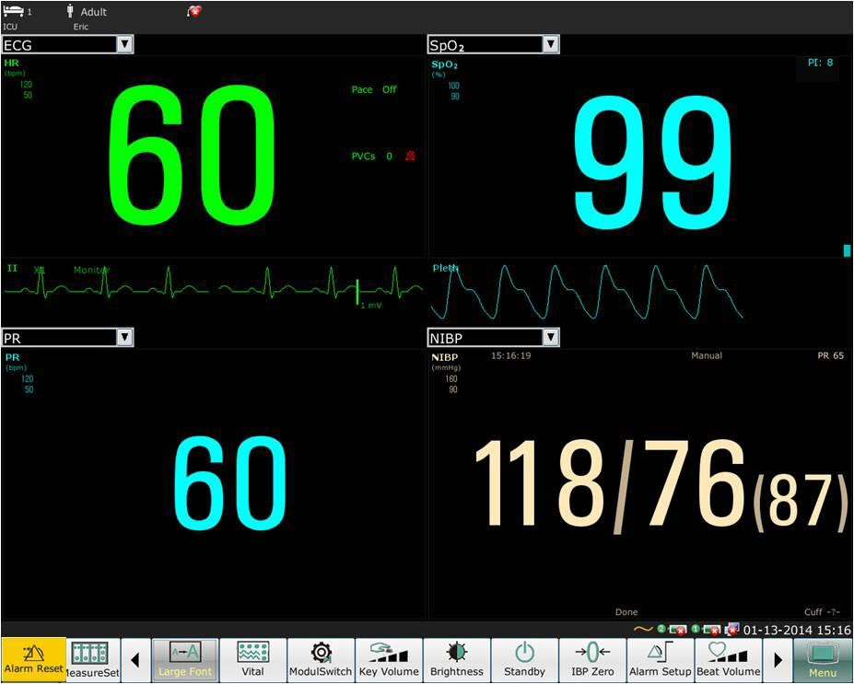

## Viewing the Vital Screen

To view the vital screen, the user can press the shortcut key on the screen directly or select **Menu** > **Display Setup > View Selection > Vital**.

## Viewing the Bed View Window

The **Bed View** window allows you to view one waveform, numeric information of all parameters and alarm information from another bed on the same network. The monitor enables a maximum of eight beds to be viewed.

NOTE:

1. The IP addresses of the monitors configured with bed view function should share the same network segment. The IP addresses of the monitors on the same LAN should be unique from each other; you cannot use the bed view function in the monitors in which an IP address conflict exists.
2. In order to use the bed view function without impediment, you need to restart the monitor after you change its IP address.
3. To use the bed view function smoothly, make sure the network connection is in good condition.
4. In the **Bed View** window, you cannot view the over-limit alarms of physiological parameters occurring on other beds. Besides, arrhythmia alarms and vital alarms will be indicated only by alarm icons.

### Opening the Bed View Window

Before opening the **Bed View** window, make sure the bed view function is configured on your monitor. To open the **Bed View** window, select **Menu**> **Display Setup** and choose **Bed View** in the **View Selection** list.

### Settings of the Bed View Window

Click on the **Bed View** window to open the **ViewBed** Setup menu on which you can:

* Assign a bed to be viewed by selecting the bed No. in the **Bed No.** list.
* Select the waveform to be displayed on the window in the **Wave Type** list.
* Use the buttons  and  to view more numeric information of parameters in the window.

## Changing Parameter and Waveform Colors

The user can set the display colors of parameter and waveform as desire. To change the display color, please select **Menu > Maintenance > User Maintain,** enter the required password **ABC**. Then select **Color Setup** to make color changes on parameter and color.

## User Configuration

Users can save the current monitor’s configuration, delete the saved user configuration and rename it. Three pieces of user configuration can be saved in the monitor.

To save the user configuration:

1. Select **Menu > Maintenance > User Maintain**, enter the required password **ABC** and then select **User Configure**.
2. Click on **Save**, enter a file name for the configuration and confirm it. A message will display after the operation.

To delete the user configuration:

1. Select **Menu > Maintenance > User Maintain**, enter the required password **ABC** and then select **User Configure**.
2. Select the configuration file needed to delete from the list, click on **Delete** and confirm the operation. A message will display after the operation.

To rename the user configuration:

1. Select **Menu > Maintenance > User Maintain**, enter the required password **ABC** and then select **User Configure**.
2. Select a configuration file needed to rename from the list and click on **Rename**.
3. Enter a name for the configuration file and confirm it.

## Default Configuration

To set default configuration, select **Menu > Default**. On the **Default** menu, users can choose a factory configuration (adult, pediatric or neonate) based on the patient category. Also, users can choose a user configuration saved in the monitor if it is available. For more information about user configuration, refer to *7.11 User Configuration*.

To check the configuration currently used, select **Menu** > **Default**. The one labeled with √ is current configuration. If there's no labeled configuration, it means the currently used configuration is not one of them.

# Chapter 8 Monitoring ECG

## Overview

The electrocardiogram (ECG) measures the electrical activity of the heart and displays it on the monitor as a waveform and a numeric. This chapter also tells you about arrhythmia monitoring and ST monitoring.

ECG connector



## ECG Safety Information

**WARNING**

1. Only use the ECG leads supplied by the manufacturer when using the monitor for ECG monitoring.
2. When connecting the cables and electrodes, make sure no conductive part is in contact with the ground. Verify that all ECG electrodes, including neutral electrodes, are securely attached to the patient but not the conductive part or ground.
3. Check every day whether there is skin irritation resulted from the ECG electrodes. If yes, replace electrodes every 24 hours or change their sites.
4. Place the electrode carefully and ensure a good contact.
5. Check if the lead connection is correct before monitoring. If you unplug the ECG cable from the socket, the screen will display the error message “ECG LEAD OFF” and the audible alarm is activated.
6. If the ECG signal exceeds the measuring range, the monitor will indicates it by a message “ECG Signal Exceeded”.
7. When using the monitor with the defibrillator or other high-frequency equipment, please use defibrillator-proof ECG lead to avoid burn.

**WARNING**

1. In order to avoid being burnt, please keep the electrodes far away from the radio knife while using electrosurgical equipment.
2. When using Electrosurgery (ES) equipment, do not place an electrode near the grounding plate of the Electrosurgery device, otherwise there will be a great deal of interference with the ECG signal.
3. For patients with pacemakers, the pacing impulse analysis function must be switched ON. Otherwise, the pacing impulse may be counted as regular QRS complexes, which could prevent an asystole event from being detected.
4. The electrodes should be made of the same metal materials.
5. ECG cables can be damaged when connected to a patient during defibrillation or using other high frequency equipment. Check cables for functionality before using them again. It is recommended to use the ECG cables which are defibrillator-proof.
6. According to AAMI specifications the peak of the synchronized defibrillator discharge should be delivered within 60 ms of the peak of the R wave. The synchronization pulse output on the patient monitors is delayed by a maximum of 35 ms from the R wave peak. Your biomedical engineer should verify that your ECG/Defibrillator combination does not exceed the recommended maximum delay of 60 ms.
7. Before outputting signals with defibrillator synchronization or ECG, check if the output is functioning normally.
8. ECG accessories are not suitable for DIRECT CARDIAC APPLICATION (Refer to IEC60601-1 for more information about the definition of DIRECT CARDIAC APPLICATION).
9. Line isolation monitor transients may resemble actual cardiac waveforms and thus inhibit heart rate alarms. Check lead wires for damage and ensure good skin contact prior to and during use. Always use fresh electrodes and follow proper skin preparation techniques.

NOTE:

1. Interference from a non-grounded instrument near the patient and ESU interference can cause inaccuracy of the waveform.
2. IEC/EN60601-1-2 (protection against radiation is 3v/m) specifies that the electrical field density exceeding 1v/m may cause measurement error in various frequencies. It is accordingly suggested that do not use equipment generating electrical radiation near ECG/RESP monitoring devices.
3. The simultaneous use of cardiac pacemaker and other patient-connected equipment may cause safety hazard.
4. If the pacemaker signals are beyond the claimed range, the heart rate may be calculated incorrectly.
5. In the default settings of the monitor, the ECG waveforms are the first two waveforms from top in the waveform area.
6. For measurements in or near the heart we recommend connecting the monitor to the potential equalization system.
7. For protecting environment, the used electrodes must be recycled or disposed of properly.

## ECG Display

The figure below is for reference only.

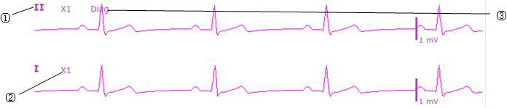

The symbol “①”indicates lead name of display waveform: there are several options, such as I, II, III, aVR, aVF, aVL, V. If you want to change the lead, please refer to section *Selecting Calculation Lead*.

The symbol “②” indicates waveform gain: there are several options, such as X0.125, X0.25, X0.5, X1, X2, X4 and Auto. If you want to change it, please refer to section *Changing the size of the ECG Wave*.

The symbol “③” indicates Filter setting, there are three options: **Monitor**, **Surgery** and **Diagnostic**. If you want to change it, please refer to section *Changing the ECG Filter Setting*.

### Changing the Size of the ECG Wave

If any of the displayed ECG waveform is too small or clipped, you can change the size of it on the screen. First select **ECG Waveform Setup** > **ECG Gain**, then select an appropriate factor from the pop-up box to adjust the ECG waveform.

**X0.125** to make strength of ECG signal waveform of 1mV become 1.25mm; **X0.25** to make strength of ECG signal waveform of 1mV become 2.5mm; **X0.5** to make strength of ECG signal waveform of 1mV become 5mm;

**X1** to make strength of ECG signal waveform of 1mV become 10mm; **X2** to make strength of ECG signal waveform of 1mV become 20mm; **X4** to make strength of ECG signal waveform of 1mV become 40mm;

**Auto** let the monitor choose the optimal adjustment factor for all the ECG waves.

NOTE:

The effect of ECG wave gain is subject to the size of the wave area. Whichever wave gain is chosen, the ECG wave has to be displayed within the wave area.

### Changing the ECG Filter Settings

The ECG filter setting defines how ECG waves are smoothed. An abbreviation indicating the filter type is shown underneath the lead label on the monitor display. Filter settings do not affect ST measurement.

To change the filter setting, in the **ECG Setup** menu, select **Filter** and then select the appropriate setting.

* + - * **Monitor**: Use this mode under normal measurement conditions.
      * **Surgery**: The filter reduces interference to the signal. It should be used if the signal is distorted by high frequency or low frequency interference. High frequency interference usually results in large amplitude spikes making the ECG signal look irregular. Low frequency interference usually leads to a wandering or rough baseline. In the operating room, the filter reduces artifacts and interference from electro-surgical units. Under normal measurement conditions, selecting **Surgery** may suppress the QRS complexes too much and thus interfere with the clinical evaluation of the ECG displayed on the monitor.
      * **Diagnos**: Use when diagnostic quality is required. The unfiltered ECG wave is displayed so that changes such as R-wave notching or discrete elevation or depression of the ST segments are visible.

## Selecting Calculation Lead

On the **Normal** interface, the users can select either **3 LEADS** or **5 LEADS** for this item. Normal QRS complex should be:

* The normal QRS should be either completely above or below the baseline and it should not be biphasic. For paced patients, the QRS complexes should be at least twice the height of pace pulses.
* The QRS should be tall and narrow.
* The P-waves and the T-waves should be less than 0.2 mV.

## Monitoring Procedure

### Preparation

The skin is a poor conductor of electricity; therefore preparation of the patient's skin is important to facilitate good electrode contact to skin.

* Select sites with intact skin, without impairment of any kind.
* Shave hair from sites, if necessary.
* Wash sites thoroughly with soap and water. (Never use ether or pure alcohol, because this increases skin impedance).
* Rub the skin briskly to increase capillary blood flow in the tissues and remove skin scurf and grease.

### Connecting ECG Cables

1. Attach clip or snap to electrodes prior to placement.
2. Put the electrodes on the patient. Before attaching, apply some conductive jelly on the electrodes if the electrodes are not electrolyte self-supplied.
3. Connect the electrode lead to the patient's cable.
4. Plug the patient cable into the ECG connector on XM module.

**CAUTION**

To protect the monitor from damage during defibrillation, for accurate ECG information and to protect against noise and other interference, use only ECG electrodes and cables specified by SINKO.

### Selecting Lead Type

To change the lead type, please:

1. Select the ECG parameter area, open the **ECG Setup** menu;
2. Set **Lead Type** to **3 Leads**, **5 Leads** or **12 Leads** based on the lead used.

### Installing Electrodes

NOTE:

The following table gives the corresponding lead names used in Europe and America respectively. (Lead names are represented by R, L, F, N, C, C1-C6 in Europe, whose corresponding lead names in America are RA, LA, LL, RL, V, V1-V6.)

|  |  |  |  |
| --- | --- | --- | --- |
| AHA (American Standard) | | IEC (Europe Standard) | |
| Electrode Labels | Color | Electrode Labels | Color |
| RA | White | R | Red |
| LA | Black | L | Yellow |
| LL | Red | F | Green |
| RL | Green | N | Black |
| V | Brown | C | White |
| V1 | Brown/ Red | C1 | White/ Red |
| V2 | Brown/ Yellow | C2 | White/ Yellow |
| V3 | Brown/ Green | C3 | White/ Green |
| V4 | Brown/Blue | C4 | White/ Brown |

|  |  |  |  |
| --- | --- | --- | --- |
| AHA (American Standard) | | IEC (Europe Standard) | |
| V5 | Brown/Orange | C5 | White/ Black |
| V6 | Brown/Purple | C6 | White/ Purple |

##### Electrode Placement for 3-lead

Take the American standard for example, see the following figure:

* RA placement: directly below the clavicle and near the right shoulder.
* LA placement: directly below the clavicle and near the left shoulder.
* LL placement: on the left hypogastrium.

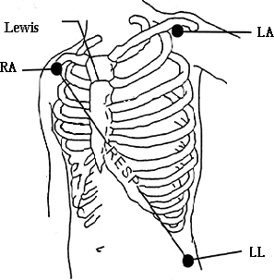

Electrode Placement for 3-lead

##### Electrode Placement for 5-lead

Take the American standard for example; see the following figure:

* RA placement: directly below the clavicle and near the right shoulder.
* LA placement: directly below the clavicle and near the left shoulder.
* RL placement: on the right hypogastrium.
* LL placement: on the left hypogastrium.
* V placement: on the chest, the position depends on your required lead selection.

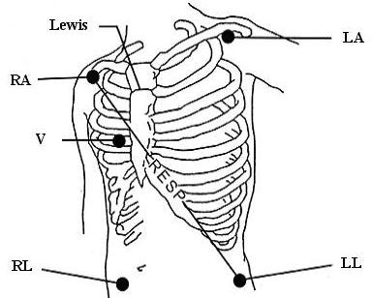

NOTE:

Electrode Placement for 5-lead

To ensure the patient safety, all leads must be attached to the patient.

For 5-lead, attach the V electrode to one of the indicated positions as below:

* V1 On the 4th intercostal space at the right sterna margin.
* V2 On the 4th intercostal space at the left sterna margin.
* V3 Midway between V2 and V4 electrodes.
* V4 On the 5th intercostal space at the left clavicular line.
* V5 On the left anterior axillary line, horizontal with V4 electrode.
* V6 On the left middle axillary line, horizontal with V4 electrode.
* V3R-V6R On the right side of the chest in positions corresponding to those on the left.
* VE Over the xiphoid position.
* V7 On the 5th intercostal space at the left posterior axillary line of back.
* V7R On the 5th intercostal space at the right posterior axillary line of back.

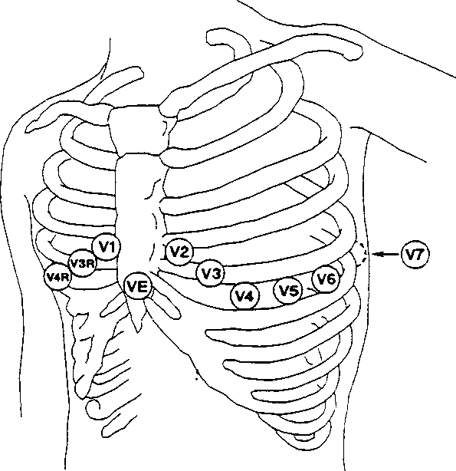

V-Electrode Placement for 5-lead

##### Electrode Placement for 12-lead

Take the American standard for example; the 12-lead electrodes should be placed as follows: The limb electrodes are placed in the same position as the 3-lead placement.

* RL placement: on the right hypogastrium.
* V1: On the 4th intercostal space at the right sterna margin.
* V2: On the 4th intercostal space at the left sterna margin.
* V3: Midway between V2 and V4 electrodes.
* V4: On the 5th intercostal space at the left clavicular line.
* V5: On the left anterior axillary line, horizontal with V4 electrode.
* V6: On the left middle axillary line, horizontal with V4 electrode.

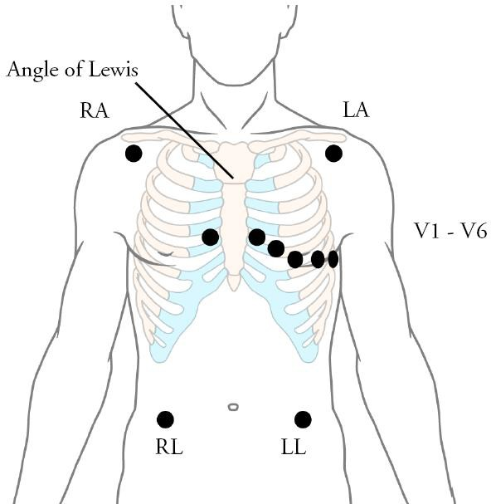

Electrode Placement for 12-lead

##### Recommended ECG Lead Placement for Surgical Patients

**WARNING**

When using Electrosurgery (ES) equipment, leads should be placed in a position in equal distance from Electrosurgery electrotome and the ES grounding plate to avoid cautery. Electrosurgery equipment wire and ECG cable must not be tangled up.

Monitoring ECG leads are mainly used for monitoring the patient’s vital signs. When using the patient monitor with other electrosurgery equipment, it is advised to use the counteracting defibrillation ECG lead.

The placement of the ECG leads will depend on the type of surgery that is being performed. For example, in an open chest surgery the electrodes may be placed laterally on the chest or on the back. In the operating room, artifacts may affect the ECG waveform due to the use of ES (Electrosurgery) equipment. To help reduce this you can place the electrodes on the right and left shoulders, the right and left sides near the abdomen, and the chest lead on the left side at mid-chest. Avoid placing the electrodes on the upper arms. Otherwise the ECG waveform will be too small.

**WARNING**

1. When using electrosurgical (ES) equipment, never place ECG electrodes near to the grounding plate of the ES device, as this can cause a lot of interference on the ECG signal.
2. ECG cables can be damaged when connected to a patient during defibrillation or using other high frequency equipment. Check cables for functionality before using them again. It is recommended to use the ECG cables which are defibrillator-proof.

NOTE:

1. If an ECG waveform is not accurate, while the electrodes are tightly attached, try to change the lead.
2. Interference from a non-grounded instrument near the patient and ESU interference can cause inaccuracy of the waveform.

## ECG Menu Setup

### Setting Alarm Source

To change the alarm source, please select **ECG Setup** > **Alarm Source**, then a pop-up box is displayed:

**HR**: the monitor considers the HR as HR/PR alarm source;

**PR**: the monitor considers the PR as HR/PR alarm source;

**AUTO**: If the Alarm Source is set to **Auto**, the monitor will use the heart rate from the ECG measurement as the alarm source whenever the ECG measurement is switched on and at least one ECG lead can be measured without a technical condition. The monitor will automatically switch to Pulse as the alarm source if:

– a valid ECG lead can no longer be measured and

– a pulse source is switched on and available.

The monitor then uses the pulse rate from the measurement currently active as system pulse. While PR is the alarm source, all arrhythmia and ECG HR alarms are switched off. If an ECG lead becomes available again, the monitor automatically uses HR as alarm source.

### Setting Beat Source

To change the beat source, select either **ECG Setup** > **Beat Source** or **PR Setup** > **Beat Source**. Select from the following options:

**HR**: HR is HR/PR beat source;

**PR**: PR is HR/PR beat source;

**AUTO**: If the Beat Source is set to **AUTO**, the monitor will use HR as the beat source whenever the ECG measurement is switched on, and at least one ECG lead can be measured. The monitor will automatically switch to PR as the beat source if:

* a valid ECG lead can no longer be measured and
* a Pulse source is switched on and available.

If an ECG lead becomes available again, the monitor automatically uses HR as beat source and a blinking heart  displays in the HR parameter box.

### Smart Lead Off

When **Lead Type** is **5 Leads** or **12 Leads** and **Smart LeadOff** is set to **On**, if the selected ECG waveform cannot be measured because of lead-off or other reasons, it will automatically switch to another available lead channel via which a waveform can be measured. And the lead name above the display ECG waveform also automatically turns into the current one.

To change the smart lead off setting, select **ECG Setup** > **Smart LeadOff**, and select the desired setting.

### ECG Display

It varies with **Lead Type**. When **Lead Type** is set to **3 Leads, Display** can be set to **Normal**, and it can display one ECG waveform on the main screen.

When **Lead Type** is set to **5 Leads, Display** can be set to **Normal**, **Full-SCR** and **Half-SCR**. Select **Normal** to display two ECG waveforms on the main screen; select **Full- SCR** to display seven ECG waveforms which occupy the area of seven waveforms on the main screen; Select **Half- SCR** to display seven ECG waveforms on the screen, occupying the area of four waveforms.

NOTE:

If **3 Leads** is selected in the **ECG Setup** menu, only **Normal** can be selected for **Display**

in the sub-menu.

### Setting Pace Status

It is important to set the paced status correctly when you start monitoring ECG. To change the paced status in the ECG Setup menu, select **Pace** to toggle between **On** or **Off**. When **Pace** is set to **On**:

* Pace Pulse Rejection is switched on. This means that pacemaker pulses are not counted as extra QRS complexes.
* Paced symbol is displayed as | on the main screen.

NOTE:

1. When monitoring a patient with a pacemaker, set **Pace** to **On**. If monitoring a patient without a pacemaker, set **Pace** to **Off**.
2. If **Pace** is set to **On**, the system will not perform some types of ARR analysis.

**WARNING**

Some pace pulses can be difficult to reject. When this happens, the pulses are counted as a QRS complex, and could result in an incorrect HR and failure to detect cardiac arrest or some arrhythmias. Keep pacemaker patients under close observation.

### ECG Calibration

This item is used to calibrate ECG waveform. When you select this item from ECG Setup menu again, the ECG waveform calibration ends.

NOTE:

The device can’t be monitored during ECG calibration.

### ECG Waveform Settings

To change the speed, select **ECG Waveform Setup** > **Sweep**, then select an appropriate setting from the pop-up list. The bigger the value is, the wider the waveform is.

## 12-Lead ECG Monitoring

In 12-lead display mode, 12 ECG waveforms and one rhythm lead waveform will be shown at the waveform area on the screen. The rhythm lead is for ECG calculation before entering 12-lead display mode. Also, in this mode, the filter mode is set to **Diagnos** and can not be changed.

### Activating 12-Lead ECG Monitoring

Select **Menu** > **Maintenance** > **User Maintain** (pass: ABC) > **Other Setups** > **12 Leads Activate** in order to get the SN number which is supposed to be supplied by SINKO for a corresponding password. Enter the password on the above-mentioned interface and restart the monitor, and the 12-lead ECG monitoring function will be activated.

NOTE:

If the 12-lead ECG monitoring fails to be activated, users can reenter the password and try to activate this function again.

### Diagnosis Function

If your monitor is configured with the 12-lead ECG monitoring function, the monitor can perform automatic diagnosis function. To perform 12-lead diagnosis analysis:

1. In the **ECG Setup** menu, set **Lead Type** to **12 Leads** and set **Display** to **12 Leads**.
2. Select the shortcut key  on the screen directly.
3. The diagnosis results will be provided in the **Diagnosis Review** window after approximately 10 seconds.

The measurement function provides the automatic measurement of the common parameters, such as heart rate, PR interval, QRS duration, QT/QTC interval, P/QRS/T axis, RV5/SV1 amplitude and RV5+SV1 amplitude. The interpretation function provides the automatic diagnosis of hundreds of abnormal cases, such as arrhythmia, AV block, IVCD (Intraventricular Conduction Block), myocardial infarction, ventricular hypertrophy and atrial enlargement, ST-T abnormality and electrical axis deviation.

### Waveform Durations and Isoelectric Segments

Between the global onset and offset of the QRS-complex, signal parts with a duration of more than 6 ms and amplitude not exceeding 20 μV should be defined as isoelectric segments.

Because the duration of the Q-, R- or S-wave of 12 leads is respectively detected by the ECG algorithm, isoelectric parts (I-waves) after global QRS-onset or before global QRS-offset (K-wave) are excluded in the measurement duration of the respective adjacent waveform.

Q R S D u r a t i o n = R d + S d + R ’ d

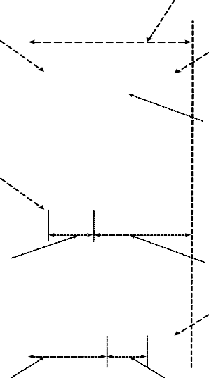

R

R ’

S

I

Q D u r a t i o n

R D u r a t i o n

K

V 1

V 3

V 5

R D u r a t i o n S D u r a t i o n

## ST Segment Monitoring

The monitor performs ST segment analysis on normal and atrially paced beats and calculates ST segment elevations and depressions. This information can be displayed in the form of ST numerics and snippets on the monitor.

ST segment monitoring function is shut off by default. You can switch it to **On** when necessary. When using the ST analysis function, the ST analysis results will be displayed on the right of the main screen, please refer to the following figure.

NOTE:

1. ST-segment analysis is intended for use with adult patients only and is not clinically validated for use with neonatal and pediatric patients.
2. ST analysis is always performed using a dedicated filter which ensures diagnostic quality. If you are monitoring ECG using an ECG filter mode other than **Diagnosis**, the ST segment of the ECG wave may look different from the ST segment of the ST template for the same wave. For diagnostic evaluation of the ST segment, always set the filter to **Diagnosis** or use the ST template.
3. The ST algorithm has been tested for accuracy of the ST segment data. The significance of the ST segment changes need to be determined by a clinician.

### Setting ST Analysis

To change ST analysis, please select **ECG Setup** > **ST Analysis**, then select **On** or **Off** from the pop-up list.

### ST Display

Your monitor screen may be configured to look slightly different from the illustrations.

III 0 .02 a V F 0 .06

0 .03

a V L

0 .10

II

V 0 .04

I 0 .08 a V R - 0 .09

**ST**

### About ST Measurement Points

The ST value for each beat complex is the vertical difference between the ISO point and the ST point, as shown in the diagram below. The isoelectric (ISO) point provides the baseline, and the ST point is at the midpoint of the ST segment. The J point is where the QRS complex changes its slope; as it is a fixed distance away from the ST point, it can be useful to help you position the ST point correctly.

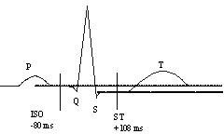

DEF POINT

The ST and ISO measurement points need to be adjusted when you start monitoring, and if the patient's heart rate or ECG morphology changes significantly. Always ensure that ST measurement points are appropriate for your patient. Abnormal QRS complex is not considered in ST segment analysis.

### Adjusting ST and ISO Measurement Points

Depending on your monitor’s configuration, the ST point can be positioned, too.

These two points can be adjusted by turning the knob. When adjusting ST measurement point, the system will show the ST Measurement Point Window. The system displays the QRS complex template in the window. It is adjustable for the highlight bar in the window. You may select ISO or ST, switch the knob left or right to move the cursor line. When the cursor is at the required position, you may select the base point or the measurement point.

## Arr. Monitoring

### Arrhythmia Analysis

The arrhythmia algorithm is used to monitor ECG of adult patients in clinics, and detect the changes of heart rate and ventricular rhythm, and also save arrhythmia events and generate alarming information. The arrhythmia analysis is not clinically validated for use with neonatal and pediatric patients. Arrhythmia algorithm can monitor paced and non-paced patients. Qualified personnel can use arrhythmia analysis to evaluate patient’s condition (such as heart rate, PVCs frequency, rhythm and ectopic beat) and decide the treatment. Besides detecting change of ECG, arrhythmia algorithm can also monitor patients and give proper alarm for arrhythmia.

The monitor can support up to 16 different arrhythmia analyses.

|  |  |
| --- | --- |
| **ARR Types** | **Occurring Condition** |
| ASYSTOLE | No QRS is detected for 4 consecutive seconds |
| VFIB/VTAC | 4 consecutive seconds' fibrillation wave occurs, or each RR interval for 5 consecutive ventricular beats is less than 600 ms. |
| VT>2 | 3< the number of consecutive PVCs < 5 |
| COUPLET | 2 consecutive PVCs |
| BIGEMINY | A dominant rhythm of N, V, N, V (N = supraventricular beat, V = ventricular beat) was detected. |
| TRIGEMINY | A dominant rhythm of N, N, V, N, N,V |
| R ON T | A type of single PVC under the condition that HR<100，R-R interval is less than 1/3 the average interval, followed by a compensating pause of 1.25X the average R-R interval (the next R wave advances onto the previous T wave). |
| PVC | Single PVC detected in normal heartbeats. |
| TACHY | Adult: RR interval for 5 consecutive QRS complex ≤ 0.5s.  Pediatric/neonatal: RR interval for 5 consecutive QRS complex ≤ 0.375s. |
| BRADY | Adult: RR interval for 5 consecutive QRS complex ≥ 1.5s.  Pediatric/neonatal: RR interval for 5 consecutive QRS complex ≥ 1s. |
| MISSED BEATS | If HR < 120 bpm, no beats are detected for 1.75 times average RR interval; or if HR ≥ 120 bpm, no beats are detected for one second. |
| IRR | Consistently irregular heart rhythm |
| PNC | PACER NOT CAPTURE: no QRS complex detected in 300ms after a pace pulse. |
| PNP | PACER NOT PACED: no pace pulse detected in 1.75 times RR interval after a QRS complex. |

|  |  |
| --- | --- |
| **ARR Types** | **Occurring Condition** |
| VBRADY | VENTRICULAR BRADYCARDIA: Each RR interval for 5 consecutive ventricular beats > 1000 ms. |
| VENT | VENTRICULAR RHYTHM: Each RR interval for 5 consecutive ventricular beats ranges from 600 ms to 1000 ms. |

### ARR Analysis Menu

##### Switching ARR Analysis On and Off

To switch ARR Analysis on or off, in the **ECG Setup** menu, select **ARR Analysis** to toggle between **On** and **Off** from the popup interface.

##### PVCs Alarm

Select **On** in the menu to enable prompt message when an alarm occurs; select **Off** to disable the alarm function, and there will be a symbol  beside **PVCs**.

**WARNING**

When the PVCs Alarm is set to OFF, the monitor won’t give an alarm prompt even if an alarm occurs. In order to avoid endangering the patient’s life, the user should use this function cautiously.

##### ARR Relearning

Pick this item to start a learning procedure, and **ECG ARR LEARNING** is displayed on the screen. The ECG ARR LEARNING will start automatically in the following status:

* + - * + Connecting leads;
        + Starting ARR learning manually;
        + Switching calculation leads.

##### ARR Alarm

By selecting **ECG Setup > ARR Analysis > ARR Alarm Setup**, the arrhythmia alarms can be individually switched on or off. They are: **R-ON-T**, **VT>2**, **COUPLET**, **PVC**, **BIGEMINY**, **TRIGEMINY**, **TACHY**, **BRADY**, **MISSED BEATS, IRR, PNC, PNP, VBRADY** and **VENT**.

**VFIB/VTAC** alarm is preset to be on. To switch it on or off, select **Menu** > **Maintenance > User Maintain**, and enter the required password **ABC**. Select **Alarm Setup > VFIB/VTAC** from the popup list to toggle between **On** and **Off**. When **VFIB/VTAC** is set to **Off**, the monitor displays the alarm off symbol , and **VFIB/VTAC Off** is displayed on a red colored background.

**ASYSTOLE** alarm is preset to be on and cannot be turned off.

# Chapter 9 Monitoring RESP

## Overview

The monitor measures respiration from the amount of thoracic impedance between two ECG electrodes. The change of impedance between the two electrodes, (due to the thoracic movement), produces a respiratory waveform on the screen.

## RESP Safety Information

**WARNING**

1. If you do not set the detection level for the respiration correctly in manual detection mode, it may not be possible for the monitor to detect apnea. If you set the detection level too low, the monitor is more likely to detect cardiac activity, and to falsely interpret cardiac activity as respiratory activity in the case of apnea.
2. The respiration measurement does not recognize obstructive and mixed apneas - it only indicates an alarm when a pre-adjusted time has elapsed since the last detected breath.
3. If operating under conditions according to the EMC Standard EN 60601-1-2 (Radiated Immunity 3V/m), field strengths above 1V/m may cause erroneous measurements at various frequencies. Therefore it is recommended to avoid the use of electrically radiating equipment in close proximity to the respiration measurement unit.
4. Cardiogenic artifact in impedance respiration monitoring may make it difficult to detect breaths or may otherwise be counted as breaths. In some instances, the breath rate may also correspond to the heart rate making it difficult to determine if the signal is due to breathing or the cardiac cycle. Do not rely on RESP monitoring as the sole method for detecting cessation of breathing. Follow hospital guidelines and best clinical practices for apnea detection including monitoring additional parameters that indicate the patient’s oxygenation status, such as EtCO2 and SpO2.

NOTE:

The RESP monitoring is not recommended to be used on patients who are very active, as this can cause false alarms.

## Electrode Placement for Monitoring RESP

Correct patient skin preparation techniques for electrode placement are important for RESP measurement: you will find this information in the chapter on ECG.

The RESP signal is always measured between two of the ECG electrodes. There are two standard ECG leads for selection: I lead (RA and LA) and II lead (RA and LL).

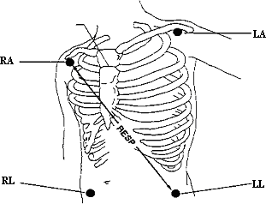

Electrodes Placement for 5-lead

## Cardiac Overlay

Cardiac activity that affects the RESP waveform is called cardiac overlay. It happens when the RESP electrodes pick up impedance changes caused by the rhythmic blood flow. Correct electrode placement can help to reduce cardiac overlay: avoid the liver area and the ventricles of the heart in the line between the respiratory electrodes. This is particularly important for neonates.

## Chest Expansion

Some patients, especially neonates, expand their chests laterally. In these cases, it is best to place the two respiratory electrodes in the right midaxillary and left lateral chest areas at the patient’s maximum point of breathing movement to optimize the respiratory wave.

## Abdominal Breathing

Some patients with restricted chest movement breathe mainly abdominally. In these cases, you may need to place the left leg electrode on the left abdomen at the point of maximum abdominal expansion to optimize the respiratory wave.

NOTE:

Place the red and green electrodes diagonally to optimize the respiration waveform. Avoid the liver area and the ventricles of the heart in the line between the RESP electrodes so as to avoid cardiac overlay or artifacts from pulsating blood flow. This is particularly important for neonates.

## Selecting RESP Lead

To change RESP lead, in the **Resp Setup** menu, select **Resp Lead** to pick up the appropriate lead from the pop-up list.

## Changing Hold Type

To change the calculation mode, in the **RESP Setup** menu, set **Hold Type** to **Manual** or **Auto**. When it is set to the **AUTO** mode, **Hold High** and **Hold Low** are unavailable, and the monitor can calculate the respiration rate automatically. When it is set to the **Manual** mode, you can adjust the broken lines in RESP area by the **Hold High** and **Hold Low** items.

## Changing the Size and Speed of the Respiration Wave

Select the RESP waveform area to open the **RESP Wave Setup** menu:

* Select **AMP**, and choose an appropriate value. The bigger the value is, the higher the waveform amplitude will be.
* Select **Sweep:** select an appropriate setting from the pop-up list.

## Changing the Apnea Time

The apnea alarm is a high priority red alarm used to detect apneas. The apnea alarm delay time defines the time period between the point where the monitor cannot detect any respiration activity and the indication of the apnea alarm.

* + 1. In the **Resp Setup** menu, select **Apnea Alm**.
    2. Select the appropriate setting from the popup list.

# Chapter 10 Monitoring SpO2

## Overview

SpO2 is based on the absorption of pulse blood oxygen to red and infrared light by means of finger sensor and SpO2 measuring unit. SpO2 Plethysmogram measurement is employed to determine the oxygen saturation of hemoglobin in the arterial blood. If, for example, 97% of the hemoglobin molecules in the red blood cells of the arterial blood combine with oxygen, then the blood has a SpO2 oxygen saturation of 97%. The SpO2 numeric on the monitor will read 97%. The SpO2 numeric shows the percentage of hemoglobin molecules which have combined with oxygen molecules to form oxyhemoglobin. The SpO2/PLETH parameter can also provide a pulse rate signal and a plethysmogram wave.

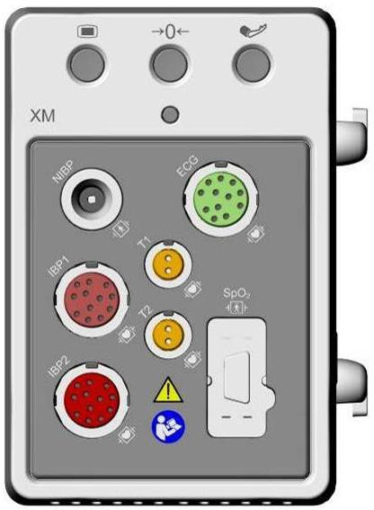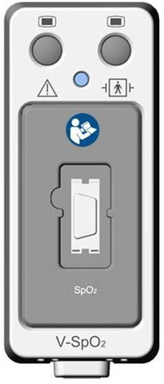

SpO2 socket

## SpO2 Safety Information

**WARNING**

1. If the SpO2 sensor cannot work properly, please reconnect the sensor or change a new one.
2. Do not use the sterile supplied SpO2 sensors if the packaging or the sensor is damaged and return them to the vendor.
3. Prolonged and continuous monitoring may increase the risk of unexpected change of dermal condition such as abnormal sensitivity, rubescence, vesicle, repressive putrescence, and so on. It is especially important to check the sensor placement of neonate and patient of poor perfusion or immature dermogram by light collimation and proper attaching strictly according to changes of the skin. More frequent examinations may be required for different patients.

**WARNING**

1. Tissue damage may be caused by incorrect application or prolonged measurement duration using the sensor (more than 4 hours). Inspect the sensor periodically according to the sensor user manual.
2. Use only SINKO permitted sensors and extension cables with the oximeter. Other sensors or extension cables may cause improper monitor performance and/or minor personal injury.
3. High oxygen levels may predispose a premature infant to retrolental fibroplasia. If this is a consideration do NOT set the high alarm limit to 100%, which is equivalent to switching the alarm off.

NOTE:

1. Make sure the nail covers the light window. The wire should be on the backside of the hand.
2. SpO2 waveform is not proportional to the pulse volume.
3. Avoid placing the sensor on extremities with an arterial catheter, or intravascular venous infusion line.
4. Don’t use the functional simulator to assess the SpO2 accuracy.
5. The device is calibrated to display functional oxygen saturation.
6. The materials with which the patient or any other person can come into contact conform with the standard of EN ISO 10993-1: 2009.
7. When the SpO2 value is potentially incorrect, it will display ‘-?-‘.

## Measuring SpO2

1. Select the correct patient category setting (adult/pediatric and neonatal), as this is used to optimize the calculation of the SpO2 and pulse rate.
2. During measurement, ensure that the application site:
   * has a pulsatile flow, ideally with a good circulation perfusion.
   * has not changed in its thickness, causing an improper fit of the sensor.

##### Measurement Procedure

1. Switch on the monitor.
2. Attach the sensor to the appropriate site of the patient finger.
3. Plug the connector of the sensor extension cable into the SpO2 socket on XM module or V- SpO2 module.

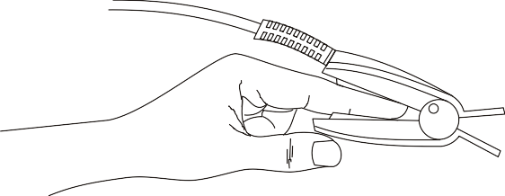

Mounting of the Sensor

**WARNING**

Inspect the application site every two to three hours to ensure skin quality and correct optical alignment. If the skin quality changes, move the sensor to another site. Change the application site at least every four hours. For neonate, change the measuring site every 20 minutes.

NOTE:

Injected dyes such as methylene blue or intravascular dyshemoglobins such as methemoglobin and carboxyhemoglobin may lead to inaccurate measurements.

Interference can be caused by:

* High levels of ambient light or strobe lights or flashing lights (such as fire alarm lamps). (Hint: cover application site with opaque material.)
* High-frequency electrical noise, including electro-surgical apparatus and defibrillators
* Intravascular dye injections
* Significant concentrations of dysfunctional hemoglobin, such as carboxyhemoglobin and methemoglobin
* Excessive patient movement and vibration
* Improper sensor application
* Low perfusion or high signal attenuation
* Venous pulsation
* Placement of the sensor on an extremity that has a blood pressure cuff, arterial catheter, or intravascular line

## Assessing the Validity of a SpO2 Reading

You can check the quality of the pleth wave and the stability of the SpO2 values to assess whether the sensor functions properly and whether the SpO2 readings are valid. Always use these two indications simultaneously to assess the validity of a SpO2 reading.

Generally, the quality of the SpO2 pleth wave reflects the quality of the light signals obtained by the sensor. A wave of poor quality manifests a decline of the signal validity. On the other hand, the stability of the SpO2 values also reflects the signal quality. Different from varying SpO2

readings caused by physiological factors, unstable SpO2 readings are resulted from the sensor’s receiving signals with interference. The problems mentioned above may be caused by patient movement, wrong sensor placement or sensor malfunction. To obtain valid SpO2 readings, try to limit patient movement, check the placement of the sensor, measure another site or replace the sensor.

NOTE:

1. The SpO2 accuracy has been validated in human studies against arterial blood sample reference measured with a CO-oximeter. Pulse oximeter measurements are statistically distributed, only about two-thirds of the measurements can be expected to fall within the specified accuracy compared to CO-oximeter measurements. The volunteer population in the studies are composed of local healthy men and women from age 19 to 37, with various skin pigmentations.
2. The pulse rate accuracy is obtained by comparison to the pulse rate generated with an arterial oxygen simulator (also an electronic pulse simulator).

## SpO2 Alarm Delay

There is a delay between a physiological event at the measurement site and the corresponding alarm at the monitor. This delay has two components:

1. The time between the occurrence of the physiological event and when this event is represented by the displayed numerical values. This delay depends on the algorithmic processing time and the sensitivity setting. The lower the sensitivity configured, the longer the time needed until the numerical values reflect the physiological event.
2. The time between the displayed numerical values exceeding an alarm limit and the alarm indication on the monitor. This delay is the combination of the configured alarm delay time plus the general system delay time.

## Perfusion Index (PI)*

* Only applicable to the SINKO SpO2 module.

PI is a numeric value indicating perfusion level. It reflects the perfusion level at the monitoring site.

As the measurement of SpO2 is based on the pulsation caused by the blood flow through the vessel, PI is in relation to the strength of the pulse. Also, you can use PI as a signal quality indicator for the measurement of SpO2.

PI is indicated by a value ranging from 0 to 10. The bigger the value is, the better the perfusion and the signal quality will be. The perfusion level and the signal quality are at their maximum when the value reaches 10. When PI is below 2, it indicates the low perfusion and the poor signal quality at the monitoring site; you need to reposition the sensor or find a better site.

The PI value will be displayed in the SpO2 parameter area.

## Setting Pitch Tone

If tone modulation is on, the PR sound lowers when the SpO2 level drops. In the **SpO2 Setup**

menu, select pitch tone to toggle between **On** and **Off**.

## Setting Sensitivity

The different sensitivity indicates different refresh frequency. **High** indicates the refresh frequency of SpO2 value is the most frequent. To change the sensitivity, please follow the steps:

1. Select the **SpO2 Setup** menu;
2. Select **Sensitivity** on the interface and select the desired sensitivity from the popup list.

## SatSeconds Alarm Management*

* Only applicable to the Nellcor SpO2 module.

### Describing SatSeconds

With traditional alarm management, upper and lower alarm limits are set for monitoring oxygen saturation. During monitoring, as soon as an alarm limit is violated by as little as one percentage point, an alarm is immediately triggered. When the SpO2 level fluctuates near an alarm limit, the alarm is triggered each time the limit is violated. Such frequent alarms can be distracting.

With the SatSeconds technique, upper and lower SpO2 alarm limits are set in the same way as traditional alarm management. However, you can also set a SatSeconds limit that allows monitoring of SpO2 below the selected lower alarm limit and above the selected upper alarm limit for a period of time before an alarm is triggered.

The method of calculation is as follows:

The number of percentage points that the SpO2 falls outside the alarm limit is multiplied by the number of seconds that the SpO2 level remains outside that limit. This can be stated as an equation:

Points × Seconds = SatSeconds Where:

Points = SpO2 percentage points outside of the limit

Seconds = number of seconds that SpO2 remains at that point outside of the limit

The alarm response time, assuming a SatSeconds limit set at 50 and a lower alarm limit set at 90, is described and illustrated below.

In this example, the SpO2 level drops to 88 (2 points below the limit) and remains there for a period of 2 seconds (2 points × 2 seconds = 4 SatSeconds). The SpO2 then drops to 86 for 3 seconds and then to 84 for 6 seconds. The resulting SatSeconds values are shown below:

|  |  |  |  |  |
| --- | --- | --- | --- | --- |
| SpO2 |  | Seconds |  | SatSeconds |
| 2 | × | 2 | = | 4 |
| 4 | × | 3 | = | 12 |
| 6 | × | 6 | = | 36 |

Total SatSeconds = 52

After approximately 10.7 seconds, a SatSeconds alarm will be triggered, because the limit of 50 SatSeconds has been exceeded. See arrow (↑) in the following figure.

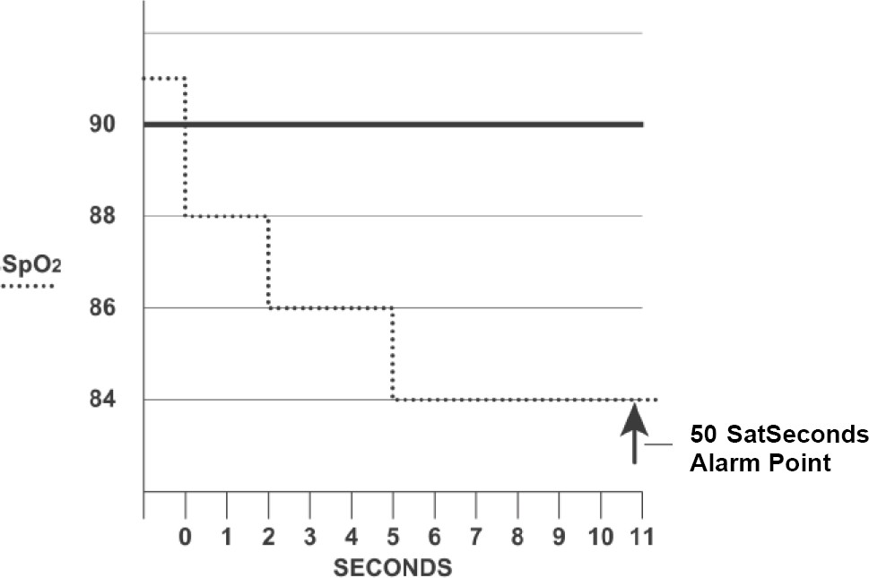

Alarm Response with SatSeconds

Saturation levels may fluctuate rather than remaining steady for a period of several seconds. Often, the patient SpO2 may fluctuate above and below the alarm limit, re-entering the non-alarm range several times. During such fluctuation, the monitor integrates the number of SpO2 points, both positive and negative, until either the SatSeconds limit is reached, or the patient SpO2 returns within a normal range and remains there.

### SatSeconds “Safety Net”

The SatSeconds “Safety Net” is for patients whose saturation makes frequent excursions below or above the SpO2 limit but does not remain in violation long enough for the SatSeconds limit to be reached. If three or more SpO2 alarm limit violations occur within a 60-second period, an alarm will be triggered even if the SatSeconds limit has not been reached.

### Setting SatSeconds Duration

You can set **SatSeconds** to **Off** or to the duration among **10**, **25**, **50** and **100**. To configure the SatSeconds settings, enter the **SpO2 Setup** menu and select the desired SatSeconds setting from the **SatSeconds** list.

# Chapter 11 Monitoring PR

## Overview

The pulse numeric counts the arterial pulsations that result from the mechanical activity of the heart in beats per minute (bpm). You can display a pulse from any measured SpO2 signal or any arterial pressure.

## Setting PR Source

The monitor provides PR source options. You can select SpO2 or arterial pressure labels as the PR source in the **PR Source** list on the **PR Setup** menu.

NOTE:

In the **PR Source** list, an arterial pressure label accompanied with a label with brackets indicates this label is in conflict. Do not select a conflicting label as the PR source.

## Setting PR Volume

Select **PR Setup** > **PR Volume**, then select the appropriate setting for the PR volume: five bars represent the maximum volume and one bar represents the minimum volume. If none of bars are selected, the PR volume will be off.

## Selecting the Active Alarm Source

In most cases, the HR and Pulse numerics are identical. In order to avoid simultaneous alarms on HR and Pulse, the monitor uses either ECG or Pulse as its active alarm source. To change the alarm source, select Alarm Source in the ECG/Pulse Alarms menu, then select

* **HR**: if you want HR to be the alarm source for HR/Pulse.
* **PR**: If you select Pulse as the active alarm source, the monitor will prompt you to confirm your choice. Be aware that if you select Pulse as the alarm source, ECG HR alarms are switched off.
* **AUTO**: If the Alarm Source is set to Auto, the monitor will use the heart rate from the ECG measurement as the alarm source whenever the ECG measurement is switched on and at least one ECG lead can be measured without a technical alarm condition. The monitor will automatically switch to Pulse for the alarm source if:
  + a valid ECG lead can no longer be measured and
  + a Pulse source is switched on and available.

The monitor uses the pulse rate from the currently active measurement as system pulse. While PR is the alarm source, all arrhythmia and ECG HR alarms are switched off. If an ECG lead becomes available again, the monitor automatically uses HR as alarm source.

NOTE:

Pulse alarms are only generated when the active alarm source is set to **PR**, a pulse source is set as system pulse and pulse alarms are switched on.

# Chapter 12 Monitoring NIBP

## Overview

This monitor uses the oscillometric method for measuring NIBP. It can be used for adult, pediatric and neonatal patients. It is also intended for use with pregnant, including pre-eclamptic patients.

Oscillometric devices measure the amplitude of pressure changes in the occluding cuff as the cuff deflates from above systolic pressure. The amplitude suddenly increases as the pulse breaks through the occlusion in the artery. As the cuff pressure decreases further, the pulsations increase in amplitude, reach a maximum (which approximates to the mean pressure), and then diminish.

The blood pressure measurements determined with this device comply with the American National Standard for Electronic or Automated Sphygmomanometers (ANSI/AAMI/ISO 81060-2:2013) in relation to mean error and standard deviation.

NIBP start/ stop key

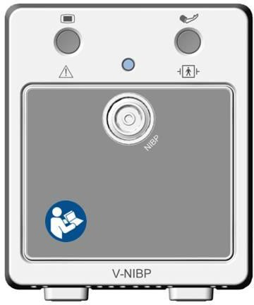

Connector for NIBP cuff

## NIBP Safety Information

**WARNING**

1. Do not measure NIBP on patients with sickle-cell disease or any condition where skin damage has occurred or is expected.
2. Do not measure NIBP on the arm of the same side with a mastectomy.
3. Use clinical judgment to decide whether to perform frequent unattended blood pressure measurements on patients with severe blood clotting disorders because of the risk of hematoma in the limb fitted with the cuff.
4. Ensure that the correct setting is selected when performing measurements. It may be dangerous for the children to use an over pressure level.
5. The equipment is suitable for use in the presence of electrosurgery.

**WARNING**

1. Before starting a measurement, verify that you have selected a setting appropriate for your patient (adult, child or neonate.)
2. Do not apply the cuff to a limb that has an intravenous infusion or catheter in place. This could cause tissue damage around the catheter when infusion is slowed or blocked during cuff inflation.
3. Make sure that the air conduit connecting the blood pressure cuff and the monitor is neither blocked nor tangled.
4. Do not attach the cuff to a limb being used for IV infusions as the cuff inflation can block the infusion, potentially causing harm to patient.
5. Measuring of blood pressure can temporarily cause malfunctioning of other medical monitoring devices on the same limb.
6. Do not apply the cuff to a limb where intravascular access or therapy, or an arterio-venous (A-V) shunt is present, otherwise, it may result in injury to the patient.

NOTE:

1. It is suggested that the user should not start NIBP measuring when the low battery displays, or the monitor may be turned off automatically.
2. If you spill liquid onto the equipment or accessories, particularly if there is a chance that it can get inside the tubing or the measurement device, contact your service personnel.
3. Continuous use of the automatic measuring mode for short intervals may lead to the discomfort of patient.
4. NIBP measurement can be affected by extremes of temperature, humidity and altitude.

## Measurement Limitations

Measurements are impossible with pulse rate extremes of less than 40 bpm or greater than 240 bpm, or if the patient is on a heart-lung machine.

The measurement may be inaccurate or impossible in the following situations:

* A regular arterial pressure pulse is hard to detect.
* Patients with cardiac arrhythmias.
* Patients with excessive and continuous movement such as shivering or convulsions.
* Patients with rapid blood pressure changes.
* Patients with severe shock or hypothermia that reduces blood flow to the peripheries.
* Patients with obesity, where a thick layer of fat surrounding a limb dampens the oscillations

coming from the artery.

* Patients on an edematous extremity.

## Measurement Methods

There are three methods of measuring NIBP:

* Manual - measurement on demand.
* Auto - continually repeated measurements (between 1 and 480 minutes adjustable interval).
* Sequence - the measurement will run consecutively in five minutes, then the monitor enters manual mode.

**WARNING**

Prolonged non-invasive blood pressure measurements in Auto mode may be associated with purport, ischemia and neuropathy in the limb wearing the cuff. When monitoring a patient, examine the extremities of the limb frequently for normal color, warmth and sensitivity. If any abnormality is observed, stop the blood pressure measurements.

## Measurement Procedures

To obtain accurate measurements, the following operating steps need to be observed:

1. Ensure the patient position in normal use, including

* Comfortably seated
* Legs uncrossed
* Feet flat on the floor
* Back and arm supported
* Middle of the cuff at the level of the right atrium of the heart

1. Relax as much as possible and do not talk during the measurement.
2. Wait for five minutes until the first reading is taken.

NOTE:

If an NIBP measurement is suspect, repeat the measurement. If you are still uncertain about the reading, use another method to measure the blood pressure.

To start the measurement:

1. Connect the air hose to the connector on XM module and switch on the monitor.
2. Apply the blood pressure cuff to the patient's arm or leg and follow the instructions below. Ensure that the cuff is completely deflated.

Apply the appropriate size cuff to the patient (About the cuff size selection, please refer to Section *NIBP accessories*), and make sure that the symbol "Φ" is over the artery. Ensure that

the cuff is not wrapped too tightly around the limb. Excessive tightness may cause discoloration and eventual ischemia of the extremity.

NOTE:

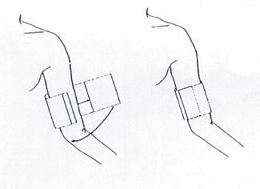The width of the cuff is either approximately 40% of the limb circumference or 2/3 of the upper arm length. The inflatable part of the cuff should be long enough to encircle 80-100% of the limb. The wrong size of cuff can cause erroneous readings. If the cuff size is in question, use another cuff with suitable size to avoid errors.

Cuff Usage

1. Connect the cuff to the air tubing.
2. Check whether the patient mode is appropriately selected. Access the **Patient Setup** menu from **Menu**. Turn the knob to select the required patient **Type** in the **Patient Info** menu.
3. Select a measurement mode in the **NIBP Setup** menu. Refer to section ***Operation Prompts***

for details.

1. Press the  button on the front panel to start a measurement.

NOTE:

1. Please make sure the cuff is well connected. A leak of air may cause measurement error.
2. Please select the cuff with the suitable size. An unsuitable cuff may cause incorrect measurements.
3. Do not disinfect the cuff with radiation or gas, or the cuff will be deteriorated.
4. Avoid incursion of liquid into the cuff. If this happens, please desiccate the cuff completely.

### Operation Prompts

1. Manual Measuring

Access the **NIBP Setup** menu and set the **Measure Mode** item to **Manual**. Then press the  button on the front panel to start a manual measurement.

1. Automatical Measurement

Access the **NIBP Setup** menu and set the **Measure Mode** item to **Auto**, then press the  button on the front panel to start the automatical measurement according to the selected time interval.

During the idle period of measurement process, press the  button on the front panel at any time to start a manual measurement. Then press the  button on the front panel to stop manual measurement and the system continues to execute auto measurement program according to the selected time interval.

1. Continuous measurement

Access the **NIBP Setup** menu and pick the **Continual** item to start a continuous measurement. The continuous measurement will last 5 minutes.

1. Stopping continuous measurement

During continuous measurement, press the  button on the front panel at any time to stop continuous measurement.

### Correcting the Measurement if Limb is not at Heart Level

To correct the measurement if the limb is not at heart level to the displayed value:

|  |  |
| --- | --- |
| Add 0.75mmHg (0.10kPa) for each centimeter higher or | Deduct 0.75mmHg (0.10kPa) for each centimeter lower or |
| Add 1.9mmHg (0.25kPa) for each inch higher | Deduct 1.9mmHg (0.25kPa) for each inch lower |

## NIBP Multi-Review Window

To set the display of NIBP measurements, select **NIBP Setup** > **Review**:

* When it is set to **On**, a window for NIBP measurements will be displayed at the waveform area on the main interface, and the size of this window varies depending on the numbers of displayed waveforms.
* When it is set to **Off**, the window is unavailable on the screen.

## Resetting NIBP

When the pressure does not work properly and the system fails to give a message for the problem, pick **Reset** in the **User Maintain > NIBP Maintain** menu to activate self-test procedure, and thus restore the system from abnormal performance.

## Calibrating NIBP

NIBP is not user-calibrated. Cuff-pressure transducers must be verified and calibrated, if necessary, at least once every two years by a qualified service professional. See the Service Manual for details.

## Leakage Test

**WARNING**

This leakage test other than being specified in the EN 1060-1 standard is to be used by the user to simply determine whether there are air leaks in the NIBP airway. If at the end of the test the system gives the prompt that the NIBP airway has air leaks, please contact the manufacturer for repair.

##### Procedure of Leakage Test

1. Connect the cuff securely with the socket for NIBP air hole.
2. Wrap the cuff around the cylinder of an appropriate size.
3. Make sure the patient type has been set to **Adult**.
4. Access **User Maintain > NIBP Maintain**.
5. Select **Leakage Test**. Then the prompt **Leak. Test Running** will appear indicating that the system has started the leakage test.
6. The system will automatically inflate the pneumatic system to about 180 mmHg.
7. After 20 seconds, the system will automatically open the deflating valve, which marks the completion of a pneumatic measurement.
8. If the alarm information **NIBP Leak** appears, it indicates that the airway may have air leaks. In this case, the user should check for loose connection. After confirming secure connections, the user should re-perform the leakage test. If the failure prompt still appears, please contact the manufacturer for repair.

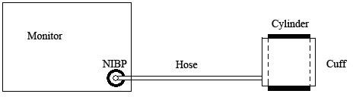

Diagram of NIBP Air Leakage Test

## Setting Inflation Mode

To change the inflation mode:

1. Select **NIBP Setup** > **Inflation Mode**;
2. Choose **Manual** or **AUTO** from the pull-down list.
   * If **Manual** is chosen, the preset value by users will be adopted as the inflation value when measuring blood pressure.
   * If **AUTO** is chosen, the default value will be adopted as the inflation value when measuring blood pressure.

# Chapter 13 Monitoring TEMP

## Overview

Body temperature is measured by means of a thermistor probe (a semiconductor whose resistance changes with temperature) that is applied to the skin or to the rectum.

Two TEMP probes can be used simultaneously to measure two TEMP values, and get the temperature difference. The standard configuration is skin probe for adult.

Connector for TEMP probe 1 Connector for TEMP probe 2



## TEMP Safety Information

**WARNING**

1. Verify probe cables fault detection before the beginning of monitoring phase. Unplug the temperature probe cable of the channel 1 from the socket, and then the screen will display the error message **TEMP T1 Sensor Off** and the audible alarm is activated. It is the same to the other channel.
2. Take the TEMP probe and cable carefully. When they are not in use, you should coil up the probe and cable into a loose circle. If the wire inside the cable is tensely pulled, it may cause mechanical damage to the probe and the cable.

NOTE:

1. The materials with which the patient or any other person can come into contact conform with the standard of EN ISO 10993-1: 2009.
2. The reference body site temperature is the same as the temperature of the measuring site.

## TEMP Monitoring Setup

* With a reusable TEMP probe you can plug the probe directly into the TEMP connector on XM module.
* Apply the TEMP probes securely to the patient.
* Switch on the monitor

It takes 5 minutes for the temperature measurement to stabilize.

## Calculating Temp Difference

The monitor can calculate and display the difference between two temperature values by subtracting the second value from the first. The difference is labeled TD.

# Chapter 14 Monitoring IBP

## Overview

IBP is measured by means of a catheter inserted directly into the circulatory system. A pressure transducer connected to the catheter converts the mechanical force exerted by the blood into an electrical signal, which is displayed graphically as pressure versus time on a monitor screen or numerically on digital display.

The monitor measures direct blood pressure of one selected blood vessel through a maximum of eight channels, and displays waveforms and pressure of measured direct blood pressure (SYS, DIA and MAP).

Zero key for IBP



IBP connector

## IBP Safety Information

**WARNING**

1. The operator should avoid contact with the conductive parts of the appurtenance when it is connected or applied.
2. When the monitor is used with HF surgical equipment, the transducer and the cables must be avoided from conductive connection to the HF equipment. This is to protect against burns to the patient.
3. Disposable IBP transducer or domes should not be reused.
4. If any kind of liquid, other than solution to be infused in pressure line or transducer, is splashed on the equipment or its accessories, or enters the transducer or the monitor, contact the Hospital Service Center immediately.

NOTE:

1. Use only the pressure transducer listed in the IBP Accessories.
2. Calibrate the instrument as frequently as dictated by your Hospital Procedures Policy.

## Monitoring Procedures

Preparatory steps for IBP measurement:

1. Plug the pressure cable into the IBP socket on XM module or V-IBP module and switch on the monitor.
2. Flushing through the system with normal saline solution. Ensure that the system is free of air bubbles.
3. Connect the patient catheter to the pressure line, making sure that there is no air present in the catheter or pressure line.
4. Position the transducer so that it is at the same level with the patient’s heart, approximately mid-axillary line.
5. For the label name selection, please refer to Selecting a Pressure for Monitoring.
6. To zero the transducer, please refer to Zeroing the Pressure Transducer.

**WARNING**

If there are air bubbles in the pressure line or the transducer, you should flush the system with the solution to be infused.

### **Selecting a Pressure for Monitoring**

Tell the monitor which pressure you want to monitor by selecting its pressure label. The label is a unique identifier for each type of pressure. When you choose a label, the monitor uses that label’s stored settings, for example color, wave scale and alarm settings. The label also determines which algorithm is used to process the pressure signal, so an incorrect label can lead to incorrect pressure values. To select the label, please refer to the following table:

|  |  |
| --- | --- |
| **Label** | **Description** |
| ART | Arterial blood pressure |
| PA | Pulmonary artery pressure |
| CVP | Central venous pressure |
| ICP | Intracranial pressure |
| LAP | Left atrial pressure |
| RAP | Right atrial pressure |
| P1-P2 | Alternative non-specific pressure labels |

### **Zeroing the Pressure Transducer**

To avoid inaccurate pressure readings, the monitor requires a valid zero. Zero the transducer in accordance with your hospital policy (at least once per day). You must perform a zero:

* When you use a new transducer or tubing
* Every time you reconnect the transducer cable to the monitor;
* If you think the monitor’s pressure readings are not correct.

When using a pressure module, the zero information is stored in the module.

### **Zeroing a Pressure Measurement**

The zeroing procedure is listed as below:

1. Turn off the stopcock to the patient.
2. Vent the transducer to atmospheric pressure, to compensate for the static and atmospheric pressure exerted on the transducer.
3. In the setup menu for the pressure, select **Zero**.
4. When you see the message **Zero Ok**, please close the stopcock to atmospheric pressure, and open the stopcock to the patient.

### **Troubleshooting the Pressure Zeroing (Taking Art for Example)**

The status message lists the probable cause of an unsuccessful calibration.

|  |  |
| --- | --- |
| **Cause** | **Corrective Action** |
| ART ZERO FAIL | Make sure that the transducer is not attached to the patient |
| ART SENSOR OFF, FAIL | Make sure that transducer is not off, and then proceed zeroing |
| IN DEMO, FAIL | Make sure that the monitor is not in DEMO mode. Contact service technician if necessary |
| PRESSURE OVER RANGE, FAIL | Make sure that the stopcock is vented to atmosphere. If the problem persists, please contact service technician |
| PULSATILE PRESSURE ZERO FAIL | Make sure that the transducer is vented to air, not connected to a patient, and try again. |

### **IBP Pressure Calibration**

IBP is not user-calibrated. Mercury calibration should be performed by a qualified service professional as frequently as dictated by your Hospital Procedures Policy.

## Changing the IBP Waveform Ruler

The top, middle and bottom rulers are available for each channel of IBP waveform. Users can adjust the top, middle or bottom rulers manually:

1. Open the menu **Wave Setup** of IBP by clicking on the IBP waveform area.
2. Select a suitable ruler from the options **TopRuler**, **MidRuler** and **BotRuler**.

## Measuring PAWP

PAWP, Pulmonary Artery Wedge Pressure, used to assess the cardiac function, is obtained by introducing a balloon-tipped pulmonary artery flotation catheter into the pulmonary artery. When the catheter is in one of the smaller pulmonary arteries, the inflated balloon occludes the artery allowing the monitor to record changes in the intrathoracic pressures that occur throughout the respiration cycle.

### **Measurement Procedures**

Pulmonary Artery Wedge Pressure (PAWP) values are affected by fluid status, myocardial contractility, valve and pulmonary circulation integrity. The most accurate PAWP values are obtained at the end of the respiration cycle when the intrathoracic pressure is fairly constant. You can use the respiration waveform as a reference when assessing the PAWP waveform, to ensure constant measurement timing relative to the respiratory cycle.

To start the measurement:

1. On the standard screen interface, select the PA parameter window to enter its setup menu. Then, select **Setup** > **PAWP Activate** to open the PAWP measurement window.
2. Prepare and check the accessories according to your hospital policy.
3. Wedge the flotation catheter into the pulmonary artery. Then inflate the balloon and pay attention to PA waveform changes on the screen.
4. After obtaining a stable PAWP waveform, press **Freeze** to freeze the waveform. In freeze status, you can adjust the PAWP scale to an appropriate position by selecting **Measure** and moving the cursors up and down according to the clinical experience. Select **Confirm** to store the PAWP, CVP, HR values. To review the frozen waveform, press **Browse** and rotate the trim knob clockwise or counter-clockwise as desired. If you need to review the stored PAWP, CVP, HR values, select **PAWP Review**.
5. Deflate the balloon when the monitor prompts you “**Please deflate the balloon!**”.
6. If you need to start a new measurement, select **Remeasure**.
7. Click on **Exit** or select **Setup** > **PAWP Exit** to exit.

**WARNING**

1. Prolonged inflation can cause pulmonary hemorrhage, infarction or both. Inflate the balloon for the minimum time necessary to get an accurate measurement.
2. If the PAWP (mean) is greater than the PA (systolic), deflate the balloon and report the incident in accordance with hospital policy, because the pulmonary artery could be accidently ruptured, and the PAWP value derived will not reflect the patient’s hemodynamic state, but will merely reflect the pressure in the catheter or balloon.

# Chapter 15 Monitoring CO2

## Overview

The monitor provides the sidestream and mainstream methods for CO2 monitoring.

The principle of CO2 measurement is primarily based on the fact that CO2 molecule can absorb 4.3μm infrared ray. Absorption intensity is proportional to CO2 concentration of patient sample, the CO2 concentration will compute according to the detecting CO2 absorption intensity of patient sample.

* Sidestream measurement takes a sample of the respiratory gas with a constant sample flow from the patient’s airway and analyzes it with a CO2 sensor. You can measure sidestream CO2 using the monitor’s built-in CO2 measurement.
* Mainstream measurement uses a CO2 sensor attached to an airway adapter directly inserted into the patient’s breathing system.

Identifying CO2 Modules

Sidestream CO2 modules (From left to right are the Respironics CO2 module and the SINKO CO2 module):

Gas inlet

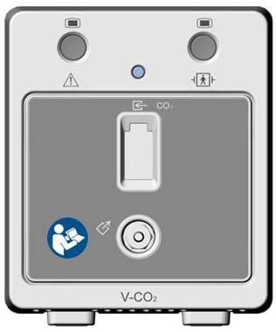

Gas outlet

Gas outlet

Water trap holder

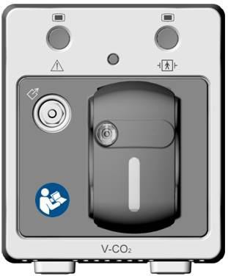

Mainstream CO2 module:

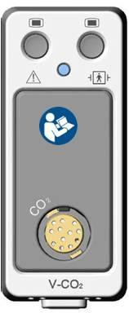

Connector for CO2 transducer

## CO2 Safety Information

**WARNING**

1. Do not use the device in the environment with flammable anesthetic gas.
2. The device should be used by trained and qualified medical personnel authorized by SINKO.
3. Nitrous oxide, elevated levels of oxygen, helium, xenon, halogenated hydrocarbons, and barometric pressure can influence the CO2 measurement.
4. The monitor will be damaged if any pipeline from the CO2 module is disconnected, or the air tube /the air inlet /the air outlet is plugged by water or other materials.
5. The accuracy of the CO2 measurement will be affected by the following reasons: the airway was highly obstructed; the leakage of air way connection or quick variation of environment temperature.
6. Follow precautions for electrostatic discharge (ESD) and electromagnetic interference (EMI) to and from other equipment.
7. In the presence of electromagnetic devices (i.e., electrocautery), patient monitoring may be interrupted due to electromagnetic interference. Electromagnetic fields up to 20V/m will not adversely affect module performance.
8. Do not place the sensor cables or tubing in any manner that may cause entanglement or strangulation.

NOTE:

1. After the low battery alarm appears, please do not start the CO2 measurement, or the monitor may turn off for the low capacity of battery.
2. For disposal of hospital waste such as accumulated fluids, calibration gases, sampled gases, where not otherwise specified, follow local regulations regarding disposal of hospital waste.

## Monitoring Procedures

### Zeroing the sensor

You must perform zeroing following the steps when using the new airway adapter.

1. Expose the sensor to room air and keep it away from all sources of CO2 including the ventilator, the patient’s breath and the operator’s.
2. In the **CO2 Setup** menu, set the **Work Mode** to **Measure**.
3. Select **Zero Calibration** in the **CO2 Setup** menu.
4. After the zeroing calibration is completed, you can start CO2 monitoring. If the system displays **Breath Detected** or **Zero Required**, zeroing has failed. Zero calibration must be performed again.

### **Sidestream CO2 Module**

##### **Measurement Steps**

For the SINKO Sidestream CO2 Module:

1. Fix the water trap to the water trap holder in the V-CO2 module (SINKO CO2 module).
2. Connect the sampling cannula or the sampling line to the water trap.
3. Set **Work Mode** to **Measure**.
4. For intubated patients, an airway adapter is required. For non-intubated patients, place the nasal cannula or the sampling mask onto the patient.

**CAUTION**

1. The water trap collects water drops condensed in the sampling line and therefore prevents them from entering the module. If the water trap is nearly filled, you should replace it to avoid blocking the airway.
2. Based on a sample gas temperature of 37oC, a room temperature of 23oC and sample relative humidity of 100%, the water trap will be filled after approximately 90 hours with the flowrate of 100ml/min and approximately 130 hours with the flowrate of 70ml/min. In clinical practice, the water trap can be used for a longer time before it is filled. It is recommended to replace the water trap once every month.

NOTE:

1. Disconnect the water trap from the holder or set **Work Mode** to **Standby** when the module is not in use.
2. To avoid patient cross infection, do not connect the exhaust tube to the ventilator circuit. If the sampled gas is returned to the breathing system, always use the bacterial filter of the sample gas return kit.

For the Respironics Sidestream CO2 Module:

1. Plug the sensor cable into the CO2 input connector on the sidestream CO2 module. Allow the sensor two minutes for warm-up.
2. Connect the cannula, airway adapter, or sample line as required to the sensor. It will click into place when seated correctly.
3. To zero the sensor, please refer to zeroing the sensor.
4. For intubated patients, an airway adapter is required;

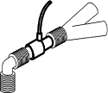

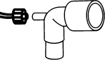

Air adapter

For non-intubated patients: Place the nasal cannula onto the patient.



NOTE:

Place the nasal cannula

1. You must perform a zero calibration as described in this procedure each time the ambient temperature changes more than 10°C (for example during transport).
2. Always connect the airway adapter to the sensor before inserting the airway adapter into the breathing circuit. In reverse, always remove the airway adapter from the breathing circuit before removing the sensor.
3. Disconnect the cannula, airway adapter or sample line from the sensor when they are not in use.
4. Do not connect the exhaust tube to the ventilator circuit. Cross infection can occur if sampling gas is returned to the breathing system.

##### **Removing Exhaust Gases from the System**

**WARNING**

Anesthetics: When using the sidestream CO2 measurement on patients who are receiving or have recently received anesthetics, connect the outlet to a scavenging system, to avoid exposing medical staff to anesthetics.

Use an exhaust tube to remove the sample gas to a scavenging system. Attach it to the sidestream sensor at the outlet connector.

### **Mainstream CO2 Module**

NOTE:

You must perform a zero calibration as described in this procedure each time you use a new airway adapter.

##### **Measurement Steps**

1. Attach the sensor connector to the CO2 connector on the mainstream CO2 module.
2. Wait two minutes, allowing the sensor to reach its operating temperature and a stable thermal condition.
3. Choose the appropriate airway adapter and connect it to the sensor head. The airway adapter clicks into place when seated correctly.

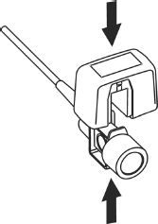

Connecting Sensor

1. To zero the sensor, please refer to zeroing the sensor;
2. Install the airway adapter at the proximal end of the circuit between the elbow and the ventilator Y-section.

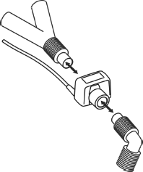

Connecting Airway Adapter

**WARNING**

1. No routine user calibration required.
2. Accuracy is affected by temperature and barometric pressure.

NOTE:

1. Replace the airway adapter, if excessive moisture or secretions are observed in the tubing or if the CO2 waveform changes unexpectedly without a change in patient status.
2. To avoid infection, use only disinfected or disposable airway adapters.
3. Inspect the airway adapters prior to use. Do not use it if airway adapter appears damaged or broken. Observe airway adapter color coding for patient population.
4. Periodically check the flow sensor and tubing for excessive moisture or secretion buildup.

##### Removing Exhaust Gases from the System

**WARNING**

Anesthetics: when using the mainstream CO2 measurement on patients who are receiving or have recently received anesthetics, connect the outlet to a scavenging system, to avoid exposing medical staff to anesthetics.

Use an exhaust tube to remove the sample gas to a scavenging system. Attach it to the mainstream sensor at the outlet connector.

## Setting CO2 Corrections

Temperature, water vapor in the patient’s breath, barometric pressure, and the proportions of O2, N2O and Helium in the mixture all influence CO2 absorption. If values seem inaccurately high or low, check that the monitor is using the appropriate corrections.

For the SINKO sidestream module, the following items are available in the **CO2 Other Setup**

menu: **N2O Compen.**, **O2 Compens.**, **ANEST. Agent, Vapor Compen.** and **Pump Rate**.

For the Respironics CO2 modules, there are **Baro Press, O2 Compens.**, **Anes. Agent** and **Balance Gas** in the **CO2 Other Setup** menu.

## Changing Apnea Alarm

This determines the time limit after which the monitor gives an alarm if the patient stops breathing.

1. Select the **CO2 Setup** menu to open it;
2. Select **Apnea Alm** from the menu;
3. Choose the apnea alarm time from the pop-up list.

**WARNING**

Safety and effectiveness of the respiration measurement method in the detection of apnea, particularly the apnea of prematurity and apnea of infancy, has not been established.

## Setting CO2 Waveform

Open the menu **CO2 Wave Setup** by clicking on the CO2 waveform area:

* Choose **Mode** and set it to **Curve** or **Filled** from the pop-up list;
* Choose **Sweep** and select a suitable setting from the pop-up list. The bigger the value is, the wider the waveform will be.

# Chapter 16 Monitoring C.O.

## Overview

The Cardiac Output (C.O.) measurement is performed by using Thermodilution method. The monitor can determine blood temperature, measure cardiac output, and perform hemodynamic calculations. You can have iced injecta using either the flow through system or individual syringes of injecta. You can perform up to 6 measurements before editing the average Cardiac Output. The prompt message on the screen will tell you when to inject.

C.O. start key

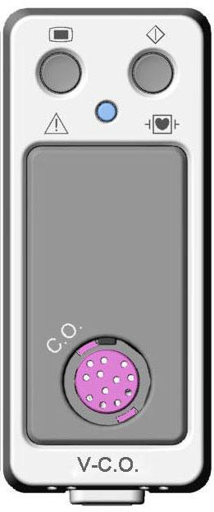

Connector for C.O. cable

## C.O. Safety Information

**WARNING**

1. Make sure that appurtenance applied is in conformity with relevant Medical Device Safety Requirements.
2. Appurtenance should be avoided from contact with conductive metal body when being connected or applied.

NOTE:

To replace the catheter thermistor, please enter the catheter computation coefficient into the **Constant** item according to the instruction.

## C.O. Monitoring Procedures

1. Plug the C.O. cable into the C.O. socket on V-C.O. module and turn on the monitor.
2. Attach the injectate probe connector and catheter thermistor connector to the appropriate parts of the cardiac output interface cable. And open the patient information window to confirm the patient’s height and weight.
3. Pick the **C.O. Measure** item in the **C.O. Option** menu.
4. You can perform more than one measurement as required.
5. After the completion of the measurement, access the **C.O. Measure** window for **Review** to edit the measured data.

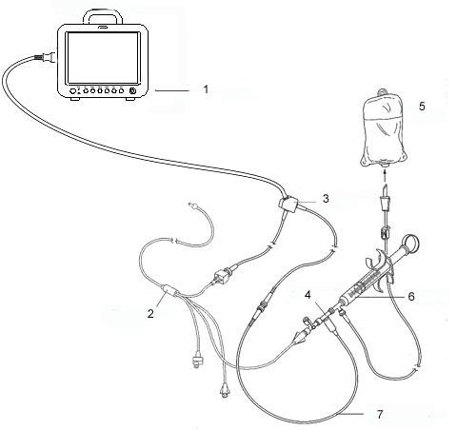

C.O. Sensor Connection

1: Monitor; 5: Injectate;

2: Thermodilution Catheter; 6: Delivery System;

3: Cardiac Output Cable; 7: In-line injectate Temperature probe.

4: Injectate Sensor Housing;

**WARNING**

1. Make sure that the computational constant for the measurement is appropriate to the catheter used.
2. Before a C.O. measurement is initiated, check the accuracy of patient setup. The calculation of C.O. is related to the patient height, weight, and catheter computation coefficient; therefore, incorrect input will lead to error in calculation.

NOTE:

The blood temperature alarm will not function during C.O. measurement. It will resume automatically when the measurement is over.

## C.O. Measurement Window

Select the **C.O. Option** menu to enter the **C.O. Measure** window and start C.O. measurement. If

C.O. transducer is not connected, the monitor will display **No Sensor** on the screen.

③

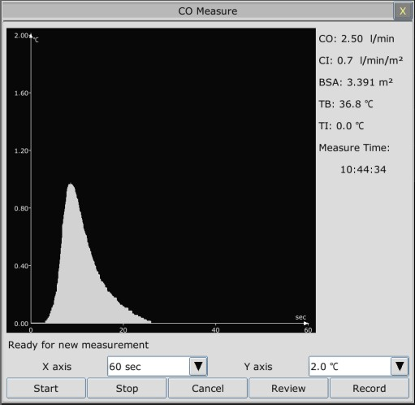

④

⑤

⑥

⑦

⑧

①

②

⑨

C.O. Measure Window

|  |  |
| --- | --- |
| ① | Measurement curve |
| ② | Prompt message area |
| ③ | Cardiac Output |
| ④ | Cardiac Index |
| ⑤ | Body Surface Area |
| ⑥ | Blood Temperature |
| ⑦ | Injectate Temperature |
| ⑧ | Start time of the measurement |
| ⑨ | Function keys |

The functional keys on the C.O. measure window are explained in the following table:

|  |  |
| --- | --- |
| **Start** | Start a measurement |
| **Stop** | If the blood temperature cannot resume in a considerably long time, the measurement could not stop automatically. Use this button to stop the measurement and display the C.O., CI calculation result. |
| **Cancel** | Cancel the processing measurement or cancel the result after measurement. |
| **Record** | Print out the curve. |
| **Y axis** | Change the scale Y (temperature) value. Three modes are available: 0°C to 0.5°C, 0°C to 1°C, 0°C to 2.0°C. Adjust the scale by the temperature differences. A smaller scale results in a larger curve. |
| **X axis** | Change the Scale X (time) value. Two modes are available: 0s to 30s, 0s to 60s. If you start measurement in the 0s to 30s mode, it will be switched to 0s to 60s mode automatically if the measurement can not finish within 30 seconds. After the switch, no further adjustment can be made to the Scale X. |
| **Review** | Enter the **Review** window |

## Measurement Process

Measurement should be taken when the message “**Ready for new measurement**” appears on the screen. Press the **Start** button, and then start injection. The thermodilution curve, current blood temperature and the injectate temperature are displayed during the measurement. Curve drawing will stop automatically when the measurement finishes, and the C.O. and CI (③ and ④ in the above figure) will be calculated and displayed on the screen. The monitor will display C.O. in the parameter area and the start measurement time (⑧ in the above figure).

To ensure the accuracy of the measurement, it is suggested that a reasonable interval should take place between two consecutive measurements. The length of the interval can be set in the C.O. Setup menu (Time unit: second). The interval time counter is displayed on the screen. The next measurement can not be performed until the time reduces to zero and a message **Ready for new measurement** appears.

NOTE:

1. It is strongly recommended that the user must push the injector within four seconds after pressing the **Start** button.
2. It is strongly recommended that you wait at least 1 minute (or longer depending on the patient’s clinical condition) before starting the next measurement.

Repeat this procedure until you have completed the measurements you want.

You can perform a maximum of six measurement editing. If you perform additional measurements, the earliest measurement each time will be deleted. If any of the curves in the editing window is not selected for calculation (excluded from the averaging calculations), the place will be taken by the new measurement.

## Editing C.O.

Pick the **Review** button on the **C.O. Measure** menu to access the **Review** as shown below:

①

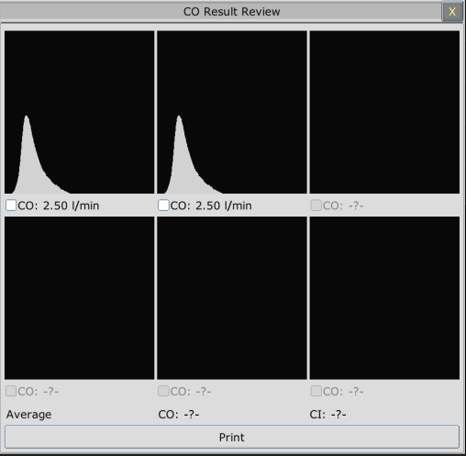

② ③

Window For C.O. Edit

* + - Contents displayed in the window:

|  |  |
| --- | --- |
| ① | Six curves of the six measurements and C.O. value |
| ② | Average value of C.O. |
| ③ | Average value of CI |

Values of selected measurements can be averaged and stored in the C.O. item in the HEMOD menu as the basis for Hemodynamic calculations.

## Blood Temperature Monitoring

Blood temperature monitoring can function when C.O. measurement is not taken. The blood temperature is measured by the thermistor situated in the distal end of the flotation catheter in the pulmonary artery.

The blood temperature alarm function will not work during the C.O. measurement. When the measurement ends, the function will automatically resume.

The current blood temperature is displayed in the C.O. parameter area.

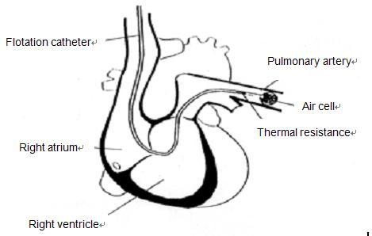

Right ventricle

Thermodilution Catheter Site

## Setting the Computation Constant

The computation constant is associated with catheter and injectate volume. When the catheter is changed, please adjust **Constant** in the **C.O. Setup** menu based on product description provided by the manufacturer.

## Recording C.O. Measurements

C.O. measurement can be recorded by the recorder. To record the C.O. measurement, please select **Record** in the **C.O. Measure** menu.

## Setting INJ. TEMP Source

To change the INJ Temp Source:

1. Select **Inj Temp Source** in the **C.O. Setup** menu;
2. Select **Auto** or **Manual** from the list;

* **Manual**: directly displaying the injectate temperature from INJ. TEMP.
* **Auto**: indicating the system obtains the injectate temperature through sampling.

## Setting the Interval

You can set the minimum interval between two measurements in sequence by selecting **C.O. Option** > **C.O. Setup** >**Interval** and configuring **Interval** to a certain value by the second. No

C.O. measurement can be taken during the interval. The adjustable range of **Interval** is: 5 to 300 seconds.

# Chapter 17 Monitoring AG

## Overview

The monitor uses ISA sidestream gas analyzer (hereinafter called ISA analyzer), Dräger AG sidestream Minimodule (hereinafter called Dräger Minimodule), and IRMA mainstream module (hereinafter called IRMA module) to monitor the anesthetic gas which can be used to measure the gases of adult, pediatric and neonatal patients during anesthesia, recovery and respiratory care. And the anesthetic gas includes Halothane (HAL), Isoflurane (ISO), Enflurane (ENF), Sevoflurane (SEV), Desflurane (DES), CO2, N2O, and O2 (Optional).

Identifying AG Module

Sideatream Module: From left to right are ISA analyzer and Dräger Minimodule.

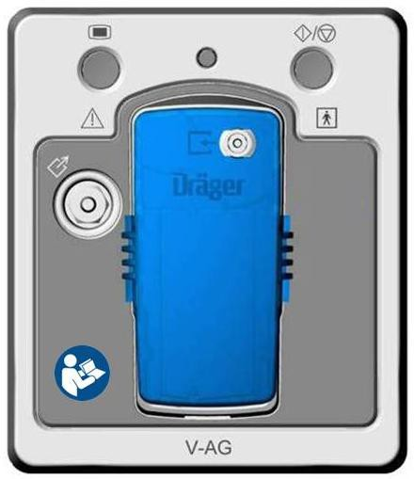

Gas inlet

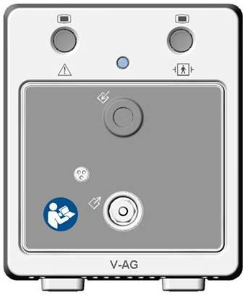

Gas outlet

Watertrap holder

Mainstream Module: IRMA module

Connector for AG transducer

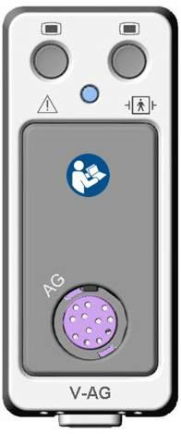

## Safety Information

### **Safety Information for ISA Analyzer**

**WARNING**

1. The ISA sidestream gas analyzer is intended for use by authorized healthcare professionals only.
2. Use only Nomoline sampling lines manufactured by PHASEIN.
3. The ISA analyzer must not be used with flammable anesthetic agents.
4. Carefully route the sampling line to reduce the risk of patient entanglement or strangulation.
5. Do not re-use disposable single-patient use Nomoline Family sampling lines due to the risk of cross contamination.
6. Do not lift the monitor by the sampling line as it could disconnect from the monitor, causing the monitor to fall on the patient.
7. Dispose Nomoline Family sampling lines in accordance with local regulations for biohazardous waste; otherwise, it may cause environmental contamination.
8. Use only airway T-adapters with the sampling point in the center of the adapter.
9. Do only use sample lines intended for anesthetic agents if N2O and/or anesthetic agents are being used.
10. Do not use T-adapter with infants, as this adds 7 ml dead space to the patient circuit.
11. Do not use adult/pediatric type sampling line configurations with infants, as this may add dead space to the patient circuit.
12. Do not use infant type sampling line configurations with adults, as this may cause excessive flow resistance.
13. Do not use the ISA analyzer with metered-dose inhalers or nebulized medications as this may clog the bacteria filter.
14. Check that the gas sample flow is not too high for the present patient category.
15. Since a successful zeroing requires the presence of ambient air (21% O2 and 0% CO2), ensure that the ISA is placed in a well ventilated place. Avoid breathing near the ISA sidestream gas analyzer before or during the zeroing procedure.
16. The Nomoline sampling line and its interfaces are non-sterile devices. To avoid damage, do not autoclave any part of the sampling line.
17. Measurements can be affected by mobile and portable RF communications equipment. Make sure that the ISA sidestream gas analyzer is used in the electromagnetic environment specified in this manual.
18. ISA analyzer is intended only as an adjunct in patient assessment. It must be used in conjunction with other assessments of clinical signs and symptoms.

**WARNING**

1. Replace the sampling line if the sampling line input connector starts flashing red, or a “Sample line clogged” message is displayed on the host.
2. No modification of this equipment is allowed without authorization of the manufacturer. If this equipment is modified, appropriate inspection and testing must be conducted to ensure continued safe operation.
3. ISA analyzers are not designed for MRI environments.
4. Use of high frequency electrosurgical equipment in the vicinity of the monitor may produce interference and cause incorrect measurements.
5. Use of high frequency electrosurgical equipment may enhance the risk of being burned; therefore, a static-free or conductive respiratory cannula is not recommended.
6. Do not use external ambient cooling of the ISA device.
7. Do not apply negative pressure to remove condensed water from the Nomoline Family sampling line.
8. Too strong positive or negative pressure in the patient circuit might affect the sample flow.
9. Strong scavenging suction pressure might affect the sample flow.
10. Exhaust gases should be returned to the patient circuit or a scavenging system.
11. Due to the risk of patient cross-infection, always use a bacteria filter on the exhaust port side if sampled gas is intended to be re-breathed.
12. Do not place the ISA gas analyzer in any position that might cause it to fall on the patient.
13. Do not immerse Nomoline Family sampling lines in liquid.
14. Do not operate the ISA sidestream gas analyzer if the enclosure is damaged.

**CAUTION**

1. The ISA analyzers should be securely mounted in order to avoid the risk of damage to the ISA.
2. Do not apply tension to the ISA analyzer cable.
3. Do not operate the ISA analyzer outside the specified operating temperature environment.
4. The sidestream AG module configured with ISA OR+ analyzer is fragile and should be handled with care.
5. After plugging the module into the monitor, remember to connect the sampling line to the module to prevent dust ingress which may result in performance degradation.

### **Safety Information for Dräger Minimodule**

**WARNING**

1. Dräger Minimodule is intended to be used by trained and authorized health care professionals only.
2. Dräger Minimodule must not be used in areas where combustible or explosive gas mixtures are likely to occur.
3. Modifications to the module may lead to malfunctions.
4. It’s recommended to use accessories approved by Dräger. If other, incompatible accessories are used, there is a risk of patient injury due to module failure.
5. Do not use the module near magnetic resonance imagers (MRI, NMR, NMI).
6. During warm-up, reported values may not be accurate.
7. If the gas sensors are not ready for operation, the patient will not be adequately monitored. Before using the medical device, ensure a suitable substitute monitoring.
8. Misdiagnosis or misinterpretation of the measured values or other parameters can endanger the patient. Do not make therapeutic decisions based solely on individual measured values and monitoring parameters. Therapeutic decisions must be made solely by qualified users.
9. When using three anesthetic agents, the oxygen measurement may be inaccurate. Only use two agents at a time.
10. The use of authentic Dräger sample lines is strongly recommended, as other sample lines with an incorrect length and/or diameter may lead to erroneous agent concentration readings and waveforms or watertrap/sample line alarms.
11. Never use standard pressure-sensor tubing or IV lines (PVC) because it absorbs anesthetic agents, which are released later (degassing) resulting in erroneous agent concentration readings.
12. The sample flow diverted by the module may reduce the breathing system volume in case of low-flow anesthesia. Compensate either by increasing the fresh-gas flow of the anesthesia machine accordingly or by returning the sample gas to the breathing system. In some anesthesia systems, the sample flow may influence the measurement of the expiratory minute volume.
13. The liquid in the watertrap could be contaminated and must be handled and disposed of with care. Dispose of the liquid in an adequate way and in compliance with local regulations.
14. Disconnect sample line before removing the watertrap from the medical device. Contaminated liquid could be pushed out of the watertrap when removing it without disconnecting the sample line.
15. Do not spray the O-rings of the watertrap holder with silicon spray. Silicon can get into the measuring cuvette and influence the gas measurement permanently.
16. Connect the sample line properly, otherwise faulty gas measurements may result.

**WARNING**

1. Used sample lines may be infectious due to the breathing gases that passed through them. Sampling lines are not reusable and must be replaced after each patient unless a bacterial filter is in place between sample line and patient.
2. To avoid patient cross infection, if the sampled gas is returned to the breathing system, always use the bacterial filter of the sample gas return kit.
3. Always connect the gas exhaust of the medical device and anesthesia machine to the scavenging system or return the medical device's sample gas to the breathing system of the anesthesia machine.
4. Ensure proper ventilation of the place where the medical device is located.
5. Negligent placement of sample line, cables, and similar device components can endanger the patient. Use particular diligence when establishing connections to the patient.
6. To avoid temporary influence on the gas measurement and prevent damage to the water trap and measuring system do not use nebulizers/aerosols in the breathing system, when the medical device is connected.
7. Do not wash or disinfect the inside of the sample line or water trap to avoid temporary influence on the gas measurement and prevent damage to the water trap and measuring system. Do not sterilize the sample line or watertrap.

**CAUTION**

1. Strictly observe the requirements in the user manual while using the module.
2. Do not operate the medical device without water trap.
3. If the water trap is nearly filled, you should replace it to avoid blocking the airway.
4. Do not apply excessive pressure (e.g., syringe, or compressed air) to the inlet, exhaust port, or the water trap of the medical device.
5. To avoid temporary influence on the gas measurement and prevent condensation and resulting failure of electrical components, do not switch on the medical device after significant temperature changes for 1 to 2 hours (e.g., after storage in unheated rooms).

### **Safety Information for IRMA Module**

**WARNING**

1. The IRMA probe is intended for use by authorized and trained medical personnel only.
2. The IRMA probe must not be used with flammable anesthetic agents.

**WARNING**

1. Disposable IRMA airway adapters shall not be reused. Used disposable airway adapters shall be disposed of in accordance with local regulations for medical wastes; otherwise, it may cause environmental contamination.
2. Do not use the IRMA Adult/Pediatric adapter with infants as the adapter adds 6 ml dead space to the patient circuit.
3. Do not use the IRMA airway adapter with adults as this may cause excessive flow resistance.
4. Measurements can be affected by mobile and RF communications equipment. It should be assured that the IRMA probe is used in the electromagnetic environment specified in this manual.
5. Use of high frequency electrosurgical equipment may enhance the risk of being burned; therefore, a static-free or conductive respiratory cannula is not recommended.
6. Do not place the IRMA airway adapter between the endotracheal tube and an elbow as this may allow patient secretions to block the adapter windows and result in incorrect operation.

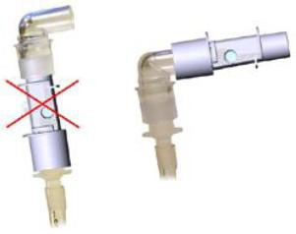

1. Do not use the IRMA airway adapter with metered dose inhalers or nebulized medications as this may affect the light transmission of the airway adapter windows.
2. The IRMA probe is intended only as an adjunct in patient assessment. It must be used in conjunction with other assessment of clinical signs and symptoms.
3. Incorrect probe zeroing will result in false gas readings.
4. Incorrect agent selection by the user for IRMA AX (no automatic agent identification) will result in false agent readings.
5. Using IRMA AX (no automatic identification) with gas mixtures containing more than one agent will result in false agent readings.
6. Replace the adapter if rainout/condensation occurs inside the airway adapter.
7. Use only PHASEIN manufactured IRMA airway adapters.

**CAUTION**

1. Do not apply tension to the probe cable.
2. Do not operate the IRMA probe outside the specified operating temperature environment.

NOTE:

For disposal of hospital waste such as accumulated fluids, calibration gases, sampled gases, where not otherwise specified, follow local regulations regarding disposal of hospital waste.

## Monitoring Steps

### **Monitoring Steps for ISA Analyzer**

##### **Performing a Pre-use Check**

Before connecting the Nomoline sampling line to the breathing circuit, do the following:

1. Connect the sampling line to the ISA gas inlet connector (LEGI).
2. Check that the LEGI shows a steady green light (indicating that the system is OK).
3. For ISA OR+ and ISA AX+ module with O2 option fitted: Check that the O2 reading on the monitor is correct (21%).
4. Breathe into the sampling line and check that valid CO2 waveforms and values are displayed on the monitor.
5. Occlude the sampling line with a fingertip and wait for 10 seconds.
6. Check that an occlusion alarm is displayed and that the LEGI shows a flashing red light.
7. If applicable: Perform a tightness check of the patient circuit with the sampling line attached.

##### **Leakage Check**

1. Connect a new Nomoline sampling line with male lock to the ISA LEGI and check that the LEGI shows a steady green light.
2. Connect a short silicon tubing with an inner diameter of 3/32” (2.4 mm) to the Nomoline male luer.
3. Exhale a long breath into the silicon tubing until the CO2 concentration is greater than 4.5 vol% or 34 mmHg.
4. Quickly connect the silicon tubing tightly to the exhaust port.
5. Wait 1 minute until the CO2 concentration has stabilized. Note the value.
6. Wait 1 minute and check that the CO2 concentration has not decreased more than 0.4 vol% or 3 mmHg. If it has decreased more there is a major leakage in the ISA unit or in the Nomoline. Do not operate the ISA if there is a major leakage in the unit.

##### **System Setup for Analyzer**

If your system is using the plug-in and measure ISA analyzer, please follow the setup instructions below:

1. Connect the ISA analyzer interface cable to the monitor.
2. Connect a Nomoline sampling line to the ISA analyzer input connector.
3. Connect the gas sample exhaust port to a scavenging system or return the gas to the patient circuit.
4. Power up the monitor.
5. A green LED indicates that the ISA analyzer is ready for use.
6. Perform a pre-use check as described in section Perform a pre-use Check.

##### **Zeroing**

The infrared module needs to establish a zero reference level for the CO2, N2O and anesthetic agent gas measurement. This zero calibration is here referred to as "zeroing".

ISA analyzer performs zeroing automatically by switching the gas sampling from the respiratory circuit to ambient air. The automatic zeroing is performed every 24 hours, and takes less than 3 seconds for ISA CO2 module and less than 10 seconds for ISA analyzer.

If the ISA analyzer is fitted with an oxygen sensor, the automatic zeroing will also include room air calibration of the oxygen sensor.

**WARNING**

Since a successful zeroing requires the presence of ambient air (21% O2 and 0% CO2), ensure that the ISA analyzer is placed in a well ventilated place. Avoid breathing near the ISA analyzer before or during the zeroing procedure.

##### **Cleaning**

The ISA sidestream gas analyzers and Nomoline Adapter can be cleaned using a cloth moistened (not wet) with max 70% ethanol or isopropyl alcohol.

To prevent cleaning liquids and dust from entering the ISA gas analyzer through its LEGI connector, keep the Nomoline Family sampling line connected while cleaning the analyzer.

**CAUTION**

Never immerse the ISA sidestream gas analyzer in liquid.

##### **Maintenance**

Once every year, or whenever gas readings are questionable, perform a leakage check according to section 17.3.1.2 and verify gas readings with a reference instrument or with calibration gas.

**WARNING**

The Nomoline sampling lines are non-sterile devices. To avoid damage, do not autoclave any parts of the sampling line.

##### **Replacement of Consumables**

The Nomoline and Nomoline Airway Adapter Set are single-patient use products. The Nomoline Adapter is a multiple-patient use product.

The T-adapter and Nomo Extension are single-patient use products.

Nomoline Family sampling lines and all consumables mentioned above should be replaced according to good clinical practice or when the sampling line gets occluded. Occlusion occurs when water, secretion etc. is aspired from the respiratory circuit to such extent that ISA cannot maintain the normal 50 ml/min sample flow. This situation is indicated by a red flashing gas inlet connector and an alarm message; Replace the Nomoline and wait until the gas inlet connector switches to green indicating that the ISA gas analyzer is ready for use.

##### **MAC Calculation**

The MAC value is calculated and displayed by using end-tidal (Et) gas concentrations according to the following formula:

X (AA): HAL=0.75%, ENF=1.7%, ISO=1.15%, SEV=2.05%, DES=6.0%

NOTE:

Altitude, patient age and other individual factors are not considered in the formula above.

### **Monitoring Steps for Dräger Minimodule**

1. Fix the water trap to the water trap holder in the V-AG module (Dräger Minimodule).
2. Connect the sampling cannula or the sampling line to the water trap.
3. Set **Work Mode** to **Measure**.
4. For intubated patients, an airway adapter is required. For non-intubated patients, place the nasal cannula or the sampling mask onto the patient.

Upon start-up, the module passes through an initialization (status message ***MultiGas Initialization*** appears) and warm-up period (status message ***MultiGas Warming Up*** appears). During this time, concentrations for certain gases may not be available and the anesthetic agent may not be identified. After the warm-up period, the module will have achieved full ISO-accuracy.

##### **Zeroing**

The module purges and zeroes itself and does not need any interaction by the user. Waveforms flat line and parameter box values blank from the screen during this cycle.

##### **MAC Calculation**

Standard MAC values

1 standard MAC is equal to the alveolar anesthetic concentration at one atmosphere (760 mmHg)

at which 50 % of all patients no longer respond to noxious stimuli. The integrated MAC algorithm is based on the MAC values shown in the following table. The values specified in the table apply to a patient age of 40 years and are guiding values only.

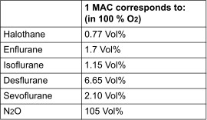

For gas mixtures, the respective multiples for N2O and anesthetic agents are added according to the following equation.

NOTE：

Age and other factors are not taken into account for standard MAC value calculation.

Age-corrected MAC values

The equation applies to patients older than 1 year.

For gas mixtures, the respective multiples for N2O and anesthetic agents are added according to the following equation.

**CAUTION**

Always set patient age correctly. Incorrect settings can lead to inappropriate MAC values and therefore to inappropriate anesthetic gas delivery.

### **Monitoring Steps for IRMA Module**

1. Plug the IRMA connector into the IRMA input and switch the power on.
2. Snap the IRMA sensor head on the top of the IRMA airway adapter. It will click into place when properly seated.

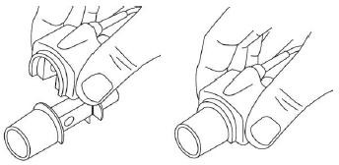

1. 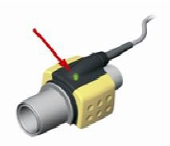A green LED indicates that the IRMA probe is ready for use.
2. Connect IRMA /airway adapter 15mm male connector to the breathing circuit Y-piece.

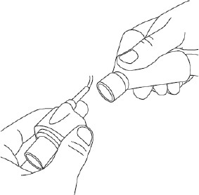

1. Connect the IRMA /airway adapter 15mm female connector to the patient’s endotracheal tube.

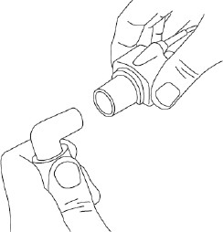

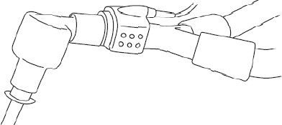Alternatively, connect an HME (Heat Moisture Exchanger) between the patient’s endotracheal tube and the IRMA probe. Placing an HME in front of the IRMA probe protects the airway adapter from secretions and effects of water vapor and eliminates the need of changing the adapter. It allows free positioning of the IRMA probe as well.

1. Unless the IRMA probe is protected with an HME, always position the IRMA probe with the status LED pointing upwards.

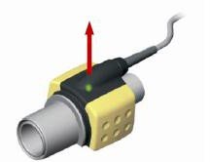

##### **Placement of IRMA Probe**

When connecting IRMA probe to an infant patient circuit, it is important to avoid a direct contact between the IRMA probe and the infant’s body. If, for whatever the reason, the IRMA probe is in direct contact with any parts of the infant’s body, an insulation material shall be placed between the IRMA probe and the body.

**WARNING**

The IRMA probe is not intended to be in long term skin contact.

##### **Performing a Pre-Use Check**

Prior to connecting the IRMA airway adapter to the breathing circuit, verify gas readings and waveforms on the monitor before connecting the airway adapter to the patient circuit.

Perform the tightness check of the patient circuit with the IRMA probe snapped on the IRMA airway adapter.

##### **Zeroing**

**WARNING**

Incorrect probe zeroing will result in false gas readings.

In order to secure high precision of the IRMA probe measurements the following zeroing recommendations should be followed.

Zeroing is performed by snapping a new IRMA airway adapter onto the IRMA probe, without connecting the airway adapter to the patient circuit, and then using the host instrument to transmit a zero reference command to the IRMA probe.

Special care should be taken to avoid breathing near the airway adapter before or during the zeroing procedure. The presence of ambient air (21% O2 and 0% CO2) in the IRMA airway adapter is of crucial importance for a successful zeroing. If a “Zero Required” alarm should appear directly after a zeroing procedure, the procedure has to be repeated.

Always perform a pre-use check after zeroing the probe.

Zeroing for IRMA AX+ probes:

Zeroing should be performed every time the IRMA airway adapter is replaced, or whenever an offset in gas values or an unspecified gas accuracy message is displayed.

Allow 30 seconds for warm up of the IRMA AX+ probes after power on and after changing the IRMA airway adapter before proceeding with the Zeroing Procedure. The green LED on the probe will be blinking for approximately 5 seconds while zeroing is in progress.

##### **Cleaning**

The IRMA probe can be cleaned using a cloth moistened with maximum 70% ethanol or maximum 70% isopropyl alcohol.

Remove the disposable IRMA airway adapter prior to cleaning the IRMA probe.

**CAUTION**

1. The IRMA airway adapters are non-sterile devices. Do not autoclave the devices as this will damage them.
2. Never immerse the IRMA probe in liquid.

##### **Maintenance**

Gas readings should be verified at regular intervals with a reference instrument or by conducting the gas check. The suggested interval is once every year.

##### **MAC Calculation**

The MAC value is calculated and displayed by using end-tidal (ET) gas concentrations according to the following formula:

MAC=%ET(AA1)/X(AA1)+%ET(AA2)/X(AA2)+%ET(N2O)/100 X(AA): HAL=0.75%, ENF=1.7%, ISO=1.15%, SEV=2.05%, DES=6.0%

## Setting Apnea Alarm Time

This determines the time limit after which the monitor gives an alarm if the patient stops breathing.

1. Select the **CO2 (AG) Setup** > **Apnea Alarm**;
2. Choose the apnea alarm time from the pull-down list.

## Working Status of ISA analyzer

Working status of the ISA analyzer can be indicated by the indicator. For the detailed information, please refer to the following table.

|  |  |
| --- | --- |
| **Indication** | **Status** |
| Steady green light | System OK |
| Blinking green light | Zeroing in progress |
| Steady blue light | Anesthetic agent present |
| Steady red light | Sensor error |
| Blinking red light | Check sampling line |

## Working Status of IRMA Module

The working status of the IRMA module can be transmitted by the IRMA probe. For the detailed information, please refer to the following table.

|  |  |
| --- | --- |
| **Indication** | **Status** |
| Steady green light | System OK |
| Blinking green light | Zeroing in progress |
| Steady blue light | Anesthetic agent present |
| Steady red light | Sensor error |
| Blinking red light | Check adapter |

## O2 Compensations

The following models need O2 compensation: IRMA AX+, ISA AX+. For the compensation details, please refer to the following table.

|  |  |
| --- | --- |
| **O2 Range** | **Set O2 Range** |
| 0 to 30 vol% | Low |
| 30 to 70 vol% | Med. |
| 70 to 100 vol% | High |

## Effects of Humidity

The partial pressure and the volume percentage of CO2, N2O, O2 and anesthetic agents depend on the amount of water vapor in the measured gas. The O2 measurement will be calibrated to show 20.8 vol% at actual ambient temperature and humidity level, instead of showing actual partial pressure. 20.8 vol% O2 corresponds to the actual O2 concentration in room air with 0.7 vol% H2O concentration (at 1013 hPa this equals for example 25°C and 23% RH). The measurement of CO 2, N2O, and anesthetic agents (e.g. all gases measured by the IR-bench) will always show the actual partial pressure at the current humidity level.

In the alveoli of the patient, the breathing gas is saturated with water vapor at body temperature (BTPS).

When the breathing gas flows through the sampling line, the gas temperature will adapt to ambient before reaching the gas analyzer. As the NOMO section removes all condensed water, no water will reach the ISA gas analyzer. The relative humidity of the sampled gas will be about 95%.

If CO2 values at BTPS are required, the following equation can be used:



where:

*EtCO2* = EtCO2 value sent from ISA [vol %]

*Pamb* = Ambient pressure sent from ISA [kPa]

*3.8* = Typical partial pressure of water vapor condensed between patient circuit and ISA [kPa] EtCO2(BTPS) = EtCO2 gas concentration at BTPS [vol%]

O2 is assumed to be room air calibrated at a humidity level of 0.7 vol% H2O.

# Chapter 18 Monitoring BIS

## Overview

Bispectral Index monitoring helps to monitor the hypnotic state of the brain based on acquisition and processing of EEG signals. The monitor processes raw EEG signals to produce a single number, namely BIS, which correlates with the patient's level of hypnosis.

Sensor check key

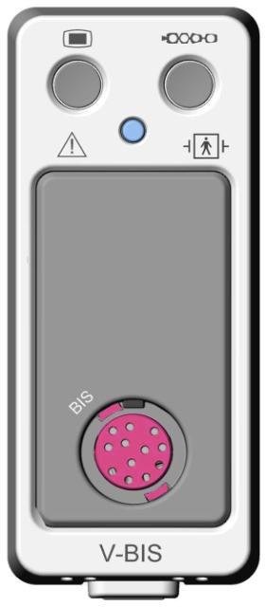

Connector for BIS adapted cable

The V-BIS module and BISx device provide the monitor with the display consisting of:

* BIS EEG waveform
* BIS trend
* Measure values of BIS, SQI, SR, SEF, TP and BC
* BIS: The BIS numeric reflects the patient’s level of consciousness. It ranges from 100 (fully awake) to 0 (absence of electrical brain activity). The BIS range guidelines are illustrated in the following chart.

|  |  |  |
| --- | --- | --- |
| **BIS Range and Clinical State** | | |
| **BIS Index Range** | 100 | **Awake**   * Responds to normal voice |
| 80 | **Light/Moderate Sedation**   * May respond to loud commands or mild prodding/shaking |
| 60 | **General Anesthesia**   * Low probability of explicit recall * Unresponsive to verbal stimulations |
| 40 | ***Deep hypnotic state*** |
| 20 | **Burst suppression** |
| 0 | **Flat line EEG** |
|  | | Note: This chart reflects a general association between clinical state and BIS values. Ranges are based in results from a multi-center study of the BIS involving the administration of specific anesthetic agents. BIS values and range calculation assume that the EEG is free of artifacts that can affect its performance. Titration of anesthetics to BIS range should be dependent upon the individual goals established for each patient. These goals and associated BIS ranges may vary over time in the context of patient status and treatment plant. |

* SQI: The SQI numeric reflects the signal quality for the EEG channel source and provides information about the reliability of the BIS, SR, SEF, TP and BC numerics during the last minute. It ranges from 0% to 100%:

0% to15%: the numerics cannot be derived.

15% to 50%: the numerics cannot be reliably derived. 50% to 100%: the numerics are reliable.

* SR: The SR is the percentage of time over the last 63-second period that the signal is considered to be in the suppressed state.
* SEF: The SEF is a frequency below which 95% of the total power is measured.
* TP: The TP numeric indicates the power in the frequency band 0.5Hz to 30Hz. The useful range is 40dB to 100 dB.
* BC: (BISx device used with Extend Sensor only) The BC numeric helps to quantify suppression, reported as the number of EEG bursts per minute, where an EEG burst is defined as a period of activity followed and preceded by inactivity (at least 0.5 second). The BC numeric is valid when SQI ≥ 15% and SR ≥ 5%.
* EMG bar graph: The EMG bar graph displays the power (in decibels) in the frequency range 70-110Hz. This frequency range contains power from muscle activity (i.e., electromyography or “EMG”) as well as power from other high-frequency artifacts. When the indicator is low, it indicates that EMG activity is low. BIS monitoring conditions are optimal when the bar is empty.

1 bar represents power in the 30-34 range.

2 bars represent power in the 35-39 range.

3 bars represent power in the 40-44 range.

4 bars represent power in the 45-49 range.

5 bars represent power in the 50-54 range.

6 bars represent power in the 55-59 range.

7 bars represent power in the 60-64 range.

8 bars represent power in the 65-69 range.

9 bars represent power in the 70-74 range.

10 bars represent power greater than 74.

## Safety Information

**WARNING**

1. Explosion hazard: Do not use the BISx device in a flammable atmosphere or where concentrations of flammable anesthetics may occur.
2. The BISx device is not designed for use in MRI environment.
3. The use of accessory equipment not complying with the equivalent safety requirements of this equipment may lead to a reduced level of safety of the resulting system. Consideration relating to the choice shall include: use of the accessory in the patient vicinity; evidence that the safety certification of the accessory has been performed in accordance to the appropriate IEC 60601-1 and/or IEC 60601-1-1 harmonized national standard.
4. Due to elevated surface temperature, do not place the BISx device in prolonged direct contact with patient’s skin, as it may cause discomfort.
5. The conductive parts of electrodes or sensor and connectors should not contact other conductive parts, including earth.
6. To reduce the hazard of burns during use of high- frequency surgical equipment, the sensor or electrodes should not be located between the surgical site and the electro-surgical unit return electrode.
7. To reduce the hazard of burns during use of brain-stimulating devices (e.g., transcranial electrical motor evoked potential), place stimulating electrodes as far as possible from the BIS sensor and make certain that sensor is placed according to package instructions.
8. The sensor must not be located between defibrillator pads when a defibrillator is used on a patient connected to the BISx device.
9. To minimize the risk of patient strangulation, the patient interface cable (PIC) must be carefully placed and secured.
10. Universal precautions shall be observed to prevent contact with blood or other potentially infectious materials. Place contaminated materials in regulated waste container.
11. Whenever an event such as spillage of blood or solutions occurs, re-test ground leakage current before further use.
12. Do not reuse the BIS sensor.

**CAUTION**

1. Do not autoclave the BISx device. Autoclaving will seriously damage the components.
2. Do not open the BISx device for any reason.
3. The BISx device has been designed to operate with a BIS sensor. The sensor is a silver/silver chloride electrode array that utilizes Aspect's patented Zipprep™ technology and uses a proprietary connector. Use of other electrodes is not recommended.
4. Considerations when using Electro-Convulsive Therapy (ECT) equipment during BIS monitoring: Place ECT electrodes as far as possible from the BIS sensor to minimize the effect of interference. Certain ECT equipment may interfere with the proper function of the BISx device. Check for compatibility of equipment during patient setup.
5. Avoid liquid ingress to the Patient Interface Cable. Contact of fluids with the PIC sensor connector can interfere with PIC performance.
6. When connecting or disconnecting the BISx device, take care not to touch the exposed contacts of either connector. Damage due to electrostatic discharge may result.
7. Using accessories other than those specified may result in increased electromagnetic emissions or decreased electromagnetic immunity of the BISx device.
8. The BISx device should not be used adjacent to or stacked with other equipment. If adjacent or stacked use is necessary, the BISx device should be observed to verify normal operation in the configuration in which it will be used.

NOTE:

The BIS measurements are very sensitive measurements that measure very small signals. Technological limitations don't allow higher immunity levels than 1V/m for radiated RF electromagnetic fields and 1Vrms for conducted disturbances induced by RF fields. Electromagnetic fields with field strengths above 1 V/m and conducted disturbances above 1 Vrms may cause erroneous measurements. Therefore SINKO recommends that you avoid using electrically radiating equipment in the close proximity of these measurements.

## BIS Monitoring Setup

Patient interface cable (PIC)

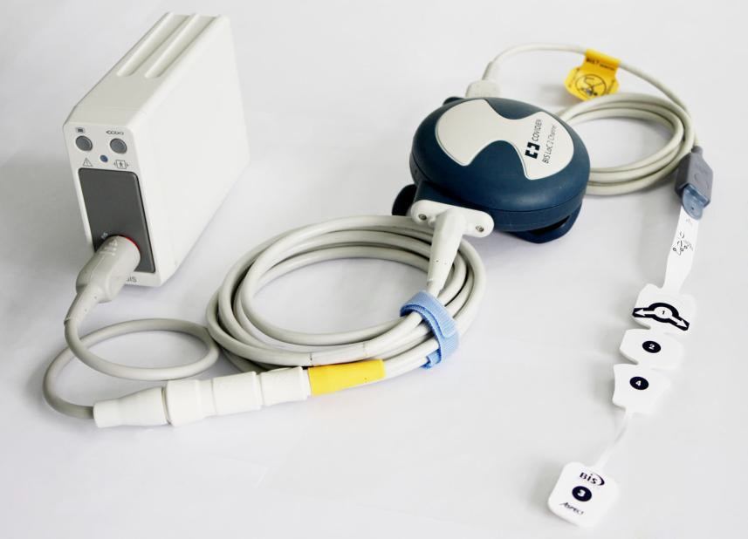

V-BIS module

BISx device

Adapter cable

BIS sensor

1. Connect the BISx device to the V-BIS module with the adapter cable and plug the V-BIS module into the monitor.
2. Using the attachment clip, secure the BISx device to a convenient location near the patient's head.
3. Prepare sensor site and place the BIS sensor on the patient in accordance with the instructions included on the sensor packaging. Make sure that the patient’s skin is dry. Be aware that a wet sensor or a salt bridge may cause erroneous BIS and impedance values.
4. Attach the BIS sensor to the PIC. To insert the sensor into the PIC, line up as shown and insert the sensor tab into the PIC sensor connector until an audible “click” is heard. The blank side of the sensor tab (i.e. the side without the computer chip) should be facing up.

**CAUTION**

1. Ensure that the BISx device does not come into prolonged contact with your patient’s skin, as it may generate heat and cause discomfort.
2. The BISx device may remain connected to a patient during defibrillation as long as the sensor is not located between the defibrillator pads.

NOTE:

After you switch the operating mode of the monitor into monitoring mode from demo mode, you need to re-plug the V-BIS module into the monitor before starting BIS measurement.

## BIS Continuous Impedance Check

The continuous impedance check is always active to enable you to understand the sensor condition in real time. It checks:

* The combined impedance of the signal electrodes and the reference electrode

This is done continuously and does not affect the EEG wave. As long as the impedances are within the valid range, no prompt message of this check or its results will be announced

* The impedance of the ground electrode

This is done every ten minutes and takes approximately four seconds. It causes an artifact in the EEG wave, and the monitor will announce **BIS Ground Check** on the screen during the check. If the ground electrode does not pass the check, another check will be performed. This continues until the ground electrode passes the check.

## BIS Sensor Check

This measures the exact impedance of each individual electrode. It causes a disturbed EEG wave.

### **Starting a Sensor Check**

The sensor check is automatically started when a sensor is connected. To manually start a sensor check:

* press the hard key  on the V-BIS module, or
* select **BIS Setup** > **Sensor States** and click **Start Sensor Check**.

### **Stopping a Sensor Check**

The sensor check stops automatically if the impedances of all electrodes are within the valid range. To manually stop a sensor check:

* press the hard key  on the V-BIS module, or
* select **BIS Setup** > **Sensor States** and click **Stop Sensor Check**.

## BIS Sensor Window

To open the BIS sensor window, select **Sensor States** on the **BIS Setup** menu**.**

The window may look slightly different on your monitor. The graphic in the BIS sensor window automatically adapts to show the type of sensor in use. Each symbol in the graphic represents an electrode and illustrates the most recently-measured impedance status of the electrodes. Although BIS may still be measured when the electrode is in Noise or High status, for best performance, all electrodes should be in Pass status.

①

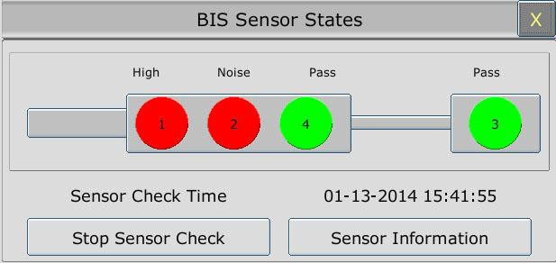

②

① The time at which the last sensor check was completed

② Click this button to open a window in which information of the sensor in use is displayed.

#### BIS Impedance Indicators

|  |  |  |  |  |  |  |
| --- | --- | --- | --- | --- | --- | --- |
| **Color** | **Status** | **Electrode-to-skin impedance** | | | | **Action** |
| Green | Pass | The impedance acceptable range. | is | within | the | No action necessary. |
| Red | Noise | The electrode impedance cannot be determined due to electrical interference (noise) from another source. | | | | Check the senor-to-skin contact. Press the edges of the sensor to ensure adhesion and proper contact. If the problem persists, remove sensor, clean skin thoroughly, and reapply sensor or apply new sensor in accordance with instructions on the sensor packaging. |
| High | The impedance limit. | is | above | the |
| Lead Off | Electrode has no skin contact. | | | | Reconnect electrode, or check the sensor-to-skin contact. If necessary, clean and dry skin. |

## Changing the BIS Smoothing Rate

The smoothing rate defines how the monitor averages the BIS value. With the decline in smoothing rate, the monitor provides increased responsiveness to changes in the patient’s state. Contrarily, the monitor provides a smoother BIS trend with decreased variability and sensitivity to artifacts.

To change the smoothing rate, open the **BIS Setup** menu and set **Smoothing Rate** to **10 sec**, **15 sec** or **30 sec**.

## Switching Secondary Parameters On and Off

A maximum of four secondary parameters can be added to display on the BIS parameter area.

Select **BIS Setup** > **Secondary Parameter Select** and select four secondary parameter maximum.

## Changing the Scale of the EEG Wave

1. Open the **BIS Wave Setup** menu;
2. Select the appropriate setting from the **Scale** list.

## Setting the Trend Length

1. Open the **BIS Wave Setup** menu;
2. Select the appropriate length of time for BIS trend from the **Trend Length** list.

## Switching BIS Filters On or Off

1. Open the **BIS Wave Setup** menu;
2. Set **Filters** to **On** or **Off**.

# Chapter 19 Monitoring RM

## Overview

The monitor measures respiratory mechanics by connecting the RM module with the flow sensor to produce numerics and waveforms for flow, volume and pressure of respiratory gases in the airway.

Connector for CO2 sensor

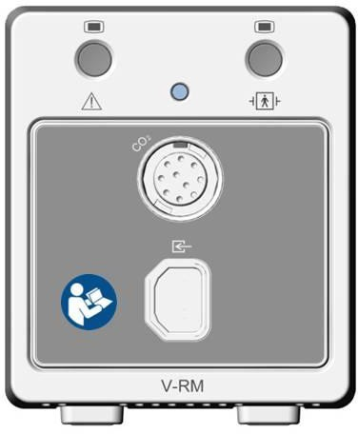

Flow input receptacle

The measurement provides:

* Airway pressure (Paw), airway flow (Flow) and airway volume (Vol) waveforms.
* Numerics for:
  + PIP (peak inspiratory pressure)
  + Pplat (plateau pressure)
  + PEEP (positive end expiratory pressure)
  + Pmean (mean airway pressure)
  + PIF (peak inspiratory flow)
  + PEF (peak expiratory flow)
  + TVi (inspiratory tidal volume)
  + TVe (expiratory tidal volume)
  + MVi (inspiratory minute volume)
  + MVe (expiratory minute volume)
  + I:E (ratio of the inspiratory time and expiratory time)
  + Cdyn (dynamic compliance)
  + Cstatic (static compliance)
  + RAWi (airway resistance-inspired)
  + RAWe (airway resistance-expired)
  + NIP (negative inspiratory pressure)
  + RSBI (rapid shallow breathing index)
  + P0.1 (airway pressure at 100 msec after the start of inspiration )
  + AwRR (airway respiration rate)
  + EtCO2 (end-tidal carbon dioxide)
  + FiCO2 (fraction of inspired carbon dioxide)

Also, the measurement provides F-V (flow-volume) loops and P-V (pressure-volume) loops. For detailed information about loops, refer to *19.8 Respiratory Loops*.

## Safety Information

**WARNING**

1. EXPLOSION HAZARD - Do not use the RM module in the presence of flammable anesthetics or other flammable gasses when mixed with air, oxygen, or nitrous oxide. Use of the RM module in such environment may present an explosion hazard.
2. Follow precautions for electrostatic discharge (ESD) and electromagnetic interference (EMI) to and from other equipment.
3. If the RM module fails to respond as described in this manual, do not use it until approved for use by qualified personnel.
4. Do not position the sensor cables or tubing in any manner that may cause entanglement or strangulation.
5. Do not apply excessive tension to any cable or pneumatic tubing.
6. ELECTRICAL SHOCK HAZARD - The RM module contains no user serviceable parts. Refer servicing to qualified personnel.
7. Reuse (disassembly, cleaning, disinfecting, sterilizing, etc.) of the single use patient flow and CO2/flow sensors may compromise device functionality and system performance and cause a potential patient hazard. Performance is not guaranteed if a sensor is reused.
8. Inspect the flow and CO2/flow sensors prior to use and periodically during use. Do not use them if they appear to be damaged or broken.
9. Do not attempt to rotate a sensor in the breathing circuit by grasping the pneumatic tubes exiting the flow sensor.
10. Periodically inspect sensor tubing for kinks.

**WARNING**

1. Replace the flow or CO2/flow sensor if excessive moisture or secretions are observed in the pressure line tubing.
2. The RM module automatically identifies the type of sensor (adult, pediatric or neonatal) when it is connected. If the module does not identify the sensor when a sensor is first connected, do not use the sensor. If the condition persists, refer the module to qualified service personnel.
3. The use of the RM module is restricted to one patient at a time. Do not connect the sensors to multiple patients simultaneously.
4. The flow or CO2/flow sensor connector should be properly inserted into the host receptacle prior to connecting a sensor to the breathing circuit, in order to avoid a circuit leak, or occlusion of sensor tubing.
5. Periodically check sensors and tubing for excessive moisture or secretion build up.
6. Although the RM module automatically purges the lines, moisture or secretions may still remain.
7. While using the sensors, a system leak, such as that caused by uncuffed endotracheal tubes or a damaged sensor may significantly affect flow related readings. These include flow, volume, pressure, deadspace, CO2 production and other respiratory mechanics parameters.
8. The use of portable and mobile radio frequency (RF) communications equipment can affect this and other pieces of medical equipment.
9. The use of accessories, sensors and cables other than those specified by SINKO may increase emissions or decrease immunity of the equipment.
10. The patient sensors must not be located between defibrillator pads when a defibrillator is used on a patient.
11. To reduce the hazard of burns in the high-frequency surgical neutral electrode connection, the patient sensors should not be located between the surgical site and the electro-surgical unit return electrode.
12. The RM module is not intended to be used as an apnea monitor.

**CAUTION**

1. Always inspect the flow or CO2/flow sensor set-up in ventilator prior to use. Insure that the patient flow connector is positively latched prior to use.
2. Always verify that the flow or CO2/flow sensor type is correctly identified by the system prior to use.

**CAUTION**

1. Always remove the flow or CO2/flow sensor from the patient circuit before disconnecting the sensor from the module.
2. Do not use the module if it appears to be damaged.
3. Do not use the RM module if it fails to operate properly, appears to have been damaged, is wet or has exterior condensation.
4. Do not clean the RM module and accessories except as directed in this manual.
5. Use only approved sensors and accessories with the RM module.
6. Do not spray cleaning agents directly into the flow sensor receptacles.
7. Never sterilize or immerse the module in liquids.
8. Do not sterilize or immerse sensors except as directed in this manual.
9. To avoid the effects of excessive moisture in the measurement circuit, insert the flow or CO2/flow sensor in the ventilator circuit with the tubes upright. Improper placement may result in erroneous data.
10. Excessive moisture in the flow or CO2/flow sensor tubing may affect the accuracy of the measurements.
11. It is recommended that the CO2/flow sensors be removed from the circuit whenever an aerosolized medication is delivered. These medications may contaminate the sensor windows, causing the sensor to fail prematurely.
12. The use of some aerosolized medications may affect the accuracy of the flow only sensors.
13. Sudden erratic changes in the CO2 and pressure waveforms that do not correlate to the physiological condition of the patient may be signs that the module is experiencing electromagnetic interference.
14. The RM module complies with IEC 60601-1-2:2001, providing reasonable protection against electromagnetic interference in a typical medical installation. The equipment generates, uses and can radiate electromagnetic interference (EMI), and if not installed and used in accordance with the instructions, may cause interference with other devices in the vicinity.
15. If interference does occur, correct it using one or more of the following measures:
    * Move the receiving device or increase separation between the equipment.
    * Consult SINKO or members of the hospital’s engineering department for more information.
16. The RM module is not intended for use in a hyperbaric chamber or an MRI (Magnetic Resonance Imaging) environment.

NOTE:

1. Set the gas compensation on module startup, and whenever the nominal gas composition delivered to the patient is changed.
2. This product and its accessories which have patient contact are free of latex.
3. The following factors can influence CO2 and flow measurement: nitrous oxide, barometric pressure, temperature, humidity, airway pressure, O2, helium and anesthetic agents.

## Sensor Setup

1. Select the appropriate flow or CO2/flow sensor in accordance with patient category.
2. If you are using a combined CO2/flow sensor, connect it to the CO2 sensor first. Snap the airway adapter until it clicks into place.
3. Before connecting the flow or CO2/flow sensor to the breathing circuit, insert its connector into the receptacle on the RM module.
4. Position the flow or CO2/flow sensor into the breathing circuit between the wye and the elbow. Some patient circuit examples are shown below:

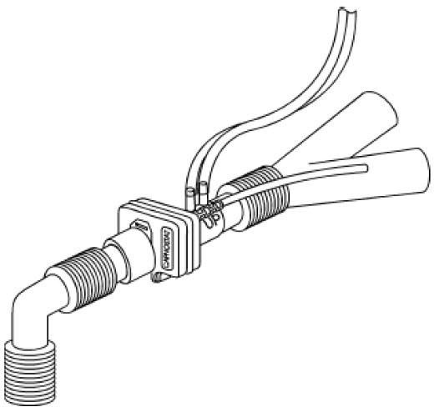To ventilator

To patient

Adult CO2/Flow Sensor with CO2 Sensor Attached

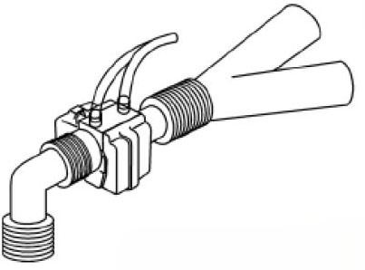To ventilator

To patient

Pediatric CO2/Flow Sensor with CO2 Sensor Attached

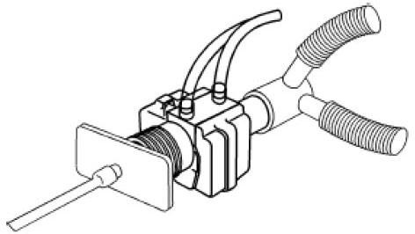To ventilator

To patient

Neonatal CO2/Flow Sensor with CO2 Sensor Attached

NOTE:

1. The flow or CO2/flow sensor type is detected when the sensor is connected to the RM module. The flow sensor type is communicated to the monitor. Flow sensors are uniquely identifiable based on connector design.
2. Adult, pediatric and neonatal flow or CO2/flow sensor bodies are color-coded to assist the user in identifying that the correct type of flow sensor is being used. For more information on which sensor to use, refer to *31.10 RM Accessories*.

## Zero Calibration

The zero calibration is performed automatically during measurement. Also, a manual zero calibration can be started whenever major errors of measurements are detected or the numerical accuracy is in doubt. To manually zero the sensor, select **Zero** on the **RM Setup** menu to initiate a zero calibration.

## Purging

The RM module features an automatic and manual purge function which provides a flush of room air to keep the sensor tubing free from water condensation and patient secretions.

### Automatic Purging

An automatic purging is performed during measurement at the intervals varying with different types of sensors. In adult mode, the system purges the sensor tubing every 10 minutes, while in neonatal or pediatric mode, the purge cycle will be at every 3 minutes.

### Manual Purging

A manual purging may be required when water condensation is accumulated in the sensor tubing or the flow wave is abnormal. To perform a manual purging, select **Purge** on the **RM Setup** menu to initiate a purge cycle.

## Gas Compensation

The proportions of anesthetic gases in the airway will influence the flow measurement; thus, gas compensation is required for correcting the calculation. Gas compensation can be finished by using the manually entered gas concentrations.

If the airway gas conditions are not properly set in the monitor, the measured flow will be incorrect. The measurement error is dependent on the airway gas conditions, flow rate and barometric pressure. The table below is an example of the magnitude of error to expect. The first line in the table is the baseline gas conditions at a flow rate of 40 L/min and a barometric pressure of 760 mmHg. Each of the successive lines in the table is the error to expect in the flow measurement with the specified gas condition if the airway gas conditions were improperly set to the baseline conditions in the first line.

|  |  |  |  |  |  |  |  |  |
| --- | --- | --- | --- | --- | --- | --- | --- | --- |
| **Gas Compensation Effects on Flow** | | | | | | | | |
| **N2** | **O2** | **CO2** | **N2O** | **Helium** | **Agent** | **Temperature** | **Humidity** | **Measurement Error** |
| 79 | 21 | 0 | 0 | 0 | 0 | 35°C | 50% | --- |
| 79 | 16 | 5 | 0 | 0 | 0 | 35°C | 50% | + 2.8 % |
| 40 | 60 | 0 | 0 | 0 | 0 | 35°C | 50% | - 2.5 % |
| 0 | 40 | 0 | 60 | 0 | 0 | 35°C | 50% | - 14.9 % |
| 35 | 60 | 0 | 0 | 0 | 5 | 35°C | 50% | - 19.6 % |
| 0 | 30 | 0 | 0 | 70 | 0 | 35°C | 50% | + 56.7 % |
| 79 | 21 | 0 | 0 | 0 | 0 | 35°C | 0% | - 0.5 % |
| 79 | 21 | 0 | 0 | 0 | 0 | 35°C | 100% | + 0.4 % |
| 79 | 21 | 0 | 0 | 0 | 0 | 25°C | 50% | - 2.1 % |

NOTE:

1. Set the gas compensation on module startup, and whenever gas compensation delivered to the patient is changed.
2. Gas compensations must sum to 100%; if less than 100%, the percent of balance gas is assumed according to selected gas compensations.

### Changing the Concentration of Inspired O2 and Inspired Agents

1. Select **RM Setup** > **Other Setups** to open the **Air Compensate** window.
2. Select the appropriate settings for the **O2 Compens.** and **Anest. Agent** items.

### Changing the Type of Balance Gas

1. Select **RM Setup** > **Other Setups** to open the **Air Compensation** window.
2. Select a balance gas from the drop-down list of **Balance Gas**.

### **Changing the Temperature of the Inspired and Expired Gas**

1. Select **RM Setup** > **Other Setups** to open the **Air Compensation** window.
2. Select the appropriate settings for the **Fi Temperature** and **Et Temperature** items.

### **Changing the Humidity of the Inspired and Expired Gas**

1. Select **RM Setup** > **Other Setups** to open the **Air Compensation** window.
2. Select the appropriate settings for the **Fi Humidity** and **Et Humidity** items.

## RM Configuration

The following settings are accessible on the **RM Setup** menu.

### **Changing the Apnea Alarm Delay**

This determines the time limit after which the monitor gives an alarm if the patient stops breathing.

1. Access the **RM Setup** menu.
2. Choose the apnea alarm delay time from the **Apnea Time** drop-down list.

### **Selecting Measured Airway Volume Components**

Users can select tidal volume (TV) or minute volume (MV) as the measured airway volume component for display in the Vol parameter window:

1. Access the **RM Setup** menu.
2. Choose the item **TV/MV** and switch between **TV** and **MV**.

### **Changing the Respiration Mode**

1. Access the **RM Setup** menu.
2. Select a mode between **Spontaneous** and **Mechanical** from the **Ventilation Mode**

drop-down list.

### **Selecting Waveform**

To select Flow or Vol waveform for display:

1. Access the **RM Setup** menu.
2. Choose the item **Flow/Vol** and switch between **Flow** and **Vol**.

## Respiratory Loops

Respiratory loops can indicate a fault in the airway tubing and help physicians to detect respiratory problems of patients.

The two types of loops are available in real time:

* F-V (flow-volume) loops: it illustrates the dynamic relation between flow and volume during respiration and provides information about condition of the airway tubing.
* P-V (pressure-volume) loops: it reflects the dynamic relation between pressure and volume as well as compliance of the respiratory system.

### **Viewing Loops**

To view the respiratory loops, select **Respiratory Loop** on the **RM Setup** menu, and the respiratory loop window will be displayed on the screen. Both graphic representation of the respiratory loop and the associated keys are available in this window.

### **Storing and Reviewing Loops**

Select the key **Save** to store the respiratory loops in the current respiratory cycle for reference. Up to four loops can be stored, and the storing time for the latest four reference loops is displayed above the loops. The latest stored loops will replace the previously stored loops when the number of stored loops is over four.

Also, users can review the stored loops by selecting the time tags in the window for displaying the corresponding stored loops.

### **Changing Loop Type**

To change the loop type, select **Respiratory Loop** > **Setup** > **Display Loop** and choose a loop type from the drop-down list.

### **Showing/Hiding the Reference Loop**

To show/hide the reference loop, select **Respiratory Loop** > **Setup** > **Reference Loop** and choose **On**/**Off** from the drop-down list.

### **Resizing the Loops**

To resize the loop, select **Respiratory Loop** > **Setup** to open the **F-V Loop Setup** or **P-V Loop Setup** window in which you can set up the top ruler and bottom ruler for Paw, Vol and Flow.

# Chapter 20 Monitoring ICG

## Overview

Impedance cardiography (ICG) monitoring provides hemodynamic parameters based on the measurement of thoracic electrical bio-impedance. With the V-ICG module, the monitor determines hemodynamic parameters as well as indexed versions of those parameters, through which you can assess a patient’s hemodynamic status and ventricular function.

Connector for ICG patient cable

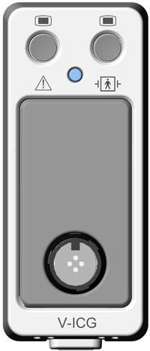

The V-ICG module and the ICG patient cable provide the monitor with an ICG waveform and the following numerics:

* HR (heart rate)
* SV (stroke volume)
* SVRI (systemic vascular resistance index)
* SI (stroke index)
* C.O. (cardiac output)
* TFC (thoracic fluid content)
* SVR (systemic vascular resistance)
* QI (quality indicator)
* DO2I (oxygen delivery index)
* CI (cardiac index)

## Safety Information

**WARNING**

1. Only connect one patient at the same time to the V-ICG module.
2. The sensors must not have a direct contact to other electrically conductive materials.
3. Because of hygienic reasons only disposable electrodes/sensors should be used.
4. Before monitoring patients with pacemakers, ensure that the function of the pacemaker cannot be influenced by the measuring current used for impedance cardiography. In the case of minute ventilation pacemakers the use of the V-ICG module and ICG patient cable is not allowed if the minute ventilation function of the pacemaker is activated.
5. The V-ICG module and ICG patient cable are not intended to be used while exposing the patient to high frequency current.
6. Handle the ICG patient cable and lead wires carefully and position them so that they do not cross over each other or other cables or power cords to avoid signal interference.
7. Do not expose the cables to mechanic or thermic impact. Avoid temperatures above 40 °C (100 °F).

NOTE:

The ICG measurements are very sensitive measurements that measure very small signals. Technological limitations don't allow higher immunity levels than 1V/m for radiated RF electromagnetic fields and 1Vrms for conducted disturbances induced by RF fields. Electromagnetic fields with field strengths above 1 V/m and conducted disturbances above 1Vrms may cause erroneous measurements. Therefore SINKO recommends that you avoid using electrically radiating equipment in the close proximity of these measurements.

## ICG Patient Cable

The patient cable for impedance cardiography contains a small box, which includes a cable splitter for the two branches (right and left):

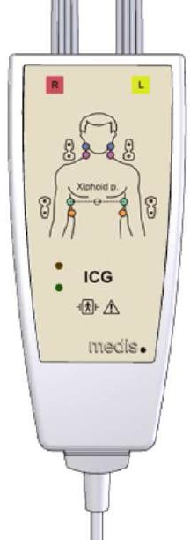

On the outside of the box, two LEDs (green and orange) display the current function of the patient cable, as indicated below:

|  |  |  |  |  |  |
| --- | --- | --- | --- | --- | --- |
| **Green** | **Orange** | | **Description of function** | | |
|  |  | | The electric part of the patient cable is not connected with the power supply; cable is disconnected or the device is switched off | | |
|  |  | | Patient cable is ready to use, but the measurement has not been started | | |
|  |  | | Measurement is running; sensor contact is good | | |
|  |  | | Bad contact between sensors and patient: at least one lead wire is disconnected or not properly fixed; sensors are too dry (eventually new sensors are necessary) | | |
|  |  | | Insufficient contact between sensors and patient: at least one lead wire is disconnected or not properly fixed; sensors are too dry (new sensors are necessary) | | |
|  |  | | Patient cable has power but the module is not ready for measurement | | |
| Legend: | | LED off | | LED flashing | LED on |

## Precautions and Limitations

With the V-ICG module and the ICG patient cable, you can examine adult patients in a resting position. The measured parameters can be used only if the ICG waveform has sufficient signal quality and is without artifact.

The method of impedance cardiography (ICG) is based on a theoretical model of blood flow

movement in the thorax (aorta). If the physiological and clinical conditions of the patient are not in accordance with the assumptions of the model, inaccuracies in the parameters may occur.

The following conditions may adversely affect the accuracy of ICG measurement:

* Septic shock
* Aortic valve regurgitation and defect of septum
* Severe aortic sclerosis, aortic prosthesis
* Severe hypertension (MAP>130mmHg)
* Cardiac arrhythmia
* Tachycardia with a heart rate higher than 200 bpm
* Patient heights below 120cm or above 230cm
* Patient weights less than 30kg or greater than 155kg
* Patient movement
* Aortic balloon or aortic balloon pump
* Simultaneous use of electrical cautery systems during surgical procedures
* During operation on the opened thorax the current distribution can be distorted and can lead to inaccuracies.

## Starting a Measurement

### **Measurement Procedure**

1. Connect the ICG patient cable to the V-ICG module and plug the V-ICG module into the monitor.
2. Prepare the patient’s skin and place the ICG sensors on the patient.
3. Correctly enter the patient information.

### **ICG Sensor Application**

Proper sensor placement is essential for accurate measurements.

1. Attach the four dual sensors to the patient. The rectangular shaped end with the heart label should be positioned closer to the heart.
2. For the neck, use the root of the neck as a reference for vertically locating the rectangular shaped detecting sensor with the corresponding circular shaped transmitting sensor being positioned directly superior and in line with the ear lobe.
3. For the thorax, use the xiphoid process as a reference for vertically locating the rectangular shaped detecting sensor with the corresponding circular shaped transmitting sensor being positioned directly inferior and along the mid-axillary line.
4. Respectively, the neck and the thorax sensors must be 180-degree opposite to each other.
5. Indentify the right and left (with respect to the patient) branches of the ICG patient cable as indicated on the patient cable yoke diagram and connect the respective leads in order from top to bottom: blue, purple, green and orange.

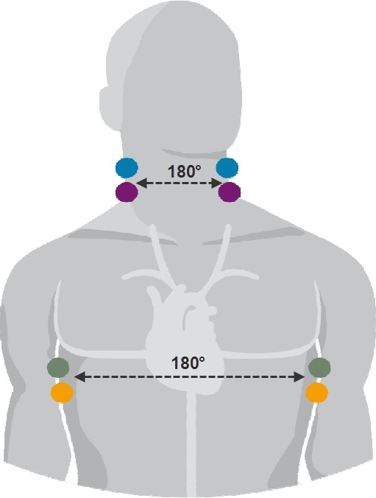Blue Purple

Green Orange

### Setting Patient Data

Choose **ICG Setup** > **Input Info**> **Patient Info**. Properly set the items including **Height**, **Weight**, **Gender** and **Date of Birth**. The setting height should range from 130cm to 250cm; weight 30kg to 250kg; age 13 to 130. If these items have not been set or the setting patient data is invalid, you will be prompted to provide relevant information or reset the relevant items.

Choose **ICG Setup** > **Input Info** and enter the **ICG Input Info** menu. The values of physiological parameters including SYS, DIA, MAP, PAWP, CVP, Hb and SpO2 are available to set. You can also directly obtain the values of SYS, DIA, MAP, CVP and SpO2 from the monitor by selecting **Get Parameter Value**. If any value of SYS, DIA, MAP, CVP or SpO2 is absent or invalid, the message **Get BP/SpO₂Value Unsuccess** will appear in the menu.

## Selecting Secondary Parameters

Choose **ICG Setup** > **Secondary Param Select**. You can select three secondary parameters to be displayed on the ICG parameter area for your preference.

# Chapter 21 Freeze

When monitoring a patient, the user may freeze the waveforms and examine them. Generally, the user can review a frozen waveform of a maximum of 12 minutes. The freeze function of this monitor has the following features:

* Freeze status can be activated on any operating screen.
* Once entering the Freeze status, the system exits all other operating menus. Besides, the system freezes all waveforms in the Waveform area of the Standard Screen, and also freezes Full Lead ECG waveforms and extra waveforms on the Full Lead ECG interface (if any). Nevertheless the Parameter area refreshes normally.
* The frozen waveforms can be reviewed and recorded.

## Entering/Exiting Freeze Status

### Entering Freeze Status

In the Non-Freeze status, press the  button on the control panel of the monitor to exit the current menu. Freeze status is entered and the popup **Freeze** menu is displayed. In Freeze status, all waveforms are frozen and will no longer be refreshed.

### Exiting Freeze Status

In the Freeze status, executing any of the following operations will command the system to exit the Freeze status:

* Exit the **Freeze** menu;
* Press the  button on the control panel again;
* Execute any operation that may trigger the adjustment of the screen or the display of a new menu.

After exiting Freeze status, the system will clear screen waveforms and resume displaying real-time waveforms. In the Screen Refresh mode, the system will sweep the waveforms from left to right in the Waveform Area.

Press the  button on the control panel, and the **Freeze** menu will appear on the bottom part of the screen. At the same time, the system freezes the waveforms.

NOTE:

Pressing the  button repeatedly over a short period of time may result in discontinuous waveforms on the screen.

## Reviewing Frozen Waveform

By moving the frozen waveform, you may review a waveform of 12 minutes before it is frozen. For a waveform of less than 12 minutes, the remaining part is displayed as a straight line. Select **Time** on the **Freeze** menu and use the up/down arrow keys to move the frozen waves so that you can review the other parts of the frozen waves not displayed on the current screen.

# Chapter 22 Review

The monitor provides 150-hour trend data of all parameters, storage of 1200 NIBP measurement results and 200 alarm events. This chapter gives detailed instruction for review of all data.

## Trend Graph Review

* The latest 1-hour trend is displayed every 1 or 5 seconds.
* The latest 150-hour trend is displayed every 1, 5 or 10 minutes.

To review Trend Graph, please press the **Trend Graph** key on the screen or select **Menu** >

**Review** > **Trend Graph**, then the trend graph interface is displayed.

In the trend graph, the y-axis stands for the measurement value and x-axis stands for the time.

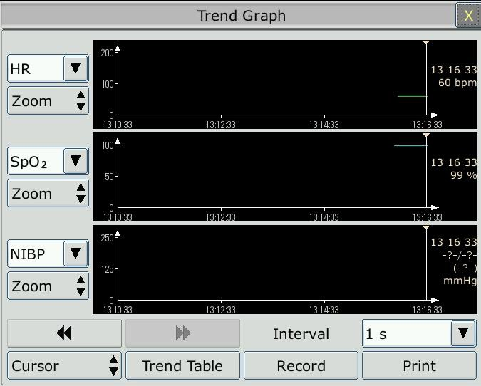

### **Selecting Trend Graph of Specific Parameter**

The monitor can review trend graph of different parameters. To change the existing trend graph, please select **Menu** > **Review** > **Trend Graph** and select a required parameter name from the popup list.

### **Adjusting Trend Scale**

You can use **Zoom** on the trend graph review interface to adjust the trend scale. Once you adjust the trend scale on the trend graph review interface, you also change the trend scale of the related parameters for the screen trend displayed on the main screen.

### **Setting Resolution**

The monitor can support five kinds of resolutions. To set an appropriate resolution, please select **Menu** > **Review** > **Trend Graph** and an interface is displayed. Choose **Resolution** on the interface to open the list and select an appropriate resolution among **1 sec**, **5 sec**, **1 min**, **5 min** and **10 min**.

### **Scrolling Left and Right the Screen**

All trend graphs can’t be displayed on the current screen due to the screen limitation. The user can scroll left and right the screen manually to see measurement trends that do not fit in the current view by selecting and pressing the symbol  and  displayed on the trend graph.

### **Switching to the Trend Table**

The user can switch to the trend table interface on the **Trend Graph** interface. To do so, please select **Menu** > **Review** > **Trend Graph** and select the **Trend Table** option from the popup interface.

### **Record**

The monitor can make a tabular trend recording of the data in the current trend graph window. The report will use the current trend interval settings. For the detailed information about recording the trend graph, please refer to *Chapter 24: Recording*.

## Trend Table Review

To review the trend table, please press the **Trend Table** key on the screen or select **Menu** >

**Review** > **Trend Table**, then the trend table is displayed.

### **Setting Resolution**

The monitor can support eleven kinds of resolutions. To set an appropriate resolution, please select **Menu** > **Review** > **Trend Table** and an interface is displayed. Choose **Interval** on the interface to open the list and select an appropriate interval among **1 sec**, **5 sec**, **30 sec**, **1 min**, **3 min**, **5 min**, **10 min**, **15 min**, **30 min**, **60 min** and **NIBP**.

### **Scrolling the Screen**

All trend tables can’t be displayed on the current screen due to the screen limitation. The user can scroll left, right, up and down the screen manually to see measurement trend tables that do not fit in the current view by selecting and pressing the symbol  ,  ,  and  displayed on the trend graph.

### **Switching to Trend Graph**

The user can switch to the trend graph on the **Trend Table** interface. To do so, please select

**Menu** > **Review** > **Trend Table** and select the **Trend Graph** option from the popup interface.

### **Recording**

The monitor can make a tabular trend recording of the data in the current trend graph window. The report will use the current trend interval settings. For the detailed information about recording the trend table, please refer to Chapter 24: *Recording*.

## NIBP Review

To review the NIBP measurement data, select the **NIBP Review** key on the screen or select

**Menu** > **Review** > **NIBP Review,** then the **NIBP Review** window is displayed.

### **Scrolling the Screen**

All measurement data can’t be displayed on the current screen due to the screen limitation. The user can scroll up and down the screen manually to see measurement data that doesn’t fit in the current view by selecting and pressing the symbol  and  displayed on the **NIBP Review** interface.

### **Recording**

The monitor can record the measurement data in the NIBP review window. For the detailed information about recording the NIBP review, please refer to Chapter 24: *Recording*.

## Alarm Review

To review the alarm event, select the **Alarm Review** key on the screen or select **Menu** >

**Review** > **Alarm Review,** then the **Alarm Review** window is displayed.

NOTE:

The monitor can store a maximum of 200 alarm events. As soon as the alarm event storage is full, the earliest alarm event will be replaced by the latest one.

### **Scrolling the Screen**

All alarm events can’t be displayed on the current screen due to the screen limitation. The user can scroll up and down the screen manually to see alarm events that don’t fit in the current view by selecting and pressing the symbol  and  displayed on the **Alarm Review** interface.

### **Selecting Alarm Event of Specific Parameter**

The monitor can review alarm event of the specific parameters. To view the alarm event of the specific parameter, please select **Menu** > **Review** > **Alarm Event** and choose **Event Type** to select the required parameter name from the popup list.

### **Setting Time Index**

The user can set end time of alarm review by selecting the **Time Index** option displayed on the alarm review interface.

If the user selects **Current Time** on the popup interface, the alarm events occurring before the current time are displayed on the alarm event review interface.

If the user selects **User Define**, he can define the review time by setting time box displayed on the interface**.** The alarm events occurring before the **User Define** option are displayed on the alarm event review interface.

## Arr Review

Select **ECG Setup** > **Arr Analysis**> **Arr Review** or **Menu > Review > Arr Review** to open the Arr review interface**.** The interface displays the latest arrhythmia events.

### **Scrolling the Screen**

All arrhythmia events can’t be displayed on the current screen due to the screen limitation. The user can scroll up and down the screen manually to see the other arrhythmia events that do not fit in the current view by selecting and pressing the symbol  and  displayed on the **Arrhythmia Review** interface.

### **Arrhythmia Alarm Review**

You may select an alarm event by the knob and access the alarm review interface to get more information. On the alarm review interface, you can:

* Right or left shift the waveform to review the complete 8-scecond waveform.
* Select **Record** and output the arrhythmia waveform by the recorder.
* Select another name from the pull-down list of **Rename** for the arrhythmia event to change its name.
* Select **Delete** to remove a specific arrhythmia event.
* Select **Alarm List** or exit the menu to get back to the arrhythmia review interface.

NOTE:

1. If there are more than 200 arrhythmia events, the monitor will only keep the recent ones.
2. The name of arrhythmia event will be shown on the alarm status area.

## 12-lead Diagnosis Review

Select **Menu** > **Review** > **Analysis Review** to open the 12-lead analysis review interface.

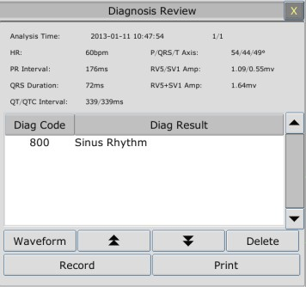

### **Scrolling the Screen**

All analysis results or waveforms can’t be displayed on the current screen due to the screen limitation. The user can scroll up and down the screen manually to see the analysis results or waveforms that do not fit in the current view by selecting and pressing the symbol  and  displayed on the 12-lead analysis review interface.

### **Deleting Diagnosis Results**

The user can delete the analysis results displayed on the current screen by selecting **Delete** on the interface.

### **Switching Between Waveforms and Results**

The user can review the analysis waveforms on the analysis result interface by selecting the **Wave** option and review the analysis results on the analysis waveform interface by selecting the **Result** option.

### **Recording**

The monitor can record the 12-lead diagnosis waveforms or results displayed on the current screen. To do so, press **Record** on the interface. For the detailed information about recording the diagnosis waveforms or results, please refer to Chapter *Recording*.

# Chapter 23 Calculation and Titration Table

The monitor provides calculation function and titration table. Calculations are patient data that are not directly measured but calculated by the monitor.

The monitor can perform drug calculation, hemodynamic calculation, oxygenation calculation, ventilation calculation and renal function calculation.

NOTE:

The drug calculation function acts only as a calculator. The patient weights in Drug Calculation menu and in Patient Information menu are independent of each other. Therefore changing the weight in Drug Calculation menu will not change the weight in the Patient Information menu.

## Drug Calculation

### **Calculation Procedures**

1. The drug calculation window is displayed by selecting **Menu** > **Common Function** >

Calculation > Drug Dose.

1. Select the right pull-down box of the **Drug** option and select the required drug name among the 15 drugs which are listed as follows. And the drug name of **Drug A, Drug B, Drug C, Drug D** and **Drug E** can be defined by the user.
   * Drug A, Drug B, Drug C, Drug D and Drug E
   * AMINOPHYLLINE
   * DOBUTAMINE
   * DOPAMINE
   * EPINEPHRINE
   * HEPARIN
   * ISUPREL
   * LIDOCAINE
   * NIPRIDE
   * NITROGLYCERIN
   * PITOCIN
2. The system generates values that can’t be treated the calculation results. The user must enter the correct parameter value based on the doctor’s instruction.
3. Manually enter the value of patient weight or directly obtain the value from the monitor by selecting **Get Info**.
4. Enter the correct parameter value.
5. Confirm whether the calculation result is correct. The following formulas are applied to dose calculation:

Concentrate = Amount / Volume INF Rate = DOSE / Concentrate Duration = Amount / Dose

Dose = Rate × Concentrate

DRIP Rate = INF Rate / 60 × DROP Size

### **Calculation Unit**

Each drug has the fixed unit or unit series to calculate. Among the same unit series, the unit binary varies with the entered parameter value.

The calculation units of the drugs are listed as follows:

|  |  |
| --- | --- |
| **Drug** | **Unit** |
| DRUG A, DRUG B, DRUG C, AMINOPHYLLINE, DOBUTAMINE, DOPAMINE, EPINEPHRINE, ISUPREL, LIDOCAINE, NIPRIDE, NITROGLYCERIN | g, mg, mcg |
| DRUG D, PITOCIN, HEPARIN | Ku, mu, unit |
| DRUG E | mEq |

When defining a drug, select Drug A, Drug B, Drug C, Drug D, and Drug E based on the unit series.

NOTE:

1. The drug calculation is displayed as invalid value before the user edits the drug name and patient weight, and the user can’t enter any value.
2. Drip Rate and Drop Size are invalid in the neonatal mode.

### **Titration Table**

After completing the drug calculation, the user can open the **Titration** on the **Drug Dose**

interface.

The user can change the following items in the titration table:

* Basic
* Step
* Dose Type

The data in the trend table will vary with the changes above. And the user can perform the following:

* Scroll up and down the screen by selecting and pressing the symbol  and  displayed on the trend graph.
* Record the data displayed in the current window by selecting **Record**.

## Hemodynamic Calculation

### **Calculation Procedure**

1. The hemodynamic calculation interface is displayed by selecting **Menu** > **Common Function** > **Calculation** > **Hemodynamics**.
2. Manually enter the values required on this interface. You can also directly obtain the values of HR, C.O., PA MAP, CVP, and PAWP if they are available from the monitor by selecting **Get Info**.
3. Select **Calculate** to output parameter value.

### **Input Parameters**

|  |  |
| --- | --- |
| **Items** | **English Full Name/Description** |
| PAWP | Pulmonary artery wedge pressure |
| CVP | Central venous pressure |
| C.O. | Cardiac output |
| HR | Heart rate |
| LV_D | Left Ventricular Diameter |
| AP MAP | Mean Artery Pressure |
| PA MAP | Pulmonary artery mean pressure |
| Height | / |
| Weight | / |

### **Output Parameters**

|  |  |
| --- | --- |
| **Items** | **English Full Name/Description** |
| CI | Cardiac index |
| BSA | Body surface area |
| SV | Stroke volume |
| SVI | Stroke volume index |
| SVR | Systemic vascular resistance |
| SVRI | Systemic vascular resistance index |
| PVR | Pulmonary vascular resistance |
| PVRI | Pulmonary vascular resistance index |
| LCW | Left cardiac work |
| LCWI | Left cardiac work index |

|  |  |
| --- | --- |
| **Items** | **English Full Name/Description** |
| RCW | Right cardiac work |
| RCWI | Right cardiac work index |
| LVSW | Left ventricular stroke work |
| LVSWI | Left ventricular stroke work index |
| RVSW | Right ventricular stroke work |
| RVSWI | Right ventricular stroke work index |
| EF | Ejection fraction |

## Oxygenation Calculation

### **Calculation Procedure**

1. Select **Menu** > **Common Function** > **Calculation** > **Oxygenation**.
2. Manually enter the values required on this interface. You can also directly obtain the values of patient height, patient weight, C.O. and FiO2 if they are available from the monitor by selecting **Get Info**.
3. Select **Calculate** to output parameter value.

### **Input Parameters**

|  |  |
| --- | --- |
| **Items** | **English Full Name/Description** |
| C.O. | Cardiac output |
| FiO2 | Percentage fraction of inspired oxygen |
| PaO2 | Partial pressure of oxygen in the arteries |
| PaCO2 | Partial pressure of carbon dioxide in the arteries |
| SaO2 | Arterial oxygen saturation |
| PvO2 | Partial pressure of oxygen in venous blood |
| SvO2 | Venous oxygen saturation |
| Hb | Hemoglobin |
| CaO2 | Arterial oxygen content |
| CvO2 | Venous oxygen content |
| VO2 | Oxygen consumption |
| RQ | Respiratory quotient |
| ATMP | Atmospheric pressure |
| Height | / |
| Weight | / |

### **Output Parameters**

|  |  |
| --- | --- |
| **Items** | **English Full Name/Description** |
| BSA | Body surface area |
| VO2 Calc. | Calculated oxygen consumption |
| C (A-V) O2 | Arterial venous oxygen content difference |
| O2ER | Oxygen extraction ratio |
| DO2 | Oxygen transport |
| PAO2 | Partial pressure of oxygen in the alveoli |
| AaDO2 | Alveolar-arterial oxygen difference |
| CcO2 | Capillary oxygen content |
| Qs/Qt | Venous admixture |
| C.O. Calc | Calculated cardiac output |
| PaO2/FiO2 | PaO2/FiO2 ratio |
| PaO2/PAO2 | PaO2/PAO2 ratio |
| AaDO2/PaO2 | AaDO2/PaO2 ratio |
| DO2I | Oxygen delivery index |
| VO2I | Oxygen consumption index |
| CaO2 Calc. | Calculated arterial oxygen content |
| CvO2 Calc. | Calculated venous oxygen content |

* 1. **Ventilation Calculation**

### **Calculation Procedure**

1. Select **Menu** > **Common Function** > **Calculation** > **Ventilation**.
2. Manually enter the values required on this interface. You can also directly obtain the values of FiO2, RR, PIP and PEEP if they are available from the monitor by selecting **Get Info**.
3. Select **Calculate** to output parameter value.

### **Input Parameters**

|  |  |
| --- | --- |
| **Items** | **English Full Name/Description** |
| FiO2 | Percentage fraction of inspired oxygen |
| RR | Respiration rate |
| PeCO2 | Partial pressure of mixed expiratory CO2 |
| PaCO2 | Partial pressure of carbon dioxide in the arteries |
| PaO2 | Partial pressure of oxygen in the arteries |
| VT | Tidal volume |
| RQ | Respiratory quotient |
| ATMP | Atmospheric pressure |
| PIP | Peak inspiratory pressure |
| PEEP | Positive end-expiratory pressure |

### **Output Parameters**

|  |  |
| --- | --- |
| **Items** | **English Full Name/Description** |
| PAO2 | Partial pressure of oxygen in the alveoli |
| AaDO2 | Alveolar-arterial oxygen difference |
| PaO2/FiO2 | PaO2/FiO2 ratio |
| PaO2/PAO2 | PaO2/PAO2 ratio |
| AaDO2/PaO2 | AaDO2/PaO2 ratio |
| MV | Minute volume |
| VD | Volume of physiological dead space |
| VD/VT | Physiological dead space in percent of tidal volume |
| VA | Alveolar volume |
| Cdyn | Compliance dynamic |

* 1. **Renal Function Calculation**
     1. **Calculation Procedure**

1. Select **Menu** > **Common Function** > **Calculation** > **Renal Function**.
2. Manually enter the values required on this interface.
3. Select **Calculate** to output parameter value.
   * 1. **Input Parameters**

|  |  |
| --- | --- |
| **Items** | **English Full Name/Description** |
| URK | Urine potassium |
| URNa | Urinary sodium |
| Urine | Urine |
| Posm | Plasm osmolality |
| Uosm | Urine osmolality |
| SerNa | Serum sodium |
| SCr | Serum creatinine |
| UCr | Urine creatinine |
| BUN | Blood urea nitrogen |
| UUN | Urine urea nitrogen |

* + 1. **Output Parameters**

|  |  |
| --- | --- |
| **Items** | **English Full Name/Description** |
| URNaEx | Urine sodium excretion |
| URKEx | Urine potassium excretion |
| Na/K | Sodium potassium ratio |
| CNa | Clearance of sodium |
| CCr | Creatinine clearance rate |
| CUUN | Urine urea nitrogen clearance rate |
| FENa | Fractional excretion of sodium |
| FEUr | Fractional Excretion of Urea |
| Cosm | Osmolar clearance |
| CH2O | Free water clearance |
| U/Posm | Urine to plasma osmolality ratio |
| BUN/SCr | Blood urea nitrogen creatinine ratio |
| U/SCr | Urine-serum creatinine ratio |

# Chapter 24 Recording

A thermal dot matrix recorder is used for the monitor and can support many recording types and output patient information, measurement data, review data waveform and so forth.

2

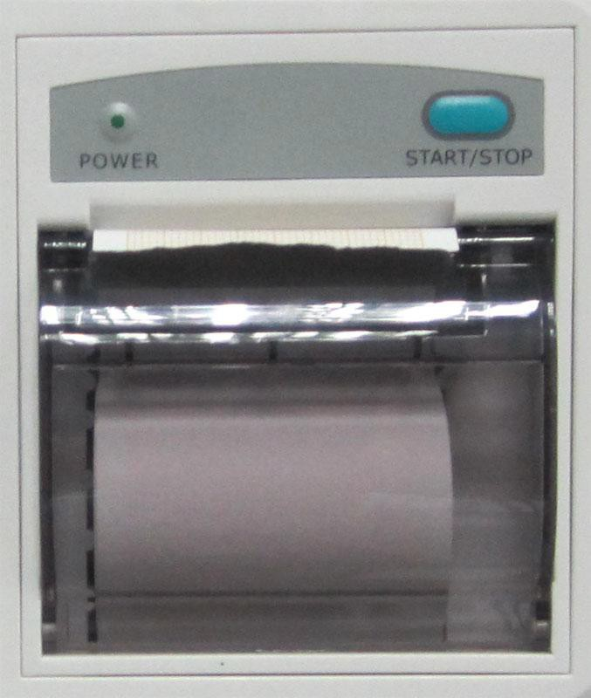

1

3

4

* + - 1. Recording indicator
      2. Paper feeding key: press this key to start or stop feeding recording paper without outputting anything on the paper
      3. Paper outlet
      4. Recorder door

## Performance of the Recorder

* Waveform record is printed at the rate of 12.5mm/s, 25 mm/s or 50 mm/s.
* 48mm wide printout paper.
* It can record up to three waveforms.
* User-selectable real-time recording time and waveform.
* Auto recording interval is set by the user, and the waveform is in accordance with the real time recording.

NOTE:

It is suggested that the user should not use the recorder when the low battery displays, or the monitor may be turned off automatically.

## Starting and Stopping Recording

The monitor provides several types of stripe recording. You can start recording following the procedure below:

|  |  |
| --- | --- |
| **Recording Type** | **Description/Procedure** |
| Continuous real-time recording | Press the **Record** button on the front panel to start the recording. |
| 8-second real-time recording | A maximum of three waveforms can be selected on the **Recorder Setup** menu and can be automatically recorded at the interval preset via **Record Interval** on the **Recorder Setup** menu. The runtime for each wave will be 8 seconds. |
| Trend graph recording | Select **Menu > Review > Trend Graph**, click **Record** to start recording. |
| Trend table recording | Select **Menu > Review > Trend Table**, click **Record** to start recording. |
| NIBP review recording | Select **Menu > Review > NIBP Review**, click **Record** to start recording. |
| Arrhythmia review recording | Select **Menu > Review > ARR Review**, select one arrhythmia alarm and click **Record** to start recording. |
| Alarm review recording | Select **Menu > Review > Alarm Review**, select one alarm and click **Record** to start recording. |
| Drug calculation titration recording | Select **Menu > Common Function > Drug Dose > Titration**, click **Record** to start recording. |
| Hemodynamic Calculation result recording | Select **Menu > Common Function > Hemodynamics**, click **Record** to start recording. |
| 12-lead diagnosis recording | Select **ECG Setup > 12-L Review**, click **Record** to start recording. |
| C.O. measurement recording | Select **CO Option > CO Measure**, click **Record** to start recording. |
| Frozen waveform recording | In the **Freeze** window, click **Record** to start recording. |

To manually stop recording, click **Record** again in the related windows. The recorder will automatically stop recording in the following situations:

* The recording task is finished.
* No paper in the recorder.
* Malfunction stops the recorder from running properly.

NOTE:

You can also use the button on the front panel to manually start or stop recording.

## Recorder Operations and Status Messages

### **Record Paper Requirement**

Only standard thermosensitive record paper can be used: otherwise the recorder may not function, the recording quality may be poor, and the thermosensitive print head may be damaged.

### **Proper Operation**

* When the recorder is working, the record paper goes out steadily. Do not pull the paper outward with force: otherwise the recorder may be damaged.
* Do not operate the recorder without record paper.

### **Paper Out**

When the **Recorder Out Of Paper** alarm is displayed, the recorder cannot start. Please insert record paper properly.

### **Replacing Paper**

1. 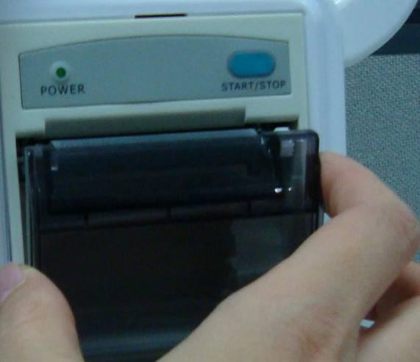 Pull outwards the upper arc part of the recorder casing to release the casing, shown in the following figure.
2. Insert a new roll of paper into the paper cassette, printing side facing upwards.

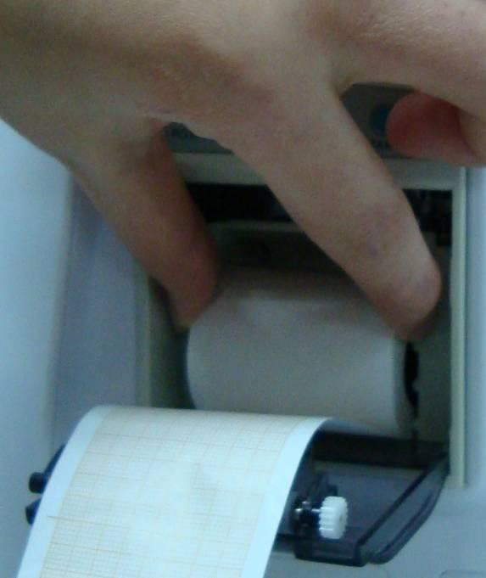

1. Ensure proper position and tidy margin.

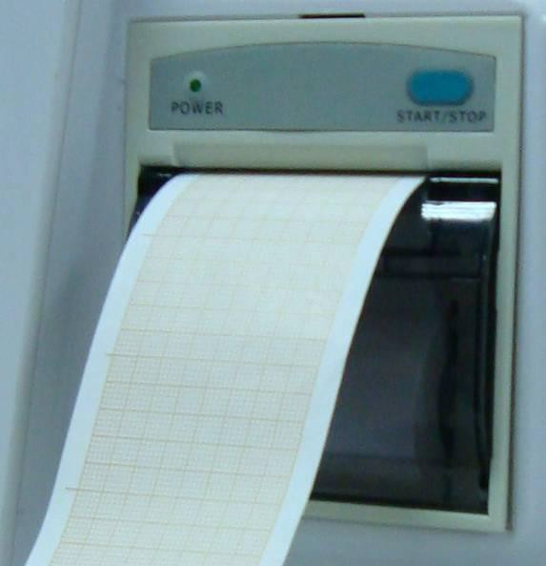

1. Pull about 2cm of the paper out, and close the recorder casing.

NOTE:

Be careful when inserting papers. Avoid damaging the thermo-sensitive print head. Unless when inserting papers or troubleshooting, do not leave the recorder catch open.

### **Removing Paper Jam**

When the recorder functions or sounds improperly, you should open the recorder casing to check for a paper jam. Remove the paper jam in the following way:

* + - * Cut the record paper from the feeding edge.
      * Open the recorder casing.
      * Re-insert the paper.

NOTE:

1. If the monitor is not installed with a recorder, it will indicate **RECORDER SETUP NEEDED** after pressing the **Record** button.
2. Do not touch the thermo-sensitive print head when performing continuous recording.

# Chapter 25 Printing Patient Reports

Patient reports can be printed out by an HP series laser printer connected with the monitor.

NOTE:

Use the printer HP Laser Jet(r) P2055dn which is tested to be compatible with the monitor.

## Printer Settings

You can configure the printer settings on the monitor before printing out patient’s reports. Click the shortcut key  or select **Menu** > **System Setup** > **Printer Setup,** and you can

* Assign a locally networked printer by selecting it from the **Printer** list.
* Search all available printers networked with the monitor by clicking **Search Printer**.
* Enable or disable double side printing by setting **DoubleSide Print** to **On** or **Off**. The reports will be printed out on A4 paper and with single side by default.

NOTE:

1. You need to search all available printers on the local network for the first time you use a networked printer.
2. Make sure the IP of the printer and the IP of the monitor share the same network segment.
3. Do not click **Search Printer** during printing patient reports, or the printer might stop the current print job.
4. When a printer simultaneously received print jobs from several networked monitors, a print job conflict may occur. Check the use status of the monitors and the printers on the same network prior to use and avoid print job conflicts.
5. Make sure there is no lack of paper before printing patient reports, or the alarm

**Printer Unavailable** will be triggered.

## Starting and Stopping Report Printing

You can print out ten types of patient reports following the procedure below:

|  |  |
| --- | --- |
| **Report Type** | **Procedure** |
| Trend graph report | In the **Trend Graph** window, click **Print** to start printing. |
| Trend table report | In the **Trend Table** window, click **Print** to start printing. |
| Alarm waveform report | In the **Alarm Review** window, click **Print** to start printing. |
| NIBP review report | In the **NIBP Review** window, click **Print** to start printing. |
| Arrhythmia review report | In the **ARR Review** window, click **Print** to start printing. |

|  |  |
| --- | --- |
| **Report Type** | **Procedure** |
| 12-lead diagnosis report | In the **Diagnosis Review** window, click **Print** to start printing. |
| 12-lead diagnosis waveform report | In the **12-Lead Diagnosis Waveform Review** window, click **Print** to start printing. |
| Drug calculation titration report | In the **Titration** window, click **Print** to start printing. |
| C.O. measurement report | In the **CO Measure** window, click **Print** to start printing. |
| Hemodynamics report | In the **Hemodynamics** window, click **Print** to start printing. |

To stop the current print job, click **Stop Printing** in the windows mentioned above.

NOTE:

You can only start one print job at a time. Before starting a new print job, you have to stop the current print job or wait until the current print job is completed.

# Chapter 26 Other Functions

## Nurse Call

The monitor provides dedicated nurse call port which is connected to nurse call system through the nurse call cable to perform the nurse call function.

NOTE:

Before using the function of nurse call, check if it is functioning normally.

## Wireless Network

Wi-Fi modules are optional to be configured in the monitors. And you should configure the settings on the monitor following the steps below before connecting the monitor to a wireless network:

1. Select **Menu** > **Maintenance** > **User Maintain**, and input the password **ABC**.
2. In the **User Maintain** menu, select **Network Maintain**.
3. In the **Network Maintain** menu, select **Wi-Fi** from the **Network Type** list. And click **Config** to open the **Wi-Fi Setup** window. The available networks will be listed in this window.
4. Choose a network from the window. You will be prompted to enter the password of that network if a password is required.

If the monitor is successfully connected to the selected network, it will be indicated by the message **Connected**, and the local IP address of the monitor will be displayed in the **Wi-Fi Setup** window. Also, a symbol indicating the networking state will be displayed on the lower portion of the main screen. The meanings of the networking state symbols are explained below:





NOTE:

Wi-Fi disconnected.

Wi-Fi connected. The signal intensity is indicated by the signal bars.

1. Be aware that some network-based functions may be limited for monitors on wireless networks in comparison with those on wired networks.
2. The obstacle may interfere with data transmission and even cause data loss.
3. To make the change of the Bed No. effective when the monitor has been connected to a wireless network, you need to disconnect the wireless connection and then connect it again or reboot the monitor.
4. If the monitor fails to connect to any wireless network or no available wireless network is in the Wireless Setup window, switch the Network Type from Wireless to Wired and then to Wireless again. Then retry to connect to a wireless network.

## Storing Data in the Storage Device

### **Data Stored in the Storage Device**

A single piece of patient data maximally contains the following information:

|  |  |
| --- | --- |
| Patient information | MRN, name, date of birth, date of admission, gender, type, height, weight, blood type, pace, doctor, bed No., department |
| Trend graph and trend table | a maximum of 240 hours |
| NIBP measurement review | 1200 sets |
| Alarm review | 200 sets |
| Arrhythmia event | 200 sets |
| 12-lead diagnosis review | 50 sets |
| Waveforms | 48 hours |

When the single patient data reach the maximum, you can choose to **Keep storing** or **Stop storing** by selecting **Menu**> **Common Function**> **Data Store**> **Data Store Rules**.

If you choose **Keep storing**, as soon as the single patient data is full, the earliest data will be replaced by the latest one.

If you choose **Stop storing**, the monitor will stop data storing and the latest data cannot be stored when the single patient data reach the maximum. For instance, if all the patient data reach the maximum except waveforms, the monitor will continue storing the waveforms until they are full, while other data such as the trend graph, trend table, NIBP measurements, arrhythmia event, alarm event and 12-lead diagnosis will stop storing.

### **Activating/ Deactivating Data Storing**

To activate/ deactivate the data storing function, select **Menu**> **Maintenance**> **User Maintain** >

**Other Setups**, and set **Data Store** to **On** or **Off**.

The monitor will stop storing data in the storage device under the following circumstances:

* No storage devices are selected.
* There is no enough space in the storage device for storing data.
* The removable device is read-only.
* The data storing function is deactivated.
* The monitor is switched off.
* The power supply is off.

### **Selecting a Storage Device**

To configure the storage device, select **Menu**> **Common Function**> **Data Store**> **Storage Medium**, and choose the storage medium from the pop-up list as desired. **Internal Storage Device** and **Removable Device** can be selected.

When you choose **Internal Storage Device** as the storage medium, if configured, the storage device name will automatically become **Internal Storage Device**. You may plug several removable devices into the monitor at the same time, but only one is operative. You can select a removable device as a working one among the plugging devices by selecting **Menu** > **Common Function** > **Data Store** > **Storage Device** and choosing the device name from the list. By default, the first plugged removable device is the working one.

After you configure the appropriate storage device, click exit. If the storage device is successfully starting data storing, the monitor will be indicated by the symbol . If there is no enough space in storage device, or the storage device is read-only/damaged, the symbol  will be displayed.

**CAUTION**

1. Not all the removable devices are compatible with the monitor, Use the removable devices recommended by SINKO.
2. DO not set the read-only switch on the removable device to on when the removable device is inserted in the monitor.

### **Reviewing Data Stored in the Storage Device**

To review data stored in the storage device, select **Menu** > **Review** > **History Patient**. You can choose to review the storage device as desired from the pop-up list. Choose a patient from the list to review the data including patient information, trend graph, trend table, NIBP measurements, arrhythmia event, alarm event, 12-lead diagnosis and waveform.

### **Deleting Data Stored in the Storage Device**

To delete data of one patient, choose the patient from the list after selecting **Menu**> **Review**> **History Patient**, and then click **Delete Current Data** on the **Review** menu. Further confirmation of deletion is required.

To delete data of all patients, select **Menu** > **Review** > **History Patient** and click **Delete All Data**

on the **History Patient Data Review** menu. Further confirmation is required.

### **Exporting Data Stored in the Internal Storage Device**

To export data of one patient from the internal storage device to the removable device, choose the patient from the list after selecting **Menu** > **Review** > **History Patient**, and then click **Export Current Data** on the **Review** menu.

To export data of all patients, select **Menu** > **Review** > **History Patient** and click **Export All Data**

on the **History Patient Data Review** menu.

### **Formatting the Internal Storage Device**

To format the internal storage device, select **Menu**> **Maintenance**> **User Maintain** > **Other Setups** > **Format internal storage device**. Further confirmation is required.

NOTE:

1. As soon as the internal storage device is formatted, all the data will be cleared.
2. You have no need to restart the monitor after formatting is successful. The internal storage device can be identified and loaded automatically.
3. If formatting is failed, try again. Restart the monitor and retry the formatting if formatting is failed repeatedly.

### **Ejecting a Removable Device**

Before unplugging a removable device from the monitor, you need to select **Menu**> **Removable Device** and click **Eject** to uninstall the removable device. In this menu, you can also check the remaining capacity of the storage device.

**CAUTION**

Do not remove the removable device without ejecting it during data storing, or the removable device might be damaged.

# Chapter 27 Using Battery

This monitor can run on battery power, which ensures its uninterrupted operation even when AC power supply is interrupted. The batteries recharge whenever the monitor is connected to the AC power source. During monitoring, if the AC power is interrupted, the monitor will take power from the internal batteries. If the monitor is powered by batteries, the monitor will switch off automatically before the batteries are completely depleted.

## Battery Safety Information

**WARNING**

1. Before using the rechargeable lithium-ion batteries (hereinafter called batteries), be sure to read the user manual and safety precautions thoroughly.
2. The service life of the batteries depends on the service frequency and time. The service life of the batteries is about three years if the batteries are well maintained and stored. The service life of the batteries may shorten if they are used inappropriately.
3. Periodic checks on the battery performance are required. Change the batteries if necessary.
4. Do not connect the positive (+) and negative (-) terminals with metal objects, and do not put the batteries together with metal objects, which can result in short circuits.
5. Do not unplug the batteries when monitoring.
6. Do not heat or throw the batteries into a fire.
7. Do not use, leave the batteries away from fire or other places where temperature may be above 60°C.
8. Do not immerse, throw, or wet the batteries in water/seawater.
9. Do not destroy the batteries: do not pierce the batteries with a sharp object such as a needle; do not hit with a hammer, step on or throw or drop to cause strong shock; do not disassemble or modify the batteries.
10. Use the batteries only in the monitor. Do not solder the leading wire and the battery terminal directly.
11. If liquid leaking from the batteries gets into your eyes, do not rub your eyes. Wash them well with clean water and go to see a doctor immediately. If liquid leaks of the batteries splash onto your skin or clothes, wash well with fresh water immediately.
12. Keep away from fire immediately when leakage or foul odor is detected.
13. Stop using the batteries if abnormal heat, odor, discoloration, deformation or abnormal condition is detected during use, charge, or storage. Keep it away from the monitor.
14. Do not use a battery with serious scar or deformation.

**WARNING**

1. Use the batteries with similar performance, which can extend the service life of the batteries. If one of the two batteries is malfunctioning, it is recommended to change both of the two batteries.
2. When the monitor is running on battery power, do not replace the batteries during monitoring patients; or the monitor will be powered off, which may result in patient injury.
3. Do not place battery in the monitor with the (+) and (-) in the wrong way.

## Battery Power Indicator

The indicator labeled Battery on the front panel of the monitor illuminates in green when the monitor is battery powered and illuminates in yellow when battery is being charged. The indicator is not illuminated when the monitor is not powered or when AC power is applied.

## Battery Status on the Main Screen

Battery status symbols show the status of each battery detected and the combined battery power remaining; also, they tell you which battery compartments they are in, either 1 or 2.

 The battery is in compartment 1.  The battery is in compartment 2. Remaining battery power: 100%.

Remaining battery power: 75% Remaining battery power: 50% Remaining battery power: 25%

Batteries are almost depleted and need to recharge immediately. No battery is installed.

## Checking Battery Performance

The performance of rechargeable batteries may deteriorate over time. Battery maintenance as recommended here can help to slow down this process.

1. Disconnect the patient from the monitor and stop all monitoring and measurement.
2. Switch the monitor power on and charge the battery for more than 6 hours continuously.
3. Disconnect monitor from mains power and let the monitor run until there is no battery power left and the monitor shuts off.
4. The running time of the battery reflects the battery performance.

If the running time is obviously less than the specified time in the specification, please change the battery or contact the service personnel.

## Replacing the Battery

To install or replace the battery, please follow the procedure:

1. To open the battery door, press the battery compartment latch and pull the battery door according to indication beside the button.
2. Remove the battery from the compartment.
3. Insert a new battery into the battery compartment.
4. Close the battery door.

NOTE:

The markers which respectively indicate compartment 1 and compartment 2 on the battery door are corresponding to the symbols  and  on the main screen.

## Recycling the Battery

When the battery no longer holds a charge, it should be replaced. Remove the old battery from the monitor and recycle it properly.

**WARNING**

Do not disassemble batteries, put them into fire or cause them to short circuit. They may ignite, explode or leak, causing personal injury.

## Maintaining the Battery

To prolong the life of the batteries, there is current limitation for using batteries. Therefore, the monitor which runs on battery power may not be powered on under following circumstances:

1. Only one battery is installed.
2. One of the two installed batteries is damaged, or large capacity difference between the two installed batteries exists.
3. Batteries in the monitor are almost empty.

If above-mentioned circumstances are detected, recharge the batteries or use another two batteries with similar capacity.

**CAUTION**

1. Batteries should be conditioned regularly to maintain their useful life.
2. Remove the batteries from the monitor if they are not used for a longer period of time. And recharge the batteries at a minimum of every 6 months when they are stored.
3. Discharge the battery completely once every month.

# Chapter 28 Care and Cleaning

Use only the SINKO-approved substances and methods listed in this chapter to clean or disinfect your equipment. Warranty does not cover damage caused by using unapproved substances or methods.

PT. Sinko Prima Alloy has validated the cleaning and disinfection instructions included in this User Manual. It is the responsibility of the healthcare professional to ensure that the instructions are followed so as to ensure adequate cleaning and disinfection.

## General Points

Keep your monitor, cables and accessories free of dust and dirt. To prevent the device from damage, please follow the procedure:

* Use only recommended cleaning substances and disinfectants listed in this manual. Others may cause damage (not covered by warranty), reduce product lifetime or cause safety hazards.
* Always dilute according to the manufacturer’s instructions.
* Unless otherwise specified, do not immerse any part of the equipment or any accessories in liquid.
* Do not pour liquid onto the system.
* Do not allow liquid to enter the case.
* Never use abrasive material (such as steel wool or silver polish).
* Inspect the monitor and reusable accessories after they are cleaned and disinfected.

**CAUTION**

If you spill liquid on the equipment, battery, or accessories, or they are accidentally immersed in liquid, contact your service personnel or SINKO service engineer.

## Cleaning

If the device or accessory has been in contact with the patient, then cleaning and disinfection is required after every use. If there has been no patient contact and there is no visible contamination, then daily cleaning and disinfection is appropriate.

The validated cleaning agents for cleaning the monitor and reusable accessories are:

* Mild near neutral detergent
* Ethanol (75%)
* Isopropanol (70%)

Cleaning agents should be applied and removed using a clean, soft, non-abrasive cloth or paper towel.

### Cleaning the Monitor

**WARNING**

Before cleaning the monitor, make sure that the monitor is switched off and disconnected from the power line.

To surface-clean the monitor, follow these steps:

1. Switch off the monitor and disconnect it from the power line.
2. Wipe the entire exterior surface, including the screen, of the equipment using a soft cloth dampened with the cleaning solution thoroughly until no visible contaminants remain.
3. Wipe off the cleaning solution with a fresh cloth or towel, dampened with tap water after cleaning until no visible cleaning agent remains.
4. Dry the monitor in a ventilated and cool place.

### Cleaning the Reusable Accessories

##### Cleaning the ECG Cable Assembly

1. Wipe the cable assembly with a soft cloth dampened with the cleaning solution until no visible contaminants remain.
2. Wipe off the cleaning solution with a fresh cloth or towel, dampened with tap water after cleaning until no visible cleaning agent remains.
3. Wipe off with a dry cloth to remove residual moisture.
4. Leave the cable assembly to air dry.

##### Cleaning the Blood Pressure Cuff

Cleaning the Cuff:

1. Take out the air bladder before cleaning.
2. Hand wash the cuff with the cleaning solution; clean the air bladder with a soft cloth dampened with the cleaning solution. until no visible contaminants remain
3. Rinse the cuff and wipe off the cleaning solution with a fresh cloth or towel, dampened with tap water after cleaning until no visible cleaning agent remains.
4. Wipe off with a dry cloth to remove residual moisture
5. Air dry the cuff thoroughly after cleaning.

Replacing the Air Bladder:

After cleaning, replace the air bladder into the cuff following the steps below:

1. Roll the bladder lengthwise and insert it into the cuff from the large opening at one end of the cuff.
2. Thread the hose from within the cuff and out through the small hole at the top of the cuff.
3. Adjust the bladder until it is in position.

##### Cleaning the SpO2 Sensor

1. Wipe the surfaces of the sensor and cable using a soft cloth dampened with the cleaning solution until no visible contaminants remain.
2. Wipe the patient contact area of the sensor with the cotton swab dampened with the cleaning solution. until no visible contaminants remain
3. Wipe off the cleaning solution with a fresh cloth or towel, dampened with tap water after cleaning until no visible cleaning agent remains.
4. Wipe off with a dry cloth to remove residual moisture.
5. Leave the sensor to air dry.

##### Cleaning the IBP Cable/ C.O. Cable/ BIS Patient Interface Cable/ ICG Patient Cable

1. Wipe the cables with a soft cloth dampened with the cleaning solution until no visible contaminants remain.
2. Wipe off the cleaning solution with a fresh cloth or towel, dampened with tap water after cleaning until no visible cleaning agent remains.
3. Wipe off with a dry cloth to remove residual moisture.
4. Leave the cables to air dry.

##### Cleaning the TEMP Sensor

1. Wipe the patient contact area with a soft cloth dampened with the cleaning solution until no visible contaminants remain.
2. Wipe off the cleaning solution with a fresh cloth or towel, dampened with tap water after cleaning until no visible cleaning agent remains.
3. Wipe off with a dry cloth to remove residual moisture.
4. Leave the sensor to air dry.

## Disinfection

For devices or accessories that have been in contact mucosal surface, High Level disinfection must occur, for all other accessories, low level disinfection is appropriate. Clean the monitor and reusable accessories before they are disinfected. The validated disinfectants for cleaning the monitor and reusable accessories are:

* Ethanol (75%)
* Isopropanol (70%)
* Cidex OPA (High level disinfection of intracavitary temperature probe only)

If Ethanol or Isopropanol is used for both cleaning and disinfecting, then a new cloth is required to be used for the disinfection step.

**WARNING**

The monitor and reusable accessories shall be disinfected to avoid patient cross infection.

### Disinfecting the Monitor

**WARNING**

Before disinfecting the monitor, make sure that the monitor is switched off and disconnected from the power line.

To disinfect the monitor, follow these steps:

1. Switch off the monitor and disconnect it from the power line.
2. Wipe the display screen using a soft, clean cloth dampened with the disinfectant solution.
3. Wipe the exterior surface of the equipment using a soft cloth dampened with the disinfectant solution.
4. Wipe off the disinfectant solution with a dry cloth after disinfection if necessary.
5. Dry the monitor for at least 30 minutes in a ventilated and cool place.

### Disinfecting the Reusable Accessories

##### Disinfecting the ECG Cable Assembly

1. Wipe the cable assembly with a soft cloth dampened with the disinfectant solution.
2. Wipe off the disinfectant solution with a dry cloth after disinfection.
3. Leave the cable assembly to air dry for at least 30 minutes.

##### Disinfecting the Blood Pressure Cuff

Disinfecting the Cuff:

1. Take out the air bladder before disinfection.
2. Wipe the cuff and the air bladder with a soft cloth dampened with the disinfectant solution.
3. Leave the cuff and air bladder to air dry for at least 30 minutes.

Replacing the Air Bladder:

After disinfection, replace the air bladder into the cuff. Refer to Section *28.2.2.2* for more information.

NOTE:

Prolonged use of disinfectant may cause discoloration of the cuff.

##### Disinfecting the SpO2 Sensor

1. Wipe the surfaces of the sensor and cable using a soft cloth dampened with the disinfection solution.
2. Wipe the patient contact area of the sensor with the cotton swab dampened with the disinfection solution.
3. Wipe off the disinfection solution with a dry cloth after disinfection.
4. Leave the sensor to air dry for at least 30 minutes.

##### Disinfecting the IBP Cable/ C.O. Cable/ BIS Patient Interface Cable/ ICG Patient Cable

1. Wipe the cables with a soft cloth dampened with the disinfectant solution.
2. Wipe off the disinfectant solution with a dry cloth after disinfection.
3. Leave the cables to air dry for at least 30 minutes.

##### Disinfecting the TEMP sensor

The intracavitary TEMP sensors should be reprocessed by high-level disinfection before and after use on each new patient. Cidex OPA is the validated agent for high level disinfection. Refer to the instructions of the disinfectant for the methods of disinfection. High level disinfection has been validated with a 12 minutes soak. Rinse and dry according to the labeled instructions of Cidex OPA. Do not dampen the sensor connector.

For the skin TEMP sensors, disinfect them as follows using ethanol or isopropanol only:

1. Wipe the patient contact area with a soft cloth dampened with the disinfectant solution (ethanol or isopropanol).
2. Wipe off the disinfectant solution with a dry cloth after disinfection.
3. Leave the sensor to air dry.

## Cleaning and Disinfecting Other Accessories

For cleaning and disinfecting other accessories, refer to the instructions delivered with the accessories. If the accessories are not accompanied by instructions, refer to this manual for the methods of cleaning and disinfecting the monitor.

# Chapter 29 Maintenance

**WARNING**

1. Failure on the part of the responsible individual hospital or institution employing the use of this equipment to implement a satisfactory maintenance schedule may cause undue equipment failure and possible health hazards.
2. If you discover a problem with any of the equipment, contact your service personnel, or your authorized supplier.

## Inspecting

The overall check of the monitor, including the safety check, should be performed only by qualified personnel every 24 months, and each time after fix up.

The following items should be checked:

* + - If the environment condition and power supply meet requirement.
    - If the power supply cord has damage and insulativity meets requirement.
    - If the device and accessories have damage.
    - Specified accessories.
    - If the alarm system can work properly.
    - If the recorder can work properly and the paper meets the requirement.
    - Battery performance
    - If all monitoring functions are in good conditions.
    - If the grounding resistance and leakage current meet requirement.

If any damage or abnormality is found, please don’t use the monitor and contact local Customer Service Center.

## Maintenance Task and Test Schedule

Maintenance shall be carried out at least once every two years, or as specified by local laws. The following tasks are for SINKO-qualified service professionals only. Contact an SINKO-qualified service provider if your monitor needs a safety or performance test. Clean and disinfect equipment to decontaminate it before testing or maintaining it.

|  |  |
| --- | --- |
| **Maintenance and Test Schedule** | **Frequency** |
| Safety checks. Selected tests on the basis of IEC60601-1 | At least once every two years, or as needed, after any repairs where the power supply is removed or replaced, or if the monitor has been dropped. |
| Check ECG synchronization of the monitor and defibrillator | At least once every two years, or as needed. |

|  |  |
| --- | --- |
| **Maintenance and Test Schedule** | **Frequency** |
| NIBP Leakage Inspection | At least once every two years, or as specified by local laws. |
| NIBP Pressure Calibration | At least once every two years, or as specified by local laws. |
| NIBP Calibration | At least once every two years, or as specified by local laws. |
| AG Calibration | If you suspect the measurement values are incorrect and need to calibrate, please contact the manufacturer. |

# Chapter 30 Warranty and Service

## Warranty

SINKO warrants that SINKO’s products meet the labeled specifications of the products and will be free from defects in materials and workmanship that occur within warranty period.

The warranty is void in cases of:

1. damage caused by mishandling during shipping.
2. subsequent damage caused by improper use or maintenance.
3. damage caused by alteration or repair by anyone not authorized by SINKO.
4. damage caused by accidents.
5. replacement or removal of serial number label and manufacture label.

If a product covered by this warranty is determined to be defective because of defective materials, components, or workmanship, and the warranty claim is made within the warranty period, SINKO will, at its discretion, repair or replace the defective part(s) free of charge. SINKO will not provide a substitute product for use when the defective product is being repaired.

## Contact Information

If you have any question about maintenance, technical specifications or malfunctions of devices, contact your local distributor.

Alternatively, you can send an email to SINKO service department at: sinkoprima@gmail.com

# 

# Chapter 31 Accessories

You can order accessories from SINKO supplies at www.elitech.id or consult your local SINKO representative for details.

**WARNING**

1. Never reuse disposable transducers, sensors, accessories and their casing that are intended for single use; or only use them on a single patient. Reuse may compromise device functionality and system performance and cause a potential hazard.
2. Use only SINKO-approved accessories. Using non-SINKO-approved accessories may compromise device functionality and system performance and cause a potential hazard. It is not recommended to use accessories supplied by SINKO with patient monitors by other manufacturers.
3. Do not use a sterilized accessory if its casing is damaged.

NOTE:

Transducers and sensors have a limited shelf life. Refer to the package labeling.

The following cables may not all be available in all countries. Please check availability with your local SINKO supplier.

## ECG Accessories

|  |  |
| --- | --- |
| **Part Number** | **Accessories** |
| 01.57.471226 | ECG trunk cable, 5-lead, 12pin, ESU, AHA/IEC, 2.7m, reusable |
| 01.57.471227 | ECG trunk cable, 5-lead, 12pin, ESU, AHA/IEC, 5.0m, reusable |
| 01.57.471228 | ECG trunk cable, 5-lead, 12pin, Defib, AHA/IEC, 2.7m, reusable |
| 01.57.471229 | ECG trunk cable, 5-lead, 12pin, Defib, AHA/IEC, 5.0m, reusable |
| 01.13.036620 | ECG limb wires, 5-lead, clip, AHA, 1.0m & 1.6m, reusable |
| 01.13.036621 | ECG limb wires, 5-lead, clip, AHA, 1.0m, reusable |
| 01.13.036622 | ECG limb wires, 5-lead, snap, AHA, 1.0&1.6m, reusable |
| 01.13.036623 | ECG limb wires, 5-lead, snap, AHA, 1.0m, reusable |
| 01.13.036624 | ECG limb wires, 5-lead, clip, IEC, 1.0m&1.6m, reusable |
| 01.13.036625 | ECG limb wires, 5-lead, clip, IEC, 1.0m, reusable |
| 01.13.036626 | ECG limb wires, 5-lead, snap, IEC, 1.0&1.6m, reusable |
| 01.13.036627 | ECG limb wires, 5-lead, snap, IEC, 1.0m, reusable |
| 01.57.471072 | ECG trunk cable, 10-lead, Defibrillator-Proof, AHA, 2.6m, reusable |

|  |  |
| --- | --- |
| **Part Number** | **Accessories** |
| 01.57.471168 | ECG trunk cable, 10-lead, Defibrillator-Proof, IEC, 2.6m, reusable |
| 01.57.109101 | ECG limb wires, 10-lead, snap, AHA, 0.9m, reusable |
| 01.57.040203 | ECG limb wires, 10-lead, snap, IEC, 0.9m, reusable |
| 01.57.471169 | ECG limb wires, 10-lead, clip, AHA, 0.9m, reusable |
| 01.57.471163 | ECG limb wires, 10-lead, clip, IEC, 0.9m, reusable |
| 01.57.471167 | ECG trunk cable, 5-lead, Defibrillator-Proof, IEC, 2.6m,reusable |
| 01.57.040207 | ECG limb wires, 5-lead, snap, IEC, 0.9m,reusable |
| 01.57.471164 | ECG trunk cable, 3-lead, Defibrillator-Proof, AHA, 2.6m, reusable |
| 01.57.471171 | ECG trunk cable, 3-lead, Defibrillator-Proof, IEC, 2.6m, reusable |
| 01.57.471165 | ECG limb cable, 3-lead, clip, AHA, 0.9m, reusable |
| 01.57.471025 | ECG limb cable, 3-lead, clip, IEC, 0.9m, reusable |
| 01.57.471276 | ECG CONDUCTIVE ADHESIVE ELECTRODES, TYCO KENDALL MEDI TRACE 210, 10PCS/package |
| 01.57.471056 | Adult Disposable Adhesive Electrodes, TYCO H99SG,30PCS/ package, CE |
| 01.57.471060 | Adult Disposable Adhesive Electrodes, TYCO Medi-Trace 200, 100PCS/ package, FDA |
| 01.57.471057 | Children/ Neonatal Disposable Adhesive Electrodes, TYCO H124SG, 50PCS/package, CE |
| 01.57.471194 | ECG trunk cable, 3-lead,12pin, Defibrillator-Proof, AHA/IEC,2.9m,DIN,reusable |
| 01.57.471195 | ECG limb cable, 3-lead, snap, IEC, 0.63m, DIN, reusable |
| 01.57.471196 | ECG limb cable, 3-lead, snap, AHA, 0.63m, DIN, reusable |
| 01.57.471197 | ECG limb cable, 3-lead,clip,IEC,0.63m,DIN,reusable |
| 01.57.471198 | ECG limb cable, 3-lead,clip,AHA,0.63m,DIN,reusable |
| 01.57.471377 | ECG cable, 3-lead, clip, 12pin, Defibrillator-Proof, IEC, 3.4m, reusable |
| 01.57.471378 | ECG cable, 3-lead, clip, 12pin, Defibrillator-Proof, AHA, 3.4m, reusable |
| 01.57.471379 | ECG cable, 3-lead, snap, 12pin, Defibrillator-Proof, IEC, 3.4m, reusable |

|  |  |
| --- | --- |
| **Part Number** | **Accessories** |
| 01.57.471380 | ECG cable, 3-lead, snap, 12pin, Defibrillator-Proof, AHA, 3.4m, reusable |
| 01.57.471385 | ECG cable, 3-lead, clip, 12pin, ESU, IEC, 3.4m, reusable |
| 01.57.471386 | ECG cable, 3-lead, clip, 12pin, ESU, AHA, 3.4m, reusable |
| 01.57.471387 | ECG cable, 3-lead, snap, 12pin, ESU, IEC, 3.4m, reusable |
| 01.57.471388 | ECG cable, 3-lead, snap, 12pin, ESU, AHA, 3.4m, reusable |

## SpO2 Accessories

|  |  |
| --- | --- |
| **Part Number** | **Accessories** |
| **For SINKO Module** | |
| 02.01.210120 | SINKO SH1 Adult Reusable SpO2 Sensor (DB9) (Only compatible with SINKO SpO2 module and SINKO SpO2 extension cable ), 1m (finger type, patient size >40kg) |
| 02.01.110492 | SINKO SH3 Neonate Wrap SpO2 Sensor (DB9) (Only compatible with SINKO SpO2 module and SINKO SpO2 extension cable), 1m |
| 02.01.210122 | SINKO SH4 Adult Silicone Soft-tip SpO2 Sensor (DB9) (Immersion Disinfection) (Only compatible with SINKO SpO2 module and SINKO SpO2 extension cable), 1m (finger type, patient size>50kg) |
| 02.01.210121 | SINKO SH5 pediatric Silicone Soft-tip SpO2 Sensor (DB9) (Only compatible with SINKO SpO2 module and SINKO SpO2 extension cable), 1m (finger type, patient size: 10kg to 50kg) |
| 01.57.471068 | SINKO SpO2 Extension cable(DB9 to 7pin, 2m, TPU) |
| 01.57.040196 | Adult disposable SpO2 sensor |
| 01.57.040197 | Pediatric Disposable SpO2 sensor |
| 01.57.040198 | Infant Disposable SpO2 sensor |
| 01.57.040199 | Neonatal Disposable SpO2 Sensor |
| **For Nellcor Module** | |
| 01.15.30043 | Nellcor Reusable Adult SpO2 Sensor (DS-100A OxiMax) (forefinger, for patient over 30kg) |
| 01.15.40096 | Nellcor Reusable Adult/Neonate SpO2 Sensor (OXI-A/N OxiMax) (forefinger or foot) |
| 01.57.471069 | Nellcor SpO2 Extension cable (Compatible with Nellcor OXI-Max SpO2 module and Nellcor sensor) |

## NIBP Accessories

|  |  |
| --- | --- |
| **Part Number** | **Accessories** |
| **For SINKO Module** | |
| 01.57.471157 | NIBP cuff, neonatal #1, 3-6cm, for single patient use |
| 01.57.471158 | NIBP cuff, neonatal #2, 4-8cm, for single patient use |
| 01.57.471159 | NIBP cuff, neonatal #3, 6-11cm, for single patient use |
| 01.57.471160 | NIBP cuff, neonatal #4, 7-13cm, for single patient use |
| 01.57.471161 | NIBP cuff, neonatal #5, 8-15cm, for single patient use |
| 01.57.471326 | Reusable blood pressure cuff, infant, E5 |
| 01.57.471327 | Reusable blood pressure cuff, small, child, E6 |
| 01.57.471328 | Reusable blood pressure cuff, child, E7 |
| 01.57.471329 | Reusable blood pressure cuff, small, adult, E8 |
| 01.57.471330 | Reusable blood pressure cuff, adult, E9 |
| 01.57.471331 | Reusable blood pressure cuff, large, adult, E10 |
| 01.59.473007 | NIBP Tube (3m) with connector |
| 01.57.471323 | NIBP cuff, neonatal, 10cm-15cm, reusable |
| 01.57.471324 | NIBP cuff, neonatal, 6cm-11cm, reusable |
| 01.59.473006 | NIBP tube for neonatal cuff (only compatible with neonatal cuff) |
| **For Omron Module** | |
| 01.59.102099 | OMRON NIBP tube (3.5m) /cuff hose(NO.1) length 3.5m, CE |
| 01.57.471457 | OMRON HXA-GCUFF-SSLA, adult/pediatric, arm circumference  limit: 12 -18cm, reusable, CE |
| 01.57.471458 | OMRON HXA-GCUFF-SLA, adult/pediatric, arm circumference limit: 17 -22cm, reusable, CE |
| 01.57.471459 | OMRON HXA-GCUFF-MLA, adult/pediatric, arm circumference limit: 22 -32cm, reusable, CE |
| 01.57.471460 | OMRON HXA-GCUFF-LLA, adult/pediatric, arm circumference limit: 32 -42cm, reusable, CE |
| 01.57.471081 | OMRON neonatal disposable cuff/ cuff (NO.10) arm 3.5-6cm, width 2.5cm, CE |
| 01.57.471082 | OMRON neonatal disposable cuff/ cuff (NO.11) arm5-7.5cm, width 3cm, CE |
| 01.57.471083 | OMRON neonatal disposable cuff / cuff (NO.12) arm7.5-10.5cm, width 4cm, CE |
| 01.57.471084 | OMRON neonatal disposable cuff/ cuff (NO.13) arm 8.5-13cm, width 5cm, CE |
| 01.59.473003 | Connecting tube for neonatal cuff (only compatible with neonatal disposable and NIBP tube)/ cuff hose (NO.3) length 3.5m, CE |

|  |  |
| --- | --- |
| **Part Number** | **Accessories** |
| **For SunTech Module** | |
| 01.57.471157 | Neonatal #1, 3-6cm, Disposable |
| 01.57.471158 | Neonatal #2, 4-8cm, Disposable |
| 01.57.471159 | Neonatal #3, 6-11cm, Disposable |
| 01.57.471160 | Neonatal #4, 7-13cm, Disposable |
| 01.57.471161 | Neonatal #5, 8-15cm, Disposable |
| 01.57.471494 | APC Cuff, Child (Green), Range: 12 – 19 cm |
| 01.57.471495 | APC Cuff, Small Adult (Royal Blue), Range: 17 – 25 cm |
| 01.57.471496 | APC Cuff, Adult (Navy Blue), Range: 23 – 33 cm |
| 01.57.471497 | APC Cuff, Large Adult (Burgundy), Range: 31 – 40 cm |
| 01.57.000974 | One piece cuff, Child |
| 01.57.000976 | One piece cuff, Small Adult |
| 01.57.000977 | One piece cuff, Adult |
| 01.57.000978 | One piece cuff, Large Adult |

## TEMP Accessories

|  |  |
| --- | --- |
| **Part Number** | **Accessories** |
| 01.15.040253 | 2pin Neonatal/pediatric Skin Temperature Probe (2.252K) |
| 01.15.040254 | 2pin Neonatal/pediatric Rectal / Oral Temperature Probe (2.252K) |
| 01.15.040255 | 2pin Neonatal/pediatric Skin Temperature Probe (10K） |
| 01.15.040256 | 2pin Neonatal/pediatric Rectal / Oral Temperature Probe (10K) |
| 01.15.040226 | 2P Skin Temperature Probe（2.252K） |
| 01.15.040227 | 2P Rectal / Oral Temperature Probe（2.252K） |
| 01.15.040225 | 2P Skin Temperature Probe（10K） |
| 01.15.040228 | 2P Rectal / Oral Temperature Probe（10K） |

## IBP Accessories

|  |  |
| --- | --- |
| **Part Number** | **Accessories** |
| 01.57.471070 | Pressure transducer interface cable, BD |
| 01.57.471172 | Pressure transducer interface cable, EDWARD |
| 01.57.471173 | Pressure transducer interface cable, HOSPIRA |
| 01.57.471166 | Pressure transducer interface cable, UTAH |
| 01.57.40121 | Disposable pressure transducer kit (BD DTX TM Plus DT-4812  682000) |

|  |  |
| --- | --- |
| **Part Number** | **Accessories** |
| 01.57.471281 | 12Pin ICP transducer interface cable (compatible with Gaeltec ICT/B  intracranial pressure transducer) |

## CO2 Accessories

|  |  |
| --- | --- |
| **Part Number** | **Accessories** |
| **For SINKO Module** | |
| 02.01.210520 | Dewatering cup (single patient use, adult/ pediatric 10ml) |
| 01.57.471275 | CO2 sampling line with male Luer lock, 2.0m |
| 01.57.471282 | All purpose sampling cannula without filter (non sterile), size: adult |
| 01.57.471283 | All purpose sampling cannula without filter (non sterile), size: infant |
| 01.57.471284 | All purpose sampling cannula without filter (non sterile), size: neonate |
| 01.57.471285 | Duo flow O2+CO2 sampling cannula (non sterile), size: adult |
| 01.57.471286 | Duo flow O2+CO2 sampling cannula (non sterile), size: child |
| 01.57.471287 | Capnomask O2+CO2 sampling cannula (non sterile), size: adult |
| 01.57.471288 | Capnomask O2+CO2 sampling cannula (non sterile), size: child |
| **For Respironics Module** | |
| 01.57.471085 | CO2 module extension cable |
| 02.08.078166 | LoFloTM module mounting bracket (Respironics 1027730) |
| 01.57.078139 | Disposable CO2 nasal cannula, adult (Respironics 3468ADU-00) |
| 01.57.078151 | Adult/ pediatric airway adapter kit with dehumidification tubing |
| 01.57.078154 | Disposable sampling line kit with dehumidification tubing (Respironics 3475-00) |
| 01.57.471019 | Reuseable adult/ pediatric airway adapter (7007-01) |
| 01.57.471020 | Reuseable neonate/ infant airway adapter (7053-01) |
| 01.59.078155 | Disposable adult airway adapter (6063-00) |
| 01.59.078156 | Disposable neonatal (infant/ pediatric) airway adapter (6312-00) |
| 01.57.078142 | Adult nasal CO2 with O2 delivery sampling cannula |
| 01.57.078143 | Pediatric nasal CO2 with O2 delivery sampling cannula |
| 01.57.078144 | Infant nasal CO2 with O2 delivery sampling cannula |
| 01.57.101019 | Adult nasal/ oral CO2 sampling cannula |
| 01.57.101020 | Pediatric nasal/ oral CO2 sampling cannula |
| 01.57.101021 | Adult nasal/ oral CO2 with O2 delivery sampling cannula |
| 01.12.031598 | Adult/ pediatric airway adapter kit |
| 01.57.078140 | Disposable CO2 nasal cannula, pediatric (Respironics 3468PED-00) |

|  |  |
| --- | --- |
| **Part Number** | **Accessories** |
| 01.57.078141 | Disposable CO2 nasal cannula, infant (Respironics 3468INF-00) |
| 01.57.078152 | Pediatric/ infant airway adapter kit with dehumidification tubing |
| 01.57.078158 | Pediatric mask/ mainstream 9960PED-00 |
| 01.57.078159 | Adult standard mask/ mainstream 9960STD-00 |
| 01.57.078160 | Adult large mask/ mainstream 9960STD-00 |
| 01.57.078161 | Band/ mainstream 8751-00 |
| 01.12.078162 | bayonet socket |
| 01.15.040143 | Respironics CAPNOSTAT 5 EtCO2 (mainstream) module |

## C.O. Accessories

|  |  |
| --- | --- |
| **Part Number** | **Accessories** |
| 01.57.471071 | Cardiac output cable |
| 01.13.40119 | In-line injection temperature probe (BD 684056-SP4042) |
| 01.57.40120 | In-line injection temperature probe housing (BD 680006-SP5045) |
| 01.57.100175 | Control syringe (Medex MA387) |

## AG Accessories

|  |  |
| --- | --- |
| **Part Number** | **Accessories** |
| **For Masimo Module** | |
| 01.57.471086 | GAS module extension cable |
| 02.08.208006 | IRMA™ mainstream analyzers, IRMA AX+, CAT. No. 200601 (CO2,  N2O, 5AA, AAID) |
| 01.57.471043 | Nomoline with Luer lock connector, 25pieces/ box, CAT.NO. 108210 |
| 01.57.471042 | IRMA airway adapter, adult/ pediatric, 25pieces/box, CAT.NO. 106220 |
| 01.57.471189 | Nomoline adapter Cat no: 108220, sampling line with female Luer lock  connector, adult/ pediatric/ infant, 0.15 m. |
| 01.57.471190 | Nomoline airway adapter set. Cat no: 108230, sampling line with  straight airway adapter, single-patient use, adult/ pediatric, 2.0 m |
| 01.57.471191 | Nomo extension Cat no: 108240, sampling line with male Luer lock connector, 2.0m, connects to Nomoline adapter, Cat no 108220,  multi-patient use. |
| 01.57.471192 | T-adapter Cat no: 108250, airway adapter with female Luer lock connector, adult/ pediatric, connects to Nomoline Cat no 108210 and  Nomo extension, Cat no 108240 |

|  |  |
| --- | --- |
| **Part Number** | **Accessories** |
| **For Dräger Minimodule** | |
| 01.57.471489 | Water Trap (Set of 12) |
| 01.57.471492 | Sample line (Set of 10) |

## BIS Accessories

|  |  |
| --- | --- |
| **Part Number** | **Accessories** |
| 01.57.471318 | BIS™ Quatro sensor |
| 01.57.471319 | BIS™ Extend sensor |
| 01.57.471320 | BIS™ Pediatric sensor |
| 01.13.036652 | BISx adapter cable |
| 01.57.471317 | BISx device |

## RM Accessories

|  |  |
| --- | --- |
| **Part Number** | **Accessories** |
| 01.57.471239 | Pediatric/adult flow sensor, color: clear |
| 01.57.471240 | Neonatal flow sensor, color: purple |
| 01.57.471241 | Pediatric/adult combined CO2/ flow sensor, color: clear |
| 01.57.471242 | Pediatric combined CO2/ flow sensor, color: green |
| 01.57.471243 | Neonatal combined CO2/ flow sensor, color: purple |

## ICG Accessories

|  |  |
| --- | --- |
| **Part Number** | **Accessories** |
| 01.57.471333 | ICG patient cable |
| 01.57.471334 | ICG electrodes |

## Other Accessories

|  |  |
| --- | --- |
| **Part Number** | **Accessories** |
| 22.08.208017 | XM module (3-lead and 5-lead ECG, RESP, SpO2, TEMP, NIBP) |
| 22.08.208047 | XM module (3-lead and 5-lead ECG, RESP, SpO2, TEMP, NIBP, IBP) |
| 22.08.208048 | XM module (3-lead, 5-lead and 12-lead ECG, RESP, SpO2, TEMP,  NIBP) |

|  |  |
| --- | --- |
| **Part Number** | **Accessories** |
| 22.08.208049 | XM module (3-lead, 5-lead and 12-lead ECG, RESP, SpO2, TEMP,  NIBP, IBP) |
| 83.60.260299 | XM module (3-lead, 5-lead and 12-lead ECG, RESP, SpO2, TEMP,  NIBP, SunTech NIBP, Nellcor SpO2) |
| 83.60.260255 | XM module (3-lead, 5-lead and 12-lead ECG, RESP, SpO2, TEMP,  NIBP, SunTech NIBP, Nellcor SpO2, IBP) |
| 22.08.208020 | V-CO2 module (sidestream, Respironics) |
| 22.08.208021 | V-CO2 module (mainstream, Respironics) |
| 03.48.348002 | V-CO2 module (sidestream, SINKO) |
| 22.08.208022 | V-AG module (sidestream) |
| 22.08.208023 | V-AG module (mainstream) |
| 22.08.208029 | V-C.O. module |
| 22.08.208030 | Parameter amplifier mainframe |
| 22.08.208031 | V-IBP module |
| 22.08.208051 | V-SpO2 module (Nellcor Module) |
| 22.08.208065 | V-NIBP module (Omron Module)* |
| 22.08.208073 | V-BIS module |
| 03.48.348003 | V-RM module |
| 03.48.348001 | V-ICG module |
| 01.57.78035 | Recording paper |
| 01.13.36014 | Power Cable(IEC Standard) 220V |
| 01.13.036106 | Power Cable(AHA Standard) |
| 01.21.064143 | Rechargeable Lithium-Ion battery |
| 01.13.114214 | SE-1 ground cable |
| 01.18.052245 | Netac USB flash disk (U208, 4G, USB2.0) |

# A Product Specifications

NOTE:

The performance of the equipment with ☆ mark is determined to be essential performance.

## Classification

|  |  |  |
| --- | --- | --- |
| Anti-electroshock Type | Class I equipment and internal powered equipment | |
| Anti-electroshock Degree | ECG, RESP, TEMP, IBP, C.O.  SpO2, NIBP, CO2, AG, BIS, RM, ICG | CF  BF |
| Ingress Protection | IPX1 (protected against vertically falling water drops) | |
| Working System | Continuous operation equipment | |
| Compliant with Standards | IEC 60601-1: 2005; EN 60601-1: 2006; | |
|  | IEC 60601-1-2: 2007; EN 60601-1-2: 2007; | |
|  | IEC60601-2-49: 2011 | |

## Physical Specifications

|  |  |  |  |
| --- | --- | --- | --- |
| **Product** | **Dimension** | **Max Weight** | **Comments** |
| PM Pro 1 | 333 mm (L) × 211 mm (W) × 289 mm (H) | <6.2 kg | Including XM module; without options |

|  |  |  |  |
| --- | --- | --- | --- |
| **Product** | **Dimension** | **Max Weight** | **Comments** |
| XM module | 188 mm (L) × 87.5 mm (W)× 120 mm (H) | <1 kg | Without accessories |
| V-IBP module | 134 mm (L) × 43 mm (W)× 104 mm (H) | <0.2 kg | Without accessories |
| V-C.O. module | 134 mm (L) × 43 mm (W)× 104 mm (H) | <0.2 kg | Without accessories |
| V-CO2 module (mainstream, Respironics) | 134 mm (L) × 43 mm (W)× 104 mm (H) | <0.2 kg | Without accessories |
| V-CO2 module (sidestream, Respironics) | 134 mm (L) × 86 mm (W)× 104 mm (H) | <0.65 kg | Without accessories |
| V-CO2 module (sidestream, SINKO) | 134 mm (L) × 86 mm (W)× 104 mm (H) | <0.65 kg | Without accessories |
| V-AG module (Masimo mainstream) | 134 mm (L) × 43 mm (W)× 104 mm (H) | <0.2 kg | Without accessories |
| V-AG module (Masimo sidestream) | 134 mm (L) × 86 mm (W)× 104 mm (H) | <0.65 kg | Without accessories |
| V-AG module (Dräger Minimodule) | 134 mm (L) × 86 mm (W)× 104 mm (H) | <1.2 kg | Without accessories |

|  |  |  |  |
| --- | --- | --- | --- |
| **Product** | **Dimension** | **Max Weight** | **Comments** |
| V-SpO2 module | 134 mm (L) × 43 mm (W)× 104 mm (H) | <0.2 kg | Without accessories |
| V-NIBP module (Omron) | 134 mm (L) × 86 mm (W)× 104 mm (H) | <0.65 kg | Without accessories |
| V-BIS module | 134 mm (L) × 43 mm (W)× 104 mm (H) | <0.2 kg | Without accessories |
| V-RM module | 134 mm (L) × 86 mm (W)× 104 mm (H) | <0.65 kg | Without accessories |
| V-ICG module | 134 mm (L) × 43 mm (W)× 104 mm (H) | <0.3 kg | Without accessories |
| PAM | 503 mm (L) × 169 mm (W)× 148 mm (H) | <2.5 kg | Without accessories |

## Environmental Specifications

The monitor may not meet the performance specifications given here if stored or used outside the specified temperature and humidity ranges.

When the monitor and related products have differing environmental specifications, the effective range for the combined products is that range which is common to the specifications for all products.

|  |  |
| --- | --- |
| **Main unit, PAM, XM module, V-SpO2 module, V-IBP module, V-C.O. module, V-BIS module, V-ICG module, V-CO2 module (sidestream, SINKO), Recorder** | |
| **Temperature** | |
| Working | +0°C to +40°C |
| Transport and Storage | -20°C to +55°C |
| **Humidity** | |
| Working | 15% to 95% (non-condensing) |
| Transport and Storage | 15% to 95% (non-condensing) |
| **Altitude** | |

|  |  |
| --- | --- |
| Working | 860 hPa to 1060 hPa |
| Transport and Storage | 700 hPa to 1060 hPa |

|  |  |
| --- | --- |
| **V-CO2 module (sidestream, Respironics)** | |
| **Temperature** | |
| Working | +5°C to +35°C |
| Transport and Storage | -20°C to +55°C |
| **Humidity** | |
| Working | 10% to 90% (non-condensing) |
| Transport and Storage | 10% to 90% (non-condensing) |
| **Altitude** | |
| Working | 530 hPa to 1066 hPa |
| Transport and Storage | 530 hPa to 1066 hPa |

|  |  |
| --- | --- |
| **V-CO2 module (mainstream, Respironics)** | |
| **Temperature** | |
| Working | +0°C to +40°C |
| Transport and Storage | -20°C to +55°C |
| **Humidity** | |
| Working | 10% to 90% (non-condensing) |
| Transport and Storage | 10% to 90% (non-condensing) |
| **Altitude** | |
| Working | 530 hPa to 1066 hPa |
| Transport and Storage | 530 hPa to 1066 hPa |

|  |  |
| --- | --- |
| **V-AG module (Masimo sidestream)** | |
| **Temperature** | |
| Working | +5°C to +40°C |
| Transport and Storage | -20°C to +55°C |
| **Humidity** | |
| Working | 10% to 95% (non-condensing) |

|  |  |
| --- | --- |
| Transport and Storage | 10% to 95% (non-condensing) |
| **Altitude** | |
| Working | 525 hPa to 1200 hPa |
| Transport and Storage | 500 hPa to 1200 hPa |

|  |  |
| --- | --- |
| **V-AG module (Masimo mainstream)** | |
| **Temperature** | |
| Working | +10°C to +40°C |
| Transport and Storage | -20°C to +55°C |
| **Humidity** | |
| Working | 10% to 95% (non-condensing) |
| Transport and Storage | 10% to 95% (non-condensing) |
| **Altitude** | |
| Working | 525 hPa to 1200 hPa |
| Transport and Storage | 500 hPa to 1200 hPa |

|  |  |
| --- | --- |
| **V-AG module (Dräger Minimodule )** | |
| **Temperature** | |
| Working | +10°C to +40°C |
| Transport and Storage | -20°C to +55°C |
| **Humidity** | |
| Working | 15% to 95% (non-condensing) |
| Transport and Storage | 5% to 95% (non-condensing) |
| **Altitude** | |
| Working | 860 hPa ~ 1060 hPa |
| Transport and Storage | 500 hPa ~ 1100 hPa |

|  |  |
| --- | --- |
| **V-NIBP module (Omron Module)** | |
| **Temperature** | |
| Working | 0°C to +40°C |
| Transport and Storage | -20°C to +55°C |
| **Humidity** | |

|  |  |
| --- | --- |
| Working | 30% to 85% (non-condensing) |
| Transport and Storage | 10% to 95% (non-condensing) |
| **Altitude** | |
| Working | 700 hPa to 1060 hPa |
| Transport and Storage | 500 hPa to 1060 hPa |

|  |  |
| --- | --- |
| **V-RM module** | |
| **Temperature** | |
| Working | +10°C to +40°C |
| Transport and Storage | -20°C to +55°C |
| **Humidity** | |
| Working | 10% to 95% (non-condensing) |
| Transport and Storage | 10% to 95% (non-condensing) |
| **Altitude** | |
| Working | 533 hPa to 1066 hPa |
| Transport and Storage | 533 hPa to 1066 hPa |

## Power Supply

|  |  |
| --- | --- |
| Line Voltage | 100 V to 240 V AC |
| Current | 1.8 A to 0.75 A |
| Frequency | 50 Hz/60 Hz |
| Fuse | T3.15AH250VP |

## Battery

|  |  |  |  |
| --- | --- | --- | --- |
| Quantity | 2 | | |
| Capacity | 5000mAh | | |
| Operating Time | PM Pro-1 | ≥9 h | with 2 new, fully charged batteries, at 25°C, (continuous SpO2 measurement and NIBP automatic measurement mode at interval of 15 minutes, ECG/TEMP module connected, recording at interval of 10 minutes, brightness set to “1”) |

|  |  |  |  |
| --- | --- | --- | --- |
|  | PM Pro-1 | ≥6.5 h | with 2 new, fully charged batteries, at 25 C, (continuous SpO2 measurement and NIBP automatic measurement mode at interval of 15 minutes, ECG/TEMP module connected, sidestream CO2 connected, recording at interval of 10 minutes, brightness set to “1”) |
| Charge Time | PM Pro-1 | ≤10 h | The monitor is on or in standby mode. |
| ≤6 h | The monitor is off. |
| Alarm | Low battery alarm is provided. | | |

## Display

|  |  |
| --- | --- |
| Model | Display |
| PM Pro-1 | Display screen: 12.1-inch color TFT screen, touch screen is configurable Resolution: 800 × 600 |

## Indicators

|  |  |
| --- | --- |
| Power-On LED | Green |
| AC Power LED | Green |
| Battery LED | Yellow/green |
| Physiological Alarm LED | Red/yellow |
| Technical Alarm LED | Red/yellow/blue |
| Alarm Mute LED | Red |

## Recorder

|  |  |
| --- | --- |
| Record Width | 48 mm |
| Paper Speed | 12.5mm/s, 25 mm/s, 50 mm/s |
| Channels | 3 |
| Recording Types | Continuous real-time recording 8-second real-time recording Automatic interval recording Physiological alarm recording Trend graph review recording Trend table review recording NIBP review recording Arrhythmia review recording Alarm review recording Titration table recording  Hemodynamic calculation recording  C.O. measurement recording  12-lead diagnosis review recording Frozen waveform recording |

## Data Storage

|  |  |
| --- | --- |
| Trend | 1 hr, at 1 second resolution |
| 150 hrs, at 1 min. resolution |
| NIBP Measurement Review | 1200 sets |
| Alarm Review | 200 sets |
| Arrhythmia Review | 200 sets |
| 12-Lead Diagnosis Review | 50 sets |

## Wi-Fi

|  |  |
| --- | --- |
| IEEE | 802.11b/g/n |
| Frequency Band | 2.4 GHz ISM band |
| Modulation | OFDM with BPSK, QPSK, 16-QAM, and 64-QAM  802.11b with CCK and DSSS |
| Typical Transmit Power (±2 dBm) | 17 dBm for 802.11b DSSS 17 dBm for 802.11b CCK  15 dBm for 802.11g/n OFDM |

## ECG

Complies with IEC 60601-2-25: 2011, IEC 60601-2-27: 2011, IEC 60601-2-51: 2003, and EN

60601-2-51: 2003.

|  |  |
| --- | --- |
| Lead Mode | 3-Lead: I, II, III  5-Lead: I, II, III, aVR, aVL, aVF, V  12-Lead: I, II, III, aVR, aVL, aVF, V1, V2, V3, V4, V5, V6 |
| Lead Naming Style | AHA, IEC |
| ☆ Display Sensitivity | 1.25 mm/mV (×0.125), 2.5 mm/mV (×0.25), 5 mm/mV (×0.5),  10 mm/mV (×1), 20 mm/mV (×2), 40 mm/mV (×4), AUTO gain |
| ☆ Sweep | 6.25 mm/s, 12.5 mm/s, 25 mm/s, 50 mm/s |
| Bandwidth (-3dB) | Diagnosis: 0.05 Hz to 150 Hz  Monitor: 0.5 Hz to 40 Hz  Surgery: 1 Hz to 20 Hz |
| ☆ CMRR (Common Mode Rejection Ratio) | Diagnosis: >95 dB  Monitor: >105 dB  Surgery: >105 dB |
| Notch | In diagnosis, monitor and surgery modes: 50Hz/60Hz (Notch filter can be turned on or off manually) |
| ☆ Differential Input Impedance | >5 MΩ |
| ☆ Input Signal Range | ±10 mV PP |
| ☆ Accuracy of Signal Reproduction | An error of ≤ ±20 % of the nominal value of the output or ±100 μV, whichever is greater.  The total error and frequency response comply with IEC 60601-2-27: 2011, Sect. 201.12.1.101.1. |

|  |  |
| --- | --- |
| ☆Electrode Offset Potential Tolerance | ±500 mV |
| Auxiliary Current (Leads off detection) | Active electrode: <100 nA  Reference electrode: <900 nA |
| ☆Recovery Time After Defibrillation | <5 s |
| Leakage Current of Patient | <10 μA |
| Scale Signal | 1 mV PP, accuracy is ±5 % |
| ☆System Noise | <30 μVPP (RTI) |
| ☆Multichannel Crosstalk | ≤ 5% of the input signal  Complied with IEC 60601-2-27: 2011, Sect. 201.12.1.101.5. |
| ☆Frequency and Impulse Response | Frequency response:  Input a 5 Hz, 1 mV sine wave signal, and the output signal amplitude remains within the range of 71 % to 110 % at 0.67 Hz and 40 Hz.  Input a 1 Hz, 1.5 mV 200 ms triangular wave input signal, and the output shall be within 11.25 mm~15 mm.  Impulse response:  Displacement value: ≤ 0.1 mV  Slope: ≤ 0.3 mV/s following the end of the pulse.  Complied with IEC 60601-2-27: 2011, Sect. 201.12.1.101.8. |
| Sampling Frequency | 1000 Hz |
| Sampling Channel Switch Time | <80 μS |
| A/D Precision | 24 Bits |
| ☆ESU Protection | Cut mode: 300 W  Coagulation mode: 100 W Restore time: ≤10 s |
| Electrosurgical Interference Suppression | Test according to ANSI/AAMI EC13:2002, Sect. 5.2.9.14. Complied with ANSI/AAMI EC13:2002, Sect. 4.2.9.14. |
| Minimum Input Slew Rate (Lead II) | >2.5 V/s |
| ☆Baseline Reset Time | <3 s |

|  |  |
| --- | --- |
| **Pace Pulse** | |
| ☆Pulse Indicator | Pulse is marked if the requirements of IEC 60601-2-27: 2011, Sect. 201.12.1.101.12 are met:  Amplitude: ±2 mV to ±700 mV  Width: 0.1 ms to2.0 ms Ascending time: 10 μs to 100 μs |
| ☆Pulse Rejection | Pulse is rejected if the requirements of IEC 60601-2-27: 2011, Sect. 201.12.1.101.13 are met:  Amplitude: ±2 mV to ±700 mV  Width: 0.1 ms to 2.0 ms Ascending time: 10 μs to 100 μs |
| Pace Pulse Detecting Lead: one among I, II, III, AVR, AVL, AVF, V1, V2, V3,V4, V5, V6 | |
| **Heart Rate** | |
| **HR Calculation** | |
| ☆Range | ADU: 15 bpm to 300 bpm  PED/NEO: 15 bpm to 350 bpm |
| ☆Accuracy | ±1% or 1 bpm, whichever is greater |
| Resolution | 1 bpm |
| Sensitivity | ≥300 μVPP |
| ☆QRS Detection Range | The detection range has exceeded the requirement described in the standard:  Width: 70 ms~120 ms for adult, 40 ms~120 ms for Pediatric/neonate.  Amplitude: 0.5 mv~5 mv  In adult mode, these two signals are not responded:   1. when QRS amplitude of 0.15 mV or less is applied; 2. when QRS duration of 10 ms and QRS amplitude of 1 mV or less is applied.   Complied with IEC 60601-2-27: 2011, Sect. 201.12.1.101.15. |
| **PVC** | |
| Range | ADU: 0 to 300 PVCs/ min  PED/NEO: 0 to 350 PVCs/ min |
| Resolution | 1 PVCs/min |
| ST value | |
| Range | -2.0 mV to +2.0 mV |

|  |  |
| --- | --- |
| Accuracy | -0.8 mV to +0.8 mV: ±0.02 mV or 10%, whichever is greater.  Beyond this range: not specified. |
| Resolution | 0.01 mV |
| **HR Averaging Method** | |
| Method 1 | Heart rate is computed by excluding the minimum and maximum values from the 12 most recent RR intervals and averaging the residual 10 RR intervals. |
| Method 2 | If each of three consecutive RR intervals is greater than 1200ms, then the four most recent RR intervals are averaged to compute the HR. |
| **Range of Sinus and SV Rhythm** | |
| Tachy | Adult: RR interval for 5 consecutive QRS complex ≤ 0.5 s.  Pediatric/neonatal: RR interval for 5 consecutive QRS complex ≤  0.375 s. |
| Normal | Adult: 0.5s < RR interval for 5 consecutive QRS complex < 1.5 s.  Pediatric/neonatal: 0.375s < RR interval for 5 consecutive QRS complex < 1 s. |
| Brady | Adult: RR interval for 5 consecutive QRS complex ≥ 1.5 s.  Pediatric/neonatal: RR interval for 5 consecutive QRS complex ≥ 1 s. |
| **Range of Ventricular Rhythm** | |
| Ventricular Tachycardia | The interval of 5 consecutive ventricular beats is less than 600 ms |
| Ventricular Rhythm | The interval of 5 consecutive ventricular beats ranges from 600 ms to 1000 ms |
| Ventricular Bradycardia | The interval of 5 consecutive ventricular beats is more than 1000 ms |
| Maximum Start-up Alarm Time for Tachycardia | |
| Ventricular Tachycardia 1 mV 206bpm | Gain 0.5: 10 s  Gain 1.0: 10 s  Gain 2.0: 10 s |
| Ventricular Tachycardia 2 mV 195bpm | Gain 0.5: 10 s  Gain 1.0: 10 s  Gain 2.0: 10 s |

|  |  |  |  |
| --- | --- | --- | --- |
| Response Time of Heart Rate Meter to Change in HR | HR range: 80 bpm to 120 bpm Range : Within 11 s  HR range: 80bpm to 40bpm  Range : Within 11 s | | |
| ☆Tall T-wave Rejection | Complied with IEC 60601-2-27: 2011, Sect. 201.12.1.101.17  minimum recommended 1.2 mV T-Wave amplitude | | |
| Accuracy of Heart Rate Meter and Response to Irregular Rhythm | Complied with IEC 60601-2-27: 2011, Sect. 201.7.9.2.9.101 b)  4), the HR value after 20 seconds of stabilization is displayed as follows:  Ventricular bigeminy: 80 bpm±1 bpm  Slow alternating ventricular bigeminy: 60 bpm±1 bpm  Rapid alternating ventricular bigeminy: 120 bpm±1 bpm Bidirectional systoles: 91bpm±1bpm | | |
| Time to Alarm for Heart Rate alarm conditions | Asystole alarm: ≤ 10 s HR low alarm: ≤ 10 s  HR high alarm: ≤ 10 s | | |
| Arrhythmia analyses | ASYSTOLE | VFIB/VTAC | COUPLET |
| VT>2 | BIGEMINY | TRIGEMINY |
| VENT | R on T | PVC |
| TACHY | BRADY | MISSED BEATS |
| IRR | VBRADY | PNC |
| PNP |  | |
| 12-Lead ECG  Synchronization Analysis | Average parameters of heart beat | | |
| Heart rate (bpm) | | |
| Time limit of P wave (ms) | | |
| PR interval (ms) | | |
| QRS interval (ms) | | |
| QT/QTC (ms) | | |
| P-QRS-T AXIS | | |

## RESP

|  |  |
| --- | --- |
| Method | Impedance between RA-LL, RA-LA |
| Measurement lead | Options are lead I and II. The default is lead II. |
| Calculation Type | Manual, Automatic |
| Baseline Impedance Range | 200 Ω to 2500 Ω(with ECG cables of 1 KΩ resistance) |
| Measuring Sensitivity | Within the baseline impedance range: 0.3 Ω |
| Waveform Bandwidth | 0.2 Hz to 2.5 Hz (-3 dB) |
| Respiration Excitation Waveform | Sinusoid, 62.8 kHz(  10%), <500 μA |
| ☆**RR Measuring Range** | |
| ☆Adult | 0 rpm to 120 rpm |
| ☆Neo/Ped | 0 rpm to .150 rpm |
| Resolution | 1 rpm |
| ☆**Accuracy** | |
| ☆Adult | 6 to 120 rpm: ±2 rpm  0 to 5 rpm: not specified |
| ☆Neo/Ped | 6 to 150 rpm: ±2 rpm  0 to 5 rpm: not specified |
| ☆Gain Selection | x0,25, x0,5, x1, x2, x3, x4, x5 |
| ☆Sweep | 6.25 mm/s, 12.5 mm/s, 25 mm/s, 50 mm/s |
| ☆Apnea Alarm Time Setup | 10 s, 15 s, 20 s, 25 s, 30 s, 35 s, 40 s; default value is 20 s. |

## NIBP

Complies with IEC 80601-2-30: 2009, EN 1060-1: 1995+A2: 2009, and EN 1060-3: 1997+A2:

2009.

SINKO Module

|  |  |  |  |  |
| --- | --- | --- | --- | --- |
| Technique | | | | Oscillometry |
| Mode | | | | Manual, Auto, Continuous |
| Measuring Mode | Interval | in | AUTO | 1/2/3/4/5/10/15/30/60/90/120/240/480 min |

|  |  |
| --- | --- |
| Continuous | 5 min, interval is 5 s |
| Measuring Type | SYS, DIA, MAP, PR |
| ☆**Measuring Range** | |
| ☆Adult Mode | SYS: 40 mmHg to 270 mmHg  DIA: 10 mmHg to 215 mmHg  MAP: 20 mmHg to 235 mmHg |
| ☆Pediatric Mode | SYS: 40 mmHg to 230 mmHg  DIA: 10 mmHg to 180 mmHg  MAP: 20 mmHg to 195 mmHg |
| ☆Neonatal Mode | SYS: 40 mmHg to 135 mmHg  DIA: 10 mmHg to 100 mmHg  MAP: 20 mmHg to 110 mmHg |
| ☆Alarm Type | SYS, DIA, MAP |
| ☆Cuff Pressure Measuring Range | 0 mmHg to 300 mmHg |
| Pressure Resolution | 1 mmHg |
| ☆Maximum Mean Error | ±5 mmHg |
| ☆Maximum Standard Deviation | 8 mmHg |
| **Maximum Measuring Period** | |
| Adult/Pediatric | 120 s |
| Neonate | 90 s |
| Typical Measuring Period | 20 s to 35 s (depend on HR/motion disturbance) |
| **Dual Independent Channel Overpressure Protection** | |
| Adult | 297±3 mmHg |
| Pediatric | 245±3 mmHg |
| Neonatal | 147±3 mmHg |
| **PR** | |
| ☆Measuring Range | 40 bpm to 240 bpm |
| ☆Accuracy | ±3 bpm or 3.5%, whichever is greater |
| **Pre-inflation Pressure** | |

|  |  |
| --- | --- |
| Adult Mode | Default: 160 mmHg  Range: 80/100/120/140/150/160/180/200/220/240 mmHg |
| Pediatric Mode | Default: 140 mmHg  Range: 80/100/120/140/150/160/180/200 mmHg |
| Neonatal Mode | Default: 100 mmHg  Range: 60/70/80/100/120 mmHg |

Omron Module

|  |  |  |  |  |
| --- | --- | --- | --- | --- |
| Method | | | Oscillometric | |
| Mode | | | Manual, Auto, Continuous | |
| Measuring Interval in AUTO Mode | | | 1/2/3/4/5/10/15/30/60/90 min, 2/4/8 h | |
| Continuous | | | 5 min, interval is 5 s | |
| ☆PR Range | | | Adult/ Pediatric mode: 40 bpm to 200 bpm | |
| Neonatal mode: 40 bpm to 240 bpm | |
| ☆PR Accuracy | | | ±2 bpm or 2% of the readings | |
| ☆Measuring Type | | | SYS, DIA, MAP | |
| ☆**Measuring Range** | | | | |
| ☆Adult/ Pediatric Mode | | SYS: 60 mmHg to 250 mmHg  DIA: 40 mmHg to 200 mmHg  MAP: 45 mmHg to 235 mmHg | | |
| ☆Neonatal Mode | | SYS: 40 mmHg to 120 mmHg  DIA: 20 mmHg to 90 mmHg  MAP: 30 mmHg to 100 mmHg | | |
| Alarm Type | | SYS, DIA, MAP | | |
| Cuff pressure Measuring Range | | 0 mmHg to 300 mmHg | | |
| Pressure Resolution | | 1 mmHg | | |
| Measuring Accuracy | | | | |
| ☆ Maximum Mean Error | ±5 mmHg | | | |
| ☆ Maximum Standard Deviation | 8 mmHg | | | |
|  | Adult/Pediatric | | | Neonate |

|  |  |  |  |  |
| --- | --- | --- | --- | --- |
|  | Normal Condition | Single Fault  Condition | Normal Condition | Single fault  Condition |
| Maximum Cuff Pressure | 300 mmHg | 330 mmHg | 150 mmHg | 165 mmHg |
| Maximum Measuring Period | Less than 160 s | Less than 180 s | Less than 80 s | Less than 90 s |
| Pre-inflation Pressure | | | | |
| Adult/ Pediatric Mode | Default: 180 mmHg  Range: 120/140/150/160/180/200/220/240/260/280 mmHg | | | |
| Neonatal Mode | Default: 120 mmHg  Range: 80/100/120/140 mmHg | | | |
| Dual Independent Channel Overpressure Protection | | | | |
| Adult/Pediatric | <300 mmHg | | | |
| Neonatal | <150 mmHg | | | |

SunTech Module

|  |  |
| --- | --- |
| Method | Oscillometric |
| Mode | Manual, Auto, Continuous |
| Measuring Interval in AUTO Mode | 1/2/3/4/5/10/15/30/60/90/120/240/480 min |
| **PR** | |
| ☆Measuring range | 30 bpm ~220 bpm |
| ☆Accuracy | ±3 bpm or ±2%, whichever is greater |
| ☆Measuring Type | SYS, DIA, MAP |
| **☆Measuring Range** | |
| ☆Adult Mode | SYS: 40 mmHg ~ 260 mmHg  DIA: 20 mmHg ~ 200 mmHg  MAP: 26 mmHg ~ 220 mmHg |
| ☆Pediatric Mode | SYS: 40 mmHg ~ 230 mmHg  DIA: 20 mmHg ~ 160 mmHg  MAP: 26 mmHg ~ 183 mmHg |

|  |  |
| --- | --- |
| ☆Neonatal Mode | SYS: 40 mmHg ~ 130 mmHg  DIA: 20 mmHg ~ 100 mmHg  MAP: 26 mmHg ~ 110 mmHg |
| ☆Alarm Type | SYS, DIA, MAP |
| Pressure Resolution | 1 mmHg |
| ☆Maximum mean error | ±5 mmHg |
| ☆Maximum standard deviation | 8 mmHg |
| **Maximum measuring period** | |
| Adult/Pediatric | 130 s |
| Adult/Pediatric (Sports Mode) | 120 s |
| Neonate | 75 s |
| **Overpressure protection** | |
| Adult/Pediatric | <300 mmHg |
| Neonate | <150 mmHg |
| **Pre-inflation Pressure** | |
| Adult Mode | Default: 160 mmHg  Range: 120/140/150/160/180/200/220/240/260/280 mmHg |
| Pediatric Mode | Default: 140 mmHg  Range: 80/100/120/140/150/160/180/200/220/250 mmHg |
| Neonatal Mode | Default: 90 mmHg  Range: 60/70/80/90/100/120/140 mmHg |

## SpO2

Complies with ISO 80601-2-61: 2011.

SINKO Module

|  |  |
| --- | --- |
| Measuring Range | 0 to 100 % |
| Resolution | 1 % |
| ☆Data Update Period | 1 s |
| ☆**Accuracy** | |
| ☆Adult /Pediatric | ±2 % (70% to 100% SpO2) |

|  |  |
| --- | --- |
|  | Undefined (0 to 69% SpO2) |
| ☆Neonate | ±3 % (70% to 100% SpO2) |
| Undefined (0 to 69% SpO2) |
| Pulse Rate | |
| Measuring Range | 25 bpm to 300 bpm |
| ☆ Adjustable Range of Alarm Limits | 30 bpm to 300 bpm |
| Resolution | 1 bpm |
| ☆Accuracy | ±2 bpm |
| Sensor | |
| Red Light | 660±3 nm |
| Infrared Light | 905±10 nm |
| Emitted Light Energy | < 15 mW |
| **Perfusion Index (PI)** | |
| Measuring Range | 0-10, invalid PI value is 0. |
| Resolution | 1 |

Nellcor Module

|  |  |  |
| --- | --- | --- |
| Measuring Range | | 1% to 100% |
| Resolution | | 1% |
| ☆Data Update Period | | 1 s |
| ☆Accuracy | DS-100A, OXI-A/N(Adult):  3% (70% to 100% SpO2)  OXI-A/N(Neonate):  4% (70% to 100% SpO2) | |
| Pulse Rate | | |
| Measuring Range | | 20 bpm to 300 bpm |
| Resolution | | 1 bpm |
| ☆Accuracy | | ±3 bpm (20 bpm to 250 bpm) |
| Sensor | | Wave length: approximately 660 and 900 nm |
| Emitted light energy: <15 mW |

NOTE:

The information about wavelength range can be especially useful to clinicians (for instance, when photodynamic therapy is performed).

## TEMP

Complies with EN 12470-4: 2000+ A1: 2009 and ISO 80601-2-56: 2009.

|  |  |
| --- | --- |
| Technique | Thermal resistance |
| Position | Skin, oral cavity, rectum |
| Measure Parameter | T1, T2, TD(the absolute value of T2 minus T1) |
| Channel | 2 |
| Sensor Type | YSI-10K and YSI-2.252K |
| Unit | * C, °F |
| Measuring Range | 0°C to 50°C(32°F to 122°F) |
| Resolution | 0.1°C (0.1°F) |
| ☆Accuracy1 | ±0.3°C |
| Refresh Time | Every 1 s to 2 s |
| Temperature Calibration | At an interval of 5 to 10 minutes |
| Measuring Mode | Direct Mode |
| Transient Response Time | ≤30 s |

Note 1: The accuracy consists of two parts, as following:

* Accuracy (not including sensor): ±0.1°C
* Sensor accuracy: ≤±0.2°C

## IBP

Complies with IEC 60601-2-34: 2011.

|  |  |  |  |
| --- | --- | --- | --- |
| Technique | | | Direct invasive measurement |
| Channel | | | 8 |
| IBP  Measure | ☆Measuring Range | Art | 0 to +300 mmHg |
| PA | -6 to +120 mmHg |
| CVP/RAP/LAP/ICP | -10 to +40 mmHg |
| P1/P2 | -50 to +300 mmHg |
| Resolution | | 1 mmHg |
| ☆Accuracy (not including sensor) | | ±2 % or ±1 mmHg, whichever is greater  ICP:  0 mmHg to 40 mmHg:  2 % or 1 |

|  |  |  |  |
| --- | --- | --- | --- |
|  |  | | mmHg, whichever is greater;  -10 mmHg to 0 mmHg: undefined |
| PR  Measure | ☆Measuring Range | | 20 bpm to 300 bpm |
| Resolution | | 1 bpm |
| ☆Accuracy | | 30 bpm to 300 bpm: ±2 bpm or ±2%, whichever is greater;  20 bpm to 29 bpm: undefined |
| Pressure Unit | | | kPa, mmHg, cmH2O |
| **Pressure sensor** | | | |
| Sensitivity | | | 5 μV/V/mmHg |
| Impedance Range | | | 300 Ω to 3000 Ω |
| Filter | | | DC~ 12.5 Hz; DC~ 40 Hz |
| Zero | | | Range: ±200 mmHg |
| Pressure Calibration Range | | IBP (excluding ICP) | 80 mmHg to 300 mmHg |
| ICP | 10 mmHg to 40 mmHg |
| Volume Displacement | | | 4.5 x 10-4 in3 / 100 mmHg |

## CO2

Complies with ISO 80601-2-55: 2011.

SINKO Module

|  |  |  |  |  |
| --- | --- | --- | --- | --- |
| Intended  Patient | Adult, pediatric, neonatal | | | |
| Measure  Parameters | EtCO2, FiCO2, AwRR | | | |
| Unit | mmHg, %, kPa | | | |
| ☆ Measuring Range | CO2 | 0 mmHg to 150 mmHg (0 % to 20%) | | |
| AwRR | 2 rpm to 150 rpm | | |
| Resolution | EtCO2 | 1 mmHg | | |
| FiCO2 | 1 mmHg | | |
| AwRR | 1 rpm | | |
| ☆Accuracy | EtCO2 | ±2 mmHg, 0  mmHg to 40 mmHg | Respiratory rate ≤60 rpm | Typical conditions:  Ambient temperature: 25±3℃ |

|  |  |  |  |  |
| --- | --- | --- | --- | --- |
|  |  | ±5% of reading, 41  mmHg to 70  mmHg |  | Barometric pressure: 760 10 mmHg  Balance gas: N2  Sample gas flowrate: 100 ml/min |
| ±8% of reading, 71 mmHg to 100 mmHg |
| ±10% of  reading, 101  mmHg to 150 mmHg |
| ±12% or ± 4 mmHg of reading, whichever is  greater | Respiratory rate >60 rpm | All conditions |
| AwRR | ± 1 rpm | | |
| Drift of Measure  Accuracy | Meets the requirements of the measure accuracy | | | |
| Sample Gas  Flowrate | 70 ml/min or 100 ml/min, optional (± 15 ml/min) | | | |
| Warm-up Time | Display reading within 20 s; reach to the designed accuracy within 2 minutes. | | | |
| Rise Time | <400 ms (water trap with 2 m gas sampling tube, sample gas flowrate: 100  ml/min) | | | |
| Response  Time | <4 s (water trap with 2 m gas sampling tube, sample gas flowrate: 100  ml/min) | | | |
| Work Mode | Standby, measure | | | |
| O2  Compensation | Range: 0% to 100%  Resolution: 1%  Default: 16% | | | |
| N2O  Compensation | Range: 0% to 100%  Resolution: 1%  Default: 0% | | | |
| AG  Compensation | Range: 0% to 20%  Resolution: 0.1%  Default: 0% | | | |
| Humidity Compensation  Method | ATPD(default), BTPS | | | |

|  |  |
| --- | --- |
| Barometric  Pressure Compensation | Automatic (The change of barometric pressure will not add additional errors to the measurement values.) |
| Zero  Calibration | Support |
| Calibration | Support |
| ☆Alarm | EtCO2, FiCO2, AwRR |
| ☆ Apnea  Alarm Delay | 10 s, 15 s, 20 s, 25 s, 30 s, 35 s, 40 s, 60s; default value is 20 s. |
| Data Sample  Rate | 100 Hz |
| EtCO2  Change1 | AwRR>80 rpm, EtCO2 descending 8%  AwRR>120 rpm, EtCO2 descending 10% |

Note 1: Use a test device equivalent to EN ISO 80601-2-55 fig 201.101 to measure at 1:2 I/E ratio. Respiration rate accuracy is determined by frequency of device, and ET READING change refers to the nominal value.

Interfering Gas Effects:

|  |  |  |
| --- | --- | --- |
| **Gas** | **Gas Level (%)** | **Quantitative Effect/Comments** |
| Nitrous oxide | 60 | The interfering gas will have no effect on the |
| Halothane Enflurane | 4  5 | measurement value if compensation of O2, N2O, anesthetic agents has been correctly set. |
| Isoflurane | 5 |  |
| Sevoflurane | 5 |  |
| Desflurane | 15 |  |

Respironics Module

|  |  |
| --- | --- |
| Applicable Patient Type | Adult, pediatric and neonatal patients |
| Technique | Infra-red Absorption Technique |
| Measure Parameters | EtCO2, FiCO2, AwRR |
| Unit | mmHg, %, kPa |
| ☆Measuring Range | |
| ☆EtCO2 | 0 mmHg to 150 mmHg |
| ☆FiCO2 | 3 mmHg to 50 mmHg |
| ☆AwRR | 0 rpm to 150 rpm (Mainstream) |

|  |  |  |
| --- | --- | --- |
|  | 2 rpm to 150 rpm (Sidestream) | |
| Resolution | EtCO2 | 1 mmHg |
| FiCO2 | 1 mmHg |
| AwRR | 1 rpm |
| ☆EtCO2 Accuracy | ± 2 mmHg, 0 to 40 mmHg | |
| ± 5 % of reading, 41 to 70 mmHg | |
| ± 8 % of reading, 71 to 100 mmHg | |
| ± 10 % of reading, 101 to 150 mmHg | |
| ± 12% of reading, RR is over 80 rpm (sidestream)  There will be no degradation in performance due to Respiration Rate. (mainstream) | |
| ☆AwRR Accuracy | ± 1 rpm | |
| Operation Mode | Measure, standby | |
| Sample Gas Flowrate (sidestream) | 50 ±10 ml/min | |
| **O2 Compensation** | | |
| Range | 0 to 100% | |
| Resolution | 1% | |
| Default | 16% | |
| Barometric Pressure Compensation | User setup | |
| **Anesthetic Gas Compensation** | | |
| Range | 0 to 20% | |
| Resolution | 0.1% | |
| Default | 0.0% | |
| Balance Gas Compensation | Room air, N2O, helium | |
| **Stability** | | |
| Short Term Drift | Drift over 4 hours < 0.8 mmHg | |
| Long Term Drift | 120 hours | |
| Zero Calibration | Support | |
| ☆Alarm Type | EtCO2, FiCO2, AwRR | |

|  |  |
| --- | --- |
| ☆Apnea Alarm Delay | 10 s, 15 s, 20 s, 25 s, 30 s, 35 s, 40 s; default value is 20 s. |
| Data Sample Rate | 100 Hz |
| CO2 Rise Time/Response Time (mainstream) | Less than 60 ms |
| Sensor Response Time (sidestream) | < 3 seconds, including transport time and rise time |

Interfering Gas and Vapor Effects on EtCO2 Measurement Values:

|  |  |  |
| --- | --- | --- |
| Gas or Vapor | Gas Level (%) | Quantitative Effect/Comments |
| Nitrous oxide | 60 | Dry and Saturated Gas |
| Halothane | 4 | 0 – 40 mmHg: ± 1 mmHg additional error |
| Enflurane | 5 | 41 – 70 mmHg: ± 2.5% additional error |
| Isoflurane | 5 | 71 – 100 mmHg: ± 4% additional error |
| Sevoflurane | 5 | 101 – 150 mmHg: ± 5% additional error |
| Xenon | 80 | *Additional worst case error when compensation |
| Helium Desflurane | 50  15 | for PB, O2, N2O, anesthetic agents, or helium is correctly selected for the actual fractional gas constituents present. |
|  |  | Desflurane: |
|  |  | The presence of desflurane in the exhaled breath at |
|  |  | concentrations greater than 5% will positively bias |
|  |  | Carbon Dioxide values by up to an additional 3 |
|  |  | mmHg at 38 mmHg. |
|  |  | Xenon: |
|  |  | The presence of Xenon in the exhaled breath will |
|  |  | negatively bias Carbon Dioxide values by up to an |
|  |  | additional 5 mmHg at 38 mmHg. |

Barometric Pressure on EtCO2 Measurement Values:

Ambient Barometric, Operational

0 – 40 mmHg: ± 1 mmHg additional error

41 – 70 mmHg: ± 2.5% additional error

71 – 100 mmHg: ± 4% additional error

101 – 150 mmHg: ± 5% additional error

*Additional worst case error when compensation for PB, O2, N2O, anesthetic agents, or helium is correctly selected for the actual fractional gas constituents present.

Quantitative Effect

NOTE:

Respiration Rate accuracy was verified by using a solenoid test setup to deliver a square wave of known CO2 concentration to the device. 5% and 10% CO2 concentrations were used. Respiration rate was varied over the range of the device. Pass/Fail criteria was comparison of the respiratory rate output from the sensor to the frequency of the square wave.

## C.O.

|  |  |
| --- | --- |
| Technique | Thermodilution Technique |
| Measure Parameters | C.O., TB, TI |
| Measuring Range | |
| C.O. | 0.1 L/min to 20 L/min |
| TB | 23°C to 43°C(73.4°F to 109.4°F ) |
| TI | -1°C to 27°C(30.2°F to 80.6°F ) |
| **Resolution** | |
| C.O. | 0.1 L/min |
| TB, TI | 0.1°C (+0.1°F ) |
| **Accuracy** | |
| C.O. | ±5% or ± 0.2 L/min, whichever is greater |
| TB | ±0.1°C (not including sensor) |
| TI | ±0.1°C (not including sensor) |

NOTE：

At least 90% of the C.O. data should reside inside the bounded region, and the lower 95% confidence interval should not exceed 85%.

## AG

Complies with ISO 80601-2-55: 2011.

### **Sidestream**

ISA analyzer

|  |  |  |
| --- | --- | --- |
| Module Type | ISA AX+ | Displaying the concentration of CO2, N2O, and two anaesthesia agent and identifying the anaesthesia agent automatically (built-in module) |

|  |  |  |
| --- | --- | --- |
|  | ISA OR+ | Displaying the concentration of CO2, O2, N2O, and two anaesthesia agent and identifying the anaesthesia agent automatically (built-in module) |
| Measurement  Parameters | CO2 , N2O , O2, Halothane (HAL), Isoflurane(ISO), Enflurane(ENF), Sevoflurane(SEV) , Desflurane(DES), AwRR, MAC | |
| Measurement  Principle | CO2, N2O, Anaesthesia Agent: infra-red absorption characteristic;  O2: Paramagnetic method | |
| Sampling Flow Rate | 50±10 ml/min | |
| Work Mode | Measure | |
| Compensations | Automatic compensation for pressure, temperature and broadening effects on CO2. | |
| Warm-up Time | <20 s | |
| Rise Time  at 50 ml/min sample flow | CO2 ≤ 300 ms  N2O, O2, ENF, ISO , SEV, DES ≤ 400 ms  HAL ≤ 500 ms | |
| Primary Anaesthesia Agent Threshold | ≤ 0.15 vol% | |
| Second Anaesthesia Agent Threshold | 0.2 vol% + 10% | |
| Agent Identification Time | < 20 seconds (typically < 10 seconds) | |
| Total System Response Time | < 4 seconds (with 2 m Nomoline Airway Adapter Set sampling line) | |
| Data Update Period | 1 s | |
| Data Sample Rate | 20 data frames, 420 bytes, per second | |
| Respiration Rate | 0 to 150 ± 1 breaths/min | |

|  |  |  |  |  |
| --- | --- | --- | --- | --- |
| Fi and ET | | Fi and ET are displayed after one breath and have a continuously updated breath average.  ET will typically decrease below nominal value (ETnom) when respiration rate (RR) exceeds the RR threshold (RRth) according to the following formulas:  CO2:  N2O, O2, DES, ENF, ISO , SEV: HAL:  NOTE: Measured at I/E ratio 1:1 using breath simulator according to EN ISO 80601-2-55 fig. 201.101 | | |
| Measurement Range | | CO2: 0 to 25 vol%  O2: 0 to 100 vol%  N2O: 0 to 100 vol%  HAL, ENF, ISO, SEV, DES: 0-25 vol%  AwRR: 0 to 150 rpm | | |
| Resolution | | CO2: 0.1%  HAL, ENF, ISO, SEV, DES: 0.1%  N2O: 1%  O2:1%  AwRR: 1 rpm | | |
| ☆ Accuracy- Standard Conditions | Gas | | Range | Accuracy |
| CO2 | | 0 to 15 vol%  15 to 25 vol% | ±(0.2 vol% + 2% of reading)  Unspecified |
| N2O | | 0 to 100 vol% | ±(2 vol% + 2% of reading) |
| HAL, ENF, ISO | | 0 to 8 vol %  8 to 25 vol % | ±(0.15 vol% + 5% of reading)  Unspecified |
| SEV | | 0 to 10 vol %  10 to 25 vol % | ±(0.15 vol% + 5% of reading)  Unspecified |
| DES | | 0 to 22 vol %  22 to 25 vol % | ±(0.15 vol% + 5% of reading)  Unspecified |
| O2 | | 0 to 100 vol % | ±(1 vol% + 2% of reading) |
| ☆Accuracy- | Gas | | Accuracy | |
| CO2 | | ±(0.3 kPa + 4% of reading) | |

|  |  |  |  |
| --- | --- | --- | --- |
| All Conditions | N2O | | ±(2 kPa + 5% of reading) |
| Agents | | ±(0.2 kPa + 10% of reading) |
| O2 | | ±(2 kPa + 2 of reading) |
| ☆AwRR Accuracy | | ±1rpm | |
| ☆Apnea Alarm Delay | | 20 s, 25 s, 30 s, 35 s, 40 s; default value is 20 s. | |
| ☆Alarm | | Providing alarms of EtCO2 , FiCO2 , EtO2 , FiO2 , EtN2O , FiN2O , EtAA , FiAA , AwRR | |
| Exhaust Emission | | Interface for exhaust collection is available | |
| Support:   * Zero calibration * O2 compensation * N2O compensation | | | |

Interfering Gas and Vapor Effects:

|  |  |  |  |  |
| --- | --- | --- | --- | --- |
| Gas or Vapour | Gas Level | CO2 | Agents | N2O |
| ISA AX+  ISA OR+ |
| N2O4) | 60 vol% | 1) | 1) | 1) |
| HAL4) | 4 vol% | 1) | 1) | 1) |
| ENF, ISO, SEV4) | 5 vol% | 1) | 1) | 1) |
| DES4) | 15 vol% | 1) | 1) | 1) |
| Xe(Xenon)4) | 80 vol% | -10% of reading 3) | 1) | 1) |
| He(Helium) 4) | 50 vol% | -6% of reading 3) | 1) | 1) |
| Metered Dose Inhaler Propellants4) | Not for use with metered dose inhaler propellants | | | |
| C2H5OH(Ethanol) 4) | 0.3 vol% | 1) | 1) | 1) |
| C3H7OH  (Isopropanol) 4) | 0.5 vol% | 1) | 1) | 1) |
| CH3COCH3 (Acetone) 4) | 1 vol% | 1) | 1) | 1) |
| CH4(Methane) 4) | 3 vol% | 1) | 1) | 1) |
| CO(Carbon monoxide) 5) | 1 vol% | 1) | 1) | 1) |
| NO(Nitrogen monoxide) | 0.02 vol% | 1) | 1) | 1) |

|  |  |  |  |  |
| --- | --- | --- | --- | --- |
| O25) | 100 vol% | 1) & 2) | 1) | 1) |

Note 1: Negligible interference, effect included in the specification “Accuracy, all conditions” above.

Note 2: Negligible interference with N2O / O2 concentrations correctly set, effect included in the specification “Accuracy, all conditions” above.

Note 3: Interference at indicated gas level. For example, 50 vol% Helium typically decreases the CO2 readings by 6%. This means that if measuring on a mixture containing 5.0vol% CO2 and 50vol% Helium, the actual measured CO2 concentration will typically be (1-0.06) * 5.0vol% = 4.7vol% CO2.

Note 4: According to the EN ISO 80601-2-55:2011 standard. Note 5: In addition to the EN ISO 80601-2-55:2011 standard. **Dräger Minimodule**

|  |  |
| --- | --- |
| Method | Sidestream gas measurement  Infrared measurement: CO2, N2O, anesthetic agents Paramagnetic measurement: O2 |
| Barometric Pressure Compensation | Automated compensation |
| Gas Sampling Rate | 200 mL/min ±20 mL/min |
| Maximum time until water trap requires draining | 41 hrs (sample gas under BTPS conditions, ambient air 23 °C) |
| Total System Response Time | <3 s |
| Drift Compensation (zeroing) | Automated cyclical zeroing,  once per day (in error-free operation) |
| Zeroing Duration | <20 s |
| Cross Sensitivity | None concerning alcohol (< 3000 ppm blood conc.),  acetone (< 1000 ppm), methane, water vapor, NO, and CO |
| **☆O2** | |
| ☆Range | 0 to 100 Vol% |
| ☆Accuracy 1 | ±(2.5 Vol% + 2.5 % rel.) |
| Rise Time (t10…90) 4 | <500 ms |
| Time to Specified Accuracy 3 | <450 s |
| **☆CO2** | |
| ☆Range | 0 to 13.6 Vol% |

|  |  |
| --- | --- |
| ☆Accuracy 1 | ±(0.43 Vol% + 8 % rel.) |
| Rise Time (t10…90) 4 | <350 ms |
| Time to availability 2 | <60 s |
| Time to Specified Accuracy 3 | <450 s |
| **☆N2O** | |
| ☆Range | 0 to 100 Vol% |
| ☆Accuracy 1 | ±(2 Vol% + 8 % rel.) |
| Rise Time (t10…90) 4 | <350 ms |
| Time to Specified Accuracy 3 | <450 s |
| ☆Anesthetic Gases Range | |
| ☆Halothane | 0 to 8.5 Vol% |
| ☆Isoflurane | 0 to 8.5 Vol% |
| ☆Enflurane | 0 to 10 Vol% |
| ☆Sevoflurane | 0 to 10 Vol% |
| ☆Desflurane | 0 to 20 Vol% |
| ☆Accuracy 1 | ±(0.2 Vol% + 15 % rel.) |
| Rise Time (t10…90) 4 | <450 ms |
| Time to Specified Accuracy 3 | <450 s |
| **Automatic Detection** | |
| Primary Gas | At the latest at 0.3 Vol% |
| Secondary Gas | At the latest at 0.4 Vol%  With a Desflurane concentration greater than 4 Vol%, mixture detection occurs at the latest when the concentration of the second anesthetic gas rises above 10 % of the Desflurane concentration. |
| **☆Respiratory Rate** | |
| ☆Range | 0 to 100/min (Respiratory rate is derived from the CO2 value) |
| ☆Accuracy | 0 to 60 /min: ±1 /min  >60 /min: not specified |
| Resolution | 1 /min |

Note 1: In accordance to ISO 21647:2004 and ISO 80601‑2‑55:2011, for respiratory rates from

0…60 1/min with I:E ratio of 1:1.

Note 2: Duration from power on at 10 °C module temperature to transmission of measurements with unspecified accuracy

Note 3: Duration from power on at 10 °C module temperature to transmission of measurements with specified accuracy

Note 4: With Dräger sample line (REF 8290286) and water trap (REF 6872130)

### **Mainstream**

IRMA module

|  |  |  |
| --- | --- | --- |
| Module Type | IRMA AX+ | Displaying the concentration of CO2, N2O and two anaesthesia agent and indentifying two anaesthesia agent |
| Measurement  Parameters | CO2, N2O, HAL, Isoflurane(ISO), Enflurane(ENF), Sevoflurane(SEV), Desflurane(DES), awRR, MAC | |
| Measurement  Principle | CO2, N2O, anaesthesia agent: infra-red absorption characteristic | |
| Barometric Pressure  Compensation | Automatic | |
| Data Sample Rate | 20 data frames, 420 bytes, per second | |
| Warm-up Time | IRMA AX+: <20 seconds (Concentrations reported, automatic agent identification enabled and full accuracy) | |
| Rise Time | CO2 ≤ 90 ms N2O ≤ 300 ms  HAL, ISO, ENF, SEV, DES ≤ 300 ms  (Measured at 10 l/min with gas concentration steps corresponding to 30% of total measuring range for each gas.) | |
| Primary Agent Threshold | 0.15 vol%. When an agent is identified, concentrations will be reported even below 0.15 vol% as long as apnea is not detected. | |
| Secondary Agent Threshold | 0.2 vol% + 10% of total agent concentration | |
| Agent Identification Time | <20 seconds (typically < 10 seconds) | |
| Total System Response Time | <1 second (Measured at 10 l/min with gas concentrations according to table 201.103 in EN ISO 80601-2-55:2011.) | |
| Respiration Rate | 0-150 ± 1 bpm. The respiration rate is displayed after three breaths and the average value is updated every breath. | |

|  |  |  |  |
| --- | --- | --- | --- |
| Fi and ET | IRMA AX+: CO2, N2O, primary and secondary agents (HAL, ENF, ISO, SEV, DES)  Fi and ET are displayed after one breath and have a continually updated breath average.  ET-values for anathesthetic agents and N2O (IRMA AX+) will typically decrease below nominal value when respiration rate exceeds 80 rpm according to the formula ET = 80*ETnom/RR (tested at I/E ratio 1:1 using breath simulators according to EN ISO 80601-2-55 fig. 201.101).  ETCO2 will be within specification for all respiration rates up to 150 rpm (IRMA AX+). | | |
| Data Update Period | 1 s | | |
| Measurement Range | CO2: 0 to 25 vol%  N2O: 0 to 100 vol%  HAL, ENF, ISO, SEV, DES: 0 to 25 vol%  AwRR: 0 to 150 rpm | | |
| Resolution | CO2: 0.1%  HAL, ENF, ISO, SEV, DES: 0.1% N2O: 1%  AwRR: 1 rpm | | |
| ☆Accuracy- Standard Conditions | Gas | Range | Accuracy |
| CO2 | 0 to 15 vol% | ±(0.2 vol% + 2% of reading) |
| N2O | 0 to 100 vol% | ±(2 vol% + 2% of reading) |
| HAL ISO  ENF | 0 to 8 vol% | ±(0.15 vol% + 5% of reading) |
| SEV | 0 to 10 vol% | ±(0.15 vol% + 5% of reading) |
| DES | 0 to 22 vol% | ±(0.15 vol% + 5% of reading) |
| ☆Accuracy- All Conditions | Gas | Accuracy | |
| CO2 | ±(0.3 kPa + 4% of reading) | |
| N2O | ±(2 kPa + 5% of reading) | |
| Agents | ±(0.2 kPa + 10% of reading) | |
| ☆AwRR Accuracy | ±1 rpm | | |
| ☆Apnea Alarm Delay | 20 s, 25 s, 30 s, 35 s, 40 s; default value is 20 s. | | |

|  |  |
| --- | --- |
| Work Mode | Measure |
| ☆Alarm | Providing alarms of EtCO2 , FiCO2, EtN2O , FiN2O , EtAA, FiAA, AwRR |
| Support:   * Real-time gas concentration monitoring * Zero calibration | |

Interfering Gas and Vapour Effects:

|  |  |  |  |  |
| --- | --- | --- | --- | --- |
| Gas or Vapour | Gas Level | CO2 | Agents | N2O |
| IRMA AX+ |
| N2O4) | 60 vol% | 1) &2) | 1) | 1) |
| HAL4) | 4 vol% | 1) | 1) | 1) |
| ENF, ISO, SEV4) | 5 vol% | 1) | 1) | 1) |
| DES4) | 15 vol% | 1) | 1) | 1) |
| Xe(Xenon)4) | 80 vol% | -10% of reading  3) | 1) | 1) |
| He(Helium) 4) | 50 vol% | -6% of reading  3) | 1) | 1) |
| Metered Dose Inhaler Propellants4) | Not for use with metered dose inhaler propellants | | | |
| C2H5OH(Ethanol) 4) | 0.3 vol% | 1) | 1) | 1) |
| C3H7OH  (Isopropanol) 4) | 0.5 vol% | 1) | 1) | 1) |
| CH3COCH3 (Acetone)  4) | 1 vol% | 1) | 1) | 1) |
| CH4(Methane) 4) | 3 vol% | 1) | 1) | 1) |
| CO (Carbon monoxide)  5) | 1 vol% | 1) | 1) | 1) |
| NO(Nitrogen monoxide) 5) | 0.02 vol% | 1) | 1) | 1) |
| O25) | 100 vol% | 1) &2) | 1) | 1) |

Note 1): Negligible interference, effect included in the specification “Accuracy, all conditions” above.

Note 2): IRMA AX+ does not measure O2.

Note 3): Interference at indicated gas level. For example, 50 vol% Helium typically decreases the CO2 readings by 6%. This means that if measuring on a mixture containing 5.0vol% CO2 and 50vol% Helium, the measured CO2 concentration will typically be (1-0.06) * 5.0 vol% = 4.7vol% CO2.

Note 4): According to the EN ISO 80601-2-55:2011 standard. Note 5): In addition to the EN ISO 80601-2-55:2011 standard.

## BIS

Complies with IEC 60601-2-26: 2012.

|  |  |  |  |
| --- | --- | --- | --- |
| Technique | Bispectral index, power spectrum analysis | | |
| ☆Measure Parameters | Primary Parameter | BIS | 0 to 100 |
| Secondary Parameters | SQI | 0% to 100% |
| SR | 0% to 100% |
| EMG | 30 dB to 80 dB |
| SEF | 0.5 Hz to 30.0 Hz |
| TP | 40 dB to 100 dB |
| BC (only applicable to BIS™ Extend Sensor) | 0 to 30 |
| Sweep Speed | 6.25 mm/s, 12.5 mm/s, 25 mm/s, 50 mm/s | | |
| Wave Scale | 50 μv, 100 μv, 200 μv, 500 μv | | |
| BIS Trend | Length of BIS trend: 6min, 12min, 30min, 60min | | |
| Smoothing Rate | 10 s, 15 s, 30 s | | |
| Noise (EEG Waveform) | <0.3 μV (0.25 Hz～50 Hz) | | |
| EEG Bandwidth | 0.25 Hz～50 Hz | | |
| ☆BIS Alarm Range | 0～100 | | |

## RM

Complies with ISO 80601-2-55: 2011.

|  |  |
| --- | --- |
| Measure Parameters | Flow, Tidal Volume, Airway Pressure, Respiration Rate |
| Sensor Zero | Typically 2 seconds. Maximum zero interval is 10 minutes for an adult and pediatric sensor, and 3 minutes for a neonatal sensor. |
| Frequency Response | >10 Hz |

|  |  |  |
| --- | --- | --- |
| Purging | Automatic. Occurs during exhalation.  Adult and Pediatric: 2.5 second duration per line at 10 minute intervals Neonatal: 1.5 second duration at 3 minute intervals | |
| **Flow** | | |
| Range | Adult | 2.0 L/min to 180 L/min |
| Pediatric | 0.75 L/min to 100 L/min |
| Neonatal | 0.25 L/min to 30 L/min |
| ☆Accuracy | Adult | 0.5 L/min or ± 3% of reading, whichever is greater |
| Pediatric | 0.25 L/min or ± 3% of reading, whichever is greater |
| Neonatal | 0.125 L/min or ± 3% of reading, whichever is greater |
| Resolution | 1.0 L/min | |
| ☆**Tidal Volume** | | |
| ☆Range | Adult | 40 mL to 2500 mL |
| Pediatric | 6 mL to 750 mL |
| Neonatal | 2 mL to 100 mL |
| ☆Accuracy | Adult | ± 10.0 mL or ± 5% of reading, whichever is greater |
| Pediatric | ± 3.0 mL or ± 5% of reading, whichever is greater |
| Neonatal | ± 1.0 mL or ± 5% of reading, whichever is greater |
| Resolution | Adult/Pediatric | 1.0 mL |
| Neonatal | 1.0 mL |
| **☆Airway Pressure** | | |
| ☆Range | Adult/Pediatric/Neonatal | -120 cmH2O to 120 cmH2O |
| ☆Accuracy | Adult/Pediatric/Neonatal | 0.5 cmH2O or ± 2% of reading, whichever is greater |
| Resolution | Adult/Pediatric/Neonatal | 1 cmH2O |
| **☆AwRR** | | |
| ☆Range | Adult/Pediatric/Neonatal | 2 rpm to 150 rpm |
| ☆Accuracy | Adult/Pediatric/Neonatal | ±1 rpm |

|  |  |  |
| --- | --- | --- |
| **☆Subparameters** | | |
| Parameters | Range | Resolution |
| Peak Inspiratory Pressure (PIP) | 1 cmH2O to 120.0 cmH2O | 1 cmH2O |
| Plateau Pressure (Pplat) | Adult/Pediatric: 1.0 cmH2O  to 99 cmH2O | 1 cmH2O |
| Positive  End-Expiratory Pressure (PEEP) | 1.0 cmH2O to 50.0 cmH2O | 1 cmH2O |
| Mean Airway Pressure (Pmean) | 0.0 cmH2O to 100.0 cmH2O | 1 cmH2O |
| Peak Inspiratory Flow (PIF) | Adult: 2.0 L/min to 180.0 L/min  Pediatric: 0.75 L/min to  100.0 L/Min  Neonatal: 0.25 L/min to  30.00 L/Min | Adult/Pediatric/ Neonatal: 1 L/min |
| Peak Expiratory Flow (PEF) | Adult: 2.0 L/min to 180.0 L/min  Pediatric: 0.75 L/min to  100.0 L/min  Neonatal: 0.25 L/min to  30.00 L/min | Adult/Pediatric/ Neonatal: 1 L/min |
| Inspired Minute Volume (MVi) | Adult: 1 L/min to 30.00 L/min  Pediatric: 0.3 L/min to 20 L/min  Neonatal: 0.1 L/min to 3 L/min | Adult/Pediatric/ Neonatal: 0.1 L/min |
| Expired Minute Volume (MVe) | Adult: 1 L/min to 30.00 L/min  Pediatric: 0.3 L/min to 20 L/min  Neonatal: 0.1 L/min to 3 L/min | Adult/Pediatric/ Neonatal: 0.1 L/min |

|  |  |  |  |  |  |
| --- | --- | --- | --- | --- | --- |
| Inspired Tidal Volume (TVi) | | Adult: 40 mL to 2500 mL  Pediatric: 6 mL to 750 mL  Neonatal: 2 mL to 100.0 mL | | | Adult/Pediatric/ Neonatal: 1 mL |
| Expired Tidal Volume (TVe) | | Adult: 40 mL to 2500 mL  Pediatric: 6 mL to 750 mL  Neonatal: 2 mL to 100.0 mL | | | Adult/Pediatric/ Neonatal: 1 mL |
| Inspiration Expiration (I:E) | to ratio | 4.0:1 to 1:4.0 | | | 0.1 |
| Rapid Breathing (RSBI) | Shallow  Index | 0-250 (br/min)/L | | | 1 (br/min)/L |
| Negative Inspiratory Pressure (NIP) | | -120.0 cmH2O to 0 cmH2O  * Relative to PEEP | | | 0.1 cmH2O |
| Airway  Resistance-Inspired (RAWi) | | Adult:  5.0 cmH2O/L/sec cmH2O/L/sec | to | 50.0 | 0.1 cmH2O/L/sec |
|  | | Pediatric: | | |  |
|  | | 20.0 cmH2O/L/sec to 100.0 | | |  |
|  | | cmH2O/L/sec | | |  |
|  | | Neonatal: | | |  |
|  | | 50.0 cmH2O/L/sec to 200.0 | | |  |
|  | | cmH2O/L/sec | | |  |
| Airway  Resistance-Expired (RAWe) | | Adult:  5.0 cmH2O/L/sec cmH2O/L/sec | to | 50.0 | 0.1 cmH2O/L/sec |
|  | | Pediatric: | | |  |
|  | | 20.0 cmH2O/L/sec to 100.0 | | |  |
|  | | cmH2O/L/sec | | |  |
|  | | Neonatal: | | |  |
|  | | 50.0 cmH2O/L/sec to 200.0 | | |  |
|  | | cmH2O/L/sec | | |  |

|  |  |  |
| --- | --- | --- |
| Dynamic Compliance (Cdyn) | Adult:  10.0 mL/cmH2O to 100.0 mL/cmH2O  Pediatric:  5.0 mL/cmH2O to 50 mL/cmH2O  Neonatal: 1.0 mL/cmH2O to 15 mL/cmH2O | 0.1 mL/cmH2O |
| Airway Pressure  100 msec after the Start of Inspiration (P0.1) | Adult/Pediatric:  0 cmH2O to 10.0 cmH2O | 0.1 cmH2O |
| EtCO2 (CO2 sensor is required) | 5.0 mmHg to 150.0 mmHg (0.7 kPa to 20.0 kPa/ 0.7% to  19.7 %) | 1 mmHg |
| FiCO2 (CO2 sensor is required) | 3.0 mmHg to 50.0 mmHg (0.4 kPa to 6.6 kPa/ 0.4% to 6.6 %) | 1 mmHg |
| ☆Alarm Type | AwRR, PIP, PEEP, MVe | |
| ☆ Apnea alarm  delay | 10s, 15s, 20s, 25s, 30s, 35s, 40s; default value is 20s. | |

## ICG

|  |  |
| --- | --- |
| Technique | Thoracic electrical bioimpedance |
| ☆Measuring Range | SV: 0 ml/beat～250 ml/beat  HR: 40 bpm～250 bpm C.O.: 0 L/min～30 L/min |
| ☆Accuracy | SV: Undefined  HR: ±2 bpm C.O.: Undefined |

## Interfaces

### **Analog Output**

|  |  |
| --- | --- |
| Bandwidth (-3dB; reference frequency: 10Hz) | Diagnosis/Monitor: 0.5Hz to 40 Hz  Surgery: 1 Hz to 20 Hz |

|  |  |  |
| --- | --- | --- |
| Maximum Transmission Delay (Diagnosis Mode) | 500 ms | |
| Sensitivity | 1 V/1 mV ±10 ％ | |
| PACE Rejection/ Enhancement | Not applicable. | |
| Waveform Display | Consistent with the calculation leads. | |
| Compliant with Standard and Directive | Complies with the requirements in terms of short circuit protection and leakage current in EN60601-1. | |
| Output Impedance | <500 Ω | |
| Interface Type | PM Pro-1 | PS2 connector |

NOTE:

While using analog output, set the calculation lead to Lead I, Lead II, or Lead III.

### **Defibrillator Synchronization**

|  |  |
| --- | --- |
| Output Impedance | <500 Ω |
| Maximum Time Delay | 35 mS (R-wave peak to leading edge of pulse) |
| Waveform | Rectangular wave |
| Amplitude | High level: 3.5 V to 5 V, providing a maximum of 1 mA output current;  Low level: <0.5 V, receiving a maximum of 5 mA input current |
| Minimum Required R-wave Amplitude | 0.3 mV |
| Pulse Width | 100 mS±10 ％ |
| Limited Current | 15 mA rating |
| Rising and Falling Time | <1 mS |
| Interface Type | PS2 connector |

### **Nurse Call**

|  |  |
| --- | --- |
| Drive Mode | Voltage output |
| Power Supply | ≤12 VDC, 200 mA Max. |
| Interface Signal | 12 V power supply and PWM waveform |
| Interface Type | PS2 connector |

### **USB Interfaces**

|  |  |  |
| --- | --- | --- |
| Number of USB Interfaces | PM Pro-1/ elite V6 | Standard: 4 |
| elite V8 | Standard: 4; optional: 4 |
| Drive Mode | HOST interface, USB1.0/2.0 protocol | |
| Power Supply | 5 VDC±5% , 500 mA Max. | |
| Interface Type | USB A-type port | |

### **VGA Interface**

|  |  |
| --- | --- |
| Number of VGA Interface | 1 |
| Horizontal Refreshing Rate | 30-94 KHz |
| Video Signal | 0.7 Vpp @ 75 Ohm, HSYNC/VSYNC signal TTL |
| Interface Type | DB-15 female receptacle |

### **DVI Interface\***

*Auto drive is only applicable to DVI display. A HDMI-to-DVI tieline is required.

|  |  |  |
| --- | --- | --- |
| Clock Rate | PM Pro-1 | ≤44 MHZ |
| DVI Video Signal | PM Pro-1 | 800×600@60 HZ; 4:3 |
| Interface Type | HDMI A-type port | |

### **RS232 Interface**

|  |  |
| --- | --- |
| Level | RS232 |
| Power Supply | ±13.2V, 60 mA max. |
| Interface Type | DB-9 female receptacle |

### **PAM Interface\***

*Only use link cable supplied by SINKO.

|  |  |
| --- | --- |
| Level | RS422 |
| Power Supply | ≤24 VDC, 2A max. |
| Interface Type | Power USB port |

### **Network Interface**

|  |  |
| --- | --- |
| Bandwidth | 10 M/100 M |
| Interface Type | Standard RJ-45 network interface |

# B EMC Information

**- Guidance and Manufacture’s Declaration**

## Electromagnetic Emissions

|  |  |  |
| --- | --- | --- |
| **Guidance and Manufacture’s Declaration – Electromagnetic Emission** | | |
| PM Pro-1 is intended for use in the electromagnetic environment specified below. The customer or the user of PM Pro-1 should assure that it is used in such an environment. | | |
| **Emission test** | **Compliance** | **Electromagnetic environment – guidance** |
| RF emissions CISPR 11 | Group 1 | PM Pro-1 uses RF energy only for its internal function. Therefore, its RF emissions are very low and are not likely to cause any interference in nearby electronic equipment. |
| RF emission  CISPR 11 | Class A | PM Pro-1 is suitable for use in all establishments, other than domestic establishments and those directly connected to the public low-voltage power supply network that supplies buildings used for domestic purposes. |
| Harmonic emissions  IEC/EN 61000-3-2 | Class A |
| Voltage fluctuations/ flicker emissions  IEC/EN 61000-3-3 | Complies |

## Electromagnetic Immunity

|  |  |  |  |
| --- | --- | --- | --- |
| **Guidance and manufacture’s declaration – electromagnetic immunity** | | | |
| PM Pro-1 is intended for use in the electromagnetic environment specified below. The customer or the user of PM Pro-1 should assure that it is used in such an environment. | | | |
| **Immunity test** | **IEC/EN 60601 test level** | **Compliance level** | **Electromagnetic environment - guidance** |
| Electrostatic discharge (ESD)  IEC/EN 61000-4-2 | ±6 kV contact  ±8 kV air | ±6 kV contact  ±8 kV air | Floors should be wood, concrete or ceramic tile. If floor are covered with synthetic material, the relative humidity should be at least 30%. |
| Electrical fast transient/burst  IEC/EN 61000-4-4 | ±2 kV for power supply lines | ±2kV for power supply lines | Mains power quality should be that of a typical commercial or hospital environment. |

|  |  |  |  |  |
| --- | --- | --- | --- | --- |
| Surge  IEC/EN 61000-4-5 | | ±1 kV for line to line  ±2 kV for line to ground | ±1 kV for line to line  ±2 kV for line to ground | Mains power quality should be that of a typical commercial or hospital environment. |
| Power frequency (50/60Hz)  magnetic field IEC/EN 61000-4-8 | | 3A/m | 3A/m | Power frequency magnetic fields should be at levels characteristic of a typical location in a typical commercial or hospital environment. |
| Voltage dips, short interruptions and voltage variations on power supply input lines | | <5% UT  (>95% dip in UT) for 0.5 cycle | <5% UT  (>95% dip in UT) for 0.5 cycle | Mains power quality should be that of a typical commercial or hospital environment. If the user of PM Pro-1 requires continued operation during power mains interruptions, it is recommended that PM Pro-1 be powered from an uninterruptible power supply or a battery. |
| IEC/EN 61000-4-11 | | 40% UT  (60% dip in UT) | 40% UT  (60% dip in UT) |
|  | | for 5 cycles | for 5 cycles |
|  | | 70% UT | 70% UT |
|  | | (30% dip in UT) | (30% dip in UT) |
|  | | for 25 cycles | for 25 cycles |
|  | | <5% UT | <5% UT |
|  | | (>95% dip in UT) | (>95% dip in UT) |
|  | | for 5 sec | for 5 sec |
| **NOTE** | UT is the a.c. mains voltage prior to application of the test level. | | | |

## Electromagnetic Immunity

|  |  |  |  |
| --- | --- | --- | --- |
| **Guidance and manufacture’s declaration – electromagnetic immunity** | | | |
| PM Pro-1 is intended for use in the electromagnetic environment specified below. The customer or the user of PM Pro-1 should assure that it is used in such an environment. | | | |
| **Immunity test** | **IEC/EN 60601 test level** | **Compliance level** | **Electromagnetic environment - guidance** |
|  |  |  | Portable and mobile RF  communications equipment should be  used no closer to any part of PM Pro-1, including cables, than the  recommended separation distance  calculated from the equation  applicable to the frequency of the  transmitter.  **Recommended separation distance**  *()*  *()*  *(),*  where P is the maximum output  power rating of the transmitter in  watts (W) according to the transmitter  manufacturer and d is the  recommended separation distance in  metres (m).  Field strengths from fixed RF  transmitters, as determined by an  electromagnetic site survey, a should  be less than the compliance level in  each frequency range and b interference may occur in the vicinity  of equipment marked with the  following symbol: |
|  |  |  |
|  |  |  |
|  |  |  |
|  |  |  |
|  |  |  |
|  |  |  |
|  |  |  |
|  |  |  |
| Conducted RF | 3 Vrms | 3 Vrms (1 Vrms |
| IEC/EN  61000-4-6 | 150 kHz to 80 MHz | when using  the ICG |
|  |  | module or |
|  |  | BIS module) |
| Radiated RF | 3 V/m | 3 V/m |
| IEC/EN  61000-4-3 | 80 MHz to 2.5 GHz | (1Vrms when  using the ICG |
|  |  | module or |
|  |  | BIS module) |
|  |  |  |
|  |  |  |
|  |  |  |
|  |  |  |
|  |  |  |
|  |  |  |
|  |  |  |
|  |  |  |
|  |  |  |
|  |  |  |
|  |  |  |
|  |  |  |
|  |  |  |

Field strengths from fixed transmitters, such as base stations for radio (cellular/cordless) telephones and land mobile radios, amateur radio, AM and FM radio broadcast and TV broadcast cannot be predicted theoretically with accuracy. To assess the electromagnetic environment due to fixed RF transmitters, an electromagnetic site survey should be considered. If the measured field strength in the location in which PM Pro-1 is used exceeds the applicable RF compliance level above, PM Pro-1 should be observed to verify normal operation. If abnormal performance is observed, additional measures may be necessary, such as reorienting or relocating PM Pro-1.

Over the frequency range 150kHz to 80MHz, field strengths should be less than 3V/m.

a

b

**NOTE 1** At 80 MHz and 800 MHz, the higher frequency range applies.

**NOTE 2** These guidelines may not apply in all situations. Electromagnetic propagation is affected by absorption and reflection from structures, objects and people.

## Recommended Separation Distances

|  |  |  |  |
| --- | --- | --- | --- |
| **Recommended separation distances between**  **portable and mobile RF communications equipment and PM Pro-1** | | | |
| PM Pro-1 is intended for use in an electromagnetic environment in which radiated RF disturbances are controlled. The customer or the user of PM Pro-1 can help prevent electromagnetic interference by maintaining a minimum distance between portable and mobile RF communications equipment (transmitters) and PM Pro-1 as recommended below, according to the maximum output power of the communications equipment. | | | |
| **Rated maximum output power of transmitter**  **(W)** | **Separation distance according to frequency of transmitter(m)** | | |
| **150 kHz hingga 80 MHz**  ( | **80 MHz ke 800 MHz**  ( | **800 MHz hingga 2,5 GHz**  ( |
| The separation distance values in the brackets are specific to the occasion when the ICG module or the BIS module is used. | | |
| 0.01 | 0.12 (0.35) | 0.12 (0.35) | 0.23 (0.70) |
| 0.1 | 0.38 (1.1) | 0.38 (1.1) | 0.73 (2.2) |
| 1 | 1.2 (3.5) | 1.2 (3.5) | 2.3 (7.0) |
| 10 | 3.8 (11) | 3.8 (11) | 7.3 (22) |
| 100 | 12 (35) | 12 (35) | 23 (70) |
| For transmitters rated at a maximum output power not listed above, the recommended separation distance d in metres (m) can be estimated using the equation applicable to the frequency of the transmitter, where P is the maximum output power rating of the transmitter in watts (W) according to the transmitter manufacturer.  **NOTE 1** At 80 MHz and 800 MHz, the separation distance for the higher frequency range applies.  **NOTE 2** These guidelines may not apply in all situations. Electromagnetic propagation is affected by absorption and reflection from structures, objects and people. | | | |

# C. Default Settings

This appendix documents the most important default settings of your monitor as it is delivered from the factory.

Note: If your monitor has been ordered preconfigured to your requirements, the settings at delivery will be different from those listed here.

## Patient Information Default Settings

|  |  |
| --- | --- |
| **Patient Information Settings** | |
| Patient Type | Adult |
| Pace | Off |

## Alarm Default Settings

|  |  |
| --- | --- |
| **Alarm Settings** | |
| Pause Time | 120s |
| Sensor Off Alarm | Off |
| Alarm Latch | Off |

## ECG Default Settings

|  |  |  |  |  |
| --- | --- | --- | --- | --- |
| **ECG Settings** | **Adult** | **Pediatric** | **Neonatal** | |
| Alarm Switch | On | | | |
| Alarm Record | Off | | | |
| Alarm Level | Medium | | | |
| Alarm High Limit | 120 | 160 | | 200 |
| Alarm Low Limit | 50 | 75 | | 100 |
| Pace | Off | | | |
| Lead Type | 5 Leads | | | |
| Display | Normal | | | |
| Filter | Monitor | | | |
| Smart Lead Off | Off | | | |
| Heart Volume | 3 | | | |
| ST Analysis | Off | | | |
| Alarm Switch | Off | | | |

|  |  |  |  |
| --- | --- | --- | --- |
| Alarm Level | Medium | | |
| Alarm Record | Off | | |
| Alarm High Limit (ST-X) | 0.2 | | |
| Alarm Low Limit (ST-X) | -0.2 | | |
| X stands for I, II, III, aVR, aVL, aVF, V, V1, V2, V3, V4, V5 or V6. | | | |
| **ARR Analysis** | | | |
| ARR Analysis | On | | |
| PVCs Alarm Level | Medium | | |
| PVCs Alarm Switch | Off | | |
| PVCs Alarm Record | Off | | |
| ARR Alarm Settings | Alarm Switch | Alarm Level | Alarm Record |
| ASYSTOLE | On | High | Off |
| VFIB/VTAC | On | High | Off |
| R ON T | On | Medium | Off |
| VT > 2 | On | Medium | Off |
| COUPLET | On | Medium | Off |
| PVC | On | Medium | Off |
| BIGEMINY | On | Medium | Off |
| TRIGEMINY | On | Medium | Off |
| TACHY | On | Medium | Off |
| BRADY | On | Medium | Off |
| MISSEDBEATS | On | Medium | Off |
| IRR | On | Medium | Off |
| PNC | On | Medium | Off |
| PNP | On | Medium | Off |
| VBRADY | On | Medium | Off |
| VENT | On | Medium | Off |

## RESP Default Settings

|  |  |  |  |
| --- | --- | --- | --- |
| **RESP Settings** | **Adult** | **Pediatric** | **Neonatal** |
| Alarm Switch | On | | |
| Alarm Record | Off | | |
| Alarm Level | Medium | | |
| Alarm High Limit | 30 | 30 | 100 |
| Alarm Low Limit | 8 | 8 | 30 |
| Apnea Time | 20s | | |
| Calculation Type | Auto | | |
| Resp Type | II | | |
| Sweep | 12.5mm/s | | |
| Amplitude | 1 | | |

## SpO2 Default Settings

|  |  |  |  |
| --- | --- | --- | --- |
| **SpO2 Settings** | **Adult** | **Pediatric** | **Neonatal** |
| Alarm Switch | On | | |
| Alarm Record | Off | | |
| Alarm Level | Medium | | |
| Alarm High Limit | 100 | 100 | 95 |
| Alarm Low Limit | 90 | 90 | 88 |
| Pitch Tone | On | | |
| Sensitivity | Medium | | |
| SatSeconds (Nellcor Module) | Off | | |
| Sweep | 12.5mm/s | | |

## PR Default Settings

|  |  |  |  |
| --- | --- | --- | --- |
| **PR Settings** | **Adult** | **Pediatric** | **Neonatal** |
| PR Source | SpO2 | | |
| Alarm Switch | On | | |
| Alarm Record | Off | | |
| Alarm Level | Medium | | |

|  |  |  |  |
| --- | --- | --- | --- |
| Alarm High Limit | 120 | 160 | 200 |
| Alarm Low Limit | 50 | 75 | 100 |
| Pulse Volume | 3 | | |
| Alarm Source | Auto | | |

## NIBP Default Settings

|  |  |  |  |  |
| --- | --- | --- | --- | --- |
| **NIBP Settings** | | **Adult** | **Pediatric** | **Neonatal** |
| Alarm Switch | | On | | |
| Alarm Record | | Off | | |
| Alarm Level | | Medium | | |
| Alarm High Limit (SYS) | | 160 | 120 | 90 |
| Alarm Low Limit (SYS) | | 90 | 70 | 40 |
| Alarm High Limit (MAP) | | 110 | 90 | 70 |
| Alarm Low Limit (MAP) | | 60 | 50 | 30 |
| Alarm High Limit (DIA) | | 90 | 70 | 60 |
| Alarm Low Limit (DIA) | | 50 | 40 | 20 |
| Alarm High Limit (NIBP PR) | | 120 | 160 | 200 |
| Alarm Low Limit (NIBP PR) | | 50 | 75 | 100 |
| Inflation value | SINKO Module | 160 | 140 | 100 |
| Omron Module | 180 | 180 | 120 |
| SunTech Module | 160 | 140 | 90 |
| Unit | | mmHg | | |
| Interval | | Manual | | |

## TEMP Default Settings

|  |  |  |  |
| --- | --- | --- | --- |
| **TEMP Settings** | **Adult** | **Pediatric** | **Neonatal** |
| Alarm Switch | On | | |
| Alarm Record | Off | | |
| Alarm Level | Medium | | |
| Alarm High Limit (T1) | 39.0 | 39.0 | 39.0 |
| Alarm Low Limit (T1) | 36.0 | 36.0 | 36.0 |
| Alarm High Limit (T2) | 39.0 | 39.0 | 39.0 |

|  |  |  |  |
| --- | --- | --- | --- |
| Alarm Low Limit (T2) | 36.0 | 36.0 | 36.0 |
| Alarm High Limit (TD) | 2.0 | 2.0 | 2.0 |
| Unit | °C | | |

## IBP Default Settings

|  |  |  |  |
| --- | --- | --- | --- |
| **IBP Settings** | **Adult** | **Pediatric** | **Neonatal** |
| Alarm Switch | On | | |
| Alarm Record | Off | | |
| Alarm Level | Medium | | |
| Unit | mmHg | | |
| Filter | 12.5Hz | | |
|  | SYS, DIA, MAP | SYS, DIA, MAP | SYS, DIA, MAP |
| Alarm High Limit (ART, P1, P2) | 160, 90, 110 | 120, 70, 90 | 90, 60, 70 |
| Alarm Low Limit (ART, P1, P2) | 90, 50, 70 | 70, 40, 50 | 55, 20, 35 |
| Alarm High Limit (PA) | 35, 16, 20 | 60, 4, 26 | 60, 4, 26 |
| Alarm Low Limit (PA) | 10, 0, 0 | 24, -4, 12 | 24, -4, 12 |
|  | MAP | MAP | MAP |
| Alarm High Limit (CVP, RAP, LAP, ICP) | 10 | 4 | 4 |
| Alarm Low Limit (CVP, RAP, LAP, ICP) | 0 | 0 | 0 |

## CO2 Default Settings

|  |  |  |  |
| --- | --- | --- | --- |
| **CO2 Settings** | **Adult** | **Pediatric** | **Neonatal** |
| Alarm Switch | On | | |
| Alarm Record | Off | | |
| Alarm Level | Medium | | |
| Work Mode | Standby | | |
| Unit | mmHg | | |
| Apnea Time | 20s | | |
| O2 Compensate | 16% | | |

|  |  |  |  |
| --- | --- | --- | --- |
| Anes Agent | 0% | | |
| Alarm High Limit (EtCO2) | 50 | 50 | 45 |
| Alarm Low Limit (EtCO2) | 25 | 25 | 30 |
| Alarm High Limit (FiCO2) | 4 | 4 | 4 |
| Alarm High Limit (AWRR) | 30 | 30 | 100 |
| Alarm Low Limit (AWRR) | 8 | 8 | 30 |
| Sweep | 6.25mm/s | | |
| Amplitude | Low | | |

## C.O. Default Settings

|  |  |  |  |
| --- | --- | --- | --- |
| **C.O. Settings** | **Adult** | **Pediatric** | **Neonatal** |
| Alarm Switch | On | | |
| Alarm Record | Off | | |
| Alarm Level | Medium | | |
| Alarm High Limit (TB) | 43.0 | 43.0 | 43.0 |
| Alarm Low Limit (TB) | 23.0 | 23.0 | 23.0 |
| Injective Temperature Source | Auto | | |
| Temperature Unit | C | | |
| Interval | 30 | | |
| Constant | 0.542 | | |

## AG Default Settings

|  |  |  |  |
| --- | --- | --- | --- |
| **AG Settings** | **Adult** | **Pediatric** | **Neonatal** |
| Alarm Switch | On | | |
| Alarm Record | Off | | |
| Alarm Level | Medium | | |
| Work Mode | Measure (Masimo Module) Standby (Dräger Minimodule ) | | |
| Apnea Time | 20s | | |
| Unit | % | | |
| O2 Compensate | OFF | | |

|  |  |  |  |
| --- | --- | --- | --- |
| Anes Agent | HAL | | |
| Alarm High Limit (EtAA) | 8.0 | 8.0 | 8.0 |
| Alarm Low Limit (EtAA) | 0.0 | 0.0 | 0.0 |
| Alarm High Limit (FiAA) | 6.0 | 6.0 | 6.0 |
| Alarm Low Limit (FiAA) | 0.0 | 0.0 | 0.0 |
| Alarm High Limit (EtN2O) | 55 | 55 | 55 |
| Alarm Low Limit (EtN2O) | 0 | 0 | 0 |
| Alarm High Limit (FiN2O) | 53 | 53 | 53 |
| Alarm Low Limit (FiN2O) | 0 | 0 | 0 |
| Alarm High Limit (EtO2) | 90.0 | 90.0 | 90.0 |
| Alarm Low Limit (EtO2) | 18.0 | 18.0 | 18.0 |
| Alarm High Limit (FiO2) | 88.0 | 88.0 | 88.0 |
| Alarm Low Limit (FiO2) | 18.0 | 18.0 | 18.0 |
| Sweep | 12.5mm/s | | |
| Amplitude | 2 | | |

## BIS Default Settings

|  |  |
| --- | --- |
| **BIS Settings** | **ADU/PED** |
| Alarm Switch | On |
| Alarm Record | Off |
| Alarm Level | Medium |
| Unit | / |
| BIS Alarm High Limit | 70 |
| BIS Alarm Low Limit | 20 |

## RM Default Settings

|  |  |  |  |
| --- | --- | --- | --- |
| **RM Settings** | **Adult** | **Pediatric** | **Neonatal** |
| Alarm Switch | On | | |
| Alarm Level | Medium | | |

|  |  |  |  |
| --- | --- | --- | --- |
| Alarm Record | Off | | |
| Apnea Time | 20s | | |
| TV/MV | TV | | |
| Respiration Mode | Self-breath | | |
| Flow/Vol | Flow | | |
| RR Alarm High Limit | 30 | 30 | 60 |
| RR Alarm Low Limit | 8 | 8 | 30 |
| PEEP Alarm High Limit | 25 | 25 | 25 |
| PEEP Alarm Low Limit | 1 | 1 | 1 |
| PIP Alarm High Limit | 40 | 25 | 20 |
| PIP Alarm Low Limit | 1 | 1 | 1 |
| MVe Alarm High Limit | 8 | 4 | 0.8 |
| MVe Alarm Low Limit | 4 | 2.5 | 0.4 |
| Loop Type | P-V | | |
| Reference Loop | On | | |
| Paw Ruler | Top Ruler: 40  Bottom Ruler: -40 | Top Ruler: 40  Bottom Ruler: -40 | Top Ruler: 20  Bottom Ruler: -20 |
| Vol Ruler | Top Ruler: 800 Bottom Ruler:-800 | Top Ruler: 200 Bottom Ruler:-200 | Top Ruler: 50 Bottom Ruler:-50 |
| Flow Ruler | Top Ruler: 150 Bottom Ruler:-150 | Top Ruler: 100 Bottom Ruler:-100 | Top Ruler: 20 Bottom Ruler:-20 |
| Sweep | 12.5 mm/s | | |
| O2 Compensation | 21% | | |
| Anesthetic Agent | 0.0% | | |
| Balance Air | Room Air | | |

## ICG Default Settings

|  |  |  |  |
| --- | --- | --- | --- |
| **ICG Settings** | **Adult** | **Pediatric** | **Neonatal** |
| Alarm Switch | On | | |

|  |  |
| --- | --- |
| Alarm Level | Medium |
| Alarm Record | Off |
| CI Alarm High Limit | 5.0 |
| CI Alarm Low Limit | 1.5 |
| Sweep | 12.5 mm/s |
| SYS | / |
| DIA | / |
| MAP | / |
| CVP | 6 |
| PAWP | 10 |
| Hb | 15 |
| SpO2 | / |
| Secondary Parameter Selection | C.O., SVR, TFC |

# D Abbreviation

|  |  |
| --- | --- |
| **Abbreviation** | **English Full Name/Description** |
| AC | Alternating current |
| Adu | Adult |
| AG | Anaesthesia gas |
| Art | Arterial |
| aVF | Left foot augmented lead |
| aVL | Left arm augmented lead |
| aVR | Right arm augmented lead |
| AwRR | Airway respiration rate |
| BC | Burst count |
| BIS | Bispectral index |
| BP | Blood pressure |
| BTPS | Body temperature and pressure, saturated |
| CCU | Cardiac care unit |
| CI | Cardiac index |
| C.O. | Cardiac output |
| CISPR | International Special Committee on Radio Interference |
| CMS | Central monitoring system |
| CO2 | Carbon dioxide |
| COHb | Carboxyhemoglobin |
| CVP | Central venous pressure |
| DC | Direct current |
| DES | Desflurane |
| DIA | Diastolic |
| ECG | Electrocardiogram |
| EEC | European Economic Community |
| EEG | Electroencephalogram |
| EMC | Electromagnetic compatibility |
| EMG | Electromyogram |
| EMI | Electromagnetic interference |

|  |  |
| --- | --- |
| **Abbr** | **English Full Name/Description** |
| Enf | Enflurane |
| ER | Emergency room |
| ESU | Electrosurgical unit |
| Et | End-tidal |
| EtCO2 | End-tidal carbon dioxide |
| EtN2O | End-tidal nitrous oxide |
| Eto | Ethylene oxide |
| EtO2 | End-tidal oxygen |
| FCC | Federal Communication Commission |
| FDA | Food and Drug Administration |
| Fi | Fraction of inspired |
| FiCO2 | Fraction of inspired carbon dioxide |
| FiN2O | Fraction of inspired nitrous oxide |
| FiO2 | Fraction of inspired oxygen |
| Hal | Halothane |
| Hb | Hemoglobin |
| Hb-CO | Carbon monoxide hemoglobin |
| HR | Heart rate |
| IBP | Invasive blood pressure |
| ICG | Impedance cardiography |
| ICP | Intracranial pressure |
| ICU | Intensive care unit |
| ID | Identification |
| IEC | International Electrotechnical Commission |
| IEEE | Institute of Electrical and Electronic Engineers |
| Iso | Isoflurane |
| LA | Left arm |
| LAP | Left atrial pressure |
| LCD | Liquid crystal display |
| LED | Light emitting diode |
| LL | Left leg |

|  |  |
| --- | --- |
| **Abbr** | **English Full Name/Description** |
| MAP | Mean arterial pressure |
| MDD | Medical Device Directive |
| MetHb | Methemoglobin |
| MRI | Magnetic resonance imaging |
| N/A | Not applicable |
| N2 | Nitrogen |
| N2O | Nitrous oxide |
| Neo | Neonate |
| NICU | Neonatal intensive care unit |
| NIBP | Non-invasive blood pressure |
| O2 | Oxygen |
| OR | Operating room |
| oxyCRG | Oxygen cardio-respirogram |
| PA | Pulmonary artery |
| PACU | Post-anaesthesia care unit |
| PAWP | Pulmonary artery wedge pressure |
| Ped | Pediatric |
| Pleth | Plethysmogram |
| PR | Pulse rate |
| PVC | Premature ventricular complex |
| R | Right |
| RA | Right arm |
| RAP | Right atrial pressure |
| RESP | Respiration |
| RHb | Reduced hemoglobin |
| RL | Right leg |
| RM | Respiration mechanics |
| RR | Respiration Rate |
| SEF | Spectral Edge Frequency |
| Sev | Sevoflurane |
| SpO2 | Oxygen saturation of arterial blood |

|  |  |
| --- | --- |
| **Abbr** | **English Full Name/Description** |
| SQI | Signal quality indicator |
| SR | Suppression ratio |
| SYS | Systolic pressure |
| TB | Blood Temperature |
| TD | Temperature difference |
| TEMP | Temperature |
| TP | Total power |
| USB | Universal serial bus |

**PT. SINKO PRIMA ALLOY**

TAMBAK OSOWILANGUN NO.61

PERGUDANGAN OSOWILANGUN PERMAI BLOK E7-E8

SURABAYA - 60191

TLP. 031-7492882,74828816,7482835

[sinkoprima@gmail.com](mailto:sinkoprima@gmail.com?subject=technical%20report)

[teknik.sinkoprima@gmail.com](mailto:mailtoteknik.sinkoprima@gmail.com?subject=technical%20report)

Website: <http://www.elitech.id>

No Document : SPA-BM/PROD-78

Ver : 1.3

Release Date : 08 Januari 2020 rev00